Climate Change in Korea and Algal Bloom Monitoring

TAE GEUN KIM, KYOUNG SIK CHOI*, SANG-PYO HONG, Jo Hee Yoon
Department of Environmental Engineering, Cheongju University, Korea
*Department of Energy Chemical Engineering, Silla University, Korea

1. Introduction
Analyzing the 20th century temperature data observed in Korea shows that the annual average temperature has risen by 1.5 ℃, exceeding the global warming trend⁽¹⁾. The average precipitation amounts during the 20th century fluctuated so much respectively and forecasts indicate increasing trends in the long term.
Korea, which belongs to the monsoon climate zone, experiences about 70% of the annual rainfall in summer, and the torrential rainfall in summer is increasing due to the effects of climate change.
The Daecheong reservoir is the largest drinking water resource in central South Korea(Figure 1). The torrential rainfall increases the runoff of non-point pollutants, thereby promoting the eutrophication of several lakes including Daecheong reservoir. Further, the increase in temperature creates algal blooms in the stagnant waters and seriously affects the water quality of the drinking water resource.
In order to control the algal blooms, it is necessary to understand the concentration and distribution of the water quality parameters. Since the water quality of the wide-area water system such as Daecheong reservoir varies in time and place, it requires a lot of personnel and costs to observe the distribution and movement of pollutants using the point sampling method⁽²⁾. . If large-scale development projects are planned within the watershed including the lake, the trophic state should be evaluated for an environmental impact assessment before and after the development project. At present, the trophic state evaluation method of the lake can not present the real trophic state of the lake because of the limitation of point sampling, but remote sensing can be used to grasp the trophic state of the lake. In this study, the distribution of chlorophyll-a and pollutants was analyzed by using satellite imagery (KOMPSAT-3) with the consideration of satellite transit time. The study area is the most severe algal bloom problem area in Daecheong reservoir.

2. Methodology
In this study, the concentration of chlorophyll-a was analyzed by sampling when KOMPSAT-3 satellite passes through the study area.
The optimal band and correlation between satellite image and chlorophyll-a concentration would be identified with the analysis of chlorophyll-a concentration.
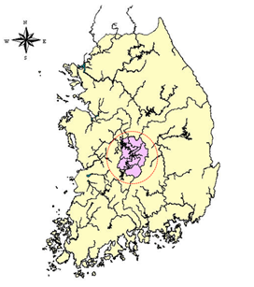
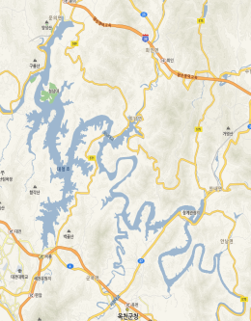

Figure 1. Location of Daecheong reservoir.

The regression analysis was performed using chlorophyll-a as a dependent variable and band reflectance as the independent variable.
The distribution of chlorophyll-a was calculated by applying a regression model to the satellite image, calculating the chlorophyll-a concentration of each pixel, and then classifying it according to concentration. The distribution of chlorophyll-a was mapped based on this procedure. The sampling point is shown in Figure 2, and the detailed procedure is shown in Figure 3. And the information of the KOMPSAT-3 satellite is presented in Table 1.

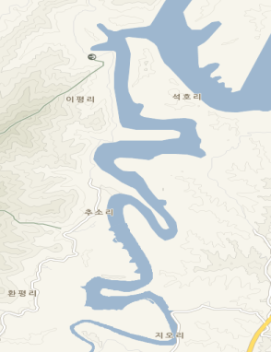
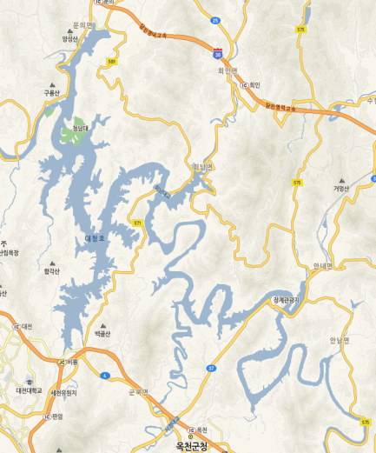
Sampling site
Figure 2. Daecheong reservoir and sampling sites.

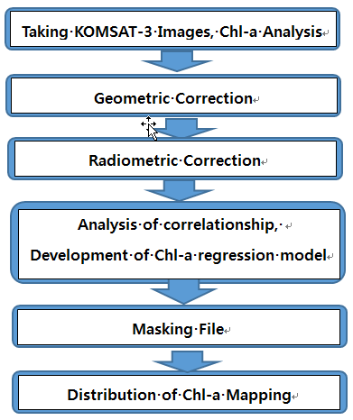
Figure 3. Detailed procedure.

Table 1. Information of KOMPSAT-3 satellite
Imaging mode | Band | Wavelength (nm) | Spatial resolution (m)
Multispectral | 1 | 450~520 | 2.8
 | 2 | 520~600
 | 3 | 600~690
 | 4 | 760~900
Panchromatic | PAN | 450~900 | 0.7

3. Results
The KOMPSAT-3 images used in this study were taken on October 16, 2016 and May 11, 2017. When the satellite passed through the study area, samples were taken and analyzed for chlorophyll-a. After pretreatment of satellite images, the correlation between chlorophyll-a field values and satellite image bands was analyzed by comparing the reflectance converted from DN(Digital Number) value and chlorophyll-a. The reason for converting the DN value to reflectance is that if the date taken by the satellite is different, the DN value should be converted to the same physical dimension so that the satellite image data can be standardized⁽³⁾. After the correlation analysis, a band with high correlation with chlorophyll-a was selected and a regression model was derived from chlorophyll-a as the dependent variable and band-specific reflectance as the independent variable.
The reflectance increased in most bands when chlorophyll-a concentration increased. A regression model was derived with using the 2nd band(green) as reflectance wavelength of the chlorophyll, 3rd band(red) as absorption wavelength and 4th band as near infrared wavelength closely related to the number of algae particles⁽⁴⁾⁽⁵⁾. A regression model with an R² value of 0.71 was obtained as follows.

Chl-a = 1779.96*BA2-1029.99*BA3-16.66*BA4+78.88 (R²=0.71)
BA : band

The concentration at each pixel was calculated by applying the satellite images at each time point. The distribution of the chlorophyll-a was obtained by dividing the ranges according to the concentration. In order to create a distribution map, a masking file was created to distinguishes between land and water. A regression model was applied to the masking file to create a chlorophyll-a distribution map. As shown in this study, if the water quality of the water body can be evaluated by using remote sensing, the representative trophic status would be expected in the environmental impact assessment of the lake.

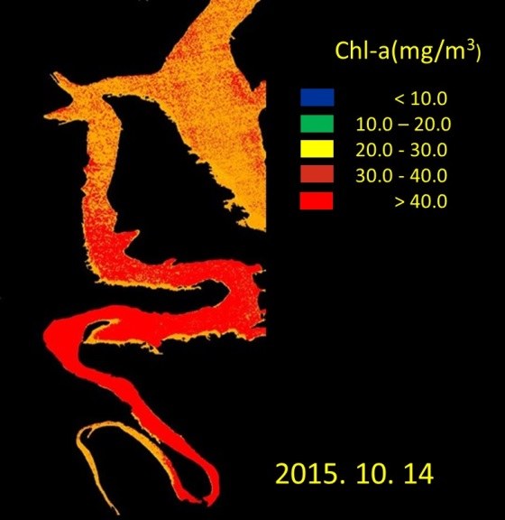 | 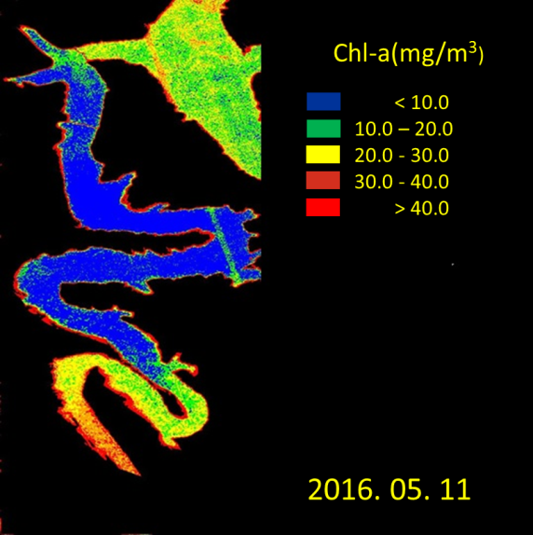
Figure 4. Chlorophyll-a distribution maps

4. Conclusion
A regression model was developed using KOMPSAT-3 satellite images and chlorophyll-a concentration. The spatial distribution of chlorophyll-a could be mapped by applying the model to the study area. The image data has very useful functions to understand the overall chlorophyll-a concentration of the wide-area and to detect a large concentration change. If continuous data accumulation is made in the future, it will be possible to manage the three-dimensional water quality.

Acknowledgement
This work was supported by the National Research Foundation of Korea(NRF) grant funded by the Korea government(GOLDEN-Solution) (NRF-2015M1A3A3A04027614)

Reference
(1) http://www.ndsl.kr/ndsl/commons/util/ndslOriginalView.do
(2) E.J. Han, T.G. Kim, D.H. Jeong, S.Y. Cheon, S.J. Kim, S.J. Yu, J.Y. Hwang, T.S. Kim, M.H. Kim, Assessment of Trophic State for Daecheong Reservoir Using Landsat TM Imagery Data, Journal of Environmental Impact Assessment, Vol. 7, No. 1, pp. 81~91, 1998.
(3) C. J. Rovinove, Computation with Physical Values from Landsat Digital Data, Photogrammetric Engineering and Remote Sensing, Vol. 48, pp. 781~784, 1982.
(4) A. M. Sheela, J. Letha, Sabu Joseph, K. K. Ramachandran, Sanalkumar S. P., Trophic state index of a lake system using IRS (P6-LISS III) satellite imagery, Environmental Monitoring and Assessment, 177(1-4), pp. 575~592, 2011.
(5) Jun Chen, Zhenhe Wen, Zhengqing Xiao, Spectral Geometric Triangle Properties of Chlorophyll-A Inversion in Taihu Lake Based on TM Data, Journal of Water Resource and Protection, 3, 67~75, 2011.

