Development of Weather Characteristics Analysis System
for Dam Construction Area

Bo-Seung Kang․ Yong-Moon Jung․ Jae-Chung Park*․ Sang-Jin Song․ Boo-Hyun Kwon
Water Resources Business Dept., K-water, Daejeon, Korea,
*Miryang Regional Office, K-water, Gyeongnam, Korea

Ⅰ. Introduction
In Korea, the amount of rainfall varies greatly by seasons and in those hydrological conditions, a dam is a useful facility to ensure a stable water supply, flood control and better water quality downstream, and to generate hydraulic power. However, dam construction is a large-scale development project and affects the environment by blocking the water flow. Therefore, it is important to predict the environmental impacts of dam construction and seek measures to reduce that.
In terms of weather conditions, dam construction and the subsequent formation of a reservoir changes the ground roughness and topography, which leads to changes in the direction and velocity of wind. Also, the water in the reservoir has a larger thermal capacity than the soil and possibly changes the air temperature of the area. Moreover, the increasing amount of water vapor from the dam reservoir and the colder withdrawal water may increase fog surrounding the dam.
Because of these concerns about possible changes in local weather, the community may develop a negative attitude toward dam construction. A statistical analysis was made of 470 cases of complaints about dam construction at six dam sites in Korea. Nearly 86% of the complaints were about latent damage caused by fog (decrease in crop yield, respiratory disease, and an increase in traffic accidents, etc.). In this context, more scientific examination should be made of the relationship between dam construction and local weather changes, and fog formation at different time periods and distances from the dam.
Traditionally, a weather characteristics analysis system used a simple J.R. Eagleman formula that calculated the amount of water vapor by multiplying the evaporation factor by the surface area. This is not logically flawed, but, the actual amount of water vapor is affected by direction and velocity of the wind, as well as topographic factors. Thus, it is problematic to forecast local weather changes before and after dam construction with a simple theoretical formula.
Given these circumstances, this study proposed Weather Research and Forecasting(WRF), a three-dimensional model, and applied the model to the Young-ju Dam being constructed of Korea . The objective is to forecast local weather changes more correctly and develop a new system to apply to EIA in water resource development projects.

Ⅱ. Research Methodology
1. Research site
The Young-ju Dam project launched in December 2009 and is scheduled to be completed in 2014. The site is located 56km upstream from the confluence point of the Nakdong River. It is a multiple-purpose dam to provide water of better quality in the downstream areas, control floods, provide water for residential and industrial uses, and generate hydroelectric power. The basin area covers 500㎢, the capacity of the reservoir is 181 million ㎥, the reservoir surface is 10.46㎢, the length of reservoir is 21km, and the maximum depth is 43m (Fig 1).
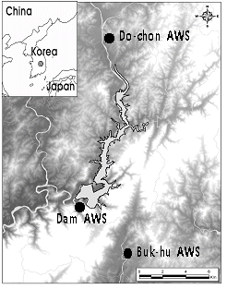
Item | Unit | Value
Basin
Basin Area | ㎢ | 500
Average rainfall | ㎜/year | 1,137
Reservoir
Flood water level | EL.m | 164.0
Normal high water level | EL.m | 163.0
Low water level | EL.m | 135.0
Total storage capacity | million ㎥ | 181.1
Area | ㎢ | 10.46
Benefits
Water supply | mil.㎥ /year | 203.3
Living/industrial | mil.㎥ /year | 10.7
Agricultural | mil.㎥/year | 6.0
River maintenance | mil.㎥/year | 186.6
Flood control | ㎥/s | 2,317
Hydroelectric power
Plant capacity | kW/plant | 2,500 x 2
Power supply | GWh/year | 16.3
Fig 1. Overview of Young-ju Dam & survey points

2. Weather characteristics forecast method
Weather Research and Forecasting(WRF), a 3D weather forecast model, was used; it was developed by the U.S National Center for Atmospheric Research(NCAR). The model is widely used at meteorological offices, Air Force Weather Agency(AFWA), and National Center for Environmental Protection(NCEP) for weather research and forecast. The WRF model selects an area and generates the initial field based on weather data grids. The grids are narrowed down for calculation. The input data includes the topographic data of the region and weather data of the surrounding area.
Topographic data was extracted from digital elevation model (DEM) data of the Korean Ministry of Environment, and the ground surface data was drawn from 30m resolution. The model covered the area of 40㎞x40㎞ with the Young-ju Dam in the center, with the grids at the interval of 1km. The weather data of the surrounding area was collected from the nearby meteorological office and Automatic Weather System (AWS) data near the research site (Fig 1). The regional weather data between 1999 and 2008 from the observatory of the Youngju, Bonghwa and Andong region were collected for statistical analysis. AWS was established at three sites near the dam to measure seven items in including (wind direction, wind velocity, temperature, humidity, solar radiation, visibility and etc.) for over a year in 2008 and 2009. To collect data on upper-layer weather for analysis of air mixing and its impact on fog formation, a Rawin Sonde was floated in each season to measure temperature, air pressure, humidity, wind direction and velocity at different altitudes.
The collected topographic and weather data were applied to the weather change forecast model. The first modeling was based on the ground conditions before the dam construction. Then, another modeling was done after the ground surface was partially changed to water surface due to construction. Weather changes before and after the dam construction were forecasted and compared. Meanwhile, a fog algorithm was separately established based on the basic weather data of temperature, humidity and wind characteristics to determine the presence of fog.

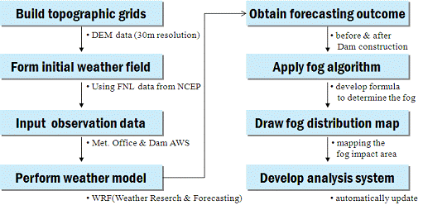
Fig 2. WRF model flow chart

Ⅲ. Conclusion and considerations
1. Evaluation of reliability of weather characteristics forecast model
The reliability of the weather forecast model was tested based on correlation analysis between the observation data and the forecast outcomes, and the review of BIAS. BIAS indicates how much a forecast value deviates from an observation data. The closer the value is to zero, the more reliable the model is. The comparison of observation data at the Young-ju observatory and the forecast outcome of the model showed a correlation of 0.9166 and BIAS value of 0.70. The comparison of observation data from Dochon AWS point and the forecast outcome showed a correlation of 0.9325 and a BIAS value of 0.64. In other words, the model closely approximated the observation data. The reliability of relative humidity formed a similar conclusion.

2. Results of weather characteristics forecast at Young-ju Dam area
The weather change forecast at the Young-ju Dam site before and after the construction showed that the annual average temperature hardly changed (less than 0.01℃); it rose by 0.01-0.03℃ in spring and winter, and fell by 0.02-0.04℃ in summer and fall. The spatial distribution of temperatures by season showed that the temperature in the surrounding region rose as the artificial lake worked as a potential source of heat during the low-temperature season. In high-temperature season, the lake worked as a source of coolness, dropping the temperature of the surrounding area. This is due to the difference in thermal capacity between water and soil.
It was predicted that relative humidity rose by 0.12% on an annual average, and it rose more near the lake than in distant areas. In other words, the artificial lake increased water vapors in the air, and generally increased relative humidity throughout the year. Wind velocity rose by 0.26m/s on annual average in the distant area (40x40km) and 0.24m/s in the adjacent area (8x15km). Since the friction of the water surface is less than the ground, the dam construction and subsequent increase in water surface leads to higher wind velocity, especially in summer.
Fog is formed when water vapor is supplied near the ground or is condensed to the form of water, reducing visibility to less than 1km. Usually, dam construction increases the probability of fog due to increasing the amount of water vapor and the difference in air and water temperature, which leads to temperature inversion. In some areas, the probability falls as the wind velocity rises. These factors come into play to affect fog formation (Lee Seung-ho, 1998). Following construction of the Young-ju Dam, the number of foggy days rose by 2 days, from 36 days to 38 days, in the distant area (40x40km) and by 5 days, from 40 days to 45 days, in the adjacent area (8x15km). The annual fog hours increased by 24 hours and 30 hours respectively, and the fog mostly appeared at the southeast part of the dam due to a dominant northwest wind.

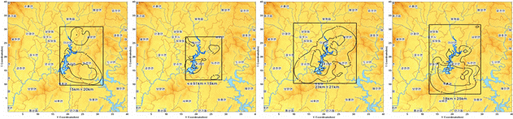
Fig 3. Changes in the number of foggy days before and after the Young-ju Dam construction
(from left : spring, summer, fall and winter)

3. Weather characteristics analysis system
Based on the forecast method and accumulated weather data, a system was established that automatically updates the weather forecasting model and the fog algorithm, and periodically checks and revises the data. The system adopted a visual display that shows weather change data by various factors, such as time periods, distances from the dam and topographic, for convenient user analysis.

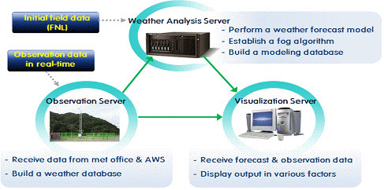
Fig 4. Structure of the weather characteristics analysis system

The system consists of three servers for weather observation, weather characteristics analysis, and visualization (Fig 4). The weather observation server receives data from the meteorological offices and dam AWS to build database. The weather characteristics analysis server realizes a weather forecasting model following topographic changes after dam construction, based on the observation data, and produces the outcomes. The visualization server receives both forecast and observation data in real-time and displays them in various factors (Fig 5).

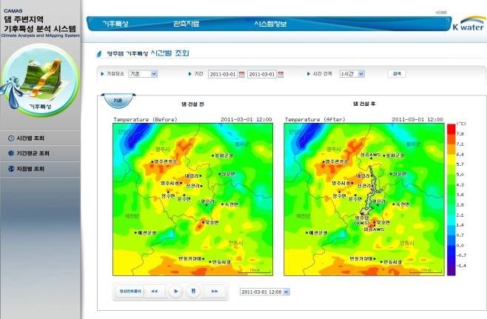 | 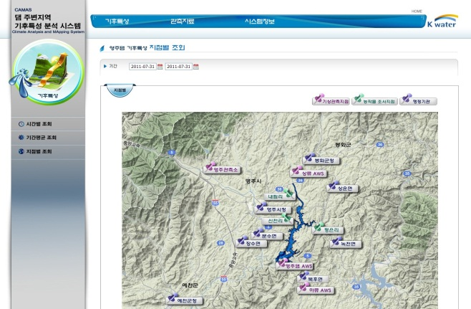
Weather changes before and after dam construction (by time periods) | Weather changes before and after dam construction (by distance from the dam)

Fig 5. Display of weather characteristics analysis system

Ⅳ. Conclusion
Dam construction is expected to change the local weather due to increasing water surface and colder withdrawal water, which is the main cause for opposing dam construction. In this study, a weather characteristics analysis system was developed for scientific research of weather changes before and after dam construction.
The research subject is an in-progress project, the Young-ju Dam construction, and WRF was used to forecast local weather changes. First, the regional meteorological data was collected and a GIS-based topographic database was established. Based on these, a three-dimensional weather forecasting model was designed, as well as a fog algorithm to determine the presence of fog. Changes in local weather before and after the construction were predicted by the WRF, and the outcomes were displayed by topographic factors, distances and time periods. The system periodically revised the model with additional input of meteorological data, and automatically updates the results.
In the case of the Young-ju Dam, the number of foggy days rose from 40 days to 45 days due to the increase in water surface and cold discharge water. The fog distribution varied in different areas. The research outcome is expected to provide scientific grounds to alleviate opposition to dam construction, and contribute to establishing methods to reduce meteorological impacts on local weather.

Reference
Byung-Il Jeon, Il-Gon Kim and Young-Mi Lee, 2002, A change of local meteorological environment according to dam construction of Nakdong-River : I. Meteorological data analysis before and after dam construction, Journal of the Environmental Sciences, 11(3), 161-168(in Korean).
Seung-Joo Baek, Kwi-Ok LEE, Heon-Ho Leem and Hwa-Woon Lee, Climatological analysis of fog occurrence at Chuncheon, Journal of the Environmental Sciences, 16(5), 583-591(in Korean).

