Development of Expert System for non-technical users
Kanji Usui*

1. Background and purpose
Expert System (ES), known as a kind of Artificial Intelligent (AI) systems, has been applied in numerous areas including EIA. ES performs problem-solving tasks in a specific field like the way skilled experts made a decision based on their experience and intuition.
ES is also one of the useful tools for EIA practitioners; however, it is applied for limited cases because its development requires huge amount of money and time, and the systems are too complicated for non-experts to use.
Although ES(s) have still a potential to become a supporting tool for decision making, the above issues should be solved so as to be applied widely in various cases.
This project aims to develop an Expert System targeting beginners and/or citizen as one of the supporting tools for EIA’s decision making.

2. Mechanism of expert system
ESs is a system that reproduces a mechanism of human’s inference on computer as follows;
Developer
Developer Interface
User Interface
Ques-
tion
Response
Working Memory
Input
Result
Mechanism of inference
Knowledge base
User
Data Input
Data Registration
Expert System
Fig.1. Mechanism of Expert System
*Environmental Consultant (Currently, work as a contracted expert with JICA in Timor Leste)
The working process of ES is as follows;
First, developer of ES obtains knowledge information (e.g. heuristics) through interview to skilled experts.
Second, the gathered information is converted to a form to be processed by computer, called “Production Rules”.
Third, the rules are put into “Knowledge base (long-term memory)” through “Developer interface”.
Fourth, user asks a question to ES through “User interface”. The question is stocked in “Working memory (short-term memory)”.
Fifth, “Mechanism of inference” retrieves a closest answer to the question from “Knowledge base”, and output the result to user.

Production rule is an artificial grammar similar to natural language. Standard forms of Production rule is expressed by IF ... THEN ... ELSE to be easily understood to developer. Examples of rules would be:

IF Sector = dam AND
Height of dam >= 15m OR
Sector = dam AND
Relocatees >= 100 THEN
Criteria = Major Impact

Interpretation of natural language:
“If the sector is dam and height of the weir is more than 15 m, or the sector is dam and the likely relocatees are more than 100 people, the likely impact by the project would be significant.”
“Knowledge base” is composed by network of the massive production rules.

3. ES as useful tool for EIA capacity building
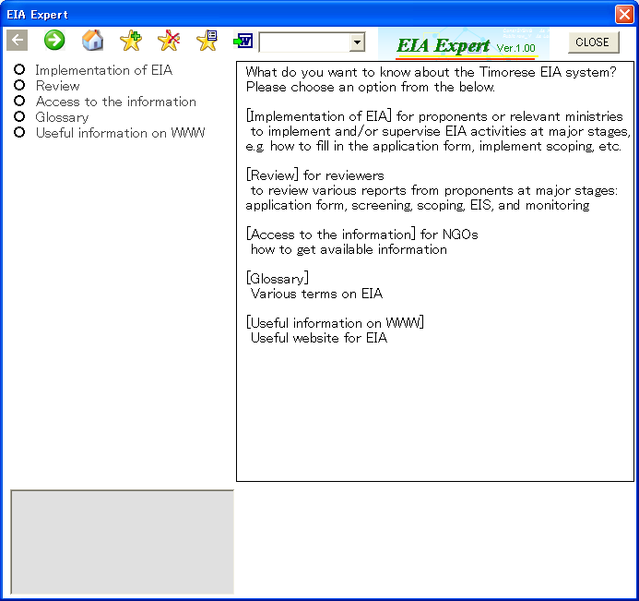
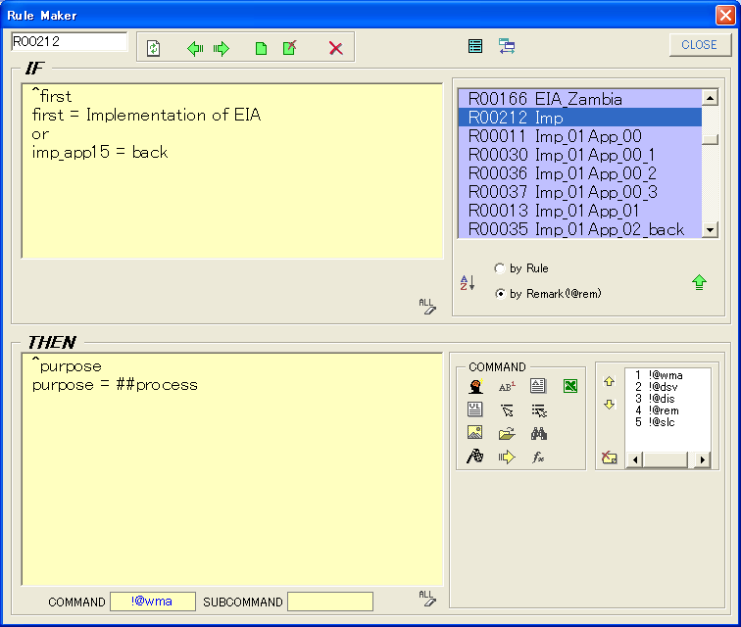
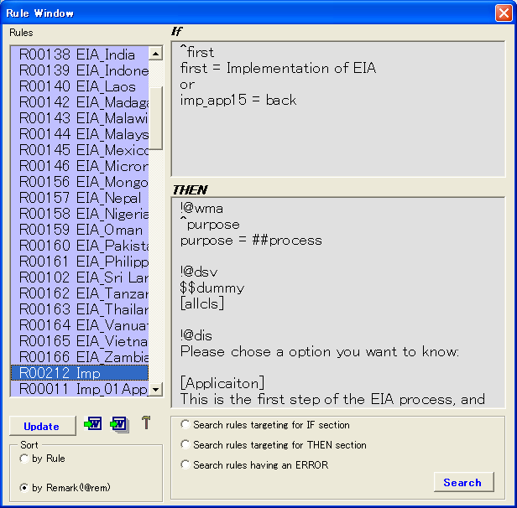
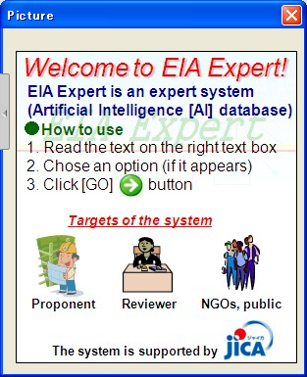
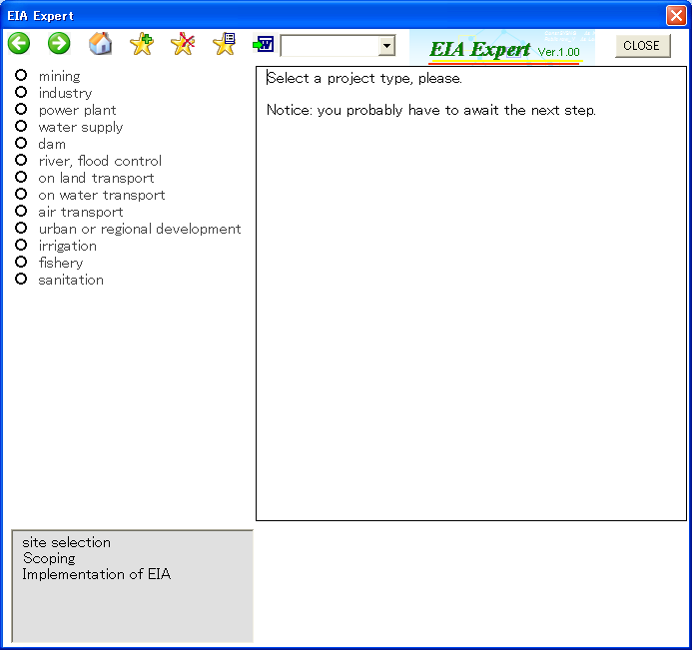
As training tools for EIA capacity building, a number of methods exist such as books, workshops, lectures, and so on. However, in case of starting an infrastructure project, the residents living close to the project area often concern about how to access useful information in earlier stage of the project cycle such as “”How significant are likely adverse impacts?”, “How and who implement suitable assessment?”, “What kind of measure of those impacts will be taken?” and so on. Of course, if the proponent and the local administration responsible for the project provide appropriate information to them, their concerns would be alleviated and they might accept the project. However, in many cases, they would not satisfy the information provided by proponents especially in earlier stage of project cycle. In more serious case, citizen must have hired a specialist by themselves so as to implement cross-review and additional environmental work.
Visualized user inter face
Dialogue-like database
Simple rule editor (developer interface)
Fig.2. Features of the prototype Expert System
ES can contribute to solving of the case at some level by provision of available knowledge to user instead of hiring a skilled expert.
In addition, ES may become useful tool for EIA beginners such as student and new employee because implementation of the system would be less expensive compared to hiring a full time worker for them.
ES is greatly expected to meet the needs because it has the following features;
To provide a solution to a specific case with difference of paper media,
To access 24 hours per day for 365 days with difference of human being, and
To reduce total cost for obtaining a solution.
Although ES is clearly useful tool for EIA capacity building, it makes up only a part of the field. It will not replace human expert because it is impossible that ES reproduce perfectly human’s inference mechanism.
4. Features of the prototype under development
Main Menu
Implementation of EIA
Review of EIA
Glossary
Access to useful source
Submission of Project brief
Scoping
Environmental Management
Screening
Review of TOR
Review of EIS
Supervision of Environmental Management
Fig. 3 Contents of the Prototype ES
Public consultation
Supervision of Public consultation
Development of ES has a long history since 1970’s and a lot of systems have been developed so far. Although there are various kinds of ES, old-fashioned ES tend to have common disadvantages such as extremely difficult appearance of command line base for beginner developer, un-user friendly interface, and so on.
The prototype ES under development has been considered to become user-friendly system through analysis of traditional ES and identification of the weak points. As the result, the system has three features compared with traditional ES as follows;
(1) Provision of simple and visualized user interface so that beginners can easily access;
(2) Dialogue like database – user can easily obtain necessary information as if chatted with an expert; and
(3) Easy way to create and modify rules by a simple rule editor.

5. Contents of the system
The prototype ES covers entire activities of EIA of each stakeholder such as proponent, administration, citizen, NGO, and so on.
The contents are shown in the Fig. 3.
Although the contents should be modified so as to match user’s demands in future, the basic concept is to provide basic information how to carry out and/or review EIA works.
In order to evaluate the system, a practical test was conducted that practitioners (beginners of EIA) use for their official work. Although the testers pointed out some disadvantages especially on lack of information and not understandable text-based information, they evaluated that most of parts of the system could contribute well their works.

6. Conclusion and further action
The ES is just a prototype and further development is needed as well; however, it shows clearly a potential of contribution to some parts of EIA work as basic guidance for beginners.
In near future, the completed system is going to be available to public and it is expected that the system would become a guide for EIA beginners.

References
Mitsuru Ishizuka (1996) “Expression of knowledge and High speed inference (Japanese: Chishiki no Hyougen to Kousoku Suiron”, Maruzen, Tokyo, pp.296.
Norihira Komoda, et. al. (1997) “Design and Development of Expert System (Japanese: Expert System no sekkei to kaihatsu)”, Syoukoudou, Tokyo, pp.182.
Prasad Modak and Asit K. Biswas (1999) “Conducting Environmental Impact Assessment in Developing Countries”, United Nations University Press, Tokyo, pp.120-123.

