Social impacts induced by Radiation risk in Fukushima

Takehiko MURAYAMA

ABSTRACT

An accident of Fukushima daiichi nuclear power plant induced by an earthquake of Magnitude 9.0 and subsequent tsunami gave various kinds of impacts around the plant. After reviewing arguments of local governments for low dose radiation risk, this paper dealt with social impacts by the risk in terms of a gap of emergency response between national and local governments, corruption of communities in various levels induced by plural statements for risk levels in low level radiation, and economic impacts for agricultural crops made in Fukushima prefecture. Afterwards, clues for improving the situation were discussed, which include understanding of characteristics of public perception, attitudes of experts and interactive risk communication.

Key Words: Nuclear accident, Radiation risk, Social impacts, Risk communication

BACKGROUND AND PURPOSE

After the severe earthquake and accident of a nuclear power plant, issues on information dissemination and communication on radiation risk are quite important for various social stages from national level to local communities. While more than 10 years has passed after Japanese experts began to discuss about risk communication, social confusion on radiation risk shows there are still many subjects to be practically resolved. While some papers including Suzuki (2011) and Akamatsu (2011) dealt with risk communication issues, those are mainly focused on attitudes of national government. Through literature survey as well as on-site interviews, this paper discussed issues on information dissemination and risk communication in Fukushima Prefecture, where most sever impacts by radioactive substances have occurred.

LOCAL GOVERNMENTS’ VIEWS ON RADIATION RISK

Prefectural government of Fukushima published on March 30th Q & A for main issues which dealt with lecture meetings by medical experts on radiation risk (Fukushima Prefectural Government, 2011a). That shows “Current situation would not bring about the condition that cumulative dose of radiation excess 100 mSv, which is a criteria of health risk.” In another Q & A published on June 30th, they argued that increase of cancer risk under 100 mSv is not scientifically proven, while long-term cancer risk would increase by dose of more than 100 mSv (Fukushima Prefectural Government, 2011b).

Although there are few cases in which municipal governments express their views on radiation risk, Fukushima municipal government, which is the capital city of Fukushima Prefecture, published an article titled “Radiation Q & A” (Fukushima Municipal Government, 2011). That article includes a view on health effects for pregnancy and childbirth, and that shows people do not need to be anxious about health effect for baby under 100 mGy at all, because it cannot be imagined that radiation dose for embryos excess 100 mGy with radioactive substances scattered by the Fukushima- Daiichi nuclear accident. As a note of that article shows mGy equals to mSv for Iodine 131 or Cesium 137, the views of those governments would refer to the judgment of International Committee on Radiation Protection (ICRP), whose criteria for health risk is 100 mSv.

PROBLEMS ON INFORMATION EXCHANGE AND COMMUNICATION AMONG VARIOUS STAKEHOLDERS

1) Differences of judgments between national and local governments
That point was more serious in more urgent situation just after the occurrence of the accident. While national government gradually expanded evacuation areas from mid-term of March to May of 2011, the decisions were not notified directly to municipal governments and some local governments which included both evacuation and non-evacuation areas had severe troubles with explanation and control for peoples’ behavior. In the stage of a couple of months after the accident, the situation was still remained almost the same, and local governments complained to attitude of national government. Japan experienced similar difficulties in a criticality accident of a nuclear fuel processing plant in 1999 (Murayama, 2006). The difference of judgments between national and local governments and a time lag of information transmission were repeated in this accident.

2) Several factors which make communication on radiation risk difficult
Through my experiences of risk communication activities on chemical substances from factories, automobiles and houses, the characteristics of radiation risk induced by this nuclear accident make effective communication among people living in Fukushima as well as less polluted areas including Tokyo more difficult.

One is plural views for evaluation of radiation risk. It would be common hypothetical views that cancer risks by chemical substances may proportionally increase according as the volumes of substances without thresholds based on experimental data, while we often do not have sufficient data for low dose. Although we do not have enough data for evaluate radiation risk as well, there are several different views on low dose. ICRP shows linear relationship between dose and the health effect without threshold like chemical substances, and European Committee on Radiation Risk (ECRR) emphasizes effects by internal exposures and argued that low dose radiation causes more severe risks. Other group supposes the existence of threshold, and some experts believe that low dose radiation may positive effects for human health. For even chemical substances, risk communication among various stakeholders would not be easy to conduct. People confront severe difficulties to manage communication under multiple views on evaluation of radiation risk.

Another point is a hybrid situation both risk and crisis management caused by this nuclear accident. Just after the accident, several standards for radioactive substances which are included in foods, drinking water and school facilities were degraded. It would be not easy to understand such degradations for lay people even in crisis situation. My experiences on risk communication activities show environmental standards are a quite effective tools for consensus making. However, change of standards related to radiation risk lead distrust for judgment of national government. As risk management and crisis management are independently dealt and insufficiently discussed so far, we should examine the relationship.

CORRUPTION OF MUTUAL TRUST IN LOCAL AREAS

Difficulties of communication on radiation risk definitely harm the relationship of mutual trust among local people in Fukushima prefecture. Even in chemical substances whose risks are relatively common for experts, people living around chemical factories have different views from that of factory workers, due to some uncertainties on monitoring and experimental data. Above-mentioned views on the evaluation on low dose radiation may enlarge the gap of judgments among stakeholders.

In fact, municipal governments as well as prefectural one tend to suppress anxiety among local people and evacuation outside their jurisdictions. On the other hand, some people living in non-designated areas for evacuation move to other regions voluntarily. According to official announcement of Fukushima prefecture, 27 thousand and 1 people moved outside the prefecture during March and August of 2011, and the population fell below 2 million after an interval of 33 years. An newspaper article shows prefectural government’s views that extreme decrease of population still continue due to the nuclear disaster (Asahi Newspaper, September 1st, 2011).

An citizen’s group, Fukushima Network for Saving Children from Radiation, was founded in May of 2011, and conduct several activities including monitoring of radiation, decontamination, knowledge dissemination, protection, evacuation and recreation. In addition, they claim the right of evacuation from non-designated area for official evacuation, and established an independent facility for measurement of volume of radioactive substances in foods.

The gap of views for evaluation of radiation risk generates different attitudes among local governments and citizens in various layers of local societies such as families, communities, companies, schools. While no one shows actual health effects by radiation risk, it should be clearly mentioned that radiation risk have been collapsing local communities in Fukushima prefecture.

CHANGE OF PRICES OF AGRICULTURAL PRODUCTS

Anxiety to radiation risk would cause the price of agricultural products in Fukushima prefecture. Figure 1 and 2 show wholesale prices of Peach and Asparagus respectively in main market of Japan. According to those figures, the price of peach made in Fukushima was about 100 to 200 Yen, and that of asparagus was around 300 Yen cheaper than same products in other regions. Prices of other products may be under similar condition. As all products which were distributed in market met the standards on radioactive contamination for shipping at that time, people’s anxiety for radiation risk would that tendency.
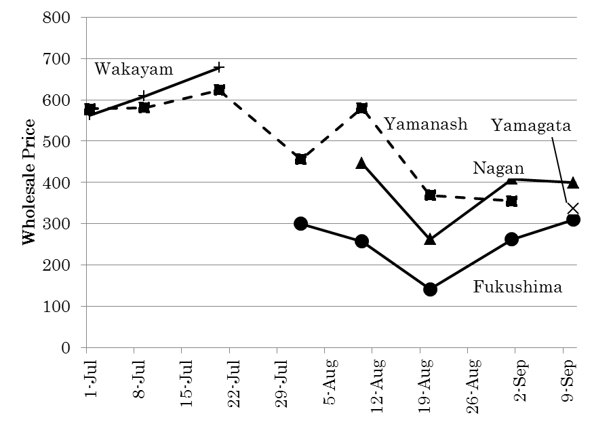
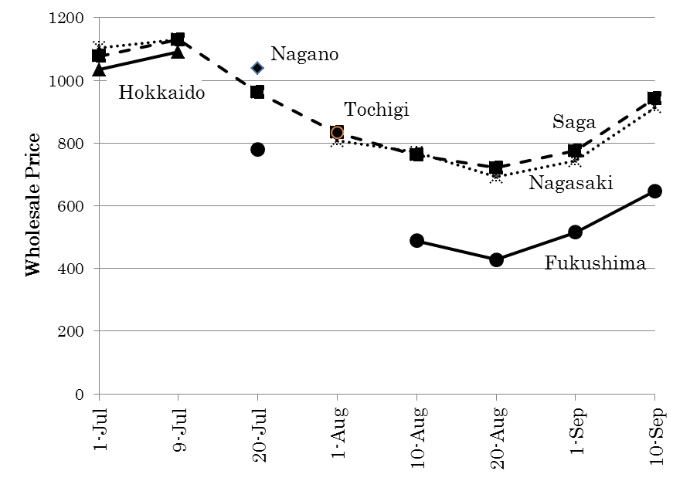
Fig.1 Change of Wholesale price of Peach
Fig.2 Change of Wholesale price of Asparagus

Source: calculated based on data from Japan Ministry of Agriculture, Forestry and Fishery

ISSUES TO BE RESOLVED

1) Understanding of risk perception among lay people
It would be quite important to understand how people perceive radiation risk. Psychological researches show that not only physical level, characteristics of risks may affect people’s perception. US National Research Council (NRC) listed several factors which impact acceptance of various risks in Table 1 (US NRC, 1989). Irrespective of physical level of risks, personal controllability, reversibility, health impact to children and other factors may affect people’s concern. According to this view, it should be avoided to compare radiation risk which is uncontrollable with other risks of smoking and poor intake of vegetables which are easy to control for lay people.

Table 1 Qualitative factors affecting risk perception
Factor | Conditions Increasing Public Concern | Conditions Decreasing Public Concern
Controllability (personal) | Uncontrollable | Controllable
Voluntariness of exposure | Involuntary | Voluntary
Effects on children | Children specifically at risk | Children not specifically at risk
Effects on future generations | Risk to future generations | No risk to future generations
Reversibility | Effects irreversible | Effects reversible
Origin | Caused by human actions or failures | Caused by acts of nature or God
Source: US NRC (1989)

2) Support of scientific experts
According to my experiences, people would judge the importance of risks through at least three types of information. One is a part which is easy to understand for lay people by their own efforts, and physical data and related information would come under this category. Second is a part which is difficult to understand and cannot but relay on experts’ judgments. Third one is related to personal values and people’s interests. While proportion of those three categories may depend on individual condition, people would judge with experts’ judgment more or less. Therefore, it would be quite important for effective risk communication to construct reliable relationship between scientific experts and lay people. For building the relationship, experts should understand the difference between physical safety and psychological relief. After this nuclear accident, some experts on radiation risk argued people should feel relieved for low dose effect. However, experts should leave issue of relief to lay people.

3) Risk communication in practical manner
For relatively low dose of radiation risk, it would not be effective to discuss in either-or situations, safety vs danger. Providing the information on characteristics of risks and several alternatives to avoid additional risks in various manners, it would be effective to discuss among stakeholders. A couple of years ago, I conducted stakeholders’ dialogues for risks induced by chemical substances (Murayama et al, 2009). In that case, stakeholders’ concerns were asked in the first step, and schematize those comments with KJ method, which is popular to summarize various facts or comments in Japan. After that, physical risks were estimated based on data from Pollution Release and Transfer Register (PRTR) data published by National government, and discussed about the data among stakeholders. As mentioned above, it would be more difficult to conduct effective dialogues for low dose radiation risk because several views on the risks exist independently. It may be, however, effective to rebuild reliable relationship among the people to make clear common and different viewpoints among stakeholders, and discuss better alternative for decontamination.

REFERENCES

Akamatsu, K. (2011): “On experiences of provisional consultant on health effect of radiation risk ‘Health Consultation Hotline’”, Research on Radiation and organism, 46（2），pp.87-92
ECRR (2010): “Recommendations of the ECRR, The Health Effects of Exposure to Low Doses of Ionizing Radiation”
Fukushima Prefecture, Headquarters for Disaster Control (2011a): “Main Q & A in past lecture meetings”
Fukushima Prefecture, Headquarters for Disaster Control (2011b): “Q & A on radiation and health effect”
Fukushima Municipal Government (2011): “Radiation Q & A, experts’ judgments”, official monthly brochure, April 21rd, 2011
ICRP (2007): “Recommendations of the International Commission on Radiological Protection”, ICRP Publication 103．
Murayama, T. (2006): “A consideration on organizational responses towards crisis management for highly technological systems”, Annual bulletin of Association of Risk Management Systems Studies, 4, pp.52-57
Murayama, T. (2009): “Practice of Community Dialogue on environmental risk with PRTR data in Kawagoe City”, 22nd annual meeting, Society for Risk Analysis, Japan Section
Suzuki, H. (2011): “Risk communication on government response to the accident of Fukushima Daiichi nuclear power plant”, Jurist, 1427, pp.58-64
USNRC (1989): “Improving Risk Communication”, 352pp.

