# A least cost path (LCP) toolbox for optimal routing of high voltage power lines for a sustainable future.

Frank Hanssen, Norwegian Institute for Nature Research (NINA)

Jørn Thomassen, Norwegian Institute for Nature Research (NINA)

Roel May, Norwegian Institute for Nature Research (NINA)

Kjetil Bevanger, Norwegian Institute for Nature Research (NINA)

## Abstract

The Norwegian Institute for Nature Research (NINA) is in charge of a project (January 2011 to December 2013) where the main aim is to develop a Least Cost Path (LCP) toolbox for environmental friendly routing of high voltage power lines. The toolbox is based on ecological, economic, social and technological perspectives and adapted to the rough topographical conditions in Norway. This project is a part of a larger scaled research project on optimal design and routing of power lines (OPTIPOL) organized by the Norwegian Centre for Environmental Design of Renewable Energy (CEDREN).

Thematic EIA-content and criteria will be defined by participatory stakeholder processes, best practices and legal requirements and thereafter implemented in the LCP-toolbox. To measure and compare the many different EIA-aspects in LCP a Fuzzy logic approach is used to calibrate and standardize the criteria based on stakeholders’ degree of accept measured on a continuous scale from 0 to 1.

Consensus on criteria definitions, criteria values and the relative importance of the thematic content will be achieved through the implementation of standardized participatory dialogue seminars.

The toolbox is meant to be a usefull planning tool in an early phase of power line routing projects in order to identify search corridors for EIA-scoping, suggest optimal routing alternatives, minimize potential stakeholder conflicts and to make the decision processes more transparent to the authorities and the public.

## Introduction

Norway is facing a significant expansion in the central power transmission line grid in the near future. Part of the existing Norwegian transmission line grid is old and requires upgrading and upscaling. The increased growth in hydropower and wind-power production also demands an increase in the capacity of the national power transmission line grid. The Norwegian Water Resources and Energy Directorate have due to May 2012 received license applications for new construction and upgrade projects of 800 km (420 kV) and 550 km (66-132 kV). A great variety of stakeholders in about 100 municipalities will be affected by these projects.

The Norwegian Government heavily supports the need for an enlargement of the central power transmission line grid. To ensure optimal power line routing for the future the Government will put greater emphasize on environmental impact assessments (EIA) and mitigating measures.

The Research Council of Norway, the private energy industry, and several research institutes and universities funded in 2009 the Centre for Environmental Design of Renewable Energy (CEDREN). CEDREN is one of eight Centers for Environmental friendly Energy Research (CEER), established as a direct response to the political agreement for a substantial increase in the research and development in the fields of renewable energy in Norway. CEDREN initiates research and development of hydropower, wind power, power line rights-of-way and implementation of environment and energy policy.

One of the seven research projects organized by CEDREN is focusing on optimal design and routing of power lines (OPTIPOL). As a part of OPTIPOL the Norwegian Institute for Nature Research (NINA) is in charge of a project (January 2011 to December 2013) where the main aim is to develop a Least Cost Path toolbox for environmental friendly routing of high voltage power lines. The toolbox is based on ecological, economic, social and technological perspectives and adapted to the rough topographical conditions in Norway. Important co-partners in this work are the Norwegian Water Resources and Energy Directorate, the Norwegian Directorate for Nature Management, the non-profit industry organization Energy Norway, the Norwegian national main grid owner and operator Statnett and SINTEF Energy research.

## Methodology and results

The Least Cost Path methodology helps to find the “optimal” path between two locations over a cost surface where the cost is a function of distance and several user defined criteria. The LCP methodology has been applied in GIS for many years and very little has changed with respect to the technical approach. Contrary the procedures for calibrating and weighting model criteria have changed rapidly (Berry 2007).

The Optipol LCP-toolbox version 1.0 was realized as a pilot in April 2012. The toolbox is developed on the ArcGIS10 platform (ArcInfo and Spatial Analyst) and contains geoprocessing functionality for calculation of cost surfaces, weighted sum overlay and least cost corridor/path in a Modelbuilder user interface. All implemented thematic contents are organized in a geodatabase as raster layers with a fixed resolution of 10x10 meters. The toolbox is flexible with respect to implementation of new thematic content, criteria and criteria values. In addition the toolbox also offers effective handling of large scale multi-criteria datasets.

To calibrate the variety of stakeholder interests and legal requirements into standardized criteria for calculation of cost surfaces in non-restricted areas, we have applied a Fuzzy logic methodology based on stakeholders’ degree of accept measured on a continuous scale from 0 to 1 (Zadeh 1965, Zadeh et al. 1996). Restricted areas where routing of power lines is prohibited are excluded from the least cost path calculation as no data areas.

How to measure criteria values? Can all kinds of criteria values be measured? For example are Samii domestic reindeer herding interests very challenging to measure because of its dynamic land use form adapted to seasonal and climatic fluctuations. Also is perception of symbolic landscapes very challenging to measure because of its value-added complexity. Despite these kind of challenges we belief that most stakeholders’ degree of accept could be generalized, quantified and measured with the use of Fuzzy logics. Fuzzy logic assumes that acceptance changes on a continuous scale, instead of binary. To exemplify this we could assess acceptable placement of power lines on high altitude ridges in order to avoid and/or reduce silhouette effects and visual disturbance for observers within visibility range. Here we may assume a difference between whether we wish to totally avoid silhouette effects and visual disturbance (i.e. absolute or binary approach) or whether we could accept silhouette effects and visual disturbance to some extent (i.e. continuously changing degree of accept, see figure 1). An absolute criteria definition could be that the only acceptable power line placement is at least half a post height below the top of the ridges (i.e. 15 meters). This will give a degree of accept of 0 (vertical placement of power lines less than 15 meters below the ridge top is not acceptable) and 1 (vertical placement of power lines more than 15 meters below the ridge top is acceptable). The function will be binary (green graph). If we define the criteria in a more flexible way we could say that it is not acceptable to place the power lines at the top of the ridges, 15 meters below the ridge top is fairly acceptable and 30 meters (1 post heigth) below the top of the ridges is most acceptable, we will have a more continuous degree of accept (red graph).

Figure : Degree of acceptance: Placement of power lines on high altitude ridges in order to avoid and/or reduce silhouette effects and visual disturbance (green graph is the binary and red graph is the continuous fuzzy logic function).

Assuming that placement of power lines 15 meters below the top of the ridge are fairly acceptable we can apply the criteria value and calculate the cost surface using the following sigmoid equation:

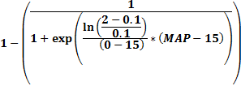

This equation assumes that acceptance or rejection is reached within the 90% confidence interval (i.e. at 0.95 and 0.05 respectively); this to avoid acceptance or rejection reaching infinity. All sub-thematic cost surfaces are calculated in the manner described above based on the degree of acceptance. They are thereafter weighted proportional to their relative importance and summarized into thematic cost surfaces. The thematic surfaces in turn are weighted proportional to their relative importance and summarized into cost surfaces for each of the perspectives (ecology, economy, societal and technology). Finally all perspective cost surfaces are weighted proportional to their relative importance and summarized into a total cost surface. Restricted areas where routing of power lines are prohibited are excluded from the least cost path calculation as no-data areas and consequently no power lines can be located in such areas.

In the methodological development we have received many usefull inputs on power line routing planning from the Norwegian Water Resources and Energy Directorate and the Norwegian national main grid owner/operator Statnett. They wished us to validate the Optipol LCP-toolbox with a real world case study. A 420 kV power line project finalized in 2005 between Klæbu and Viklandet in central Norway was selected for this purpose. To save time and work preparing historical EIA-data from 2001 and 2002 we focused on five affected municipalities in the study area. A subset of themes was identified (both from the Statnett application for construction and the two EIAs) and prepared for the Optipol LCP-database (see figure 2).

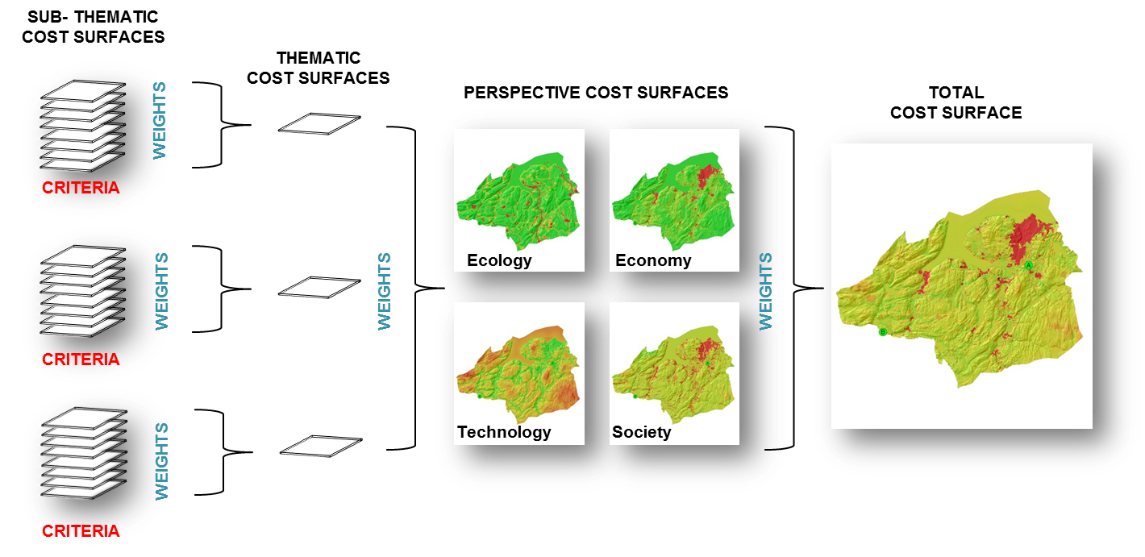

Figure 2: Preparation of a total cost surface based on the historical EIA (2001/2002) for the 420 kV power-line constructed in 2005 between Klæbu and Viklandet, central Norway.

Based on the total cost surface the toolbox calculates a least cost corridor (threshold at 0.5 standard deviations) and a least cost path that correlates relatively well with the existing power line built in 2005 (see figure 3). When comparing LCP calculations for the individual perspective’s cost surface, we can see that the ecological and economic paths tend to deviate a lot from the existing power line path. The societal and technological optimal paths fit much better with the existing power line path.

The calculated societal and technological optimal paths correlates also spatially relatively well with the calculated optimal path for all perspectives. For this example, this is caused by the weighted sum overlay of all perspective cost surfaces which results in a total cost surface holding a relatively similar distribution of costs around the existing power line path area as the cost surfaces for society and technology. Even though each perspective is weighted equally by 25% the cost surfaces for society and technology have relatively higher values than the cost surfaces for economy and ecology (see figure 2). Given the present stakeholder interests in the area, the applied criteria definitions and values in this example and for this study area, the overall effect is that the societal and technological values are more influent on the LCP routing calculation than the ecological and economic values.

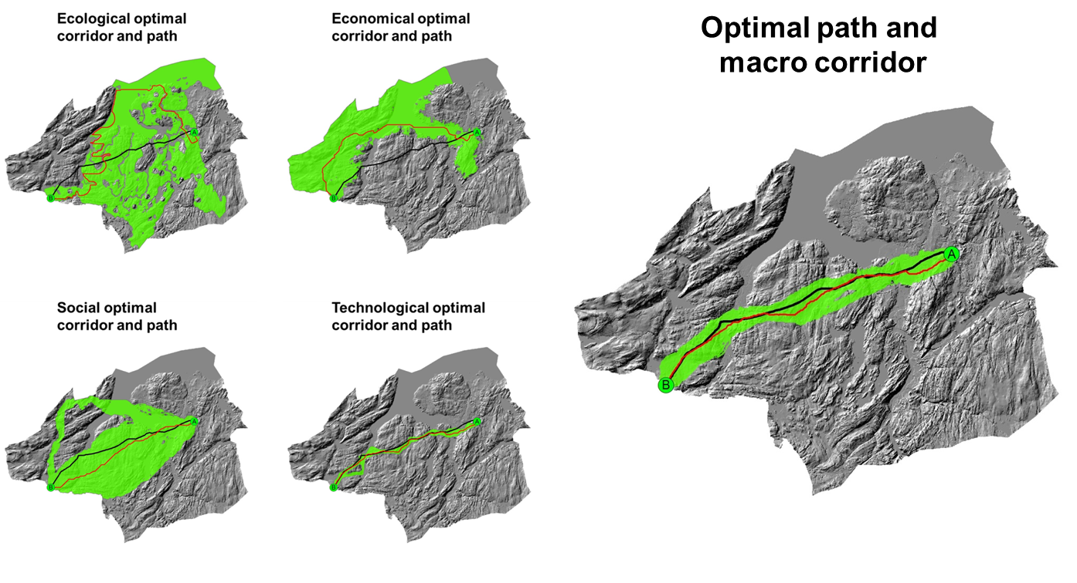

Figure 3: Validation of the Optipol LCP-toolbox based on the 420 kV power-line constructed in 2005 between Klæbu and Viklandet, central Norway.

This validation exercise illustrates the advantage of LCP as an effective planning tool that ensures a holistic approach in handling the multi-criteria context of a power-line routing project. It also shows that the Optipol LCP-toolbox and the traditional way of power line routing in Norway are comparable.

To achieve broad stakeholder consensus about the toolbox contents with its themes, sub-themes, criteria, criteria values and weights we have used a methodology for standardized dialog seminars. The first stakeholder dialog seminar was successfully held in Stjørdal, Norway, May 23-24th 2012. In order to reduce potential conflicts and to increase the public transparency in power line routing decision processes, the attendants at the seminar considered the Optipol LCP-toolbox and the dialog methodology as very important tools if implemented early in a planning process. The results from the first dialog seminar are summarized in [NINA report 856](http://www.nina.no/Publikasjoner/Publikasjonslisteforansatt.aspx?ansattid=14011) (OPTIPOL Least Cost Path dialog). The findings from the first dialog seminar will be implemented in version 2.0 of the Optipol LCP-toolbox. The first seminar will be followed up by a web-survey for setting criteria values and weights and a second seminar in order to consolidate final consensus. The complete toolbox will be launched in December 2013.

Our belief is that the LCP-toolbox could be a very helpful planning tool in an early planning phase in order to scope EIA, to reduce conflicts and to make decision processes more transparent to the public.

We would like to acknowledge the Research Council of Norway, CEDREN, the Norwegian Water Resources and Energy Directorate, the Norwegian national main grid owner Statnett, SINTEF Energy research and all participating stakeholders.

Read more about the project at [www.nina.no/archive/nina/PppBasePdf/rapport/2011/762.pdf](http://www.nina.no/archive/nina/PppBasePdf/rapport/2011/762.pdf).

## References

Berry, J. K. 2007. *Map Analysis.* Geo Tec Media, 224 p.p.

Zadeh, L.A. 1965. "Fuzzy sets", *Information and Control* 8 (3): 338–353.

Zadeh, L.A., Klir, G.J. & Yuan, B. (eds.) 1996. *Fuzzy Sets, Fuzzy Logic, Fuzzy Systems. Selected papers by L.A. Zadeh*. World Scientific Press.