**IAIA 2012 - Porto**

Tools and Methods Session: Tiering: A Missing Link

BI, Putting Tiering Into *Best* Practice

*Author: Marco Leonardi, Co-authors: Giuditta Di Caro, Valentina Invernizzi1*

1 Saipem spa

Summary of Abstract:

Through the illustration of a Sub-Saharan case study, the paper shows how tiering in the form of a BIS allows for a better harmonisation of Planning, Project and ESHIA.

Abstract:

ESHIA tiering implies executing assessments in the first three levels of planning and decision-making (Policy, Plans, Programs), not only in the so-called fourth level (Project). However, Oil&Gas projects are often formulated within a planning assessment devoid context, and their ESHIAs hence contain decisions on project scope that preceded area assessment studies.

Business Intelligence Studies (BIS) foresee commencing ESHIAs prior to any project’s planning and programming, example in a bidding phase. They identify National development policies and programmes present in the host Country, as well as any existing criticalities and opportunities, in order to then guide projects’ future formulation in alignment and support of these instruments. While, in the absence of National development programmes, on the basis of assessments’ findings, BIS subsequently outline possible development guidelines to be factored into a projects’ elaboration; in this manner, the all to diffused concept that what is not expressly prohibited is permissible, is finally superseded.

A Sub-Saharan case study is presented, where existing local economy development programmes (tourism, agriculture and fishing) for the area of interest were identified; none excluded the possibility of Oil&Gas development, indeed local Government expressly requested it. The two areas of development would appear to be mutually exclusive. The BIS’s output hence consisted in guidelines that incorporated, into any future Oil&Gas development, considerations on project actions that might damage or support other development plans for the area.

The underlying concept is encouraging decision-making in synergy with development policies of/for the host Country rather than merely handing-out compensation.

**1. Dead Heat Problems**

Environmental, Social and Health Impact Assessment (ESHIA) tiering implies executing assessments in the first three levels of planning and decision-making (Policy, Plans, Programs), not only in the so-called fourth level (Project)[1]. The Oil & Gas projects, especially those that are formulated as a result of new discoveries, are often developed in a context characterized by the absence of specific sectorial planning and, especially in developing countries, often in the presence of poor planning at strategic level, too. The projects developed in such context at best apply general criteria of best practice deriving from the (ESH)IA process, such as general “sustainable” design criteria, compliance with emission/discharge limitations, “best” location in generic environmental terms. Oil&Gas projects are often formulated within a planning assessment devoid context, and their ESHIAs hence contain decisions on project scope that preceded area assessment studies.

In practice planning does not always precede programs and programs projects. Hence we often encounter proposed projects which were not (originally) included in the relevant plans and programs.

In the meantime, in current practice, impact assessment (ESH)IA begins with a Screening phase coinciding/following the project’s Conceptual phase. In this way, the fundamental choices for the project (location, engineering solutions, logistics) are made before an environmental study has been carried out.

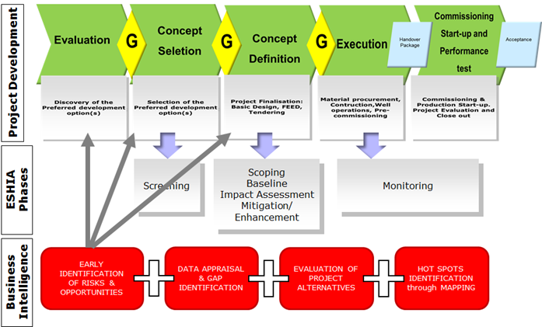

Unlike economic and technical business evaluations, ESHIA outcomes cannot actually feed into the initial Project Concept Phase. In practice, the ESHIA procedure begins once project design is almost complete; data-choice for impact evaluation requires knowledge of the project. Even preliminary ESHIAs foresee project alternatives’ assessment and hence follow basic project design. This is true also for the issue of taking into consideration any national policies and programmes present in the project’s host country. The usual procedure in IA: *Project 🡪Data collection (National Policies and programmes)🡪 Identification of risks and synergies🡪 Formulation of project’s development guidelines*, for the reasons above mentioned, fails in providing timely guidance to the project. At this point in the timeline, in fact, any project modifications in response to ESHIA outcomes generate both temporal and economic losses, without even having to consider the hypothesis of a whole new project design.

The consequential result consists in evaluating impact mitigation and compensation, rather than looking into project alteration options.

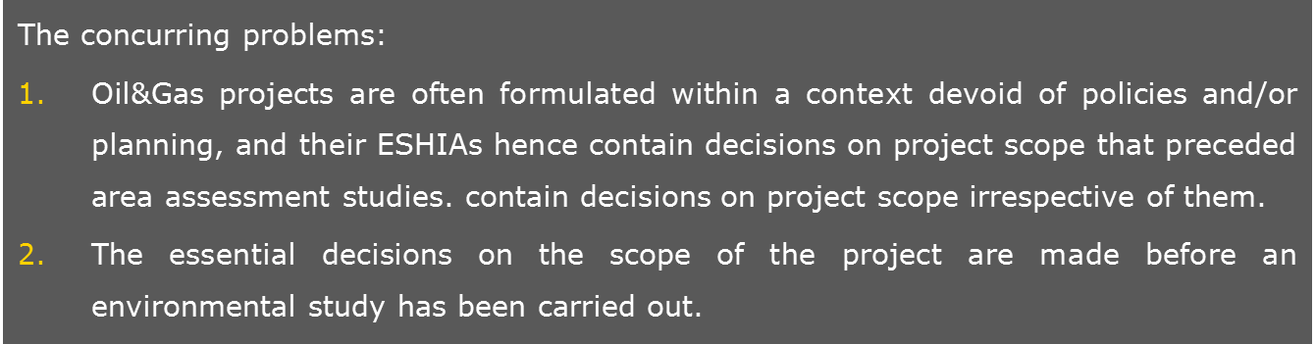

**2. Business Intelligence (BI) studies**

O&G country approach, in a phase preceding any project formulation, example in a bidding phase, should make the effort to direct all future projects’ development on the basis of identified policies and programmes.

To achieve this goal, ESHIAs could be envisaged to begin in a preceding phase: before any project is ideated a study of existing plans and policies, in an effort to align with these, is carried out. Nevertheless, this is not sufficient to ensure that the sustainability of the project is considered from the beginning; should there not be any proper zoning in the area of interest, there is the need to identify in a timely manner existing criticalities and opportunities for the Country and thence outline possible development guidelines to be factored in to any future projects’ development. Thus supplementing the first two levels of tiering and contradicting the all to diffused concept that what is not expressly prohibited is in fact permissible.

Here is where Business Intelligence (BI) steps in. Business Intelligence mainly refers to computer-based techniques and analysis methodologies used in identifying, extracting and analysing data, in view of generating information and hence supporting knowledge-based decision-making[2]. In fact, a decision is the choice selected among multiple alternatives, while criteria are the measure of each alternative’s effectiveness. In selecting an alternative, it is mainly economic, technical and logistic criteria that influence companies’ business investment choices; in more recent years legal, ethical, environmental, social and political considerations are also included in the evaluation. With regards to environment, social and health issues, Saipem applies BI concepts to a wider range of information. Here is a general check list in principle valid for all the Countries in which it operates:

|  |  |
| --- | --- |
| * Bathymetry * Biodiversity * Demography and social aspects * Economy * Ecosystem Service & local Communities’ Well-being * Ecosystems * Evaluation * Geohazard * Geology * Geomorphology * Hydrogeology * Hydrology | * Land use * Local administration * Meteo-climatic condition * Meteo-ocean condition * Physical, economic and Human Resources * Protected and conservation areas * Regulatory framework * Satellite image * Sensitive areas * Social and Health Risks * Soil * Stakeholders * Topography |

**3. The case study**

BI has been applied to an Exploration & Production initiative in a Sub-Saharan country. The initiative foresaw the need of heavy investments in plants and infrastructures along the coast. The set of secondary data gathered for the project, among the check list previously shown, was:

* Geographic Data Resources
  + Topography
  + Bathymetry
  + Land Use
  + Remote Sensing
* Geohazards
  + General aspects
  + Data Sources
  + Site Specific Earthquakes Hazard
  + Site Specific Neotectonic Faults Hazard
  + Site Specific Tsunami And Seiches Hazard
  + Site Specific Volcanoes Hazard
* Plans and Policies
  + Local
  + Regional
  + State-level
  + International Framework
* Climatic Conditions
  + Ambient Temperature
  + Air Humidity
  + Rain
  + Wind
  + Droughts
  + Floods
* Social and Health Risks
  + Livelihood Resources & Ecosystem Services
  + Welfare
  + Geopolitical issues
  + Physical Infrastructure
  + Disease Burden
  + Health Services Coverage and Responsiveness

As far as Plan and Policies are concerned, the study found that the national Government has drafted a pluriannual strategy plan for tourism development in view of boosting the provincial economy. Indeed, the specific study area has a high tourism potential according to this Plan, which also includes proposals for ecotourism development in the more remote areas of the Province. The Province’s tourism potential depends greatly on its rich landscape, faunal and floral diversity, i.e. its natural resources, which therefore yet again prove to be an important source of income to the population.

The BI study identified the following risks and opportunities for the area:

* High agricultural and non-agricultural potential for the development of the primary sector;
* Predominance of subsistence activities over production for sale or to market;
* Distantly situated larger markets, deficient product conservation capacities, logistic barriers
* Sharp dependency of local communities on natural resources for livelihood supply, implying high sensitivity of the anthropic receptor to environmental perturbations
* Elevated tourism potential
* Presence of strong cultural connections of local communities to the land;
* Presence of actual and potential conservation areas with aesthetic and livelihood value to the local population.
* Presence of diverse obstacles to economic growth of the local markets, among these low technical know-how and technology-use, poor road conditions prolong travel time and costs

It was therefore possible to identify, on the basis of [1] the socio-economic and health criticalities extracted through data collection and elaboration together with [2] the development strategies programmed by the Government, sustainable development proposals for the study area, among these:

|  |  |
| --- | --- |
| **Activity** | **Benefits** |
| Infrastructure (roads) | Providing solutions to the issues of:  (1) food products transport to principal/larger markets;  (2) accessibility to public services.  Alignment with Government plans to develop tourism infrastructure and support small-holder famers and artisanal fishermen access to markets. |
| Energy supply | Responds to the problem of deficient food products conservation capacities |
| Development of airport | Support governmental plans to develop tourism and relative infrastructure;  Alignment with Government interests to increase accessibility to that region of the Country. |

**4. Formulation of Project Development Guidelines**

Project’s host Country’s policies and programmes don’t exclude the possibility of Oil&Gas development, indeed local Government expressly requested it. Yet, the two areas of development would appear to be mutually exclusive given that the national development policies and plans for the area rely on the high quality of the natural ecosystems. Therefore the BI study proposed these natural resources should be preserved through:

1. Incorporation of the guidelines for the tourism sector development into the project actions to explore synergies,
2. Identification and mapping of sensitive ecosystems and provision of prescriptions for project design (no-go for specific project actions like docks, pipelines, helipads, lights, etc.),
3. Avoid disrupting livelihood resource supply areas, given high reliance of the local populations on small-scale farming, fishing, herding, etc. for subsistence.

Considering the existence of current national policies, the establishment of a dialogue with Government stakeholders prior to the Project’s conceptual phase, aimed at increasing investments in potential tourism areas and primary sector activities/industries, in view of boosting economic development in alignment with local views on growth.

**5. Conclusions**

One of Business Intelligence studies’ main outputs consists in guidelines for any future Oil&Gas project development which incorporate limitations that could hinder/damage other development plans for the area, as well as considerations that project activities might align with, favour and provide support to these ‘other’ co-existing national/local development programs.

The basic underlying concept is that of encouraging industry decision-making in synergy with development policies of/for the host Country rather than merely handing-out compensation.

1. EIA and SEA tiering: the missing link? Position Paper IAIA SEA Conference, Prague’05, Jos Arts, Paul Tomlinson & Henk Voogd, d.d. 22/11/04.
2. Adapted from Vercellis C. “Business Intelligence: Data Mining and Optimization for Decision-Making”, Polytechnic of Milano, Italy, Wiley Publications, 2009.