ANALYSIS OF BIODEGRADABLE WASTE TREATMENT IN ORDER TO REDUCE QUANTITY OF DISPOSED WASTE

ABSTRACT
According to data obtained by analysis of quantity and composition of municipal solid waste in Republic of Serbia, the most significant waste fraction represents organic waste which takes more than 40% of total amount, and roughly can be divided into food waste and garden or yard waste. In case of Serbia, practically all biodegradable waste ends up mostly on non sanitary landfills, contributing to large negative impact due to high production of methane, as one of the most significant greenhouse gas (GHG). In order to comply with increasing national and international requirements, one of the main objectives is reduction to 75% (by weight) of the total quantities of biodegradable municipal solid waste which ends up at landfill until 2016 and it represents the first step to accomplish this requirements. This paper analyzes possible ways for treatment of biodegradable from households in Serbian municipalities in order to achieve this goal. Therefore, in this paper, flows of garden and other biodegradable waste in municipal solid waste are analyzed by MFA (Material Flow Analysis) and two scenarios are presented. For decision makers in the field of waste management, obtained information will be of great importance in order to develop appropriate waste management system and to achieve specific targets for biodegradable waste according to national and EU Directives.

1. INTRODUCING
Organics waste can represent 20 to 80% of total municipal solid waste (MSW) stream, which mostly depending on country’s economic development. Approximately 25-35 millions tones of biodegradable waste is produced in the EU every year, and nearly 50% of that amount including green waste from public places and parks, and garden waste from households [1], [2].
In contrast to most European countries, in Serbia currently almost all amount of organics waste end up usually on unsanitary landfills. The production of landfill gas, which contains CH₄, as a GHG gas, largely depends on disposed amount of the mentioned waste fraction. Consequently, and in accordance with waste hierarchy, landfills are the last options for organic waste.
EU Directive (2008/98/EC) sets objectives to reduce the amount of biodegradable waste, through separate collection, composting, biogas production or materials/energy recovery and recycling [3]. According to this, Serbian Landfill Directive was adopted in 2010. Main objectives are:
      - Not later than 2016 reduction to 75% of the total quantities (by weight) of biodegradable municipal waste.
      - Not later than 2019 reduction to 50% of the total quantities (by weight) of biodegradable municipal waste.
      - Not later than 2026 reduction to 35% of the total quantities (by weight) of biodegradable municipal waste [4].

2. BIODEGRADABLE WASTE
According to data obtained by analysis of quantity and composition of municipal solid waste in Republic of Serbia, the most significant waste fraction represents organic waste which takes more than 40% of total amount, and roughly can be divided into food waste and garden or yard waste.
The estimation of the amount of food and garden waste is one of first steps and it is necessary for determination of the size and type of treatment.
Garden waste is becoming a significant waste stream in many countries. In most cases garden waste from household in Novi Sad is collected mixed with other municipal waste. In most municipalities in Serbia, the total amount of garden waste is unknown. Novi Sad is municipality where exist data about generation of garden waste. Partially this fraction of waste is generated in public places and parks and the second stream is garden waste generated within households. According to data from the public company responsible for collecting and transporting of green waste in Novi Sad, from public areas and parks in 2009 were collected about 15,000 tons. Also, based on municipal waste quantification and characterization study conducted for Novi Sad, it was shown that generated garden waste from households represents 9.13% of all MSW, or 11,000 tons per year. The total of garden waste from public area and household collected in Novi Sad is about 26,000 t [5]. According to the same study, percentage of food waste in MSW in 2008 was 40.8% [5] and the total amount of food waste collected in Novi Sad was about 50,000 tons.
Total municipal waste generated in Novi Sad in 2008 was 120,773 tons. According to morphological composition of municipal waste in Novi Sad shown in Table 1, the amount of biodegradable waste (including paper and cardboard) which was sent to landfill was estimated to 78000 t per year [5]. If we include garden waste generated in public places and parks, the total amount of biodegradable waste disposed to landfill was 92.000 tons. Proper treatment of this waste presents necessary activity in waste management system in order to fulfill landfill targets.

Table 1: Morphological composition of municipal waste in Novi Sad [5]
Waste category | %
Garden waste | 9.13
Other biodegradable waste | 40.73
Paper | 8.57
Glass | 11.19
Cardboard | 6.06
Waxed cardboard | 0.72
Al-coated cardboard | 0.91
Metal- packaging and other | 0.98
Metal-Al cans | 0.43
Plastic- packaging | 4.57
Plastic bags | 3.85
Hard plastic | 3.66
Textile | 3.09
Leather | 0.03
Nappies | 1.29
Fine waste particles | 4.73

3. TREATMENT OF BIODEGRADABLE WASTE
In case of Serbia, practically all biodegradable waste ends up mostly on non sanitary landfills, contributing to large negative impact due to high production of methane, as one of the most significant greenhouse gases (GHG).
In order to comply with increasing national and international requirements, one of main objectives is reduction to 75% (by weight) of the total quantities of biodegradable municipal solid waste which ends up at landfill until 2016 and it represents the first step to accomplish this requirement.
Observing mentioned quantities and targets defined in the Serbian Landfill Directive, this paper points out possibility for treatment of garden waste from household and public places and the possibility for treatment of food waste from households in Novi Sad municipality.

3.1. Windrow composting of garden waste
Composting is an effective biological treatment used to reduce organic material volume and weight, which also converts it into a valuable product (compost) for soil protection and crop growth. However, these benefits cannot be achieved if composting is not carried out properly or if raw materials contain non-compostable materials which themselves can contain non-desirable constituents, such as heavy metals or persistent organic compounds [6].
Composting in low-technology plants like windrow composting plants is the most common management of garden waste in Europe in general [7]. This solution would mean that the public company responsible for collecting of green waste will also be transport it to the centralized composting facility.
Green waste from public places and parks waste, which includes grass clippings, hedge cuttings, tree pruning, small branches, leaves, and wood debris, can be easily composted in centralized composting operations, and that option can be a low-effort, cost-effective and environmentally sound method to reuse yard waste. Landfill space in that way is conserved, disposal costs are reduced and a useful end product is produced with composting.
Generally, the efficiency of composting stages depends on a variety of parameters, such as aeration, temperature, moisture, pH and material for composting. Temperature and oxygen ratio are considered as the most important parameters for efficiency of the composting process [7].
The advantage of composting is related to the fact that compost and the digested material can be used as a soil improver because the majority of nutrients, contained in the source materials, are preserved. As such, it can be used as a substitute for mineral fertilizers. The use of compost has a positive effect on soil microbial activity and soil transformation processes. Water retention and infiltration are increased resulting in less susceptibility for erosion and drought. Furthermore, the technical demand is low and there is nearly no waste water [8].
The Ĺrhus case study showed that a garden waste management system based on windrow composting generates rather small potential impacts on the environment [9].
The environmental assessment indicates that current practices for garden waste management could be made more environmentally sound if composting operations were optimized. For instance, a relevant environmental load is represented by “greenhouse” gasses (GHG) emissions (CH₄ and N₂O) occurring during degradation of organic materials in windrow composting. Possible adjustments, regarding for instance the turning frequency of the heaps or the size of the windrows, should be investigated to determine whether such gas emissions can be prevented [9].

3.2. Anaerobic digestion (AD) of food waste
This segment would involve the introduction of primary separation of food waste from households. Mentioned waste stream will be treated by anaerobic digestion. This reduces the volume of waste and makes it biologically inactive so it can be landfilled without releasing methane.
As well as being better for the climate, AD has other benefits over traditional waste management technologies. Plants can be small so they can be situated in towns, reducing haulage distances and associated traffic pollutants. AD also produces less air and solid emissions than incineration, landfill and pyrolysis and gasification.
The quality and quantity of the input material are the only real changing factors in the anaerobic digestion process, which is otherwise kept as constant as possible [10]. If the residue is clean enough it can also be used for land sites, landfill restoration and as a soil additive.

4. MFA OF TWO SCENARIOS
Material Flow Analysis (MFA) has become a reliable instrument to describe material flows and stocks within various systems[11, 12].
Flows of garden and other biodegradable waste in municipal solid waste are analyzed by MFA and two scenarios are presented. For decision makers in the field of waste management, obtained information will be of a great importance in order to develop an appropriate waste management system and to achieve specific targets for biodegradable waste according to national and EU Directives.

4.1. Scenario 1
In Scenario 1, two streams are showed: garden and food waste. In compositing facility, 26,000 tons of garden waste, originating from public collection of garden waste from a household (42%) and green waste from public areas and parks (58%), will be treated. Food waste will not be treated, and it will be disposed to landfill.

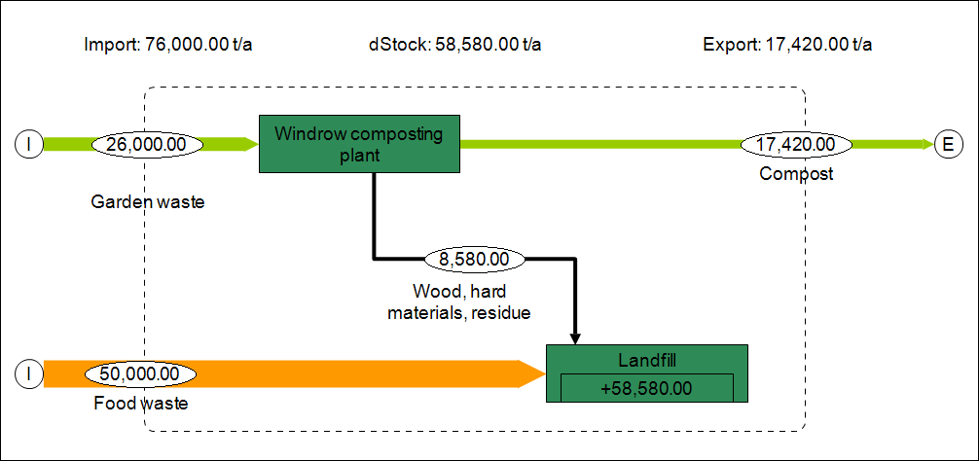
Picture 1: Treatment of Garden waste

The total amount of biodegradable waste is reduced for about 17,500 tons. Large amount of this waste, about 58,500 tons (without paper and cardboard) is still disposed to landfill.
4.2. Scenario 2
In Scenario 2, also two streams are showed: garden and food waste. 50,000 tons of food waste from household will be treated with anaerobic digestion. Garden waste will not be treated, and it will be disposed to landfill.

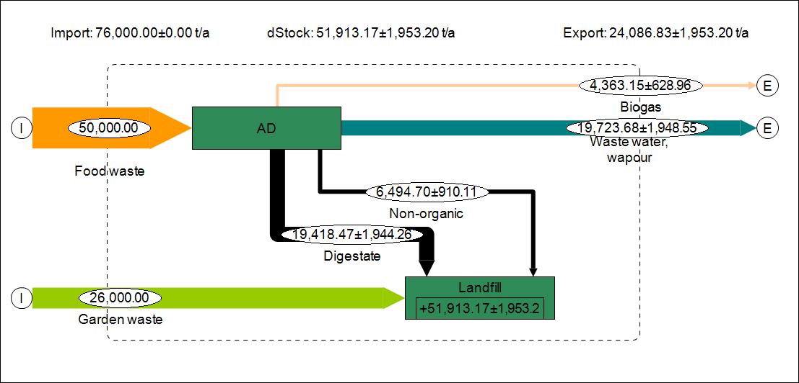
Picture 2: Treatment of Food waste

Total amount of biodegradable waste is reduced for about 30,000 tons. About 46,000 tons of biodegradable waste (without paper and cardboard) is still disposed to landfill.

5. CONCLUSION
EU Directive (2008/98/EC) sets objectives to reduce the amount of biodegradable waste, through separate collection, composting, biogas production or materials/energy recovery and recycling.
In order to achieve specific targets for management of biodegradable waste according the Serbian and EU Directives for decreasing disposal rate on landfills, this paper describes two possible scenarios of the treatment of waste.
In scenario 1, the treatment of garden waste through windrow composting is analyzed, and the total amount of biodegradable waste is reduced to 81% (by weight). With this scenario the target for 2016 will not be achieved.
In scenario 2, the treatment of food waste trough anaerobic digestion is analyzed, and the total amount of biodegradable waste is reduced to 67% (by weight). With this scenario the target for 2016 will be achieved.
Only if both scenarios are applied, the target for 2019 will be achieved. For fulfilling the target for 2026 some other treatments must be included, for example: paper and cardboard recycling, incineration of residue from composting.

REFERENCES
- B. K. Adhikari, A. Trémier, J. Martinez and S. Barrington, “Home and community composting for on-site treatment of urban organic waste: perspective for Europe and Canada”, Waste Management & Research, 2010, Vol. 28, pp. 1039–1053.
- G. Palacios, R. Apodaca, C. Rebollo, J. Azcárate, “European policy on biodegradable waste: a management perspective”, 2009.
- Directive 2008/98/EC of the European Parliament and of the Council on waste and repealing certain Directives, Official Journal of the European Union, (2008) 312/3-312/30.
- Waste Management Law, Official Gazette of the Republic of Serbia, RS-36/09 (2009).
- Vujić, G., Jovičić, N., Redžić, N., Jovičič, G., Batinić, B., Stanisavljević, N., Abuhress, O.A. (2010) A fast method for the analysis of municipal solid waste in developing countries - case study of Serbia. Environmental Engineering and Management Journal, 9, 8, 1021-1029
- Marga López Montserrat Soliva, F. Xavier Martínez-Farré, Mónica Fernández, Oscar Huerta-Pujol, “Evaluation of MSW organic fraction for composting: Separate collection or mechanical sorting” Resources, Conservation and Recycling 54 (2010) 222–228
- Karolina Marešová, Mária Kollárová, “Influence of compost covers on the efficiency of biowaste composting process” Waste Management 30 (2010) 2469–2474
- The use and application to land of MBT compost-like output - review of current European practice in relation to environmental protection Environment Agency – January 2009
- Alessio Boldrin “Environmental Assessment of Garden Waste Management”, Technical University of Denmark Department of Environmental Engineering, September 2009
- P. Illmer, G. Gstraunthaler, “Effect of seasonal changes in quantities of biowaste on full scale anaerobic digester performance” Waste Management 29 (2009) 162–167
- O. Cencic, H. Rechberger, “Material flow analysis with software STAN” J. Environ. Eng. Manage., 18(1), 3-7 (2008)
- Paul H. Brunner, Helmut Recheberger., Practical Handbook of Material Flow Analysis, Lewis Publishers, USA, 2004.

