Acceptance of renewable energies in Alpine areas
1. Introduction
Alpine areas are on the one hand destined for using their natural resources (especially biomass and water) to producing renewable energies. The remoteness of some inner alpine areas has sustained the demand on autarky in energy supply strategies. On the other hand the implementation of renewable energies in alpine areas is frequently limited by several factors: Firstly the productivity of renewable energy suppliers can be reduced due to topographic and meteorological factors (e.g. the contours of the valley which lead to minor sun intensity, snow cover, and instable wind situation). Secondly space is limited and conflicts of interest can occur (e.g. between agriculture and energy production). A third aspect is the increased sensitivity of alpine landscapes, which involve an awareness of the susceptibility of alpine species and a stronger focus on the visual aspects.
In many (pre) alpine destinations tourism plays an important role. Tourism industry has a double stake regarding energy – on the one hand being a major consumer and on the other hand being majorly impacted by possible negative effects of renewable energy sources (especially visual effects). Furthermore recent studies reveal a different perception of impacts by tourists and residents regarding effects on landscape (see Frantál and Kunc 2011). Planning needs to consider all these aspects in order to be pro-active and assess possible impacts at an early stage.
This paper analyses diverse approaches of public participation processes in alpine areas. In contrast to existing studies with participation at national level (Stocker et al. 2011, Madlener et al. 2007) this paper addresses local level. They vary according to the intensity of involvement (Rowe and Frewer 2004, Creighton 2005) as well as the timeframe for the participation process (see Ley and Weitz 2003, Arbter 2010). The paper analyses three case studies, which applied individual approaches to participation for impact assessment purposes (see fig.1).
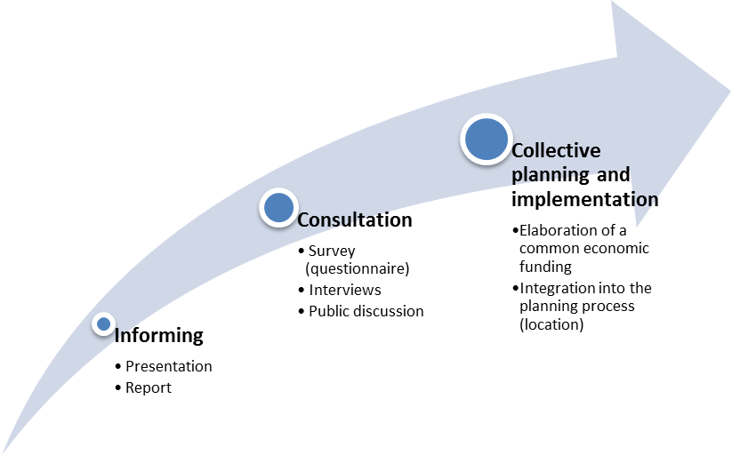
Case study 2 Case study 1&2 Case study 3
short term
long term
Fig. 1. Intensity and time frame of participation in the case studies
In each case study a different focus is set regarding the stakeholder groups, which are directly involved. In case studies 1 (and partly 2) special focus is set on the role of tourism. We discuss to what extent tourists’ perception can be integrated into impact assessment and which form of involvement is possible. According to different models of participation the aspects of information and consultation (case study 1 and 2) and co-implementation (case study 3) were covered (see Fig. 1). The next sections contain the case studies and finally draw conclusions.
The following criteria (based on Sustainable Development Commission 2008, Creighton 2005, www.iap2.org) were applied to attempt an analysis of the impact of diverse models of participation on the acceptance of renewable energies:
A Time frame: Is a long-term involvement possible for the included stakeholder groups? At which stage of the planning process does the participation start? At which stage of the planning process do I need information from which stakeholders?
B Intensity: What is the appropriate strategy (method) to include the stakeholders? To what extent is involvement possible in the planning process? What factors encourage the involvement in the participation process?
C Identification of possible conflicts: Which aspect of sustainable planning is majorly addressed - do the stakeholders consider environmental, social or economic concerns? What intensity of participation is needed to solve these conflicts (see B)?
D Level of acceptance: Is it a probable acceptance and/or a confirmed acceptance (dependent on the stage of planning)? Which involvement in the planning process encourages the acceptance (see A)? To what extent is “habituation” an important factor for acceptance of renewable energies?
2. Case 1 - Perception of renewable energies by winter sport tourists
This case study deals with the application of renewable energies in winter sport destinations. Within the research project ADAPT (AlpS) a questionnaire was developed directed at winter sport tourists. This questionnaire was applied in four large Austrian ski destinations (Lech am Arlberg, Schladming, Zell am See, Silvretta Montafon) which are all covered by artificial snowing to a great extent. Larger resorts (which means medium to large size in comparison with the Austrian “average”) were chosen because of their financial and management potential to introduce and integrate renewable energies into their overall energy concept. Respondents were asked to fill in the questionnaire during the cable car rides, which gave us a response rate of around 70%. A total of 1165 tourists were involved in the study. 79% were visiting for one week, 13% were day visitors about 6% were ski instructors and local visitors and 2% were other guests. About 25% of the respondents were under the age of 29 years, 17% were between 30 and 39 years old, and 18% were over the age of 50 years. The majority (40%) was between 40 and 49 years old. In order to ask tourists about renewable energy supply we had to explain the possible options. To avoid a potential bias we decided not to use pictures, photographs or drawings. The selection of renewable energy supply facilities is based on the existing offers and application in the Alpine ski resorts and cable car enterprises (Zegg 2010, Österreichischer Seilbahnverband 2011). We tried to describe the size and location as clear as possible (see also Pröbstl et al 2011).
This approach started participation of tourists at an early stage (most of the resorts are about to increase their share of renewable energy facilities but did not install a greater share of them yet). Involvement of winter sport tourists is short term only since they are on a weekly basis in the resort and could only be involved through “representatives of interest” in a long-term process. Thus only a consultation process was possible, which means a low-to medium intensity of involvement.
The results illustrate that tourists distinguish between environmental effects and possible impacts on the landscape. This is visible in the different evaluation of photovoltaic panels on meadows, small compact wind turbines and small biogas plants. Large exposed wind turbines are least preferred in both cases and small compact wind turbines are also expected to impact the landscape in a negative way (see fig. 2)
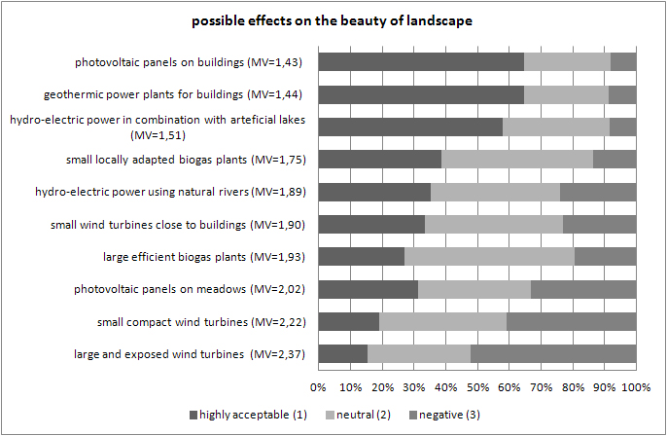
Fig. 2: possible effects on the environment (mean value: 1=highly acceptable, 2=neutral, 3=negative) n=879
Another interesting aspect analyses differences in the tourists’ perception in case they have been already exposed to renewable energies in skiing areas or have never experienced them during their skiing holiday. A differentiation of winter sport areas with renewable energies in use and those without current application can provide more information about presumed acceptance and expected acceptance (see Frantál and Kunc 2011). Overall this example showed that tourists prefer the use of existing technical infrastructure such as the system for artificial snowmaking or photovoltaic detached to existing buildings. This emphasises the increased acceptance of well-known infrastructure and could support the hypothesis of increased acceptance of renewable energy facilities after time (e.g. solar shields). Asked directly about their attitude towards a skiing area, which uses 100% renewable energies, around 60% of the tourists consider this fact as important or even very important (see also Pröbstl et. al. 2011). The general acceptance of renewable energies in winter sport areas is relatively high therefore. However environmental concerns – especially regarding the landscape view – turned up and need to be considered within the future planning processes by differentiating the diverse options of facilities and mitigation measures.
3. Case study 2 - Biomass study Oberaudorf
The second case study evolved from a research project in Bavaria. Fifteen students and 5 academic researchers collected data on biomass potential and development options for biomass plants in a skiing area in the village of Oberaudorf. Interviews with community planners, the major, hoteliers/gastronomy and farmers were conducted. Biomass potentials for a local biomass plant were evaluated and possible options (size, supply, location) discussed. Tourism companies (hotels, gastronomy) were involved as a potential supplier (waste). Furthermore critical perceptions were listed oriented towards economic productivity, biomass potentials and conflicts of interest between stakeholder groups. The perception of tourists themselves was not included and never taken into account during the whole process (though the tourism suppliers were represented). The students elaborated final options (on biomass productivity and resources from the stakeholders involved in the process) and presented them to the interested public afterwards. Thus participants were exposed to different scenarios. Recommended strategies were made public in a report based on the discussion results.
Since the project was embedded into a long-term process of increasing the share of renewable energies in the community (which is already above the German average), the interest towards renewable energies and understanding of the topic biomass utilization for energetic purposes in special was elevated. Thus the acceptance level was relatively high already at the beginning of the project. During the public discussion the participants merely economic concerns arouse regarding the biogas potentials of the community and the productivity of a possible biogas plant. In this context the comparison of concrete scenarios with data about energetic potentials and possible numerical output proofed to be a necessary element to question first hand opinions and get to a common vision. This confirms similar results from Austria (Späth and Rohracher 2010; Trumevyte and Stauffacher 2011), which showed benefits of a discursive practice linking visions with concrete energy scenarios in the latter case based on multi criteria assessment. Within the project itself a medium intensity of involvement was reached, which ended after the consultation process.
4. Case study 3 - Wind park Spörbichl
The Windpark Spörbichl is located in Upper Austria in the rural village Spörbichl in the municipality „Windhaag bei Freistadt“ close to the Czech border. The two spin wheels with 660kW power each - compared to recent technology a small wind park - was built in 1999 about 350 metres away from the next residential buildings with intensive participation of the people living around the site. The level of participation reached from information and consultation to co-implementation. Already before the wind measurements started for the detailed planning of the wind park, the neighbours were taken to already existing wind parks during an excursion and asked if they would agree to live besides such a facility. As no objections arose at that stage the planning was continued with information meetings about the planning stages. Furthermore economic involvement was proposed. At the beginning 11 people started with founding a limited company a juristic person in order to screen the land use plan amendments, development consents, contract the company to build the wheels and apply for public subsidies that were available at that time. On total, the needed private equity capital was about 582.000,-- € for the 1,44 Mill. € project, of which the 11 initiators hold 35.000,-- €. The rest of the money was collected by subsidies (367.000,-- €), advance payments for future energy delivery and bank loans. From the beginning the initiators wanted to build a bottom-up project with as many participating people as possible. They also wanted to create environmental awareness for renewable energy carriers. Therefore, they chose a model for the equity acquisition in which private natural persons could buy between 1 and 10 shares of 2.200,-- € each, with which the average yearly electricity demand of the Austrian household can be covered by wind power production in the local wind park. A leaflet to households and two evening events in local meeting places in the municipality Windhaag and the close district capital town Freistadt advertised the project. It only took 10 days to collect the required financial means. 100 persons participated who come from the neighbourhood and the region of the wind park.
As the people were actively involved in the project from the beginning and could participate in the investment and the financial benefits up to now no objections against the wind power plant arose. Overall the level of acceptance is very high. Furthermore, it is interesting that people identify with the project, and at shareholder meetings discussion does not focus on the financial benefits (which are there) but on produced energy, saved emissions and reduced environmental pressures. From this project we conclude that a high level of participation in the development and planning process, and especially the possibility to invest in a renewable energy project and participate in the benefit, considerably increases the acceptance. It even seemed to raise environmental consciousness of the people participating. Therefore, such projects also have the notion of environmental education initiatives.
5. Conclusions
The case studies are directed to two different groups: tourists as short-term users especially seeking recreation (case 1) and domestic population (cases 2 and 3) who are constantly exposed to renewable energy facilities (and are sub-divided in additional stakeholder groups). For the first group it is interesting to see that small-scale facilities are preferred to large scale ones. Furthermore, the combination with existing infrastructure increases the acceptance significantly. The exposure at their home destination seems to influence also their acceptance. Further verification is needed, however, to identify whether the habituation and/or the information about renewable energies in general is influencing the acceptance. A stronger participation process of local residents as showed in case study 2 and 3 is therefore able to increase the acceptance of renewable energies in general. Whereas in case study 2 limitations of biomass were discussed at the economic and resource level, case study 3 dealt with concerns regarding the quality of life as well as environmental and economic aspects. We can also detect that a clear locally agreed vision for renewable energy production combined with the possibility for the local people to financially benefit from the projects provides for the highest level of acceptance.
References
Abter, K. (2010): Handbuch Bürgerbeteiligung für Land und Gemeinden, Amt der Vorarlberger Landesregierung (Hrsg.).
Creighton, J. L. (2005): The Public Participation Handbook: Making Better Decisions Through Citizen Involvement.
Frantal, B., Kunc, J. (2011): Wind tourbines in tourism landscapes: Czech Experiences. In: Annals of Tourism Research, Vol. 38, 2, 499-519.
Ley, A., Weitz, L. (Hrsg.), 2003: Praxis Bürgerbeteiligung Ein Methodenhandbuch.
Madlener, R., Kowalski, K., Stagl, S. (2007): New ways for the integrated appraisal of national energy scenarios: The case of renewable energy use in Austria. In: Energy Policy, Vol. 35, 12, 6060-6074.
Österreichischer Seilbahnverband, 2011: unpublished survey on environmental performance and projects in Austrian skiing areas.
Pröbstl, U., Jiricka, A., Hindinger, F., 2011: Renewable energy in winter sports destinations - desired, ignored or rejected?. In: Borsdorf A., Stötter J., Veuillet E. (eds.), Managing Alpine Future II "Inspire and drive sustainable mountain regions" Proceedings of the Innsbruck Conference November 21-23, 2011.
Rowe G, L.J., Frewer, (2004): Public Participation Methods: A Framework for Evaluation. Science, Technology & Human Values, Vol. 25, 3, 3-29.
Späth, P., Rohracher, H. (2010): “Energy Regions” The transformative power of regional dicourses in socio-technical futures. In: Research Policy, Vol. 39, 4, 449-458.
Stocker, A., Großmann, A., Madlener, R., Wolter, M.I. (2011): Sustainable energy development in Austria until 2020: Insights from applying the integrated model “e3-at”. In: Energy Policy, Vol. 39, 10, 6082-6099.
Sustainable Development Commission (2008): Planning and Designing Engagement Processes. A full SDC guide. Stages 1-4. (www.sd-commission.org.uk)
Trumevyte, E., Stauffacher, M., Scholz R.W. (2011): Supporting energy initiatives in small communities by linking visions with energy scenarios & mulit criteria assessment. In: Energy Policy, Vol. 39, 12, 7884-7895.
Zegg, R., T. Küng, R. Grossrieder, 2010: Energiemanagement Bergbahnen - Studie und Handbuch 2010, Seilbahnen Schweiz (Hrsg).

