eia REVIEW methodology

introduction
This proposal of a peer review methodology consists of providing a global and independent review of the EIA of a project to minimize significant problems that would affect its probability of approval by the authorities, the integrity of the project and the image of the owner company. To this end, the review process is designed to evaluate the submission risks of the EIA, both in the local and international evaluation scenarios.

This methodology may be applied to any project that requires the development of an EIA, and has used successfully in several mining and hydroelectric projects.

The review is performed using an interactive spreadsheet with the review evaluations and observations, that is shared with the client company and the authors of the EIA, and which serves as a living document during the review process. This spreadsheet represents a practical tool as all the participants will add their commentary during the progress of the review.

This methodology has significant advantages at the moment of decision of the client company. In one hand it is an interactive process in which the company, the environmental consultant and the reviewers work together, step by step enriching the EIA. On another hand, is an efficient and objective tool that supports the decision making process. As a result, this review methodology has been accepted by companies that have requested this type of peer review to be applied in their projects.

methodology
The peer review methodology being presented has as an objective to reduce a document of thousands pages to a few summary lines, representing the main elements to support the decision to deliver or not deliver the EIA.

The methodology is carried out by dividing the EIA into individual environmental components for review. This division enables the reviewer to follow the development of each component in a logical way from its characterization in the baseline, through the identification of impact sources, impact and risk assessments, prevention and mitigation measures and monitoring plans. Components are grouped in different environments or environmental systems, as follows:

- Geological Environment: geomorphology, geology, seismology, cryo-geology, and hydrogeology.

- Hydrological Environment: meteorology, groundwater, surface water, geochemistry, hydro-geochemistry and aquatic life.

- Biotic Environment: soil, vegetation, habitat, wildlife, biodiversity and ecology.

- Land Use Environment: land use, landscape, cultural heritage, and protected areas.

- Built Environment: air quality, noise, vibrations, transport and infrastructure.

- Socio-Economic Environment: demography, welfare, life-style, economy and economic activity.

The evaluation criteria consider the following questions for each EIA component:

- Sensitivity: What is the scientific relevance for this project? And what is the relevance perceived by local authorities? The sensitivity of each environmental component is a complementary factor that will be weighted in the final risk assessment.

- Statutory Compliance: Do scope and content comply with statutory requirements? The study must comply with all binding statutory requirements, which are defined by regulations regarding the environmental assessment of industrial projects.

- Data Sufficiency: Is there enough data to justify the analysis of important issues? The study should cover the area of influence of the project, and data obtained should be representative of said area for an adequate period of time in order to characterize seasonal variations of the environmental component analysed. Regulated parameters should be represented by the measured variables.

- Quality of the analysis: Have a good analysis and data interpretation been conducted? Do the analysis and data interpretation support the conclusions that are presented? The methodology used for analysis and the quality of data interpretation should be according to the state of the art of environmental assessment. Thus it may be concluded that baseline information and project data have been properly analysed to justify assessments regarding impacts and risks of the project. It will also ensure that adequate prevention and mitigation measures have been adopted for the scenarios under evaluation.

- Consistency of the study: Is there consistency and coherence between components regarding data, presentation and conclusions? Environmental components that are directly related should be treated and analysed consistently. This situation should be reflected by the supporting data, data display, and focus and conclusions in these components.

The qualifications in each of these review factors must be based on specific observations, such as shown in the following table. The comments, made ​​by the specialist, should be concise and strategic, rather than scientific-analytical. The observations made on the EIA will be presented quoting specific texts, tables or figures in such a way that one can identify if observations have been answered in the successive versions of the document. The reviewer follows up the observations as the progressive versions of the chapters are issued.

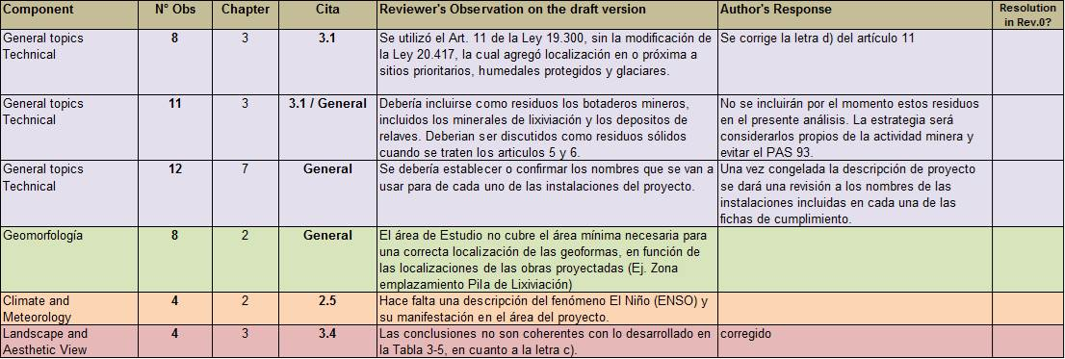

Finally, each component is evaluated in one of four categories according to its level of preparation for presentation in the EIA, taking into account the considerations mentioned above.

To reach these results, the methodology uses the following rating table in relation to questions that have been made to each component, in the items of: Regulatory Compliance (REG), Data Sufficiency (DAT), Quality of the Analysis (ANA) and Consistency of the Study (CON).

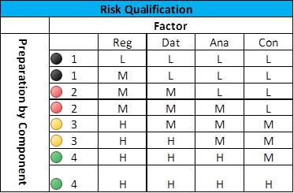
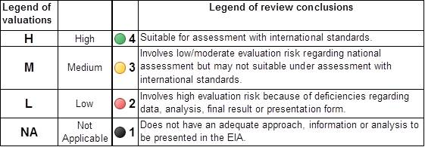

These results are entered into a tabulation of the level of preparation of the EIA:

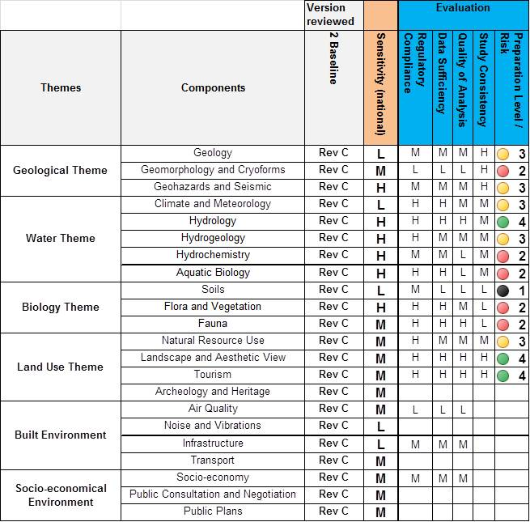

Finally, the review team compiles a summary of the evaluations to assign a final qualification to the EIA in terms of risk, or level of preparation for submission to the authorities, taking into account the sensitivities of those components that have been evaluated as at greater risk.

At this point also, the level of bankability of the EIA may be assessed by addressing the following question: Is the scope and content in compliance with IFC guidelines, and Equator Principles? This looks at the study from the perspective of a private project that would be evaluated by international banks for financing. This last point is optional given that some client companies are not interested in seeking international bank funding.

conclusions
The EIA peer review is an appropriate tool for quality control at the time prior to delivering an EIA to the evaluating authority. This methodology is being required by companies with major capital investment projects. It has so far been implemented in five projects in South America: three mining projects ranging from U$S 750 million to approximately U$S 2,000 million investment and two power plants with installed capacity in the range of of 50MW to 500MW.

The proposed methodology achieves an objective, orderly and standardised review with criteria that are transparent to all the participants. Ass the review progresses, it becomes interactive, involving reviewers, the EIA consultants and the company that owns the project. This interaction can result in the correction of concepts in the EIA as it progresses, leading to a finished product suitable for submission to authority.

