Title: An applied sustainability method energy supply in informal settlements
1 – Introduction
Urban planning has a decisive role in the development of human activities and in case of that it is essential dispose an operational instrument of assessment that provides the possibility to consistently support the social development and the main principles concerning sustainable development. Has stated by Khakee (1998), planning and evaluating are two inseparable concepts [1]. The decision-making process in planning is a very complex process and the energy supply system to promote a large level access is determinant to the sustainable development [2].
Energy is a determining factor in the development of human activities and it has a constant presence and one of the most important roles in the various dimensions of sustainable development [3]. The energy supply and it´s availability of access are directly related to urban life quality, both on social and economic levels [4]. On other hand, local and global negative impacts result over the environment by the use of energy.
The sustainability assessment of urban planning is a fundamental way to ensure that one can predict when and how the development of our cities will occur and if the main planning objectives are accomplished [5].
The defining characteristic of sustainability assessment is that all of the decisions are informed by sustainability-based criteria and aim to deliver multiple, lasting, mutually reinforced gains rather than just mitigation of environmental damage [6].
Seasons (2003) argue that the determination of the main variables for urban planning assessment should contribute to the selection of the most efficient model, in which case studies can be crucial to identify and select the type of organization and resources fundamental to that process.
It is determinant that the scientific researches of models of assessing the implementation of urban plans are based on long term studies [7,8].
A comprehensive literature review possibly a clear knowledge about the sustainability assessment of urban plans practices and theory concept [9, 10, 11, 12,13,14] who allow the use of the knowledge in future practices that accomplished the stabilization of parameters and criteria of assessment. Some of this authors describe the operated process of the assessment of urban plans and the results have been showing that the qualitative and quantitative efficiency of the implementation of urban plans have direct effect on the improvement of quality of life and the sustainability of urban plans [10, 11,12,13,14,15,16,17].
The Plan Implementation Evaluation (PIE)[18] proposes that the urban policies evaluation and urban plan assessment should be made by to major principles: i) extent ii) penetration, to apply to evaluation phases. In this scenario of direct association between urban planning and sustainable development occurs the opportunity to apply and aggregate different tools of assessment: Planning Balance Sheet Analysis (PBSA)[19]; Community Impacte Evaluation (PBSA/CIE) [20]; Goal Archievment Matrix [21]; Multicriteria evaluation [22,23,24]; Environmental Impact Assessement (EIA) [25]; Cost-Benefits Evaluation (CBE).
In 2003, Sherbini et al. [12] introduces the Assessment with ESI – Environmental Sustainable Indicators e USI – Urban Sustainable Indicators, developed to provide a higher uniformity. This methodology has been applied on GengXicono project - New Tool Measuring China’s Cities, and the results are monitoring until today with positive outputs.
Nowadays, multi-criteria assessment is mostly present in regional urban planning, mostly because of the use of indicators and composite indices. This methodology characterizes itself by the possibility to include measurable and non-measurable impacts, as opposite of what happened with other methodologies.
Some European experts have concluded that the relation between sustainability and urban planning didn´t achieve, so far, efficient results [26]. Urban planning is just a part of a bigger problem, which brings to the equation the necessity of scientific research and the pursuit of a methodology to support sustainability assessment of urban planning [27].
The sustainability assessment of urban plans returns many advantages for the administrative units (municipalities, regions,..) that take action on implementing them. It is possible to diagnose existing problems at a local level and promote an higher standard of quality of life. It also potentiates the competiveness between regions/cities/neighborhoods.
The lack of a complete tool for sustainability assessment of urban planning has compelled so far to the use of methodologies and techniques that only allow a partial assessment [17]. The assessment of urban policies, urban plans, programs and projects must confirm the presence of sustainability principles in their implementation [28].
A sustainability assessment can´t be dissociated of all the conception phases of an urban plan. It is important a continuous assessment action during all the elaboration phases of the urban plan, for a more effective final assessment and subsequent monitoring.
The good management of the energy sector is crucial to a positive action in urban development especially on developing countries. To this goal is necessary created and develop a model that can guarantee the assess though the urban plans the population access to energy especially the countries that aim to redesign and rehabilitate areas of informal settlements.
In another hand the urban planning actions can use a large number of existing criteria to reflect the performance of the urban planning and the energy inclusion on the process. It is not totally clear how many criteria are necessary to rich the goal because the relevance of criteria group makes difference to the quality and success on the introduction of energy issue in a urban planning actions from the beginning of conception plan. Also the evaluation of the planning actions are dependent from the stage of indicators selection since the appropriate and suitable selection are crucial to guaranty the energy sector as a part of urban planning process and so assure that real sustainable development take place.
The focus of this paper is how to expand and redesign environmental assessment processes to establish an effective foundation for sustainability assessments. It makes an approach to the problems posed by the need to establish a clear methodology to identify and select the group of sustainable indicators suited to evaluate the life cycle of a project and to find a proper balance between all actions that contributes to energy supply in informal settlements.

2 – Method to the energy supply in urban planning in development countries: implementation in informal settlements
There are some barriers to the implementation of urban planning sustainability assessment, mainly on the developing countries - weak development of information systems and the insufficient financial resources to invest in that kind of systems. Besides the technical and economic barriers, it exists also a big opposition to urban plan assessment by politicians and urban planning professionals, due to the fright of its complexity and, many times, to the fear of the final conclusions of the assessment.
The practical application of an assessment methodology for a multi-criteria indicator system of sustainability can be very expensive, which in the case of developing countries is very challenging, as this isn´t usually a priority for investment. So it’s important that the sustainability assessment can be done gradually, step by step, starting by the most important sectors on the local, regional and global levels, in which the energy sector is indubitably present. The application of this methodology aims to assist actions in informal settlements, particularly in developing countries, as a way to improve the sustainability and the quality of life of the population. It was identified and selected a group of sustainable indicators suited to evaluate the life cycle of a project and to find a proper balance between all actions that contributes to energy supply in developing countries.
An energy sustainability assessment and monitoring system of the urban plans assures the efficiency of the implementation and the achievement of strategic objectives of the plan.
The development of this methodology must include the sustainability principles to account on the elaboration of an urban plan, particularly in terms of energy efficiency. This methodology integrates environmental, institutional, social and economic components that characterize the principles of sustainability expected to achieve by the entity that elaborates/commissions the urban plan.
On the first approach, sustainability assessment uses available tendencies and statistic information, and also the current territorial characteristics to obtain a reference status. The expected territorial dynamic is planned and establishes the energy requirements to the future, using the assessment indicators as a measuring and referential tool.
It is fundamental that sustainability assessments of urban plans in informal settlement areas are simulated during the elaboration process. By this way is possible to anticipate measures and possible solutions for existing obstacles when the implementation phase of the plan occurs. This methodology creates a model that permits the simulation and evaluation of the conditions to the energy access by the population and also estimates future variations from the implementation process of the plan.
The phase of assessment and monitoring takes place in the end of the process and, if unexpected deviations are observed throughout the indicators, is possible correct some actions.
The presented energy assessment methodology is based on a series of indicators (Figure 1), common to other assessment methodologies, with direct impact over the energy sector. This model was also based on a series of indicators of another global sustainability assessment methodologies designed for the developing African country of Cape Verde [17], in which the magnitude of the energy sector in informal settlements areas was revealed.

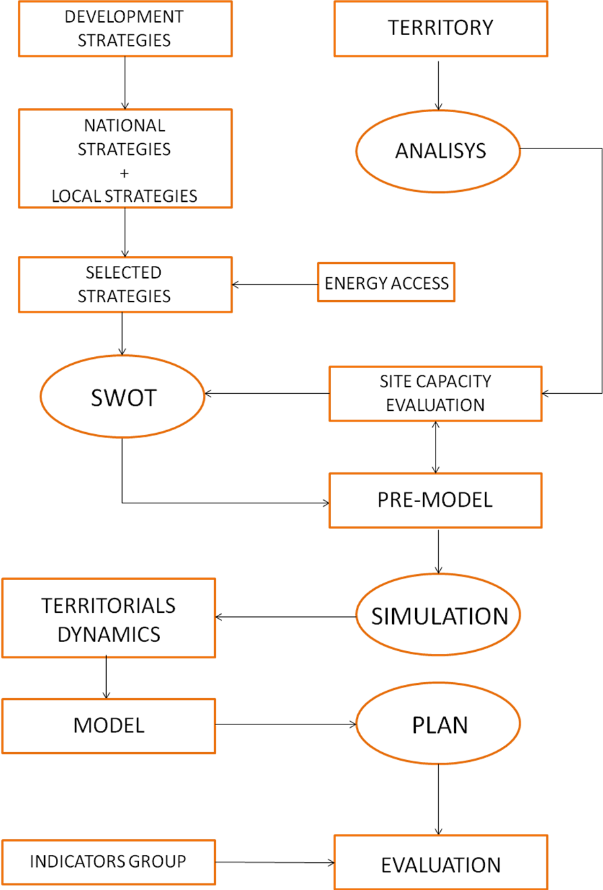
Figure 1 – Model of evaluation - implementation of a sustainable urban plan (municipal scale)

The analysis of territorial dynamics is extremely important in determining the forthcoming of those territories. The need to preview the results of their implementation is vital. Because of the many parameters involved, the evaluation process of territorial dynamics, which results from the actions defined in the municipal plan’s strategies, is of difficult quantification. However, the possibility of simulating and previewing the possible territorial dynamics that will occur in a given municipality will enable us to confirm the proposed model or reconfigure it. This previewing action uses scenario creation tools, computer simulation tools and, jointly, quick evaluation tools that can result on comparisons and measurements. These tools can be implemented as long as they are articulated with sustainable development indicators.
The graphical evaluation of land use change (in percentage), the change in infrastructure, the number of public facilities and the creation of new industrial and commercial activities will help in easily identifying the territorial dynamics and frame them in the scope of sustainability.
The evaluation of all the factors and links, between them, will enable us to verify if the decisions taken will be effective.
In the Cape Verde [17] example, the evaluation will be implemented by the Delphy method and the voting method [29], screening the initial list of indicators - result of the contribution of all municipalities and governmental institutions. After that, the action of subjective weighting will derive to a consistent result, by a pairwise evaluation comparison method [30, 31, 32, 33, 34, 35].
In this model, the last step corresponds to the evaluation of the planned territorial model. This evaluation will be done pursuing a set of indicators of urban sustainability, developed specifically for this purpose, as mentioned before. The development of this action will corroborate and assess the inclusion level of the sustainability principles in the municipal plan and the level of energy access to the population.

3 – Conclusions

Sustainable development in urban planning is essential to the future of humanity. The energy consumption is directly linked to the efficiency of urban planning and leads to the following conclusions:

- A correct methodology to urban planning evaluation is determinant to the efficiency of the land transformation process;
- The energy sector has a major role in the efficiency model of urban planning sustainability;
- Efficient evaluation and decision-making becomes possible if a suitable group of indicators is used in the evaluation phase of urban planning;
- Effective sustainable development can be achieved if the appropriate energy sector indicators are used in the urban planning process;

References

[1] Khakee, A. (1998), Evaluation and planning: inseparable concepts, Town Planning Review 1998;69(4): 359-374.
[2] Wang, J.; Jing, Y.; Zhang, C.; Zhao, J., (2009), Review on multi-criteria decision analysis aid in sustainable energy decision-making, Renewable and Sustainable Energy Reviews 2008; 13:2263-2278.
[3] Omer, A.M.,(2008), Energy – environment and sustainable development, Renewable and Sustainable Energy Reviews 2008; 12:2265-2300.
[4] Ratti, C.; Baker, N.; Steemers, K., (2005) Energy consumption and urban texture, Energy and Buildings (2005) Article in Press, Science@Direct.com
[5] Valentine, N J., (2008), Plan-it Newburgh Sustainable Master Plan. New York.
[6] Gibson, R. B., (2005), Sustainability Assessment – Criteria and Processes. London: Earthscan
[7] Brody, S. D.,(2003), Are we learning to make better plans? A longitudinal analysis of plan quality associated with natural hazards. Journal of Planning Education and Research. Tallahassee: Association of Collegiate Schools of Planning; 23:191-201.
[8] Amado, M. P.,(2005), Planeamento Urbano Sustentável. Editorial Caleidoscópio, 1ª edição. Casal de Cambra,pp.234, (in portuguese).
[9] Chougill, C.L., (1996), Toward sustainability of human settlements. Habitat International, 20(3), V-Viii.
[10] Voogd, H. (1997), The changing role of evaluation methods in a changing planning environment: some Dutch experiences. European Planning Studies, 5(2), 257-266.
[11] Pender, A.; Dunne, L.; Convery, F. (2000), Environmental Indicators for the urban Environment. A literature Review, Environmental studies Research Series, Working Papers, 00/07, University Collage, Dublin.
[12] Sherbini, (2003), GengXicono project: New Tool Measuring China’s Cities – ESI, Environmental Sustainable Indicators and USI, Urban Sustainable Indicators, Report, UN-Habitat.
[13] Berke, P.; Backhurst, M.; Day, M.; Ericksen, N.; Laurian, L.; Crawford,J., (2006), Wath makes plan implementation successful? An evaluation of local plans and implementation practices in New Zeland, Environment and Planning B, Planning & Design, 33(4), 581-600.
[16] Repetti, A; Desthieux, G. (2006), A relational indicator set model for urban land-use planning and management: methodological approach and application in two case studies, Landscape and Urban Planning, 1-2,77, pp.196-215
[15] Atay, H. Sustainable Measurement in Urban Planning – Pratice: Evaluating the Environment Plans of the Cities in Aegean Region, Master thesis in Engineering and Sciences of Graduate School in Turku, 2009
[16] Oliveira, V; Pinho, P., (2010), Measuring success in planning: developing and testing a methodology for urban planning evaluation. Town Planning Review, 81(3),307-332.
[17] Amado, M. P.; Lopes, T.; Moura, E.B.; Freitas, J.: Ribeiro, R., (2011), Avaliação da Sustentabilidade do Plano Director Municipal, in 6º CLME,2011/ III CEM – A Engenharia como Alavanca para o Desenvolvimento e Sustentabilidade, J. F. Silva Gomes et al. (eds), pp.387-382, ISBN:978-972-8826-24-6.
[18] Laurian, L.; Day, M.; Berke, P.; Ericksen, N.; Backhurst, M.; Crawford,J., (2004), Evaluating plan implementation. A conformance-based methodology, Journal of the American Planning Association, 70(4), 471-480.
[19] Lichfield, N., (1998), Trends in planning evaluation: a British perspective. In N.Lichfield, Barbanente, A; D. Borri, A. Khakee & A. Prat (eds), Evaluation in Planning: Facing the challenge of complexity (pp. 1-15). Dordrecht: Kluwer.
[20] Moroni, S. (2006), Planning, evaluation and the public interest. In E.Alexander (Ed) Evaluation and Planning – evaluation and prospects, pp.55-71, Aldershot, Ashgate.
[21] Hill, M. (1968), A goals-archievement matrix for evaluating alternative plans. Journal of the American Institute of Planners, 34(1), pp.19-28.
[22] Voodg, H. (1983), Multicriteria evaluation for urban and regional planning. London: Pion.
[23] Nijkamp, P.; Rietveld, P.;Voodg, H., (1990), Multicriteria evaluation in physical planning, Amesterdan: Elsevier Science Publishers.
[24] Belton & Stewart (2002), Multiple Criteria Decision Analysis – An integrated Approach. Massachusetts: Kluwer Academic Publishers
[25] National Environmental Policy Act (NEPA) de 1969, United States of America
[26] McEldowney, M.; Ryley, T.; Scott M. & Smyth, A., (2005), Integrating Land-use Planning and Transportation in Belfast: A New Policy Agenda for Sustainable Development?, Journal of Environmental Planning and Management, Volume 48, Issue 4, 2005, pages 507-526
[27] Choguill, C. L., (2008). Developing sustainable neighbourhoods. Habitat International, 32, 41-48.
[28] Morrison- Saunders,A. & Therivel, R., (2006), Sustainability integration and assessment. Journal of Environmental Assessment Policy and Management, Vol. 8, nº3, (Sept 2006), pp. 281-298
[29] Conitzer, V., (2006), Computational aspects of preference aggregation. Pittsburgh: Computer Science Department, Carnegie Mellon University.
[30] Wang, J-J, Jing, J-J, Zhang, C-F, Shi, G-H, Zhang, X-T, (2008), A fuzzy multi-criteria decision-making model for trigeration system. Energy Policy, 36:3826-3832.
[31] Bell, S.C., Morse, S., (1999), Sustainable indicators: Measuring the immensurable, London. Earthscan.
[32] Parris, T.M., Kates, R.W., (2003), Characterizing and measuring sustainable development, Annual Review Environmental Resources, 28(13): 559-568.
[33] Stewart, K.: Designing good urban governance indicators: the importance of citizen participation and its evaluation in greater Vancouver. Cities, 2006, vol.3, núm.23, p.196-204
[34] DGOTDU (2010), Sistema Nacional de Indicadores e Dados-base sobre Ordenamento do Território e Desenvolvimento Urbano. Análise exploratória de sistemas de indicadores como instrumentos na avaliação de politicas publicas.

