Assessing bioenergy potentials in rural landscapes
1.0 Introduction
Previous bioenergy potential assessments often consider how much land is available, the potential biomass yield, the potential energy output and the money to be invested and gained as measures of bioenergy potentials (van der Hilst et al., 2010, Fischer et al., 2010, Hellman & Verburg, 2011). All of these measures are not adequate because they do not take account of how much energy is being invested into getting the final energy output. Available land as a measure of bioenergy potential only considers land related factors; e.g. the area that can be sustainably used for biomass/bioenergy production, the most suitable bioenergy crop under prevailing local conditions e.g. climate, soil and socio-economic factors etc. (Fischer et al., 2010).
Assessing bioenergy potentials in terms of biomass yield per hectare is only applicable to biomass that grows on land and is therefore quantifiable by area (hectares) of land. Other biomass sources are quantified differently because they are not products of direct growth of biomass on land, but products of other human activities e.g. farm manure, refuse, garden wastes, industrial wastes etc. (Hellman & Verburg, 2011). The use of available land, the potential biomass yield per hectare and the potential energy output does not also account for energy invested to obtain the energy output. Measuring the bioenergy potential in monetary terms is also inaccurate because prices fluctuate due to lots of political and market mechanisms e.g. subsidies (van der Hilst et al., 2010).
This study focuses on two bioenergy potential measures that include the potential energy outputs, energy to be invested into obtaining the energy output and the energy gained from the various biomass/bioenergy production activities. These are the Net Energy Gain (NEG) and the Energy Return on Energy Invested (EROEI) indices. NEG is the gained difference in energy between energy invested into a biomass/bioenergy production activity and the energy output returned after production (Hill et al., 2006).
Net Energy Gain becomes a loss when it is less than 0.
EROEI (energy efficiency) is the ratio of the energy output (expected return) obtained from a particular biomass/bioenergy production activity to the energy input (investment required) required to get that energy (Hall et al., 2009).
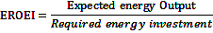
NEG estimates the amount of energy that will be gained after the biomass/bioenergy production activities. EROEI estimates the amount of energy gained after the biomass/bioenergy production activities (in multiples or fractions), and it also indirectly measures the ability of the energy production activities to support continuous socio-economic functions (Hill et al., 2006, Hall et al., 2009). Energy production with an EROEI value greater than 3 is considered capable of supporting continuous socio-economic function while those below 3 are not (Hall et al., 2009).

2.0 Strategic Environmental Assessment (SEA)
Strategic Environmental Assessment examines the impacts, feasibility and sustainability of policy objectives (European Commission, 2010); SEA also offers alternatives for avoiding the negative impacts and constraints associated with a policy; the alternatives may be in form of plans, programmes, projects or policies. Based on article 4 of EU directives on SEA (UNECE, 2003), an SEA process will be required to assess the sustainability of energy production (bioenergy production inclusive) within its member state (e.g. the Netherlands).
An SEA for bioenergy production like other SEAs should be holistic in nature i.e. should fully account for all the interactions in the biomass/bioenergy production chain, the application of the NEG/EROEI approach could be very relevant and, in fact, crucial for an SEA. This study seeks to demonstrate the advantages of using NEG and EROEI for assessment of bioenergy potential. This will help to evaluate the actual energy being added to the provincial bioenergy policy drive, after the energy invested must have been considered, and to determine and chose the most energy efficient and profitable bioenergy production options at provincial scales. This will also offer clues on alternatives to minimizing energy waste and maximizing energy gains of different biomass/bioenergy production activities.
3.0 Scope of the study
The biomass/bioenergy production activities examined by this study are limited to four options on the rural landscape; they are considered benign or even beneficial in terms of food security, nature conservation concerns, well-being of the local people and other socio-economic needs for biomass. They include growing alfalfa (Medicago sativa) on surplus pasturelands, utilizing crop residues, collecting farm manure and using excess grasses from natural grassland. The technology prescribed for the production of the four biomass/bioenergy wet streams is the wet anaerobic co-digestion.
The case study area is the Overijssel province of the Netherlands. Crops whose residues are of interest to this study are high residue yielding crops grown locally in commercial quantities within the Overijssel province (Scarlat et al., 2010). Also targeted was the bioenergy potential of manure from farm animals with high manure yield (beef and dairy cattle), high energy yield (pig and chicken), amount of time spent on hard surfaces and barns, and population advantage within the province (Fehrs, 2000, DEFRA, 2008). The There are three possible harvest schemes for natural grasslands or pasturelands in the Netherlands, they include: 1. Early harvest scheme (EHS) - harvesting grasses of less than 12 cm height; results in lower yield per harvest (2 tonnes/hectare), but allows for more regrowth and harvest opportunities (3 harvests annually). 2. Late harvest scheme (LHS) - harvesting grasses of more than 25 cm height; results in higher yield (5 tonnes/ha), but less opportunity for fast re-growth and less number of harvests (1 harvest annually). 3. Intermediate Harvest scheme (IHS)- harvesting grasses between 15 – 20 cm heights; relatively high yield (up to 4 tonnes/hectare) and allows for one more re-growth and harvest opportunity (2 harvests annually) (van Vuuren et al., 2010, Veepro Holland, 2011).
Based on Overijssel’s population, its projected renewable energy target from bioenergy sources by 2030 as extrapolated from the PGG (Platform Groene Grondstoffen) forecast can be estimated as follows: about 23 PJ/yr of transport fuels, 13 PJ/yr of heat, 14 PJ/yr of electricity and 10 PJ/yr of industrial raw materials (totaling about 60 PJ/yr) (Rabou et al., 2006).

4.0 Methodology
This involves a combination of Life Cycle Inventory (LCI) and GIS capabilities for the compilation of all the energy inputs and outputs involved in the production of energy from biomass sources on the rural landscapes of the Overijssel province. Data (in form of models, parameters, land cover, coefficients and statistics) used for the calculation of the energy inputs and outputs was obtained from GIS databases and literature sources; the energy input and output stocks obtained was used to compute the NEG and the EROEI.
4.1 Life Cycle Inventory (LCI)
An LCI for a biomass source involves a listing of all the energy input that will be involved in obtaining energy from a biomass source and the potential energy output obtainable from such a source (EPA, 2006). The LCI drew instances from literature sources; however, some biomass/bioenergy conversion models and coefficients were not explicitly found. In such cases, assumptions were made based on similar processes or production chains.
4.2 GIS Tools
GIS operations were used for the estimation of the total area covered by the natural grassland. This we did by extraction of the statistics of the natural grassland from the LGN 6 land cover. The following procedures were followed:
- Conversion of the raster based LGN 6 land cover data to a polygon.
- Clipping the Overijssel province’s land cover out of the LGN 6 Land cover data of the whole of Netherlands.
- Re-calculation of the areal geometry of the clipped Overijssel land cover map to eliminate errors arising from clipping operation.
- Selecting the natural grassland land cover from the clipped Overijssel land cover map.
- Checking the areal statistics of the selected natural grassland land cover.
Energy inputs in form of fuel (diesel and/or gasoline) used by tractors, trucks and farm machinery for field operations, or in form of natural gas (LPG) or electricity consumed for post-field operations, pre-treatment and processing were all converted to Joules for data harmonization.
Energy inputs for wet anaerobic co-digestion of straw include: energy for stalk shredding to prevent clogging during digestion; mowing and chopping; baling and stacking; human labour; transportation to the digester; wet oxidation process; and biogas plant operation. For farm manure, the energy inputs include energy for manure collection, storage and haulage; human labour; transportation to the digester; wet oxidation process; and biogas plant operation. For grasses from natural grassland, the energy inputs include energy for mowing and chopping; baling and stacking of grasses; human labour; transportation to the digester; wet oxidation process; and biogas plant operation. For grasses (alfalfa) cultivated on surplus pasturelands, the energy inputs include energy for cultivation of the alfalfa; production of fertilizer applied; production of crop protection chemicals applied; mowing and chopping of grasses; baling and stacking of grasses; human labour; transportation to the digester; wet oxidation process; and biogas plant operation. The expected energy outputs include: Energy from biogas; energy from digestate- fibre; energy from digestate- liquor.

5.0 Discussion and Conclusions
An average of 66 PJ (more than 99%) of NEG can be produced from unconventional biomass sources such as crop residues (4.9-8.6 PJ), farm manure (35.3-58.9PJ) and grasses from natural grassland (259.4-327.2 TJ); while only 3.34TJ (less than 1%) will come from the conventional biomass sources. About 91% out of this bioenergy was from biogas, while the remaining 9% was from Digestate (fertilizer replacement). As seen in Table 1 below the energy efficiencies (EROEI) of by-products are close to what we currently have for fossil fuels (Guilford et al., 2011).
Table 1: NEG and EROEI of the different biomass/bioenergy production options
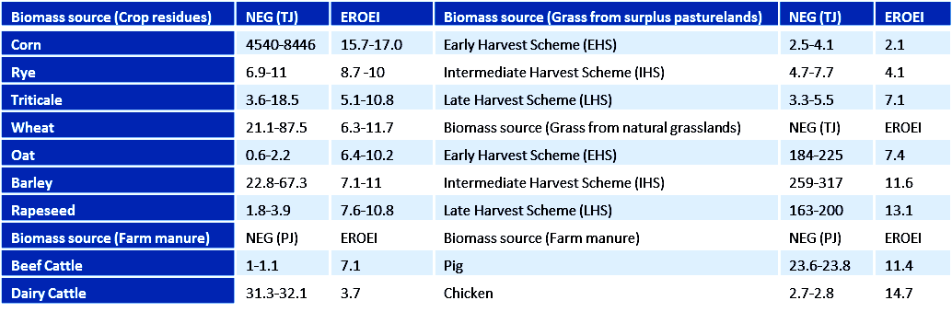
Corn residues has the highest EROEI and NEG values amongst crop residues, and therefore the most energy efficient and profitable; conversely, dairy manure has the lowest EROEI and the highest NEG amongst the manures, it is the least energy efficient but the most energy profitable, this is due to high energy expended on manure collection, storage and haulage. For grass cultivated on surplus grassland, the most energy efficient and feasible option with the highest EROEI and relatively large NEG is the late harvest scheme (LHS). For grasses on natural grasslands, the most energy efficient option is the late harvest scheme (LHS), though not feasible, because Netherland’s grassland management policy stipulates that grasses on natural grasslands be cut at least 2 times annually (Oenema et al., 2006); therefore, the next most energy efficient option, which also has the largest NEG value (the intermediate harvest scheme-IHS) will be the most feasible option.
Under a fully optimized scenario (AEBIOM, 2009, Ecofys, 2010), as shown in Table 2 below, the total NEG from biogas can meet Overijssel’s electricity, heat and transport fuel targets from bioenergy sources.
Table 2: Evaluation of Overijssel’s bioenergy potential
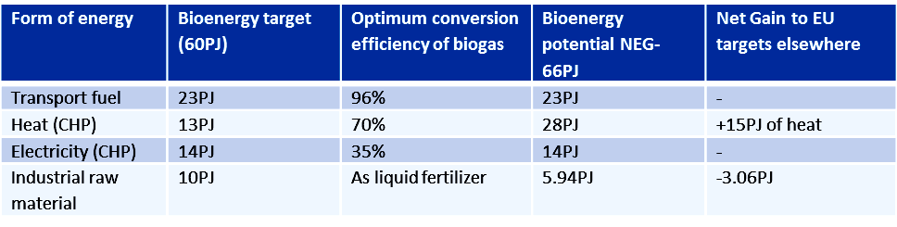
NEG/EROEI approach proves a more holistic approach under an SEA framework. It opens up more opportunities for further analysis; assesses biomass sources their feasibilities and vulnerabilities to policy constraints and offers alternatives aimed at minimizing constraints to bioenergy production and maximizing its potential outputs. From this study, the alternatives offered for bioenergy production within the Overijssel province include:
- Increased exploitation of unconventional biomass sources e.g. farm manure, crop residue, grasses from grasslands etc.; as opposed to indefinite search for land for conventional planting of bioenergy crops.
- The use of farm scale wet anaerobic co-digestion as biomass production technology for all wet biomass types (manure, grasses, straws etc.), this is because of the ease of co-digestion of different biomass types, increase in efficiency as a result of proximity of biomass sources to digesters, and the opportunity it offers for mineral nutrient recovery (Monnet, 2003).
- Better animal management options and farm structure technologies for increased energy efficiency e.g. piping of dairy manure to nearby farm scale digesters.
The information generated from this analysis can form a basis for discussion, and help drive stakeholder interaction and participation under an SEA framework.

REFERENCES
AEBIOM (2009). A Biogas Road Map for Europe. Retrieved October 2, 2011 from http://www.aebiom.org/wp/wp-content/uploads/file/Publications/Brochure_BiogasRoadmap_WEB.pdf
DEFRA (2008). The Biomass Environmental Assessment Tool (BEAT2), Worksheet - Electricity and heat generated in a combined heat and power plant contained within a centralised anaerobic digestion plant using dairy manure as a feedstock. Retrieved September 26, 2011 from http://www.biomassenergycentre.org.uk/portal/page?_pageid=74,153193&_dad=portal&_schema=PORTAL
DEFRA (2008). The Biomass Environmental Assessment Tool (BEAT2), Worksheet - Electricity and heat generated in a combined heat and power plant contained within a centralised anaerobic digestion plant using pig manure as a feedstock. Retrieved September 26, 2011 from http://www.biomassenergycentre.org.uk/portal/page?_pageid=74,153193&_dad=portal&_schema=PORTAL
DEFRA (2008). The Biomass Environmental Assessment Tool (BEAT2), Worksheet - Electricity and heat generated in a combined heat and power plant contained within a centralised anaerobic digestion plant using wet poultry waste from egg-laying birds as a feedstock. Retrieved September 26, 2011 from http://www.biomassenergycentre.org.uk/portal/page?_pageid=74,153193&_dad=portal&_schema=PORTAL
Ecofys (2010). Final report : Evaluation of improvements in end-conversion efficiency for bioenergy production. Retrieved October 16, 2011 from
http://ec.europa.eu/energy/renewables/transparency_platform/doc/2010_report/2010_02_25_report_conversion_efficiency.pdf
EPA (2006), Life Cycle Assessment: Principles and Practices. Retrieved September 23, 2011 from http://www.epa.gov/nrmrl/lcaccess/pdfs/chapter1_frontmatter_lca101.pdf
European Commission (2010). Strategic Environmental Assessment. Retrieved August 27, 2011, from http://ec.europa.eu/environment/eia/sea-legalcontext.htm
Fehrs J.E. (2000). Vermont methane pilot project resource assessment. Retrieved September 28, 2011 from http://publicservice.vermont.gov/energy-efficiency/ee_files/methane/resourceassesment.pdf
Fischer, G., Prieler, S., van Velthuizen, H., Berndes, G., Faaij, A., Londo, M., et al. (2010). Biofuel production potentials in Europe: Sustainable use of cultivated land and pastures, Part II: Land use scenarios. Biomass and Bioenergy, 34(2), 173-187.
Fischer, G., Prieler, S., van Velthuizen, H., Lensink, S. M., Londo, M., & de Wit, M. (2010). Biofuel production potentials in Europe: Sustainable use of cultivated land and pastures. Part I: Land productivity potentials. Biomass and Bioenergy, 34(2), 159-172.
Guilford M.C, Hall C.A.S, O’Connor P., Cleveland C.J (2011). A New Long Term Assessment of Energy Return on Investment (EROI) for U.S. Oil and Gas Discovery and Production. Sustainability 2011(3), 1866-1887.
Hall, C. A. S., Balogh, S., & Murphy, D. J. R. (2009). What is the minimum EROI that a sustainable society must have? Energies, 2(1) 25-47.
Hellmann, F., & Verburg, P. H. (2011). Spatially explicit modelling of biofuel crops in Europe. Biomass and Bioenergy, 35(6), 2411-2424.
Hill, J., Nelson, E., Tilman D., Polasky S., Tiffany D. (2006). Environmental, economic, and energetic costs and benefits of biodiesel and ethanol biofuels. Proc. Natl. Acad. Sci. U.S, 103(30), 11206–11210.
Monnet F. (2003). Final report: An Introduction to Anaerobic Digestion of Organic Wastes. Retrieved October 2, 2011 from http://www.biogasmax.co.uk/media/introanaerobicdigestion__073323000_1011_24042007.pdf
Oenema O., Velinga T.V., van Keulen H. (2006). Nutrient management under Grazing. Retrieved September 23, 2011 from http://library.wur.nl/frontis/perennial_ryegrass/04_oenema.pdf
Rabou, L.P.L.M., Deurwaarder, E.P., Elbersen H.W. & Scott E.L. (2006). Biomass in the Dutch energy infrastructure in 2030. Retrieved August 4, 2011, from http://library.wur.nl/way/bestanden/clc/1871436.pdf
Scarlat N., Martinov M., Dallemand J.F. (2010). Assessment of the availability of agricultural crop residues in the European Union: potential and limitations for bioenergy use. Waste Management, 30 (10), 1889-1897.
UNECE (2003). Protocol on Strategic Environmental Assessment to the Convention on Environmental Impact Assessment in a Transboundary Context. Retrieved August 23, 2011 from http://live.unece.org/env/eia/about/sea_text.html
Veepro Holland (2011). Forage management. Retrieved September 27, 2011 from http://www.veepro.nl/uploadimages/VeeproForageManagementsmall.pdf

