Assessing environmental pressures of energy strategies
1. Introduction
Energy saving, energy efficiency, renewable energy carriers. These are the three pillars of any energy strategy from supranational, national to regional and local levels. Energy strategies and roadmaps are generated anywhere, but at least in Austrian practice most of them are based on energy balances and energy flow charts without introducing spatial dimensions. Our research in the projects PlanVision (Stoeglehner et al. 2011a), ELAS (Stoeglehner et al. 2011b) and INKOBA (Narodoslawsky et al. 2010) clearly revealed that integrating the spatial dimension into such planning processes leads to considerably improved analyses, visions and action plans, and also allows for a better integration of planning and assessment process.
At least in Austria, many regional and local energy strategies are elaborated at least partly by volunteer work of the interested public with experts being contracted by municipalities or regional governments. Spatial and/or environmental planners are normally not present. Therefore, not only the spatial dimension is missing, but also the assessment dimensions is rudimentarily developed mainly focusing CO₂-emissions balances for the direct energy consumption for room heating, electricity and mobility. Embodied energy is normally not addressed. Further assessment often does not take place.
Therefore, we propose that “strategic planning and assessment methods” (Stoeglehner 2010a) have to be developed and used that comprise the following features, which are in more detail described in Stoeglehner and Narodoslawsky (2012):
- be strategic, which means focussing on the general picture and being pro-active as well as oriented on visions and values (Noble 2000), aiming at positive environmental effects (Hacking and Guthrie 2008);
- be integrated, which means supporting a system of environmental, social and economic issues in line with the strong sustainability concept;
- support social learning, especially single-loop- and double-loop-learning (Argyris 1993, in Innes and Booher, 2000, Stoeglehner 2010b), which means learning about facts and values;
- support “rational-communicative planning” (according to Stoeglehner 2010b), where decision making is perceived as aggregating a level of facts and a level of values by clearly defined rules. Agreeing values and aggregation rules in this scheme is task of a communicative process where generating facts and applying the aggregation rules is science-based;
- provide consistent guidance: assessment schemes and indicators have to be used that provide consistent guidance from the supra-national level to the individual decisions of companies and households in order to efficiently implement sustainability.
In this contribution we propose to use the ecological footprint as environmental carrying capacity oriented indicator to assess the environmental pressures arising from energy strategies. In section 2 we introduce our footprint concepts, which are different from the Rees and Wackernagel (1997) and Global Footprint Network (2010) methods and allow for more practical and policy advice. In section 3 we show an application for residential areas and in section 4 for industrial and commercial sites. Section 5 contains some conclusions.
2. Energy footprints as a measure of environmental pressures
Calculating ecological footprints of energy sources is extensively documented in literature. Concerning fossil fuel most calculation methods use either the land required to produce the amount of energy from an agricultural or wood-based energy source (Wackernagel and Rees 1997, Monfreda et al. 2004) or determine the amount of land to be used for carbon uptake (e.g. Global Footprint Network 2010 and many more). These methods show considerable conceptual and practical constraints when a footprint calculated like that is used for the assessment of energy strategies, inter alia, that only energy saving, but not the substitution of fossil by (biomass-based) renewable energy can be expressed (for further critique please refer to Stoeglehner 2003, Stoeglehner and Narodoslawsky 2008, 2009). Other footprint models, that are more precise or especially designed for the energy sector like the energy footprint (Stoeglehner 2003) or the Sustainable Process Index (SPI, Krotscheck and Narodoslawsky 1996, Narodoslawsky and Stoeglehner 2010) overcome the limitations of “classical” footprint calculations and can be used for policy advice, planning and assessment on all levels of policy making.
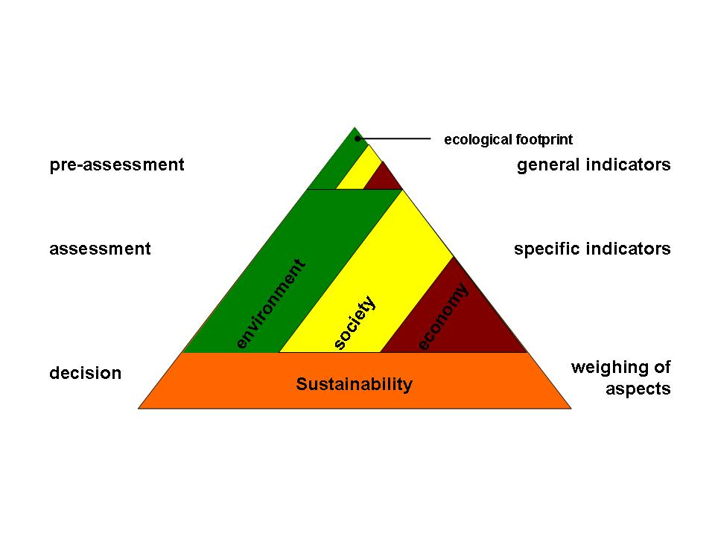
Such calculation methods as the energy footprint or the SPI can be placed on the top of the “indicator pyramid” (Fig. 1, Stoeglehner and Narodoslawsky 2008), a model that shows that during a decision making process the information load increases. The top of the pyramid represents strategic planning and assessment methods, e.g. carrying capacity in an “unsustainability-test”: all alternatives that do not meet carrying-capacity-targets should be eliminated at early planning stages, so that only sufficiently “sustainable” alternatives of energy strategies should be elaborated and assessed in more detail. Such a pre-assessment-step can be compared to a scoping in an environmental assessment, and should also involve social and economic criteria.
Fig.1: Indicator pyramid (Stoeglehner and Narodoslawsky 2008)
Applying the ecological footprints in the manner described can achieve three targets (Narodoslawsky and Stoeglehner 2010): (1) awareness rising on the one hand by decision makers to start and implement planning for sustainable energy strategies, on the other hand by the general population to show the demand for participation in the planning and implementation processes; (2) getting a consistent indicator that can be applied in planning, assessment and monitoring; and (3) support social learning, especially double-loop-learning. Societies can reflect visions, objectives and actions in the light of their perceived environmental pressures an can be supported in normative debates about how much land should be devoted to energy production, and which mix of energy saving, energy efficiency and renewable energy sources should be implemented in the energy strategy.
3. Ecological footprints in the ELAS-calculator
The ELAS-(Energetic Long-term Analysis of Settlement structures)-calculator (Stoeglehner et al. 2011b ) comprises a very complex model and database for the calculation of energy demands of residential settlements, where data about existing or planned settlements can be entered and the energy demand for constructing and running the buildings, constructing and maintaining technical infrastructures as well as the mobility of the expected population (depending on the location of the settlement, the supply structure and the age structure) is estimated. Embodied energy is part of the calculation, which finally produces numbers [in kWh] for the total energy demand as well as its different components.
Depending on the way the energy is supplied the calculator also shows the SPI and the CO₂-life-cycle-emissions. Furthermore, a regional-economic analysis for Austria is carried out showing how much turnover, revenue and jobs are created by the settlement project. (Be careful: the less turnover the better, as this increases the private income to invest in other aspects of quality of life besides housing). All figures are calculated on the basis of life-cycle-assessments, but given per year. In this way the ELAS-calculator provides indicators to tackle all issues of sustainable development on the level of a pre-assessment according to the indicator pyramid. Therefore, the “unsustainability-test” can be carried out for a multitude of planning alternatives for residential settlement structures including spatial criteria and integrating all pillars of sustainability on a strategic level. It supports single- and double-loop learning as by changing the parameters in the calculator and “playing” with the figures, alternatives can be instantly assessed and discussed. Advice is consistent within all types of settlement structures. Therefore, planners, decision makers and the public get a strong tool to optimize residential projects from the perspective of sustainable energy supplies, and in that an integration of spatial dimensions and energy strategies is possible.
The ELAS-calculator is freely available on the internet: www.elas-calculator.eu and has a German and an English language version. If locations outside Austria are chosen, only energy demand, SPI and CO₂-emissions are available. All readers are invited to use the ELAS-calculator for analysing and assessing energy demands and for optimizing existing or planned residential areas from the energy perspective.
4. Ecological footprints and the PNS
The process network synthesis (PNS, Halász et al. 2010) was applied in a project for the energy optimisation of industrial parks in Upper Austria and their supply with regional renewable resources (INKOBA, Narodoslawsky et al. 2010). Energy optimisation does not only include energy efficiency and energy saving, but also the potential of industrial parks to deliver energy services for the surrounding settlements, e.g. district heating via waste heat, biogas using residues, or electricity. The PNS is an expert model, the software is available on the internet: http://www.p-graph.com. The PNS offers the possibility to interlink different technologies with each other. The user defines resources, technologies, products and intermediate products which are put together to a network (the maximum structure). From this maximum structure the PNS choses the optimal structure for a technology network, with different possibilities of optimisation. Normally, it is an economic optimisation, where the network is perceived as “one big company”. The profit of the system is calculated considering investments, operating costs, depreciation and prices for products as well as waste treatment. Different technologies might produce the same product. Once the maximal structure is defined, alternatives can be calculated, sensitivity analyses can be made (e.g. concerning different price levels etc.).
In the INKOBA-project we used the PNS as economic optimisation, accompanied by an SPI-evaluation, where the environmental pressures related to the alternatives were calculated. Furthermore, for selected alternatives a macro-economic analysis was calculated to estimate regional turnover, investments and created jobs. The alternatives varied in different frameworks, technologies that should be applied in any case, regional resources that should be used, settlements that should be provided with district heat etc. Alternatively, the PNS could also be used to optimize the scenarios according to the smallest ecological footprint.
The results of the PNS can be used in the same way as the ELAS-calculator for residential settlements. Both tools provide criteria for the pre-assessment as “unsustainability test”. If no thresholds are available, which is especially true for industrial sites in the planning phase, as they for instance don´t have inhabitants (so that footprint per person cannot be estimated) or the companies which will use the site are not known yet, the alternatives with the lowest footprints can be chosen. For the implementation of the proposed energy strategy for an industrial park, minimum and maximum energy demands, on-site energy production, energy services for surrounding areas etc. have to be defined, and companies selected that meet these criteria. Again the spatial dimension is included in the planning process as energy services and resources, which then determine technological options, are defined based on spatial surveys.
5. Conclusions
As shown by the two examples of strategic planning and assessment methods integrating environmental pressures of energy strategies at early planning stages is feasible and can be supported by powerful decision-making tools. What makes them powerful are the features of being strategic, being integrated, supporting social learning, making facts, values and aggregations and their connections traceable in the sense of the “rational-communicative” planning model and supporting consistent guidance on all levels of decision making including individual decisions of households, persons and companies.
Furthermore, it can be shown - and calculated - that reducing environmental pressures is not only a task of energy planning by introducing energy efficiency measures or renewable energy sources. It is also a matter of spatial context and the integration of spatial structures and energy systems. To achieve this task, integrated spatial and energy planning schemes have to be developed and applied, which includes the level of planning and assessment instruments as well as strategic planning and assessment methods and tools. We encourage academics and practitioners to develop many of these methods and tools and apply them in planning practice, as consistent guidance to manage the energy turn towards sustainable, efficient and renewable energy systems is urgently needed.
References
Hacking, T. & Guthrie, P. 2008. A framework for clarifying the meaning of Triple Bottom-Line, Integrated and Sustainability Assessment. Environmental Impact Assessment Review, 28, 73-89.
Halász, L.; Eder, M.; Sandor, N. K.; Niemetz, N.; Kettl, K.-H.; Tomo, H. S.; Narodoslawsky, M.: Optimal Integration of Sustainable Technologies in Industrial Parks. - in: Chemical Engineering Transactions, Volume 19, 2010. (2010), S. 43 - 48
Innes, J and D E Booher 2000. Collaborative Dialogue as a Policy Making Strategy. Institute of Urban and Rural Development, University of California, Berkeley – Working Paper Series, http://repositories.cdlib.org/iurd/wps/WP-2000-05 [last accessed 06 April 2012]
Krotscheck C., Narodoslawsky M., 1996. The Sustainable Process Index. A new dimension in ecological evaluation. Ecological Engineering 6, 241-258.
Monfreda, C., Wackernagel, M., Deumling, D., 2004. Establishing national natural capital accounts based on detailed Ecological Footprint and biological capacity assessments. Land Use Policy 21, 231-246.
Narodoslawsky, M.; Eder, M.; Niemetz, N.; Kettl, K.H.; Sandor, N.; Stöglehner, G.; Haselsberger, B.; Steinmüller, H.; Kollmann, A.; Lindorfer, J.; Tichler, R.; Fazeni, K. (2010): Durchführbarkeit von nachhaltigen Energiesystemen in INKOBA-Parks. Projekt gefördert aus Mitteln des Klima- und Energiefonds, der INKOBA-Region Freistadt sowie des Landes Oberösterreich.
Narodoslawsky M., Stoeglehner G. (2010): Planning for Local and Regional Energy Strategies with the Ecological Footprint. Journal of Environmental Policy and Planning: 12(4), 363-379.
Noble, B F 2000. Strategic Environmental Assessment: What is it? and What makes it strategic? Journal of Environmental Assessment Policy and Management, 2(2), 203-224.
Stoeglehner, G. (2010a) SUP und Strategie – eine Reflexion im Lichte strategischer Umweltprobleme, UVP-Report, 23(5), 262-266.
Stoeglehner, G. (2010b) Enhancing SEA effectiveness: Lessons learnt from Austrian experiences in spatial planning, Impact Assessment and Project Appraisal, 28(3), 217-231.
Stöglehner, G.; Mitter, H.; Weiss, M.; Neugebauer, G.; Narodoslawsky, M.; Niemetz, N.; Kettl, K.H.; Baaske, W.; Lancaster, B. (2011b): ELAS - Energetische Langzeitanalyse von Siedlungsstrukturen. Projekt gefördert aus Mitteln des Klima- und Energiefonds, der Länder Oberösterreich und Niederösterreich sowie der Stadt Freistadt. www.elas-calculator.eu. Letzter Zugriff: 15.07. 2011. [www.elas-calculator.eu, last access: last accessed 06 April 2012].
Stoeglehner, G. & Narodoslawsky, M. (2012): Stoeglehner, G., Narodoslawsky, M. (2012): Energy-conscious planning practice in Austria: Strategic planning for energy-optimized urban structures. In: Stremke, S., Van den Dobbelsteen, A. (Eds): Sustainable Energy Landscapes: Designing, Planning and Development. Boca Raton: Taylor & Francis. In press.
Stoeglehner, G. & Narodoslawsky, M. (2009): How sustainable are biofuels? Answers and further questions arising from an ecological footprint perspective. In: Bioressource Technology 100: 3825-3830.
Stoeglehner, G. & Narodoslawsky, M. (2008): Implementing ecological footprinting in decision-making processes. In: Land Use Policy 25: 421-431.
Stöglehner, G.; Narodoslawsky, M.; Steinmüller, H.; Steininger, K.; Weiss, M.; Mitter, H.; Neugebauer G.C.; Weber, G.; Niemetz, N.; Kettl, K.H.; Eder, M.; Sandor, N.; Pflüglmayer, B.; Markl, B.; Kollmann, A.; Friedl, C.; Lindorfer, J.; Luger, M.; Kulmer, V. (2011a): PlanVision – Visionen für eine energieoptimierte Raumplanung. Projektendbericht. Projekt gefördert aus Mitteln des Klima- und Energiefonds.
Stöglehner, G. (2003) Ecological Footprint – a tool for assessing sustainable energy supplies. Journal of Cleaner Production 11/2003: 267-277.
Wackernagel, M., Rees, W., 1997. Unser ökologischer Fußabdruck - Wie der Mensch Einfluss auf die Umwelt nimmt. Birkhäuser, Basel.Global Footprint Network (2010)

