Bats adapting to manmade structures - The case of the Concessão Transmontana Highway bridges

Resumo
Os morcegos estão entre os grupos de espécies mais ameaçadas. Tradicionalmente, os morcegos abrigam-se em estruturas naturais como árvores velhas e grutas mas o uso de estruturas humanas tem aumentado. As pontes, em particular, podem ser utilizadas como abrigo pelos morcegos dependendo do tipo de estrutura e das características do habitat envolvente. Em alguns países a utilização deste tipo de estruturas é conhecida há mais de 30 anos. Em Portugal, foi apenas durante o primeiro ano do Programa de Monitorização da Auto-estrada da Concessão Transmontana que se detectou uma colónia de maternidade de grandes dimensões no viaduto sobre o Rio Tinhela. Este viaduto, que atravessa um dos maiores rios da região, é utilizado por várias centenas de morcegos-rabudos (Tadarida teniotis) que utilizam as fendas verticais das cornijas para se abrigarem pelo menos entre Julho e Novembro, não tendo sido observados morcegos durante o Inverno. No segundo ano de monitorização e durante todo o período de obras manteve-se a utilização do abrigo apesar da intensa perturbação resultante da presença humana, da circulação de máquinas e dos trabalhos de construção do novo viaduto estarem a decorrer a poucos metros do viaduto já existente. Durante os trabalhos de monitorização verificou-se que apenas uma das maiores pontes que atravessam os principais rios da região não é utilizada como abrigo por morcegos. Com base na análise dos ultra-sons obtidos ao final do dia, quando os morcegos saem do abrigo, foi possível estimar em 13 o número de espécies de morcegos que utilizam os viadutos da Concessão Transmontana como abrigo. A protecção deste tipo de abrigos de morcegos é de extrema importância na fase anterior e durante as obras, assim como durante a sua manutenção, dado poderem albergar um número muito significativo de indivíduos, para além de ser uma medida de valorização ambiental. Por fim, são apresentadas algumas sugestões para a detecção e protecção das estruturas ocupadas.

Introduction
Bats are part of an important biodiversity heritage but they are also crucial in ecosystem balance. Insectivorous bats, as are all the species of our fauna, can eat more than half their body weight of insects each night thus consuming enormous quantities of insects that could be pests for agriculture and disease vectors (Palmeirim & Rodrigues, 1992). Therefore bats have, with no doubt, an economic importance at the local level where they occur.
All Portuguese bats are protected by Portuguese and European law because all 27 species are afforded a status of Annex B-IV of Habitats Directive and 10 of these are also afforded a status of Annex B-II (Decreto-Lei nº140/99, de 24 de Abril). Under this directive all bats and their roosts are protected from intentional disturbance or destruction during reproduction, hibernation and resting.
One of the main reasons for the extreme vulnerability of this group is their slow reproductive rate, as females give birth to a single pup per year. The females form nursery colonies during the summer, which can congregate in the same place a very high number of bats. Therefore, the disturbance or destruction of a single roost can have a serious impact on the local bat population.
Traditionally, bats roosted in natural structures such as old trees and caves but, through loss of suitable natural sites and adaptation, they frequently make use of man-made structures (Masterson et al. 2008). Among these are bridges which can provide roost for a great number of bats, depending on their structure and surrounding conditions. The biggest known roost is located in the Congress Avenue bridge in Austin, Texas, where more than a million of bats roost since the 1980s (Keeley & Tuttle, 1999).
Searching for bat roosts was part of the environmental monitoring programme of the “Concessão Transmontana” highway that started at 2010. Construction works had already started in some parts of the road and the main objective was to detect existing roosts as soon as possible and to take the necessary measures to protect them from disturbance and/or destruction. The project aims to convert a previously existing freeway road into a highway, so improvement of existing structures and construction of new ones is intended.

Methods
During the monitoring works of the “Concessão Transmontana” highway bat roosts were searched in the vicinity of the road inside a 2km wide buffer. Topographic maps were analysed previously to field work in order to identify potential roost places (e.g. mines, ruins, bridges). All this places were visited during field work and local people were enquired if they had previous knowledge of any bat roosts. Works were conducted monthly for 2 years: March to October in 2010 and July to October in 2011.

Results
Searching efforts around the existing road revealed few bat roosts holding a small number of bats and the enquiries to local people were unfruitful in locating important roosts. The most important roosts were found just below the road, in crevices (figure 1) of some of the concrete bridges that pass over the most important rivers and their tributaries in the region: rivers Corgo, Tinhela, Tua and Sabor (figure 2).
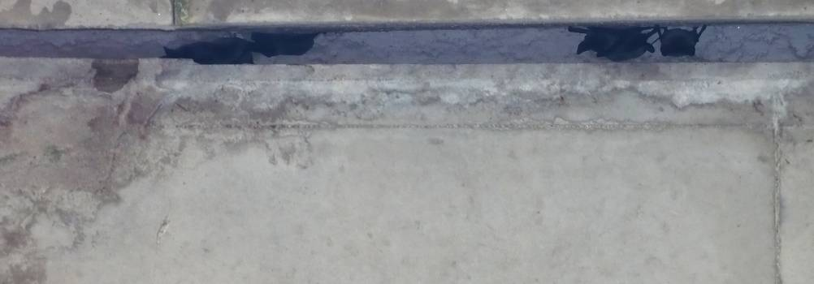
Figure 1 – European free-tailed bats in the vertically open crevices of the bridge over Tinhela river.
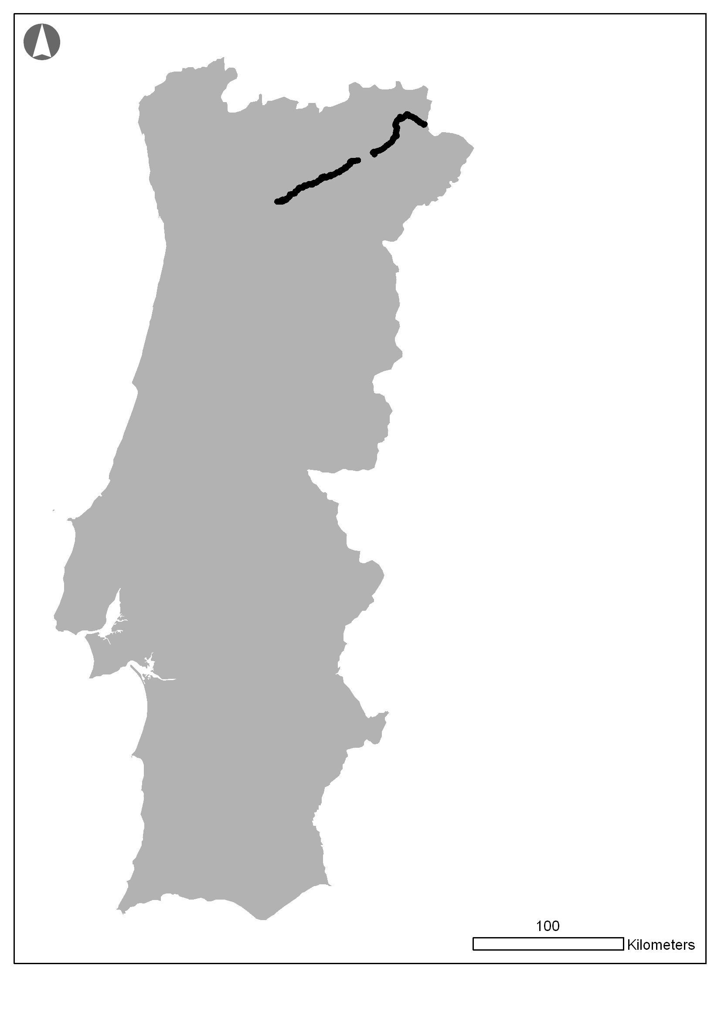
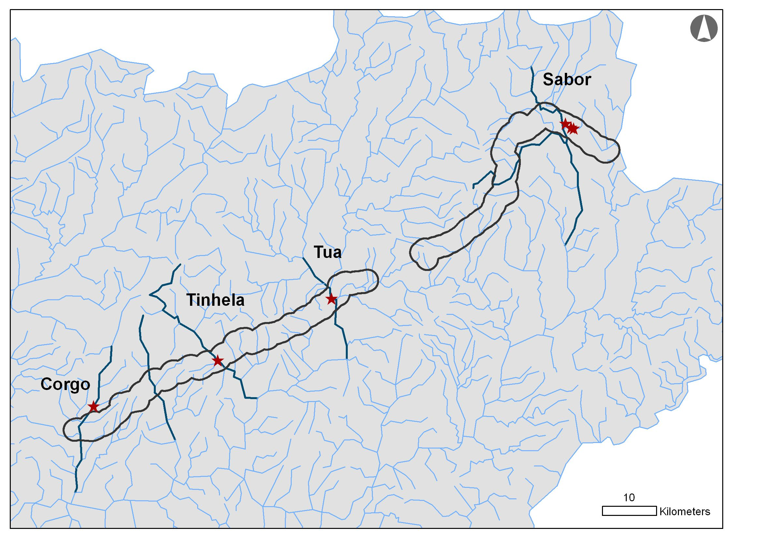

Figure 2 – Location of Concessão Transmontana study area and detail showing most important rivers in the region. Rivers where bats were detected roosting in the bridges passing over are indicated by corresponding name.
The first roost to be detected was located in the bridge over the Tinhela and the number of bats was estimated at about 600 to 1000 individuals, based on bat counts of a small area using binoculars. The observed bats were gathered in the vertically open crevices under the bridge for water drainage. All observed bats and a corpse found under the bridge were European free-tailed bats (Tadarida teniotis) but sound recordings captured at dusk revealed also the presence of Common pipistrelle (P. pipistrellus). Bats were present at least between July and November but not in January indicating this is as a maternity roost. During the second monitoring year bats were still present despite the human disturbance and machinery working a few meters apart and the number of bats was very similar, even slightly higher (151 in October 2010 and 201 in October 2011).
Observation of bats using binoculars, photographs and ultrasound recordings analysis obtained in all the bridges where bats were detected revealed the potential presence of 12 bat species (Table 1).

Table 1 – Conservation status and population trends based on the Portuguese Red Data Book of the species detected in the bridges of the Concessão Transmontana. *: not evaluated because its presence in Portugal was only confirmed after 2005.
Species | Conservation status in Cabral et al. (2005) | Population trend
Lesser horseshoe bat  Rhinolophus hipposideros | Vulnerable | Indeterminate
Pipistrelle bat  Pipistrellus pipistrellus | Least Concern | -
Kuhl’s pipistrelle  Pipistrellus kuhli | Least Concern | -
Soprano pipistrelle  Pipistrellus pygmaeus | Least Concern | -
Leisler’s bat  Nyctalus leisleri | Data Deficient | Unknown
Serotine  Eptesicus serotinus | Least Concern | -
Meridional serotine bat  Eptesicus isabellinus* | - | -
Barbastelle  Barbastella barbastella | Data Deficient | Unknown
Brown long-eared bat  Plecotus auritus | Data Deficient | Unknown
Grey long-eared bat  Plecotus austriacus | Least Concern | -
Scheiber’s bat  Miniopterus schreibersii | Vulnerable | Stable
European free-tailed bat  Tadarida teniotis | Data Deficient | Unknown

Observation points made at dusk below the bridges when bats were leaving the roost suggest that the most abundant species is T. teniotis which is classified in the Data Deficient category and its population trend is unknown both in Portugal and Europe.
Because some of the species are very difficult to distinguish based on ultrasound recordings the number of species roosting in the bridges can be smaller. The presence of N. leisleri, a tree roosting species, has to be considered with some reservation because it might be from an individual from the surrounding area although the sound recording was made at sunset while bats were leaving their roosts.
Construction works were in progress when the first roost was detected and bats kept using the bridges despite the presence of people, machinery and vehicles around the area, sometimes even during the night. New bridges built close to existing ones were occupied just as they were finished revealing their exceptional conditions for bat roosting.

Conclusions and guidelines for bridge surveys
Bridges like the ones present in the “Concessão Transmontana” can be of great value for the conservation of bats since they can provide roost for a variety of species and sometimes accommodate a high number of bats of some of the species. Based on the results of the present monitoring programme and the work developed in other countries we can conclude that bridges can provide very good conditions for bat roosting, namely safety from predation, and the water flowing beneath maintains both temperature and humidity (Masterson et al. 2008).
Monitoring these bridges can also provide information about population trends of some species that are very difficult to evaluate as is the case of T. teniotis, which was originally a rock-roosting bat and so, consequently, natural roosts are very difficult to detected, being almost impossible to estimate the size of their population.
Protecting the presence of bats in existing bridges before, during and even after construction is of extreme importance to bats but can also be an opportunity to mitigate environmental impacts from a road thus showing a proactive commitment of the company to the environment.
Current information on bat roosts in bridges is scant in Portugal but evaluating structures for bats or signs of bat use is not difficult or costly and can be of great value both for planners and the conservation of bats. Information on survey techniques to evaluate highway structures for bat use, measures to minimize the effect on bats of works in bridges and how to create bat roosts in highway structures is available on-line (see BCT no date and Keeley & Tuttle, 1999). These and a technical note of ICNB on this issue (see Rainho, 2011) were important information sources for the present work.
The use of bats can be confirmed by visible bats, audible chirping, droppings and stains from urine or body oils at or below the roost. All these were observed in the monitored bridges but in most of the observations the use of binoculars was needed. This is also advised in published information as well as the combination with a high-powered rechargeable light. The use of a bat detector is very important not just to detect the presence but also to sound analysis afterwards in order to try to identify the bat species. The use of a mirror or a miniature camera mounted on a telescoping pole is also referred on literature but none were used in the present work.
Enquiries made to the personnel involved in the construction works may not be very helpful as we found that most people didn’t notice bat presence despite the construction sites were located below the roosts and it was possible to see very close the bats coming out from the open crevices.
Bridge inspectors can and should be involved as they are a good opportunity to detected bat roosts in advance and with no extra cost for the company. Awareness of other people that might be involved in all the critical phases before a bridge roost might be disturbed or destroyed is also important. Passing promptly any relevant information about roosts or potential roosts to the ICNB, besides the inclusion of the collected information in official reports, is also very important.

References
Bat Conservation Trust. No date. Bats in Bridges. Specialist Support Series. Available at:
http://www.google.com/url?sa=t&rct=j&q=&esrc=s&frm=1&source=web&cd=1&ved=0CDAQFjAA&url=http%3A%2F%2Fwww.coventry.gov.uk%2Fdownload%2Fdownloads%2Fid%2F1760%2Fbats_in_bridges&ei=s55sT8HLGoTQ0QWNw5y7Bg&usg=AFQjCNF4QszhUhvNPx3pIH198LkYAAZ0gg
Cabral, M.J., Almeida, J., Almeida, P.R., Dellinger, T., Ferrand de Almeida, N., Oliveira M.E., Palmeirim, J.M., Queiroz, A.I., Rogrado, L. & M. Santos-Reis (eds.). 2005. Livro Vermelho dos Vertebrados de Portugal. Instituto de Conservação da Natureza. Lisboa. 660 pp.
Keeley, B.W. & M.D. Tuttle. 1999. Bats in American Bridges. Bat Conservation International. Available at: http://www.batcon.org/pdfs/bridges/BatsBridges2.pdf
Masterson, M., Buckley, D., O’Brien, M. & C. Kelleher. 2008. An Investigation into Bridge Usage by Bats within the Sullane & Laney River Catchments, Co. Cork. The Heritage Council & National Parks and Wildlife Service. Co. Cork. 17pp.
Palmeirim, J.M. & L. Rodrigues. 1992. Plano Nacional de Conservação dos Morcegos Cavernícolas. Estudos de Biologia e Conservação da Natureza No. 8. SNPRCN, Lisboa.
Rainho, A. 2011. Morcegos em viadutos. Instituto da Conservação da Natureza e da Biodiversidade. Lisboa. 10pp.

