Biodiversity in Deep-Sea Habitats Intended for O&G Exploration
Introduction
Recent interest in oil and gas exploration has suggested that deep-water sites offshore the Island of Borneo contain marketable reservoirs of oil and gas. Due to the expense of ecological surveys, the deep-water habitats offshore Borneo are poorly known. In general, as oil and gas exploration shifts to deep-water offshore environments, site-specific environmental data is typically lacking for a full environmental assessment and evaluation of potential impacts.
In order to understand these habitats and the possible impacts of drilling, it is necessary to develop baseline data. Consequently, in 2011, TOTAL E&P Deep Offshore Borneo B.V. issued a contract for an environmental baseline study (EBS) of its Block CA1 offshore Brunei Darussalam in water depths of 1000–1700 m. This study was intended to collect sufficient samples of the sediment and water column to understand the types of habitats that would potentially be impacted by exploration and production and to develop a database sufficient to use as a baseline for further monitoring efforts. These studies were part of an Environmental Baseline Survey (EBS) and associated Environmental and Social Impact Assessment (ESIA) conducted prior to exploratory drilling. Review of existing literature revealed site specific data gaps pertaining to environmental topics relevant to offshore habitats in the study area. Because little is known regarding the seafloor conditions, benthic biodiversity, sediment, and water column chemistry, physical properties of the sediment, single point short term current readings and presences of sensitive seafloor communities within the proposed project area were evaluated as part of the EBS.
Methods
A 12-day survey was conducted 28 May 2011 to11 June 2011on the R/V Emma, a 40 meter survey vessel. Data was collected using a Seatronics DTS-6000 camera system that provided both video and still images to assess seafloor topography, bioturbation, and megabenthic fauna from 54 stations; a Gulf of Mexico 0.25 m² box core was used to collect sediment for benthic infauna, sedimentology, and geochemistry at 51 stations; a Seabird 19+ CTD (conductivity, temperature, depth profiler) was used to collect vertical profiles of temperature, salinity, fluorescence, and dissolved oxygen with depth; and six 2-L Niskin Bottles were mounted to the DTS-6000 frame to collect water for chemistry, nutrients, and pH from near the surface, 500 m, and near the seafloor at 15 stations. Navigation was assisted with a USBL (Ultra-short baseline) underwater acoustic positioning device. By using this system, the surveying team is able to accurately determine both the actual position of the deployed package and its depth in meters that is separate from the actual position of the survey vessel determined by GPS (Global Positioning System). Data for fisheries threatened and endangered species, climatology, and broad-scale oceanographic processes were obtained from published sources.

Results
There is little information on deep water currents in the vicinity of CA1 and long-term moorings are required to understand their direction and velocity. Preliminary results from an electromagnetic current meter deployed as part of the CA1 survey suggest that apart from variable surface currents that deeper water current velocities are very low, usually no more than 0.2 m/sec.
CTD profiles were typical of regional patterns. Dissolved Oxygen was lower at the surface and increased with depth. Salinity was lower at the surface and increased with depth. Warmer surface temperatures declined with depth. Fluorescence (chlorophyll) increased rapidly in the first 50 m and then decreased gradually with depth and was consistently similar across all stations. pH declined slightly with depth while turbidity (TSS) was not detected at 1.0 mg/L.
The sediment chemistry data did not indicate any exceedences suggesting prior contamination. Sediment grain size consisted of 94–99%. silt and clay at all stations.The silt fraction ranged from 42–79%; the clay fraction ranged from 20–52%. Total organic carbon (TOC) values were highly variable, and ranged from 0.4–5.9% (median 1.6, SD ± 1.3). Total sedimentary nitrogen ranged from 632–5970 mg/kg (median value of 2380 mg/kg SD ± 1168). Total phosphorous concentrations in sediments ranged from 349–534 mg/kg (median of 427 mg/kg, SD ± 35). No total petroleum or individual aliphatic or polycyclic aromatic hydrocarbon (TPH, PAH) compounds were detected above the Limit of Reporting (LOR). Aluminum and iron make up large fractions of clay minerals. One station contained a unique aluminum and iron signal relative to the other project samples. At this station, these elements were measured at about a factor of two above the overall median sediment concentration for the area. Barium concentrations ranged from 205–1690 mg/kg (median value of 370 mg/kg, SD ± 290) and correspond with global results. Barium was measured at each of these stations above 1000 mg/kg. Concentrations of nickel, chromium, cobalt, lead, vanadium, and zinc were relatively uniform throughout the study area and all within the range of typical marine sediment concentrations.
The seafloor imaging task revealed a relatively uniform habitat of ambient sediments consisting of silt and clay. A wide variety of biogenic structures were observed including straight rows of slit-like burrows, solitary burrows both large and small, paired burrows, or unusual rings of burrows. Minute clusters of burrows were unusual and formed by unknown organisms. Fecal deposits also come in a variety of spiraled, consolidated, or mounded types. Tracks caused by slow-moving holothurians contrast with more random disturbance by brittle stars. Relatively few organisms were abundant in the images. One brittle star, Ophiomusium lymani, was very abundant over the 1171–1294 m depth range. Likewise a larger slow-moving grey-colored sea cucumber is relatively common at 1200–1350 m. The common halosaur fish, Halosauropsis macrochir, is found throughout the survey area. Other species of invertebrates and fish are rare. The swimming polychaete worm, Teuthidodrilus samae, commonly called the Squid Worm is newly reported for the South China Sea. Originally reported from the Celebes Sea Basin, this worm was observed very near the seafloor in several of our images. These organisms and biogenic structures are illustrated in Figure 1.
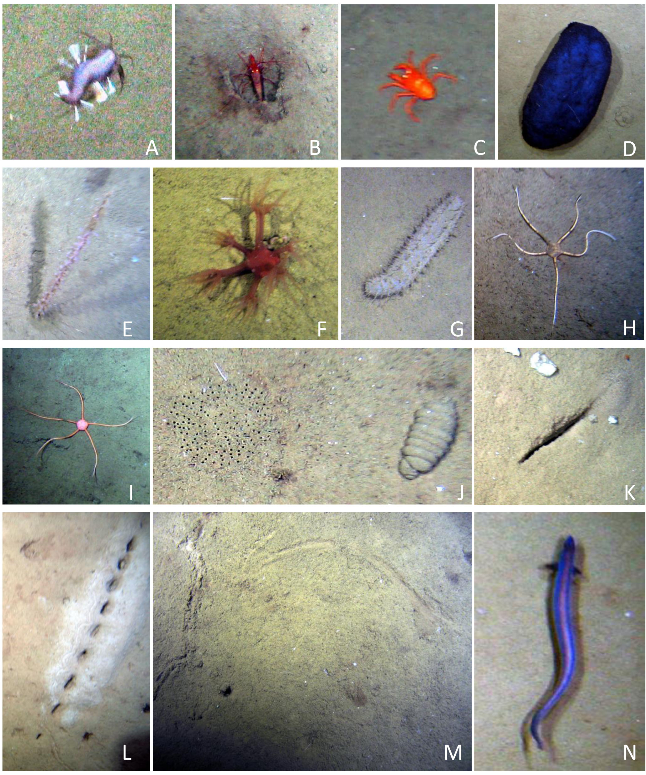
Figure 1. Benthic organisms and biogenic features from Block CA1 off shore Brunei Darussalam. A, Squid worm, Teuthidodrilus samae; B, Shrimp; C, Galathaeid crab; D. Blue holothurian; E, Sea Pen, F, Soft coral; G, grey holothurian; H, ophiuroid, Ophiomusium lymani; I, Ophiuroid, unknown species; J, Burrow clusters (left); fecal casting (right); K, Slit-like burrow; L, Rows of burrow openings; M, Tracks from holothurians; N, Common halosaur fish, Halosauropsis macrochir.
For the benthic infauna, the faunal composition is typical for slope and deep-sea sediments, with polychaetes dominating the fauna, and groups such as amphipod, isopod, and tanaidacean crustaceans being common together with bivalve and gastropod molluscs. Over 600 species of benthic invertebrates were identified including at least 400 species that are believed new to science. The fauna consists of a mix of common and rare species together with other dominant taxa such as Aurospio dibranchiata, Prionospio fauchaldi, Levinsenia flava, Glycera tesselata, and Prionospio fauchaldi that are more widely distributed in deep-sea habitats. Although density of organisms was relatively low, species richness and diversity were very high in all samples.
Evenness was very high in all samples, ranging from 0.92 to 0.98, reflecting the equitable distribution of individuals among species. These results are similar to other deep-sea habitats where species diversity estimates are often among the highest recorded on the planet. Non-dimensional diversity demonstrated that all samples were highly diverse and approached the log-series distribution of species of individuals predicted by Fisher’s Log series model (Figure 2). This result becomes a powerful tool in monitoring because deviations from Fisher’s model could indicate a disturbance in community parameters. There were no apparent depth-related patterns and benthic community structure as determined by cluster and ordination analysis did not suggest any apparent patterns or faunal assemblages. Instead most of the stations appeared to represent similar patterns. A suite of multivariate analyses suggest that a large group of about 35 stations form an assemblage that is composed of many of the more widely distributed species. This result, however, is at a relative high level of similarity, but suggests that the benthic faunal assemblages are more or less similar throughout the study area.

Figure 2. Rarefaction curves for each of 51 stations sampled in May–June 2011 off Brunei. All curves exhibit a steep slope, indicating very high diversity within each 0.1 m² biology sample taken from the box core.

Silvestre and Garces (2004) recorded 313 species of fish and invertebrates caught in trawl surveys off Brunei between July 1, 1989 and June 28, 1990. Of these only 25 species comprised approximately 70% of the catch (which averaged 111.3 kg per 0.5 h standard trawl drag) and therefore comprise the bulk of the trawlable biomass in the coastal waters of Brunei. There is currently no commercial fishing activity in the vicinity of the project site, mainly because of existing maritime disputes. Commercially important fish and marine mammals are believed to migrate through the exploration area though.
Sensitive marine habitats such as coral reefs and mangroves are not located in the vicinity of the drilling sites. The mangroves off Brunei’s coastline although located far distant from the study area, have nevertheless been identified as being particularly sensitive to oil spills. These mangroves are unique in being some of the best preserved and least exploited mature stands in the region.

Conclusions
This study has, for the time, elucidated the nature of benthic communities in the South China Sea offshore Brunei Darussalam. The larger megabenthic fauna observed in the video images are taxa that are typical of deep-sea sediments around the world (Gage and Tyler 1991). The smaller infaunal fauna, while comprised of taxonomic groups typical of other deep-sea areas, with a few species that are widely distributed in the world’s oceans, the larger list mainly consists of species that are new to science. The species richness and diversity is remarkably high and additional species are expected with further sampling. It is noteworthy that while 798 species were collected from the ACSAR mid-Atlantic program off the NE United States, (Grassle and Maciolek, 1992) and 616 from off Brunei and seemingly comparable species richness, the ACSAR results required the collection of over 90,000 specimens, whereas less than 9,000 were required from off Brunei to achieve similar species richness. These comparisons suggest that the deep-sea benthic fauna in the South China Sea is one of most species-rich and diverse habitats yet explored. We expect that the main elements of the fauna discovered as part of this study will be found more widely distributed in the South China Sea. These results provides a strong baseline for completion of the ESIA and for any future monitoring programs.

References
Gage, J.D. and P.A. Tyler. 1991. Deep-Sea Biology: A Natural History of Organisms at the Deep-Sea Floor. Cambridge University Press, xvi + 504 pp.
Grassle, J.F. and N.J. Maciolek. 1992. Deep-sea species richness: Regional and local diversity estimates from quantitative bottom samples. The American Naturalist 139(2): 313–341.
Silvestre, G.T.V and L.R. Garces. 2004. Population parameters and exploitation rate of demersal fishes in Brunei Darussalam (1989–1990). Fisheries Research 69: 73–90.

