Bird and bat mortality at Portuguese wind farms

Introduction
Wind energy had a remarkable growth in Portugal over the last 10 years. As it happened in other countries, several pre- and post-construction monitoring studies have been performed in order to assess the impacts of turbines on flying vertebrates. However, few studies gathered data collected at different sites and analysed it in an integrated way.
As one of the first tasks of the R&D project, Wind & Biodiversity, this paper presents the results of the bibliographic review regarding bat and bird mortality at onshore wind farms. We were interested to know: 1) which species or assemblages present higher levels of mortality; and 2) when and where this problem is more evident.
Methods
From March to July 2011 we performed an intensive literature research of monitoring reports about bird and bat activity and mortality at onshore wind farms, published between 2003 and 2010. A total of 85 monitoring reports concerning 62 Portuguese wind farms have been analysed. From these studies, 56 were used to collect data regarding bird mortality/activity and 45 to collect data regarding bat mortality/activity.
The information contained in each one of the documents was gathered for each species found dead, including time of the year in which the fatality occurred. Alongside this information, we collected data about the activity of each group all over the year, including activity peaks. Since different wind farms had different sampling efforts (regarding the number of turbines searched and the number of searches performed per year), the collected mortality data were weighted. The following formula was used to reach the value of adjusted mortality:
Adjusted mortality = (observed mortality / No. of turbines searched / No. of searches performed)
Using this formula we were able to compare data from different monitoring reports and analyze in which wind farms and for which species higher mortality levels were observed.
In order to analyze the spatial distribution of observed mortality and adjusted average over the country, the mortality values were weighted by region, taking into account the total number of wind farms considered within each site. This information was then introduced on a GIS separately for the group of birds and bats. We also intended to establish a relation between mortality and activity peaks of flying vertebrates. To accomplish this objective, we analyzed the information contained in each monitoring report concerning to references to higher activity levels or mortality peaks. As sampling effort differed in each study (e.g. different moths were sampled, different number of samples in each month), the number of times a given month was registered has having a peak of activity or mortality was weighted by the number of sampled studies that monitored that same month.
Results
Which were the most affected species?
Regarding the sample of reports analyzed, a total of 414 carcasses were found at Portuguese wind farms, 200 of them were birds and 214 bats.
Concerning birds, the results showed that the most affected bird species was house martin (Delichon urbica) (0,091 fatalities/turbine/search and an absolute number of 40 carcasses detected), followed by skylark (Alauda arvensis) (0,057 fatalities/turbine/search and a total of 20 carcasses detected) and corn bunting (Emberiza calandra) (0,043 fatalities/turbine/search and 20 carcasses detected). Thirty of the 200 registered fatalities were birds of prey. Common Kestrel (Falco tinnunculus) is the most common raptor affected with 20 carcasses found and an adjusted mortality of 0,011 fatalities/turbine/search. The Montagu's Harrier (Circus pygargus) is the only bird species detected (0,003 fatalities/turbine/search; 7 carcasses detected) which presents an unfavorable a conservation status, classified as Endangered (EN) by Portuguese Vertebrates Red List (Cabral et al., 2006).
Regarding bats, the 214 carcasses found corresponded to 14 different species or assemblages. The analysis showed that the most affected species was common pipistrelle (Pipistrellus pipistrellus), with 76 fatalities and a value for adjusted mortality of 0,104 carcasses/turbine/search, followed by Leisler's bat (Nyctalus leisleri), with 43 fatalities and an adjusted mortality of 0,078 carcasses/turbine/search. This last species, Leisler's bat (Nyctalus leisleri), is classified as Data Deficient (DD) by the Portuguese Vertebrates Red List (Cabral et al., 2006), but the majority of the carcasses found belong to species classified as Least concern (LC) (Cabral et al., 2006). However, one of the species found is classified as vulnerable (VU), the bentwing bat (Miniopterus schreibersii), and other three species are classified as deficient data: Savi's pipistrelle (Hypsugo savii), european free-tailed bat (Tadarida teniotis) and giant noctule (Nyctalus lasiopterus).
When and where did they die?
The higher mortality values for birds (carcasses/turbine/search) were found in Faro region, in the south of Portugal, followed by Viseu region (Figure 1). These values, however, showed apparently no differences between the coastal and inland wind farms. For bats, the highest adjusted mortality values were registered in Viseu region, in central continental Portugal (Figure 1). Bat mortality appears to be similar in coastal and inland Portuguese wind farms, however, it is higher in the North, reflecting the location of the majority of the existing wind farms.
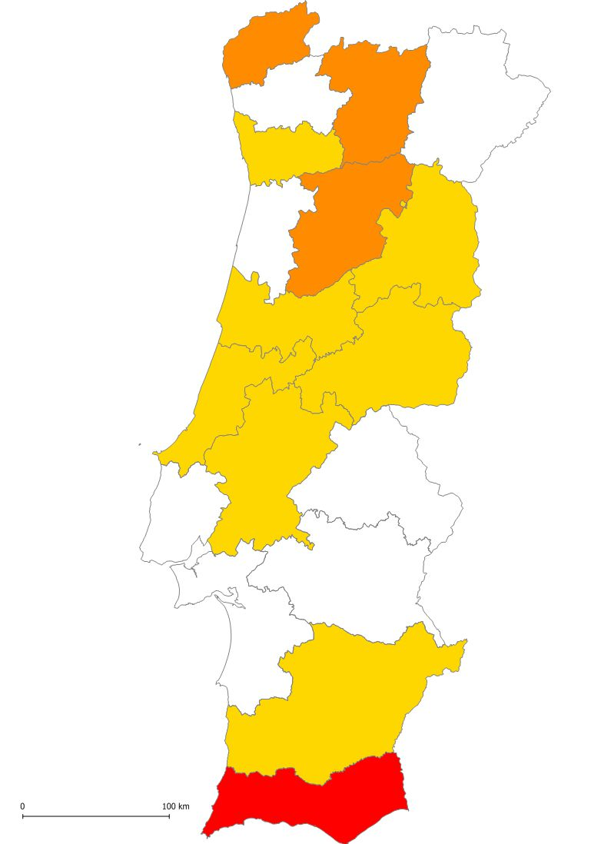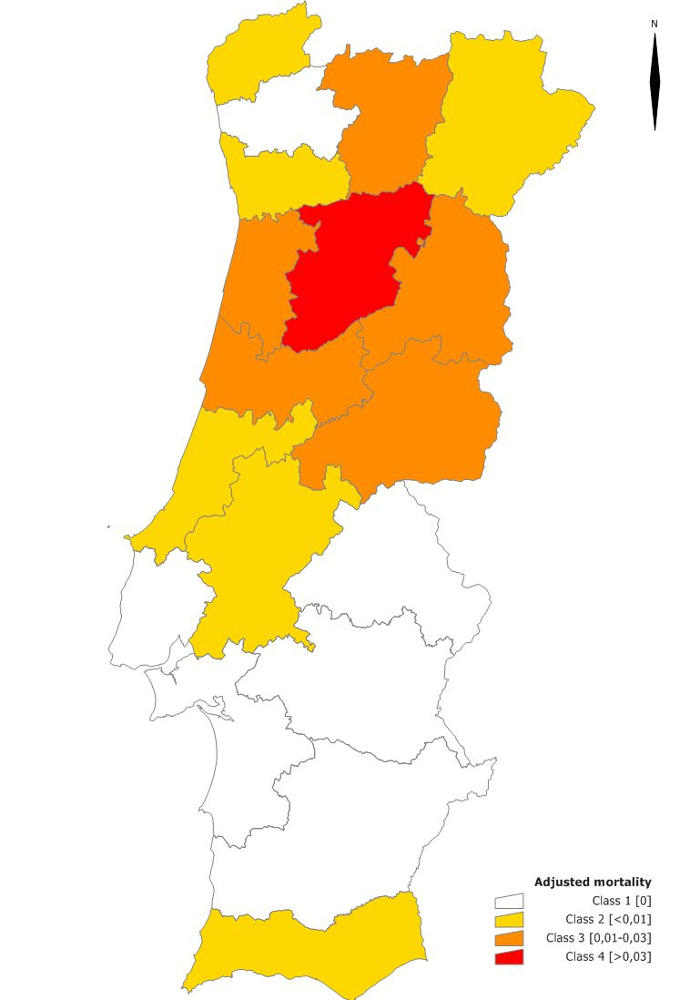
Birds
Bats
Figure 1 - Adjusted mortality of bird (in the right) and bat (in the left) for each region of Portugal.
Concerning the temporal analysis, the results put in evidence the existence of activity peaks for birds along the year. A higher activity period between September and October has been detected in several studies. This time of the year is coincident with the post-breeding migration period. After this period, during the winter, the activity reaches low levels and in spring rises again, until the summer. In the spring and summer the activity levels are quite similar. Despite the activity patterns observed, the mortality temporal analysis did not show any evident pattern, yet, the probability of occurrence of mortality peaks in the spring is higher than in any other time of the year.
For bats, the activity temporal analysis clearly evidenced two sharply defined peaks, one in May and one in August/September, although activity levels remain high from July to October. On the other hand, the number of fatalities was higher in May and in the late summer, between August and October. Thus, the results evidenced a relation between bats activity peaks and the number of carcasses detected around the turbines. These results are consistent with those published by the Portuguese Institute for Nature Conservation and Biodiversity (ICNB, 2010), that found similar results concerning this relation.
Conclusion
A relation between bats activity and mortality peaks has been identified, with higher mortality when the activity level is superior, during May and in late Summer. This relation has not been found for birds, in spite of the existence of activity peaks between September and October.
Although none of the species with higher fatalities rates are included in the Portuguese Red List, some of them have low resilience to additional mortality (e.g. raptors) and/or little is known about their population (e.g. Hypsugo savii). Thus, it is essential not only to incorporate the results of these types of reviews in future EIA, but also to focus monitoring studies on the most affected species and to put into action the appropriate mitigation/compensation plans.

References:
Cabral M.J. (coord.), Almeida J., Almeida P.R., Dellinger T., Ferrand de Almeida N., Oliveira M.E., Palmeirim J.M., Queiroz A.I., Rogado L. & Santos-Reis M. (eds.). 2006. Livro Vermelho dos Vertebrados de Portugal 2ª ed. Instituto da Conservação da Natureza/Assírio & Alvim. Lisboa.
ICNB. 2010. Avaliação do efeito dos parques eólicos sobre os morcegos em Portugal continental (documento de trabalho). Instituto da Conservação da Natureza e da Biodiversidade. Relatório não publicado. 87pp.

