Compensation Measures at Amareleja Solar Power Station

Introduction
The Amareleja Solar Power Station occupies an area of approximately 280ha and part of this area is inside a Special Protection Area (SPA) (figure 1). Previously to its construction this project was object of an Environmental Impact Assessment during which a small population (ca. 3 to 4 pairs) of Stone curlew Burhinus oedicnemus was identified. This species is classified as Vulnerable in the Portuguese Red Data Book (Cabral et al. 2005) and is listed at the annex I of the Birds Directive (EEC-79/409). Considering that this population of Stone curlew would be affected by the construction of the Power Station and the dispositions of the article 6(4) of the Habitats Directive (92/43/EEC) it was decided that the project could be implemented but Compensation Measures should be developed having this bird species as its target.
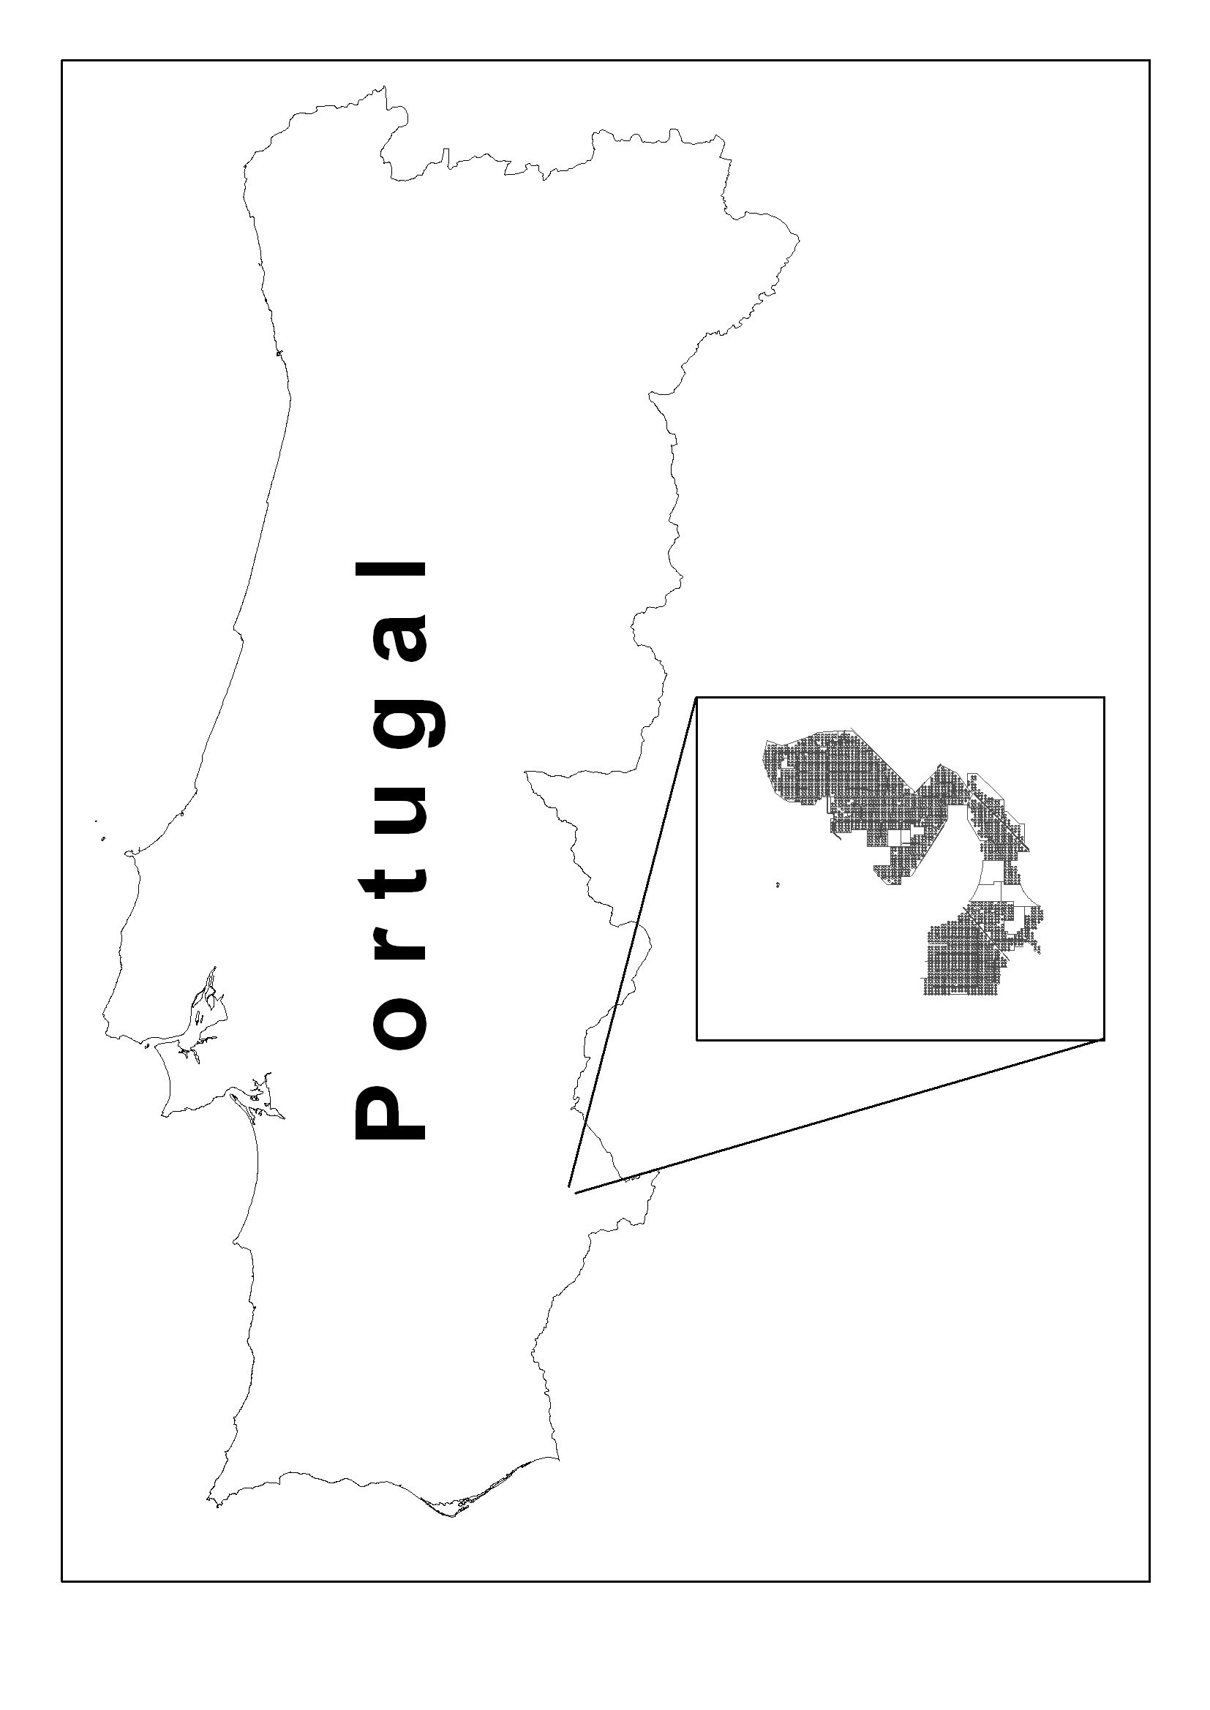
Figure 1 - Study area.

According to the referred Habitats Directive the Compensation Measures should be proportional to the damage and developed inside the Classified Area (in this case de Moura/Mourão/Barrancos SPA). As the Power Station uses solar panels that follow the sun throughout the day the open space between the panels is large (ca. 11m and 17m at the projection) and therefore allows for the management of this territory without interfering with the production of electricity (figure 2).
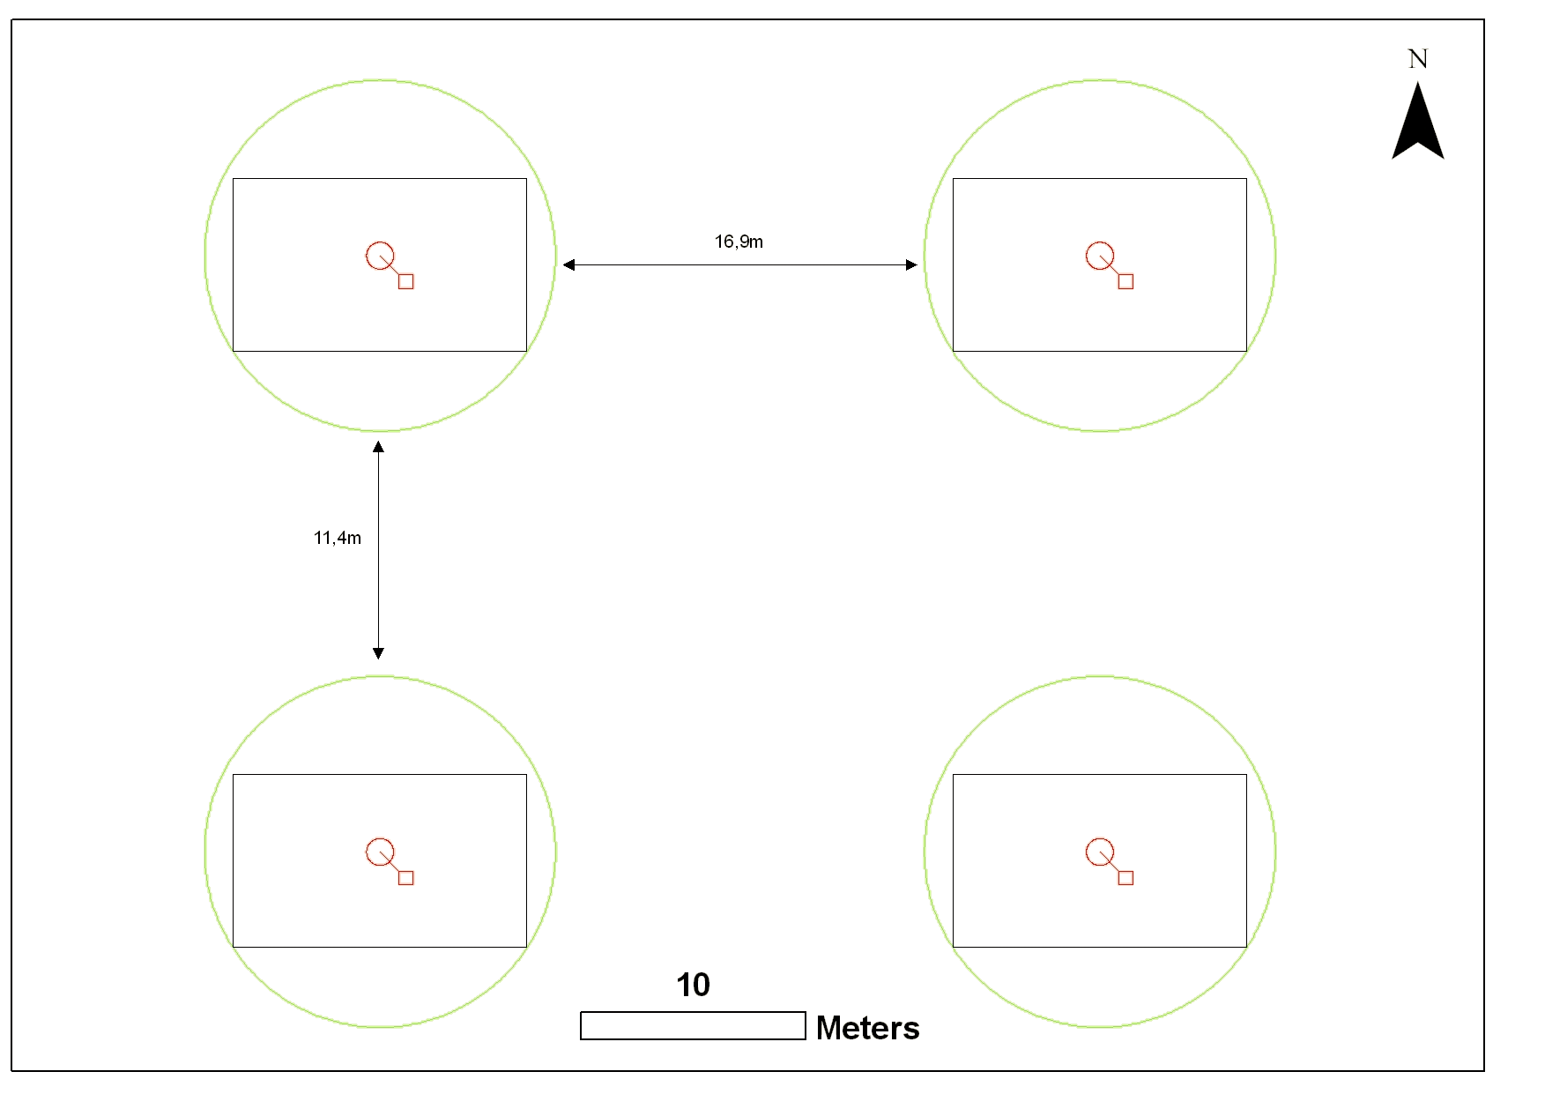
Figure 2 – Arrangement of the solar panels.
Given these particular circumstances the national authority (Institute for Nature Conservation and Biodiversity – ICNB) accepted the development of Compensation measures inside the limits of the Power Station and the measures were implemented. The present paper reports what was done, and its results, from 2009 to 2011.

Objectives, Methods and Actions
The methodological Protocol for the Compensation Measures defined the following main objectives:
- To restore de Stone curlew population to its initial level, estimated in 3/4 pairs,
- Make sure that at least 25% of the bird species present before the Power Station was built were still present 3 years after the construction.
Additionally a number of specific objectives were defined as follows:
  - Objective 1 – Maintain the existing vegetation at the Power Station after the construction,
  - Objective 2 – Maintain all the Holm oak trees that were not affected by the construction,
  - Objective 3 – Promote a vegetation cover dominated by short grass and thus providing favourable habitat for the Stone curlew. The management of this cover should be done with the help of sheep, in the short term, and with wild rabbits when the population of this species is large enough for this purpose.
  - Objective 4 – Promote the development of a diversified vegetation cover, namely favouring the native sclerophylous scrub species,
  - Objective 5 – Promote the installation of a resident population of grazers (rabbit) that in the future may contribute to the maintenance of a vegetation cover adequate to the Stone curlew needs.
The actions carried to insure that those objectives were accomplished were the following:
- At the southern part of the Power Station, where the soils were poor and stonier, we have sown a selection of grasses (Trifolium sp., Vicea sp., Lollium sp. and other) over an area of approximately 100ha. These grasses were allowed to grow during its first season and from its first autumn were grazed by sheep during well defined periods (mainly end of spring, late autumn and winter).
- At the northern part of the Power Station, where soils are slightly deeper and more productive, our option was to let the natural vegetation develop and allow grazing by sheep from the first summer throughout most of the year but removing the animals during at least 3 to 4 months in summer, when the southern area was being grazed. A flock of 500 registered black merino sheep owned by a local farmer was used for the grazing.
- In order to promote a diversified vegetation cover we first tried sowing with seeds from wild scrub species under the solar panels. The seeds were collected locally in the summer of 2009 and sown during autumn. However this proved to be inefficient for two reasons: the presence of sheep did not allow for the growth of the plants and its growth could interfere with the production of the Power Station as they could shade the panels. Given this limitations we decided to plant a selection of bushes and small trees in 9 fenced areas well distributed throughout the area of the Power Station and in places where they would not interfere with the power production. A total of 171 bushes and trees were planted, including Crataegus monogyna, Pistacia lentiscus, Prunus dulcis, Olea europaea, Mirtus communis, Phillyrea angustifolia, Rosmarinus officinalis, Punica granatum and Ficus carica. Furthermore, fences were placed around the wild pears Pyrus bourgaeana regeneration to protect them from grazing and thus allowing its development.
- Finally, we have installed small earth mounds (with tree branches underneath to provide galleries) that can be used as rabbit shelter and breeding areas in order to favour the presence of rabbit inside the territory occupied by the Power Station (Moreno & Villafuerte 1995). A total of 21 of those mounds were built between 2009 and 2011. Furthermore, during the construction of the Power Station a number of trees was removed from the installation area and the remains of the cutting, mostly small branches, were left on the ground. Part of this wood was used in the construction of the mounds but those that were already occupied with rabbits were left where they were and contributed to the re-colonisation of the Power Station.
To access the efficiency of the measures and actions implemented and to verify if the main objectives were accomplished a monitoring programme was set up. This programme included regular census of the whole bird population, during breeding and wintering periods, a census of the breeding population of Stone curlew and a survey of the rabbit distribution and relative abundance.
The whole bird census was carried out using point counts (Bibby et al. 1992) on the same grid used previously to the construction of the Power Station (2006/2007). A total of 27 points were used.
Specific methodology was developed for the Stone curlew census given its habits. They comprised surveys at dusk and at night during the peak of the mating period (late winter and early spring) and a follow up of the nesting pairs found at the beginning of the breeding season.
The size of the rabbit population was accessed by indirect methods, namely counting latrines and droppings along pre-defined line transects, and verifying the occupancy of the earth mounds built.
In what concerns the two first specific objectives, maintenance of the natural vegetation and of the trees, no actions were needed as its success depended on the natural regeneration of the vegetation.

Results
Grassland
The results of the sowing were positive for most of the grass species used. Although, it proved unsuccessful for those species that produce digestible seeds, as they are eaten by sheep and lost. The combination of sowing and sheep grazing allowed for the installation of perennial grassland with the right habitat conditions for the Stone curlew.
Scrub diversity
The plantation of bushes and small trees only started in 2010 and therefore its effects will only be visible within a few years when the plants reach a reasonable size and are able to support a diversified fauna. So far, the fact that those plants were watered during summer favoured the rabbit colonisation of the Power Station.
Birds
During the winter period of 2010/2011 70% of the bird species that were censused at the reference winter were still present whereas in the spring of 2011 the total species richness corresponded to 94% of the reference richness and thus the second of the main objectives set up at the beginning was accomplished.
The results suggest that species richness is slightly higher in areas not subjected to grazing during spring (sown areas) than in those areas where grazing was permitted during this period (the difference was statistically significant in 2011).
Forest species were the most affected by the construction of the Power Station, as the loss of habitat was almost complete: open grassland species were also affected in a negative way, particularly those which are more sensitive to habitat disturbance (Little bustard Tetrax tetrax and Calandra lark Melanocorypha calandra), although some of them seemed to adapt well to the new conditions (Red-legged partridge Alectoris rufa, Meadow pipit Anthus pratensis, Thekla lark Galerida thecklae and Corn bunting Miliaria calandra) as they reached higher numbers at the end of the survey period.
Stone curlew
The surveys indicate that the number of pairs that use the area where the Power Station was built and its close proximity has remained relatively stable throughout the monitoring period, and even during the construction as the works were suspended during the critical period, varying between 3 and 5 pairs. Although the areas located at the inner part of the Power Station were initially abandoned they were gradually reoccupied, at least as a feeding ground, as confirmed by observations.
Figure 3 shows the distribution of territories from 2007 to 2011. In the last survey at least one, possibly two, of the nests were inside the limits of the Power Station, suggesting that the birds were gradually adapting to the new conditions.
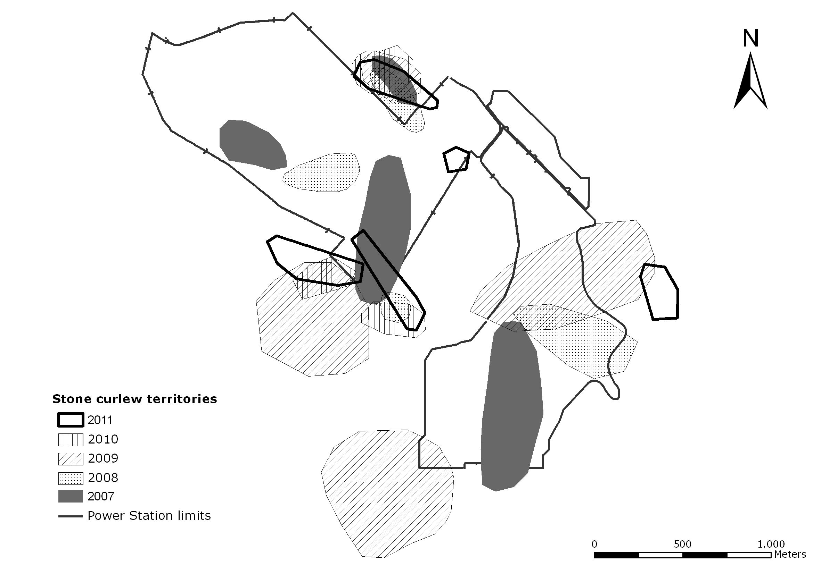
Figure 3 – Distribution of Stone curlew territories during the study period.

Rabbit
The installation of the earth mounds proved to be effective as the inner parts of the Power Station were gradually occupied by rabbits, with more than 50% of the area showing signs of the presence of the species in 2011. At the beginning of the implementation of the measures the rabbits were only present along the Power Station fence and on the piles of wood left at the end of the construction (figure 4).
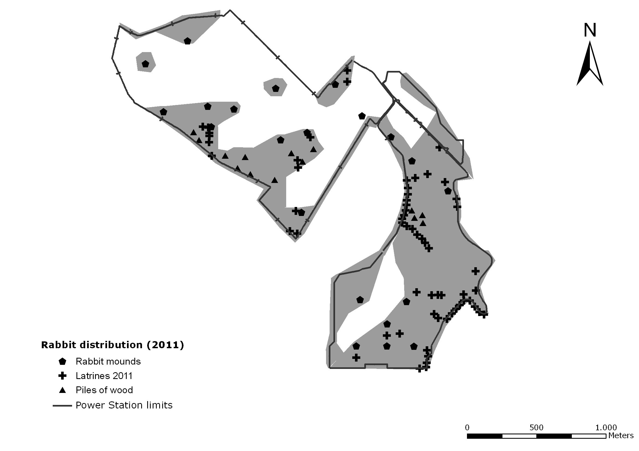
Figure 4 – Distribution of rabbit in 2011.

At the end of the study 20 out of 21 mounds were occupied by rabbits.
The evolution in the number of rabbits was also positive as shown by the latrines census results (table 1).

Table 1 – Mean number of latrines per visit (3 visits/year) in each of the survey transects.
Transect | 2008/09 | 2009/10 | 2010/11
1 | 8,67 | 23,33 | 23,00
2 | 0,00 | 0,00 | 4,00
3 | 9,00 | 12,67 | 15,00
4 | 33,00 | 26,67 | 25,33
5 | 8,67 | 6,00 | 7,67
6 | 0,00 | 0,00 | 0,00
7 | 0,00 | 9,00 | 4,50
Total | 56,33 | 71,67 | 75,33

Conclusion
The main objectives of the Compensation Measures were achieved as a large proportion of the bird species maintained populations within the limits of the Power Station, well over the 25% limit established in the Methodological Protocol. Also the Stone curlew population not only remained in the area but gradually reoccupied the inner parts of the Power Station.
The use of sheep to manage the grass vegetation growth together with the increasing presence of rabbits inside the Power Station will allow for the maintenance of favourable Stone Curlew habitat in the area and possibly to favour an increase in its population.
The effect of habitat diversification resulting from the installation of small areas of trees and bushes will contribute for a more diversified bird fauna within the limits of the Power Station.

References
Bibby, C., Burgess, N., Hill, D.A. & Mustoe, S.H. 1992. Bird Census Techniques (second edition). Birdlife Internacional, Ecoscope, RSPB & British Trust for Ornithology. Academic Press. California USA.
Cabral, M.J., Almeida, J., Catry, P., Encarnação, V., Franco, C., Granadeiro, J.P., Lopes, R., Moreira, F., Oliveira, P., Onofre, N., Pacheco, C., Pinto, M., Pitta, M.J., Ramos, J. & Silva, L. 2005. Livro Vermelho dos Vertebrados de Portugal. Instituto da Conservação da Natureza, Lisboa.
Moreno, S. & Villafuerte, R. 1995. Traditional management of scrubland for the conservation of rabbits Oryctolagus cuniculus and their predators in Doñana National Park, Spain. Biological Conservation 73:81–85.

