Introduction

The Institute for Environmental Monitoring and Research (IEMR) was established in 1995 in response to a recommendation by an independent Environmental Assessment Panel which was appointed to review military flight training activities from the Canadian Forces Base at Goose Bay (CFB-Goose Bay). Its purpose is to oversee the environmental effects of Allied flight training conducted over 130,000 km² within Newfoundland and Labrador (NL) and Northeastern Quebec.

Figure 1: Location of low level training area within NL and Quebec

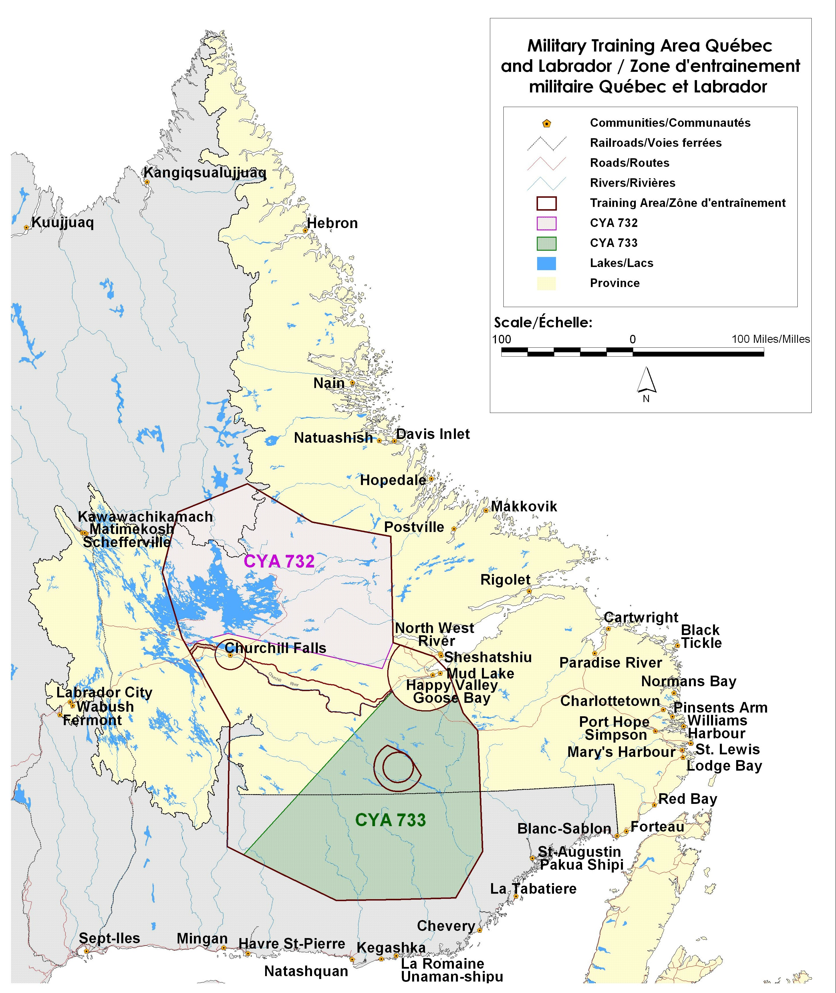

As an independent advisory body to the Ministers of Environment and National Defence, the Institute’s mandate is to:

• Focus on the protection of the environment and, within the concept of sustainable development, support the viability of the military flight-training program;
• Provide independent verification of environmental effects as well as expertise and advice on structuring adequate monitoring and mitigation measures; and
• Foster a level of trust amongst all groups affected by the military training program.

In the event that studies show significant impacts are occurring that cannot be mitigated or justified, the Institute may recommend that appropriate actions be taken to address the situation including making recommendation to the Ministers of Environment and National Defence that military flying activities be limited or phased out.
The Institute is governed by a Board of nine directors representing six Aboriginal groups, as well as representation from four municipal and economic organizations with a direct interest in military training activities operated from 5 Wing Goose Bay, Labrador. The Board is directed by an independent Chair and five non-voting members representing three Federal Departments and two Provincial Governments. The IEMR was mandated by the Federal Government to function within a consensus decision model.

Consensus Decision Model

In response to the Federal Government directive that the IEMR develop a consensus decision model which respect both traditional and Aboriginal customs and practices, a participatory decision approach was developed by the Board members to serve as their decision process.

The IEMR and the Aboriginal members of the Board agreed to incorporate the following nine guiding principles within their decision model:
- Process must be inclusive not exclusive
- Voluntary participation
- Self design
- Flexibility
- Equal access to all information
- Respect for divergent views and interests
- Accountability
- Acceptable time limits
- Outcome must be implementable

They agreed that a consensus decision process could be defined as a state of mutual agreement among members of a group where all legitimate concerns of individual members would be addressed to the satisfaction of the group. In seeking mutual agreement, the consensus process fosters respect for individual differences, enables personal self-reliance and self-esteem, encourages creativity and innovation, and demonstrates responsibility and accountability. The members also agreed on the concept that consensus was not necessarily unanimous agreement by all members on all issues, the model provided options for respecting disagreement without compromising the decision process.

The following four components were developed as integral and essential components of the decision process:

- Pre-consensus process:
  - Overview of the Institute goal and objectives
  - Understanding the meaning of consensus as accepted by the group
  - Set standards for interpersonal behaviour
  - Set a defined timeline for each issue

- Defining the issues:
  - Clearly state the issues
  - Clarify ambiguities
  - State concerns
  - Discuss potential impacts for the communities or the environment
  - Review option for consensus

- Resolving concerns:
  - Clearly re-state all concerns
  - Identify the knowledge gaps
  - Define the risk associated with accepting to approve the project
  - Identify potential option for resolving concerns or knowledge gaps
  - Second review for consensus
  - If consensus cannot be reached
  - Evaluate Institute goals and objectives
  - 3rd call for consensus
  - Evaluate motives which impede consensus
  - Final call for consensus

Capacity building, outreach sessions

Contract for more time
  - Bridge building sessions
  - Send issues to a sub-group
  - Proposal is modified

Sending Concerns or Proposals to a Small Group

Depending on the complexity of the issue, the IEMR could decide to send the issue to a small committee for discussion. The committee may be a sub-group of the Institute Board or an ad-hoc committee of selected experts on the issue. In specific cases, the small committee may be empowered to come to a consensus in the name of the Institute. Whatever form it takes, this sub-group must respect the guiding principles.

Standards for Interpersonal Behaviour within the IEMR Consensus Process

- Agreement that diverse perspectives are valuable, not detrimental, in arriving at the best decision.

- Listening with the perspective of understanding another person’s perspective.

- Members are required to be present for all of the discussions in order to participate in the decision.

- Individual members agree that their purpose is to come to a consensus on the best decision after they have understood the different perspectives of an issue.

Discussion

The consensus decision model developed and adopted by the IEMR Board has fostered a level of trust and respect for the divergent views brought to the table by its members. Many issues were hotly debated; however, within each debate, the members agreed that their views had been listened to with respect and consideration.

During its 15 years of operation, the IEMR has always been able to achieve consensus prior to completion of the 3rd step. Given the diversity of its membership this represents a significant achievement. All of the original groups are still active at the table with some representatives from the Aboriginal Communities having served for the entire 15 years.

The consensus decision model developed by the IEMR does demonstrate individuals with divergent views and interest in the outcome of decisions can achieve consensus and agree to move forward when they feel empowered in deciding on the outcome.

Department of National Defence. 1994. Environmental Impact Assessment on Military Flying Activities in Labrador and Quebec.
Department of National Defence. 1995. Government Direction Governing Establishment of the Institute of Environmental Monitoring and Research (BG-95-023).

