Does territorial level matter? TIA for energy policy impact assessment

Abstract

The issue of levels is one of the pending questions in impact assessment. This contribution addresses its two aspects: territorial distribution of impacts and use of assessment results in policy making across different governance levels. The answers are sought by applying the territorial impact assessment (TIA) approach on two EU directives: Directive 2009/28 on use of renewable resources and Directive 2010/31 on energy efficiency of buildings in the case of Slovenia. TIA differs from other types of assessments in its territorial sensitivity, meaning that it explicitly takes into account differences across territories in their physical and governance characteristics. The impacts were assessed using NUTS3 regions clustered according to their characteristics related to energy policy. Evaluation of impacts reflected upon impacts using territorial cohesion objectives in three different levels (EU, national, local) as reference framework. The hypothesis of territorial differentiation of impacts could not be unambiguously confirmed, on the other hand, different levels of evaluation frameworks revealed considerable differences in results. These confirm that multi-level approach reveals the impacts and their perception on the sub national levels. It is therefore important that vertical differentiation is used in impact assessment if TIA is to be used as a tool to inform policy maker in the process of negotiating the EU directive.

Keywords: territorial cohesion, EU energy policy, multi-level assessment

1. Introduction
Territorial Impact Assessment (TIA) is one of the recently emerging assessment approaches conceived as a strategic assessment of sectoral policies in terms of their impacts on territorial cohesion (Schindegger, Tatzberger, 2005). Territorial cohesion was introduced as a community aim with the Third Cohesion Report (CEC, 2004a, p. 27) and formulated as EU policy in Territorial Agenda of the EU 2020 (TA, 2011) defining it as “…a set of principles for harmonious, balanced, efficient, sustainable territorial development. It enables equal opportunities for citizens and enterprises, wherever they are located, to make the most of their territorial potentials and reinforces the principle of solidarity to promote convergence between the economies of better-off territories and those whose development is lagging behind” (Territorial…, 2011, p.4). While there are several exogenous challenges and potentials for territorial cohesion, such as demographic and climate change, economic crises, etc., also sectoral policies may have (side) effects, which can either hamper or contribute to territorial cohesion. These effects, for the most part, differ from one territory to another depending on the territorial context and the interventions of other policies active in that territory (ARL, 2008; Territorial…, 2011; CEC, 2009). TIA is used to inspect the territorial consequences of the interaction of disparate EU policies in particular places (Dühr et al., 2010). It can therefore be used to provide more awareness (ex-ante and ex-post) of the territorial implications, synergies, or costs of non-co-ordination of EU policies, as well as to improve co-operation in both horizontal terms (between policies) and vertical terms (ARL, 2008; Finka, 2007). To achieve this, TIA observes and describes impacts in territorial units as well as pays explicit attention to the level of objectives used for impact evaluation. A relatively short period of developing and applying TIA has shown that the methodological choices, related to these two aspects are important yet insufficiently resolved issues in the assessment. In the context of EU policy making, these issues reflect in problems of national governments to anticipate impacts of directive proposals and, as a consequence, to establish their national positions. Unexpected impacts may thus only be detected when it's too late for corrective action, i.e. once a directive has already been transposed.

The issue of levels is relevant for methodology in two aspects; the first one follows from the assumption of TIA that the territorial impact of policy will largely be conditioned by the intrinsic territorial characteristics of different regions and localities. The concepts such as Regional Exposure and Sensitivity Matrices have been used to describe these differences, based on the general typologies (ESPON, 2010). Alternatively the parameters can be selected in ad-hoc fashion, taking into account a given directive (for example: share of area under NATURA2000 designation for the Habitat Directive, age of the building stock for the directive on the Energy Efficiency of Buildings). As a part of scoping, the level and method of observing impact must be chosen to actually identify these differences. In (1) a »case study based« approach, a number of most exposed regions is examined in close detail. Since the results cannot be extrapolated to other regions this approach does not provide comprehensive coverage, but the results provide greater detail and nuanced appreciation of the possible impacts of a directive. It may therefore be a time and resource efficient choice especially when there is sufficient confidence that impact will occur only (or predominantly) in certain regions. (2) Alternatively, the whole territory may be divided into territorial units, which are then grouped in clusters of regions sharing similar characteristics. The assessment and evaluation of impacts is done for a cluster of regions with results being generalized for all regions in a cluster. The results from this approach are less exact for an individual region, but they bring a better overall picture regarding the distribution of impacts across the whole territory. (3) Finally, there may be cases when preliminary identification of types of regions/localities where impacts may be particularly significant is difficult or highly uncertain. The option then is to assess and evaluate impacts in each of the territorial units individually. While this may be a burdensome and lengthy task, especially when there are many territorial units, it will yield most exact and relevant results regarding impact in each individual unit as well the distribution of impacts and their relevance for territorial cohesion. The choice of approach will depend on available resources and data, the administrative competences etc.

Another level related choice refers to the reference frame for evaluation of impacts. This issue is less specific for TIA and refers to the governance applicability of assessment results. Most common solution is to apply the reference frame at the same level as the observed policy (i.e. EU objectives for EU policy assessment). In contrast to this, TIA explicit aim at supporting the vertical coordination of policies calls for multi-level evaluation. This means applying EU, national as well as subnational reference frames specifying territorial cohesion objectives.

The EATIA project in the frame of the ESPON (European Observation Network, Territorial Development and Cohesion) program aimed at developing a procedure and tools for the TIA to support regional and local administrations to establish the potential positive and negative impacts a directive may have on their territory, thus enabling them to provide bottom-up feedback on draft directives to national governments when they are in the process of formulating national positions. The following chapters will introduce the methodology and report on the results obtained by its testing on an example of two directives related to energy policy; Directive 2010/31 on energy efficiency of buildings and Directive 2009/28 on use of renewable resources.

2. Method

The approach divides the TIA process into four main stages: screening, scoping, assessment, and evaluation. Most of the work was done in the workshop discussions supported by tools such as logical chains, check lists, matrices, and maps. Scoping (with implications for assessment) and evaluation phases are most important from the viewpoint of multi-level approach and will be therefore explained in more detail.
The scoping included answering the following questions:
- Which elements of the policy are relevant as a cause of the impacts (measures)?
- Which are the territorial criteria that may be used to describe the impacts?
- Which are the territorial units where these impacts are likely to emerge?
The scoping workshop was devoted to one directive each and hosted participants from national level administrations and from academic/scientific institutions. The policy elements were identified using official directive text and a logical chain approach to determine the measures. There were altogether 6 measures identified for the energy efficiency of buildings and 12 for the renewable resources. Territorial criteria were selected by participants from the check-list of 61 criteria compiled by consideration of literature on impact assessment (ESPON, 2010) and territorial cohesion policy documents on the EU and national levels (TA, 2011, SDSS, 2004). The 33(34) selected criteria cover economic, environmental, social, and administrative aspects of territorial development. The last question is the most important regarding the levels. The NUTSIII level was considered appropriate for the assessment: there are 12 such regions in Slovenia, without administrative power, but with certain role in regional development and community coordination as well as relatively good data coverage. The case based approach was not considered appropriate since it was difficult to single out individual regions to be special in terms of impacts for either of the energy policy directives. On the other hand, time and resources did not allow for the comprehensive assessments for each of the 12 regions. We opted for ad-hoc clustering the regions to identify the groups of regions with expected similar impacts. Indicators used for clustering were chosen so as to relate to the (energy) policy as well as to the characteristics of regions and to resonate with policymakers at the local and regional scales of governance. The clusters were as follows: for the directive 2010/31 on energy efficiency of buildings: (1) Regions with lowest number of buildings requiring renewal, and longest heating season (2) Regions with medium number of buildings requiring renewal, and shortest heating season and (3) Regions with highest number of buildings requiring renewal, and medium heating season. For the directive 2009/28 on use of renewable resources: (1) Regions with high potential for geothermal energy and medium for hydro energy and gas, (2) Regions with potential for geothermal energy hydro energy and low potential for biomass, (3) Regions with potential for biomass.

Completing the impact assessment matrix (IAM) in the assessment phase required to consider the impact of each policy element on each cluster of regions in terms of the chosen territorial criteria to. The description of each impact covered its magnitude (expected size or scale of the impact) expressed numerically (0 = negligible impact, 1 = some impact or 2 = major impact); and orientation (+ for an increase of baseline condition, - for a decrease). It was suggested that each score is also qualitatively described.

The evaluation stage of the TIA determined whether the potential impacts identified in the assessment phase are either positive or negative. To do this, the impacts were interpreted in terms of their compliance with three different levels of territorial policy objectives, using an evaluation table. We chose the Territorial Agenda (TA, 2011) and its priorities as a frame of reference for the EU level, the Strategy of Territorial Development of Slovenia (SDSS, 2004) for the national level; and locally the Land Use Plan for the Municipality of Novo mesto. Each objective was related to a set of criteria used in the IAM. The impact descriptions from the IAM were then interpreted in terms of territorial objectives.

3. Results

Energy policy will have impacts on all four aspects of territorial cohesion, most notably the economy where very postive impacts are expected from both directives. Directive on renewable resources will also have very positive impacts on environment, while these will be „only” positive for Directive on energy efficiency. Society will experience positive impacts from bot directives, administration on the other hand will be negatively affected (Table 1).

Table 1: An overview of the impacts of both directives, aggregated according to 4 main aspects of Territorial cohesion
Aspect of territorial cohesion  Policy document | Economy | Environment | Society | Administration
Directive 2010/31 on energy efficiency of buildings | ++ | + | + | -
Directive 2009/28 on use of renewable resources | ++ | ++ | + | -

Contrary to the assumption of the TIA, there is little territorial differentiation of impacts especially on aggregated level; meaning that directives are viewed as a whole and impacts are grouped into social, economic, environmental and administrative. The only differentiation on this level can be found in the case of Directive on the renewable resources and its environmental impacts, where the regions with high potential for geothermal energy and medium for hydro energy and gas will experience stronger positive impacts then the regions of the rest two groups (Picture 1).

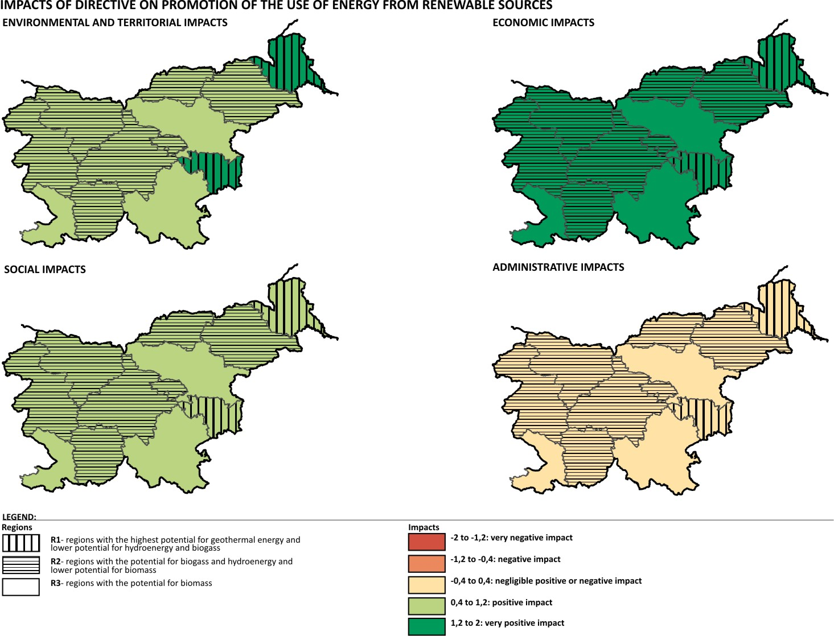

Picture 1: Territorial differentiation of impacts on the aggregated level of assessment: territorial impacts of Directive 2009/28 on use of renewable resources on four aspects of territorial cohesion.

In the case of directive on the energy efficiency, differentiation between the clusters of regions can only be tracked when observed disaggregated impacts (i.e. on the level of single policy measures and their impacts on single criterion). For example, Measure 1 (Calculating the energy performance of buildings) of this directive will have differentiated impact as measured by criteria pollution with solid particles. Impact is expected to be moderately positive except for the regions with smallest stock of buildings needing renovation, where it will be negligible (Picture 2). Other examples of such differentiating criteria are forest area, urbanization, use of fossil fuels, infrastructure quality. An administrative cost is the only criterion where differences between groups of regions include orientation of impacts.

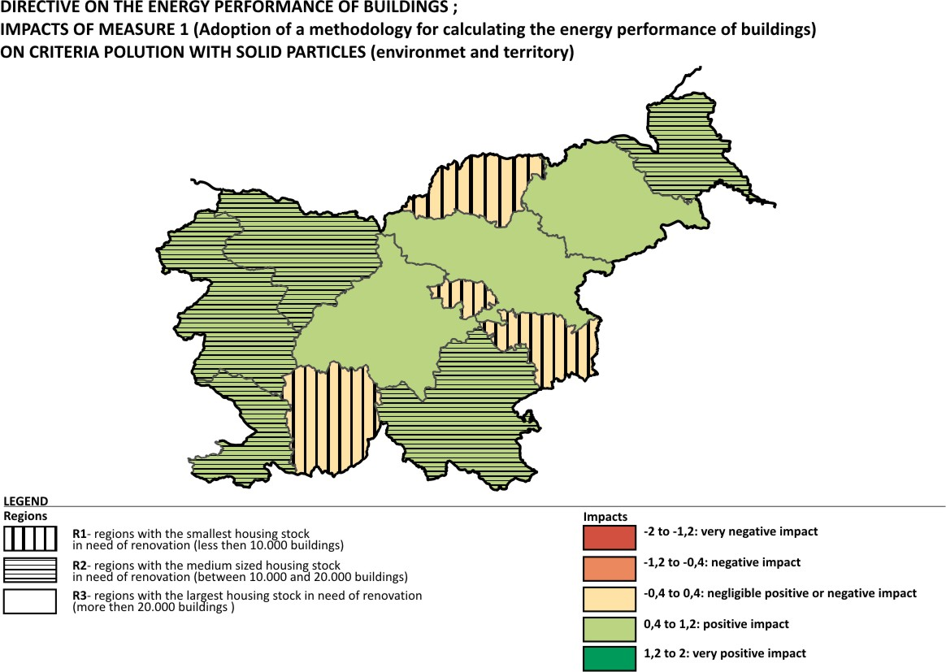

Picture 2: Territorial differentiation of impacts on the disaggregated level of assessment: territorial impacts of Measure 1 of the Directive 2010/31 on energy efficiency of buildings on the criterion pollution with solid particles.

When evaluated against existing territorial cohesion objectives on three different governance levels (EU, national, and local); both directives perform overall positive. However, comparison between three governance levels discloses some differences since both directives are evaluated more favourably on the EU then on the local and national levels. Negative impacts of Directive on energy efficiency of buildings can only be expected with reference to one (out of 6) objectives on the EU level, while there are three negatively affected objectives (out of 11) in case of local objectives and 5 (out of 12) on national level. In the case of Directive 2009/28 on use of renewable resources, EU level objectives are all related to positive impacts, while 4 objectives on national and 4 on local level can be hampered by some negative impacts. Direct comparison between the objectives on different levels is difficult since their contents do not necessarily correspond. For this comparison, objectives were grouped in five thematic groups. The results show that there is general agreement between the three levels of objectives referring to (1) competitiveness and (2) polycentric and balanced territorial development. Objectives related to (3) cross-border integration and connectivity also reveal positive effects on all three levels for renewables but in case of energy efficiency include negative effects on both national and local levels. The objectives of (4) preserving nature, landscape and cultural values will have in both cases positive effects on the EU level but negative ones on both national and local levels. The most mixed results are related to objectives of (5) integrated development, which will be negatively affected when observed from the EU and national, and positively when viewed from the local level (in case of energy efficiency). In the case of renewables EU and local optic reverse while national keeps negative picture.

4. Conclusions

Testing of the proposed TIA framework for EU energy policy as formulated in directives 2010/31 on energy efficiency of buildings and 2009/28 on use of renewable resources and the resulting impact of their implementation in Slovenia have shown an overall positive picture especially when observed from highest (EU) or most generalized levels. However, the results also indicate that a more layered insight would reveal also negative impacts and diverging aspects between EU, national and local level. Rather against the expectation and the assumption of TIA, we could not very convincingly show differentiation among the regions. This may be explained in different ways: firstly, the chosen directives do not differentiate very much among the localities. Having in mind their measures (renovation of buildings, use of potentials for renewable resources etc.) this explanation doesn’t seem very plausible. Secondary, the chosen approach for the impact assessment, using clusters of regions based on ad-hoc typology may not be sensitive enough. According to the reports from the assessors, this may be true, since they did not feel very comfortable assessing as group regions, which they from own experience knew were in reality different. It resulted in a too high level of generalization to convincingly differentiate among the groups of regions. Based on these results we would rather suggest using the “case based” (in case of a need for time efficiency) or a “region-by-region” approach (if full national area coverage is important).

On the other hand, the evaluation through different level optics convincing reveals differences between the levels despite some reservation regarding vagueness in the interpretation of the objectives. Altogether the results of the EATIA project confirms the importance of down scaling the impacts in terms of level of observation as well as in terms of reference fame for evaluation. This will provide better and more complete information and guidance for policy makers on national and EU levels.

References

- ARL, Academy for Spatial Research and Planning (2008.), The Territorial Cohesion Principles. Position Paper to the EU Green Paper on Territorial Cohesion. Position Paper from the ARL. No. 78, Hanover
- CEC, Commission of the European Communities (2009.), Green Paper on Territorial Cohesion – Turning Territorial Diversity into Strength Directorate General – Regional Policy, Directorate-General Energy and Transport, Brussels
- Dühr, S., Colomb, C. & Nadin, V. (2010.), European Spatial Planning and Territorial Cooperation, Routledge, London, New York
- ESPON (2010.), ESPON project ARTS - Assessment of Regional and Territorial Sensitivity: Draft final report, ESPON, Luxembourg
- Finka, M. (2007.), Territorial Cohesion – Between Expectation, Disparities and Contradictions. In D. Scholich (ed.), German Annual of Spatial Research and Policy, Springer Verlag: 23–40, Leipzig
- Schindegger, F., & Tatzberger, G. (2004). Territorial impact assessment (TIA) A certain tool or a whole kind of tools (contribution for first Interim Report of ESPON 3.1). Vienna: ÖIR - Austrian Institute for Regional Studies and Spatial Planning.
- SDSS, Spatial Development Strategy of Slovenia (2004.), Ministry of the Environment, Spatial Planning and Energy, Ljubljana
- TA, Territorial Agenda of the European Union 2020, agreed at the Informal Ministerial Meeting of Ministers responsible for Spatial Planning and Territorial Development, 2011 Godollo, Hungary

