EIA Coordination: A Tool for Decision Making

Abstract

Given the key role of environmental impact assessment (EIA) in decision making, this paper presents the importance of the General Coordination on Environmental Impact Studies as an integrator of various stakeholders (such as government agencies, project sponsors and population) and processes involved (like the design, the public participation and the opinion of the committee). Developments will be analysed both in the scope of legal and regulatory requirements and of the tools to support the forecast of impacts linked to renewable energy projects.

Key words: Environmental impact assessment coordination; renewable energy; decision making.

Introduction

The increasing need of energy in our modern society and the environmental problems that its production and consumption implies make essential to find and implement a system where the renewable sources inputs are more and more important. These are one of the major challenges that our society faces nowadays.

In Portugal the efforts in that sense have been significant in the last few years and the major goal is to reduce the fossil energy production with the increase of the eolic production, hydroelectric, natural gas and combined power cycle plants, among others.

These alternative sources of energy have been included in government programs and concessions. To meet the defined goals a large investment is under way.

Each kind of energy source has different and typical impacts that in general are significant not only for the natural environment but also regarding social, cultural and economic components.

In addition to these specific impacts there are also those that are induced by the energy sources dispersion in the territory and the need of a long network for the electrical energy transportation towards consumers.

The environmental impact assessment in such projects is very important not only to find the best solutions and mitigate the impacts but also because it is the opportunity to guarantee a global approach to each project.

The methodology for the characterization and impact evaluation of each environmental descriptor are well known and in this paper it will be out of the scope.

The Role of EIA Coordination

The coordination of the EIA is a major condition for the success and efficiency of the process due to the increasing complexity of each environmental descriptor, the need to include all stakeholders on the process, the more and more complex planning and legislation requirements, the growing environmental constrains and the importance to share all the information with the authorities and public.

The Figure 1 below shows the global view of the importance of environmental impact management in all phases of EIA focused on a sustainable project development including environmental impact mitigation.
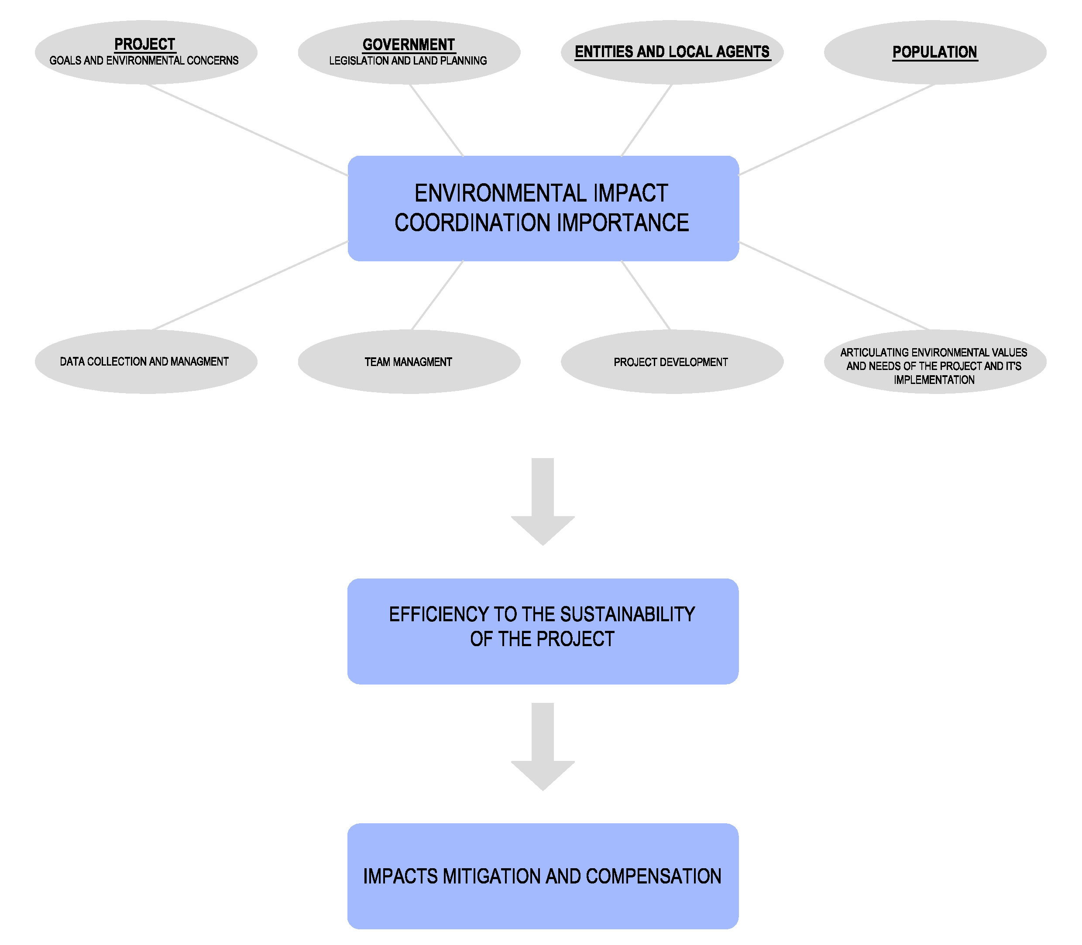
Figure 1 – Environmental Impact Assessment Coordination Importance

Our experience in this approach applied to different types of energy projects confirms the importance of the coordination in these kinds of processes.

The Figure 2 shows the range of environmental impact assessment processes that are the base of our experience. This includes wind farms, power lines, hydroelectric power stations, power plants, gas pipelines, refineries, oil product storage facilities and liquefied natural gas terminals.
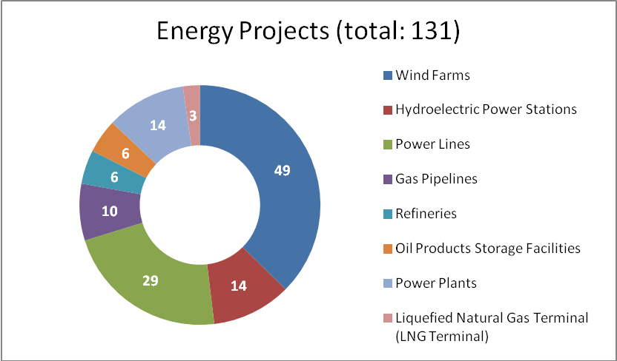

Figure 2 – Energy Environmental Impact Assessment Processes

Conclusions

The presentation will include the principal aspects and steps that are essential for a successful coordination.

It will also include some examples of measures considered in some environmental impact assessment processes where the role of general coordination was essential to mitigate the impacts, namely:

- Compensation of local community impacts due to the dam construction through the construction of a canoeing channel;
- Creation of the dam reservoir use through new recreation centres;
- Reinforcement and protection of high value ecological habitat;
- Establishment of sustainable and feed measures for fauna;
- Integration of cultural and heritage programs;
- Selection of wind turbine location regarding archaeological value protection;
- Selection of power line layout to avoid social and ecological values ;
- Definition of successful models dealing with local population participation in the project.

