Effectiveness of Strategic Environmental Assessment applied to energy sector in Brazil

Abstract
Strategic Environmental Assessment (SEA), an important instrument to support decision-making, is increasing its application worldwide. In Brazil, despite some institutional and legal initiatives for regulating the instrument, SEA is not mandatory to plans and programmes. Nevertheless there are about 30 SEAs prepared in the last 15 years, related with different motivators and focused on different issues and sectors. The energy sector holds the majority of SEAs prepared so far, with 13 strategic assessments focused on hydropower and watershed planning, oil and gas. The present paper aims to analyse how SEA is being carried through the energy sector, considering the context of its application, the strategic level (policy, plan or programme), the objectives that have been set, in order to analyse the procedural effectiveness of SEA applied to energy plans and programmes. This methodological procedure permitted to identify a general framework for SEA applied to energy planning in Brazil, thus contributing to better understand how the instrument is being used in the country.
Key words: Strategic Environmental Assessment; effectiveness; energy sector.

Introduction
The energy sector plays an important role in national economies and its development, being fundamental to production and population well-being (PERERIRA JR. et al., 2008). Nevertheless, there are significant environmental costs associated with energy supply and use that need to be considered. To assess the impacts related to energy infrastructure and activities, Environmental Impact Assessment (EIA) is commonly applied to projects, as happen in Brazil where this kind of study is mandatory, for example to electricity plants above 10MW and oil exploration. However, the necessity to assess the environmental consequences of higher decision making level is been pointed (TOLMASKIM et al., 2001), especially based on doubts about EIA ability to deal with energy supply challenges (JAY, 2010), being the Strategic Environmental Assessment (SEA) indicated as an important instrument to deal with these challenges earlier (JAY, 2010).
In Brazil, despite SEA is not mandatory, there were some institutional and legal initiatives to regulate the instrument and there are about 30 SEAs prepared in the last 15 years. The energy sector holds the majority of then, with 4 SEAs focused on oil and gas, 2 applied to electric energy planning, 6 focused on hydropower and watershed planning and 1 considering the biofuel production. However, Brazilians SEAs are made in different contexts and without a guideline (TEIXEIRA, 2008), contributing to an inadequate use of the instrument (OPPERMANN; MONTAÑO, 2011). Hence, little is known about procedural steps and effectiveness of Brazilian SEA practice, included the SEAs applied to energy sector.
In this context, the paper aims to analyse an overall picture of how SEA is being carried in Brazilian energy sector and to analyse its procedural effectiveness, verifying the adequacy of the methodology proposed. These purposes are addressed by analysing 9 reports of energy planning SEAs, considering its application context, strategic level, and motivator agent and applying 16 criteria of procedural effectiveness, which permit to construct a general framework of SEA practice in Brazilian energy sector.

Methodology
To assess how SEA is been carried out in energy sector in Brazil, first we analysed the SEA reports identifying the context, the strategic level and the motivating agent of its application. It is important to mention that 9 SEA reports were assessed and the other 4 were not because its reports are not public available and were not possible to obtain than.

Table 1 – Procedural effectiveness criteria.
Procedural effectiveness criteria | Reference
1) Presents the need for SEA application. | (d)
2) Describes the content and objectives of SEA object (PPP). | (a, c)
3) Refers to relevant Policies, Plans and Programmes and analyze how they are linked with SEA object. | (a, c, e)
4) Describes the current state of environment (baseline). | (a, c, d)
5) Identifies key environmental and sustainability issues relevant to SEA (that may be the focus of the assessment). | (c, d)
6) Describes SEA objectives. | (a, b, c, d, e)
7) Defines indicators related to SEA objectives (to be used in assessment process). | (c, e)
8) Presents probably environmental evolution without SEA object. | (a, c, e)
9) Identifies strategic alternatives to SEA object. | (a, b, d, e)
10) Identifies and evaluates possible environmental consequences of strategic alternatives. | (a, b, d, e)
11) Presents mitigation measures (for example in terms of preferred alternatives, modifications on the PPP objectives, measures for avoiding possible impacts). | (a, b, e)
12) Proposes a follow-up/monitoring stage. | (a, b, d, e)
13) Describes how proposals and considerations of SEA and public participation were taken account in the decision making and PPP final version. | (a)
14) Consultation to interested authorities on SEA object happens. | (a, b, d, e)
15) Public participation happens. | (a, b, d, e)
16) SEA report is public available. | (a, f)
a) EU Directive 2001/42/CE; b) Fischer (2007); c) Polido; Ramos (2011); d) Retief (2006); e) Thérivel (2004); Thérivel; Minas (2002).

Second, to analyse the procedural effectiveness, we evaluated the same SEA reports with 16 procedural effectiveness criteria (Table 1), selected from the international literature. With these criteria we want to identify which steps of an SEA processes happened, partially happened or did not happen. Aiming to comprehend how SEA is done as a whole, the criteria used seek to address the most common steps of SEA process, instead knowing that SEA process can vary for different countries and contexts (FISCHER, 2007). Moreover, it is important to highlight that this evaluation was based only on the information presented on the SEA reports, whereas the documentation is one of the factors that contribute to SEA effectiveness (THÉRIVEL; MINAS, 2002) and is the usual way to record the process.

SEA applied to energy planning in Brazil
First of all, it’s important to highlight that because of the novelty and the Brazilian inexperience with SEA, some assessments were called SEA despite of not having sure about what kind of assessment it really were. Examples are the SEAs about watershed planning, which were called SEA but nowadays similar studies are called Integrated Environmental Assessment. However, for this study all the practices that are called SEA were considered.
Figure 1 presents an overall picture of SEA practice in the energy sector, showing the SEA application context (the sector SEA was applied), strategic level (policy, plan, programme or structuring project) and motivating agent (private initiative, government or international financing institution). The application context analyses show a predominance of hydroelectric and oil and gas sector (respectively 4 SEAs applied to one sector and 3 to the other), indicating the importance of both energy source in the country, and the importance of renewable energy, that includes 4 SEAs applied to hydropower energy and 1 that considers biofuel production.

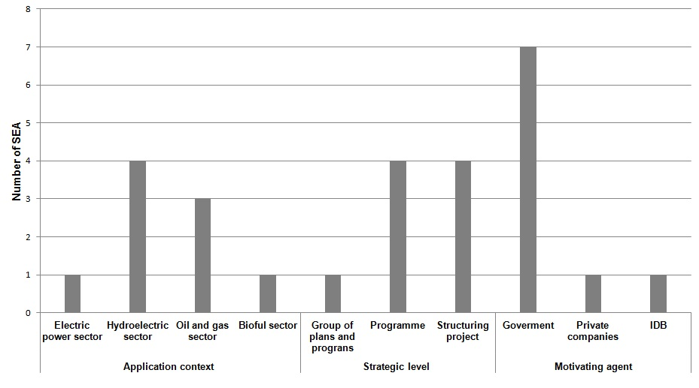

Figure 1 – SEA analyses considering its application context, strategic level and motivating agent.

About strategic level a characteristic that stands out in Brazilian planning is the level called structuring project. It is defined as interventions that cause sequential changes in a given situation (economic, environmental, social), leading to a higher stage of development (MMA, 2002), and in the group of “structuring project-SEA” are included SEAs which the object were a group of projects with large influence in the regional development, e.g. a group of hydropower plants in a watershed or a group of petroleum and naval activities in a coastal region. As portrayed in Figure 1, this type of SEA and Programme-SEA are the most common in Brazil.
Despite of SEA is not regulated and not normative in Brazil, for most of the applications analysed the motivating agent was the government. In this specific SEA group, the international financing institutions had small influence.

Procedural effectiveness of SEA applied to energy sector
The summary of criteria analysis is provided in Figure 2, allowing an overview of procedural effectiveness for energy planning SEA, and the identification of strengths and weakness related to SEA procedures.
The criteria that were met more frequently were criteria 1, 4 and 11. Criteria 1 is about presenting the need for SEA application (part of the screening), criteria 4 is about description of environmental current state (part of the scoping) and criteria 11 is about presenting mitigation measures (part of the assessment results).
In the other hand, criteria about presenting the environmental evolution without the SEA object and presenting strategic alternatives (criteria 8 and 9), are the criteria worst met. Similar results for considering alternatives in SEA offshore was presented by Fidler and Noble (2012), indicating that one of SEA’s deficiency is the absence of broader alternatives. However, according to Fischer (2007) SEA benefits is closely related to considering alternatives at the right time, thus deficiencies in this assessment step can affect the whole assessment effectiveness.

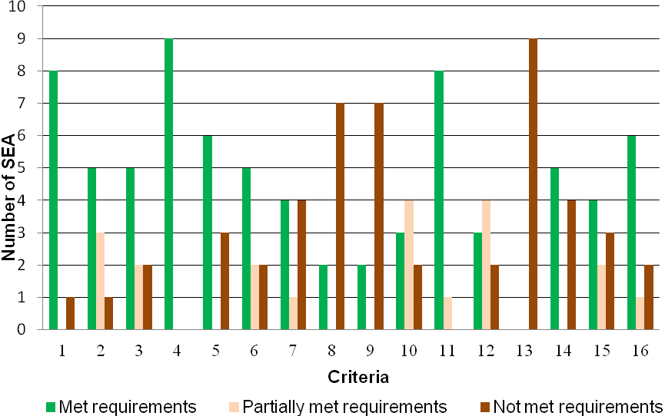

Figure 2 – SEA analyses for each procedural effectiveness criteria.

Another observation that should be pointed out is about identifying and evaluating environmental consequences of strategic alternatives (criteria 10), which was satisfactorily met only by three of analysed SEA reports, and partially met by four of them. In most of the cases in which this criteria was partially met it happens because strategic alternatives were not indicated, so environmental consequences were identified and evaluated only for the unique alternative presented.
Four of SEA reports analysed did not present or partially presented SEA objectives (criteria 6), and five did not present indicators related to SEA objectives (criteria 7), indicating other weakness of these practices. Thérivel (2004) says that presenting SEA objectives aims to indicate a desired direction, e.g. “reduce greenhouse gas emissions” or “maintain biodiversity”, being essential for this kind of assessment and directly affecting other SEA steps (baseline, alternatives evaluation, monitoring). Moreover, define and clearly present the assessment objectives is crucial to achieve some performance criteria (IAIA, 2002), like being focused on key issues and being participative.
As mentioned before, these results permitted to construct a general framework of SEA practice in Brazilian energy sector. The methodology used does not permit to assess information like the quality of each SEA step or to comprehend why one SEA was better than other, although it permits to identify how the instrument is commonly used, the most important strengths and weakness related to procedure, and the steps that need more attention in next studies. Thus, these evidences are important not only to better understand SEA practice in energy context, but to improve the instrument in Brazil.

Conclusions
The results presented shows that the methodology used is adequate to make an overall picture of SEA applied to Brazilian energy planning, making possible to identify the assessment context and the procedures that are well done in the practices analysed and the ones that need more attention.
In general, this work presents an overall picture of SEA application in energy sector in Brazil, highlighting some strengths and weakness of these practices. Thus, a more detailed work is necessary to continue the discussion about procedural effectiveness and its implications. Moreover, other important points related to substantive effectiveness need to be observed in next works, like the SEA timing and if the instrument objectives were meet, to better discuss the instrument effectiveness in this sector.

Acknowledgment
Financial support from Foundation for Supporting Research in Sao Paulo State (FAPESP) is gratefully acknowledged.

References
FISCHER, T. B. Theory and practice of strategic environmental assessment: towards a more systematic approach. UK; USA: Earthscan, 2007.
FIDLER, C.; NOBLE, B. Advancing strategic environmental assessment in the offshore oil and gas sector: Lessons from Norway, Canada, and United Kingdom. Environmental Impact Assessment. v. 34, p. 12 - 21, 2012.
GLASSON J.; SALVADOR, N. N. B. EIA in Brazil: a procedures-practice gap. A comparative study with reference to the European Union, and especially the UK. Environmental Impact Assessment Review. v. 20, p. 191 – 225, 2000.
GELLER, H., SCHAEFFER, R., SZKLO, A.; TOLMASKIN, M. Policies for advancing energy efficiency and reneawable energy use in Brazil. Energy Policy. v. 32, p. 1437 - 1450, 2004.
JAY, S. Strategic environmental assessment for energy production. Energy Policy. v. 38, p. 3489 - 3497, 2010.
MINISTÉRIO DO MEIO AMBIENTE - MMA. Avaliação Ambiental Estratégica. Brasília: MMA/SQA. 2002. 92 p.
OPPERMANN, P.; MONTAÑO, M. Strengths and weaknesses of SEA in Brazil. In: 31nd Annual Conference of the International Association for Impact Assessment: Impact Assessment and Responsible Development for Infrastructure, Business and Industry, 2011, Puebla. Available in: <www.iaia.org/conferences/iaia11/uploadedpapers/review-papers-draft.aspx>. Accessed on Out. 09, 2011.
PARTIDÁRIO, M. R. Strategic Environmental Assessment: key issues emerging from recent practice. Environmental Impact Assessment Review, v. 16, n. 1, p. 31-35, 1996.
PEREIRA JR. A. O.; SOARES, J. B.; OLIVEIRA, R. G de; QUEIROZ, R. P. de. Energy in Brazil: Toward sustainable development? Energy Policy. v. 36, p. 73 – 83, 2008.
POLIDO, A; RAMOS, T. B. Evaluation of Strategic Environmental Assessment Scoping Effectiveness. In: 31nd Annual Conference of the International Association for Impact Assessment: Impact Assessment and Responsible Development for Infrastructure, Business and Industry, 2011, Puebla. Available in: <http://www.iaia.org/conferences/iaia11/uploadedpapers/review-papers-drafts.aspx>. Accessed on: February, 27, 2012.
RETIEF, F. The quality and effectiveness of Strategic Environmental Assessment (SEA) as a decision-aiding tool for national park expansion – the grater Addo Elephant National Park case study. Koedoe. v. 49, p. 103 – 122, 2006.
TEIXEIRA, I. M. V. O uso da Avaliação Ambiental Estratégica no planejamento da oferta de blocos para exploração e produção de petróleo e gás natural no Brasil: uma proposta. Thesis (Doctorate) – Federal University of Rio de Janeiro, COPPE, Rio de Janeiro, 2008. 308 p.
THÉRIVEL, R. Strategic Environmental Assessment in Action. London: Earthscan, 2004.
THÉRIVEL, R.; MINAS, P. Measuring SEA effectiveness: Ensuring effective sustainability appraisal. Impact Assessment and Project Appraisal. v. 20, p. 81 – 91, 2002.
TOLMASKIM, M. T.; MOTTA, R. S. da; LA ROVERE, E. L; BARATA, M. M. L.; MONTEIRO, A. G. Environmental valuation for long-term strategic planning – the case of the Brazilian power sector. Ecological Economics. v. 37, p. 39 – 51, 2001

