ENVIRONMENTAL RISK AND GEOHAZARDS IN EIA’S
The Risk-Based Approach to Human Enterprises
Most people use a risk-based approach to life, weighing up risks against rewards. Whether it is ancient communities that hunted to live whose reward was a food supply and whose risks were injury or death, or a modern Formula-1 racing car driver, all weigh up the risks considering the probability and consequences of success, versus the probability and consequences of failure. It follows that in any serious enterprise, there should be a risk assessment. The greater the risks and rewards, the more rigorous should be the risk assessment.
Large capital projects should be subject to a risk assessment. An overall risk assessment for a project addresses the underlying physical risks, meaning the risks to human health and safety, to the physical components of the environment and to physical property, upon which non-physical risks are predicated. The non-physical risks are those that affect social, economic, legal and political entities and which culminate in financial risk to the enterprise.
Risk Assessment in an EIA
Environmental Impact Assessments (EIA) should be a forum for the socio-environmental part of the risk assessment of an enterprise. In general, EIA’s follow a procedure of forecasting the effect of overlaying a project on a pre-existing environment. This starts with an understanding of the baseline environment and a description of the project to be evaluated. The recognition of the environmental aspects of the project leads to the identification and assessment of potential effects on the environment. When the expected effects of the project are considered to have a high level of probability they are analyzed as impacts, whereas when there is a low level of probability they are addressed as risks. As an example of an environmental impact, the regulation of river flow downstream of an operating hydroelectric dam is a certainty with 100% probability. As an example of an environmental risk, the overflowing of river diversion structures by flood flows during construction has a high level of uncertainty, perhaps in the 5-10% range. The uncertainty associated with risks may be a function of the natural variations in the environment, or alternatively a function of the level of care in the design, construction and operation of the project, or a combination of the two. Returning to this risk example, the overflowing of the diversion structures may be as a result of an unusual flood event, or it may be a result of an inadequate design, deficient construction or faulty operation of the diversion system.
In the risk analysis, as opposed to the impact analysis it is useful to distinguish the origins of the uncertainty, and to recognize the environmental aspect as a hazard. The conceptual procedure for an environmental risk assessment is similar to that of an impact assessment, substituting environmental “hazards” for environmental “aspects”, where environmental hazard is understood as the potential of an activity in the project to produce harm to the environment or human health. The following figure compares the process for impact assessment with that of risk assessment.

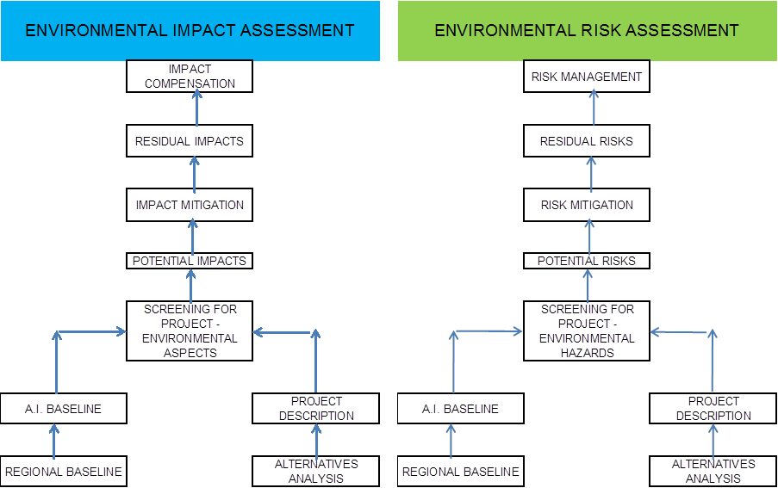
Figure 1: Processes for impact and risk assessments
Incorporating Natural Hazards into an EIA
Given that environmental risks may be generated by natural events as well as human fallibility, a thorough environmental risk analysis will include the effects of natural hazards. The incorporation of natural hazards into an EIA requires examination of the different components of the atmosphere, hydrosphere, geosphere and biosphere. There is a natural tendency of each of these systems which are normally in equilibrium to pass through sudden adjustments or extreme events, such as earthquakes and storms, leading to natural risks. A suggested classification of the various types of natural hazards that produce risks to human enterprises is as follows: seismic hazards and the related tsunami hazards, surface geological hazards and the related hydrological-hazards, and storm hazards and avalanche hazards. This is illustrated in the following figure of the environmental components that make up the natural world.
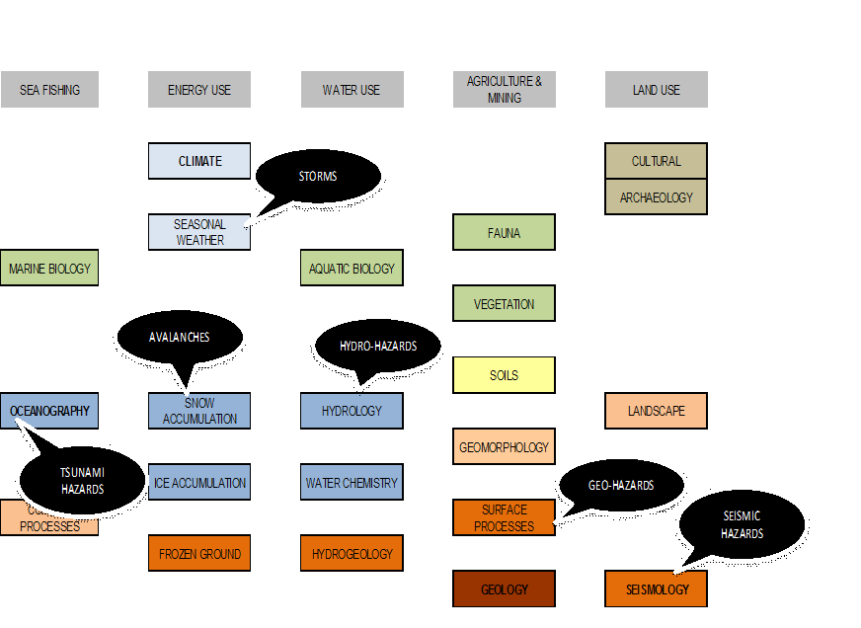
Figure 2: Environmental components and natural hazards
In an EIA, a baseline of the natural risks to the environment should be established. Then, an analysis should be carried out of ways in which the project activities might modify those risks to the receiving environment, either by changing the probability of occurrence of natural hazards, or by changing the consequences of those hazards. An example of the former is the destabilization of natural slopes by civil excavations, leading to increased risk to riverine habitat downslope. An example of the latter is the effect of the construction of a reservoir dam that could fail under seismic stress, leading to catastrophic flooding downstream of the dam.
In conclusion, not only the potential environmental impacts of the project are assessed, but also the effects of natural hazards in enhancing the risks of environmental impacts. This can be illustrated with the use of an environmental aspects matrix, which is a tool for identifying potential impacts and risks.
Figure 3: Identification of environmental impacts and risks enhanced by natural hazards
Examples from EIA’s for hydroelectric projects in the Andes
Hydroelectric projects in the Andes are particularly prone to natural hazards, which must be considered in addition to their inherent environmental and social effects. These hydroelectric projects because of their location are subject to the following natural hazards amongst others: seismic stress, soil liquefaction, tsunamis, volcanic ash fallout, pyroclastic flows, diverse landslide hazards, and river floods.
Several of these natural hazards such as landslide, liquefaction and river flooding may be modified by the hydroelectric facilities, for instance as construction diversions modify river flooding patterns, and reservoir filling affects pore pressures in adjacent hill slopes or saturates soils which may become susceptible to seismically induced liquefaction. Furthermore, the risks to human life of natural hazards like seismic stress and pyroclastic flows may be modified by the insertion of water retention structures in the risk pathways. Therefore, these natural hazards should be factored into the socio-environmental risk analysis since they may modify the risks of a plethora of undesirable events. Socio-environmental risks that may be enhanced by natural hazards include: risks to downstream population, to the workforce on site, to lake-margin habitat and to water quality and aquatic life.
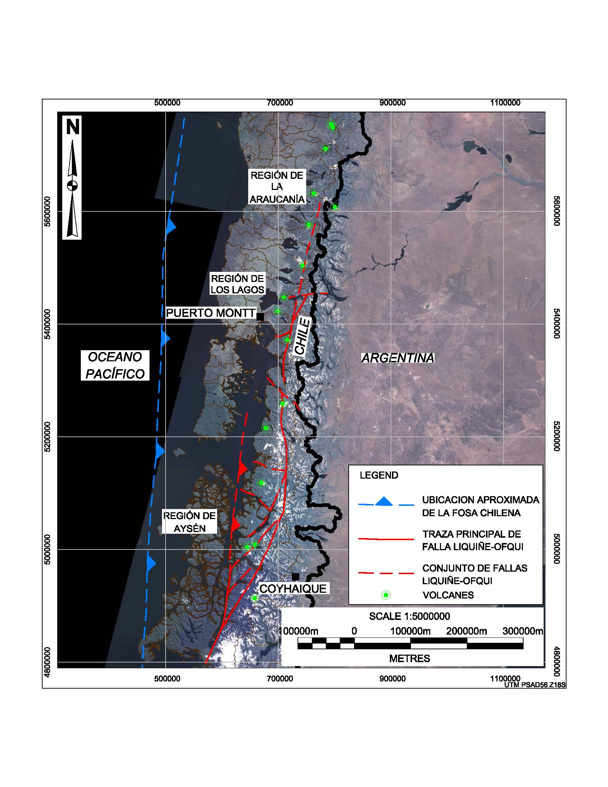
Figure 4: Location of active faults and volcanoes
Risk Management
Finally, environmental risk has to be managed, within an overall project risks management program presented in the EIA. This requires additions to an environmental management plan. In a conventional EMP, the potential impacts that have been identified and assessed are mitigated, and after mitigation any residual risks are compensated. An environmental risks program involves additionally the use of a “risk register”, which includes the identification, assessment and mitigation of the risks. Since it is not useful to compensate residual risks the corresponding activity is residual risk management.
Conclusion
A risk based approach to environmental assessment enables all the environmental risks for a project to be identified, including those increased by the effects of natural hazards. Once identified, the environmental risks may be assessed and managed with the aid of a risk management register.

