IAIA’12 Energy Future: The Role of Impact Assessment

Expected and actual impacts of infrastructure

Abstract
Many human interventions in the environment in the past form valuable and protected habitats today. There are many areas, changed by the human, populated with endangered species. Those examples show that nature adjusts to human activities in a relatively short time period. For planned electrical infrastructure many EIA do not predict any positive impacts on nature. This raises some doubts about their appropriateness; we believe that if we are to start the same project as it is already implemented and it also had positive impacts on the nature, its impacts would be evaluated negatively today. We suggest that before evaluating planned projects, evaluation of implemented ones should be performed. We also believe that evaluation of impacts and also mitigation measures for the same species differ from country to country; we think that the criteria should be standardised. Some endangered species in particular countries are common in other countries. Some reasons for the species’ rarity are also inappropriate living conditions. We think that a red list of endangered species is to be prepared on the basis of data for the whole continent or, even better, for the whole planet.

Key words: biodiversity, infrastructure, impact assessment

- Introduction
Human’s impact on nature in the past was small and limited to immediate environment, while nowadays impact is constantly growing. Since the beginning of industrial revolution, signs of impact on the environment were appearing. In Slovenia operation of different types of infrastructure has started to show changes of the environment more than half a century ago, often also negative impacts on it and especially on nature. This caused need to study impact of infrastructure and other human activities before implementation so SEA and EIA were performed. Experts in this assessments estimate expected impacts and propose mitigation measures. Most of the impacts aren’t measurable so they depend on experts’ knowledge but are seldom verified in the time of stable operation of the infrastructure. SEA and EIA are inherently biased to looking at negative impacts and are always finished before the construction of infrastructure starts. So the loop of learning from verifying expectations from SEA and EIA comparing to impacts of infrastructure is not closed. SEA and EIA documents are written in national language of the country where infrastructure is located and rarely published and so not easy accessible for analysis of current practice. Usually documents are not translated so comparison between them for same species is difficult unless you have an international team. Infrastructure with cross-border impacts is an exception. At least certain types of projects bring also positive effects within a certain time period. The problem might be that it affects positively different species than the ones on which it has negative effect. Sometimes there is also some doubt if infrastructure exclusively causes negative changes in the area where it is built.

- Evolution of both conservation policies and impact assessment methods
Nature conservation has a 200-year long tradition and it has evolved from strict protection to more flexible forms. Environmental management has evolved alongside; EU has designed a set of policies that ensure good quality of environment and natural resources in the member states, such as Water Framework Directive, Birds Directive and Habitat Directive. In this article, we shall focus on Birds Directive and Habitat Directive and Natura 2000 network.
Birds Directive and Habitat Directive are not prohibitive, but contain a set of measures that ensure good status of species and habitats, important on the EU level. As a result, a series of steps and procedures is devised in each country in order to ensure full consideration of potential impacts of development as well as management practices of these areas. Monitoring of priority species and habitats provides information on how successful these procedures are.
Development of new conservation practices and policy measures, bring ever tighter considerations when a project is planned. In each planning process, there are numerous planning limitations, protection regimes etc. that have to be considered in the design of a plan or project and in the SEA and EIA process. In the new Member States the relatively rapid introduction (compared to old member states) of entire EU legislation caused considerable confusion: with such fast process, it is all the more obvious that nowadays some of the past (i.e. already implemented) projects, especially large infrastructure would not be feasible anymore without elaborate impact assessments and mitigation measures designed in the planning process. This puzzles the investors, including state institutions and public utilities in charge of large infrastructure (transmission lines, roads, flood protection measures etc.). Since there is lack of monitoring of actual, especially long term impacts of existing infrastructure, there is little information on both negative and positive impacts of them that would help to better plan the new infrastructure.

- Examples of Infrastructure and areas changed by human in Natura 2000 and other protected areas
Slovenia has established first nature protected areas several decades ago. In the EU approximation process, Slovenia has established Natura 2000 areas on more than one third of its area by 2004. Many protected areas include infrastructure and places changed by human activities.
One of the most important Natura 2000 areas for birds is Drava River, where eight hydro power plants are operating. The most populated is the Ptuj Lake, which is the biggest artificial lake in Slovenia, and is a part of channel-type power plant Zlatoličje, which is in operation from 1978. In less than 35 years birds have got accustomed to artificial lake and use it as a stop on their migration path or live there constantly (Figure 1). We don’t have data available of habitats and their value before hydro power plants were built, but we can confirm the importance of artificial lakes for birds in present time (Elektro-Slovenija, d. o. o., 2012 and Environmental Atlas of Slovenia, 2012).

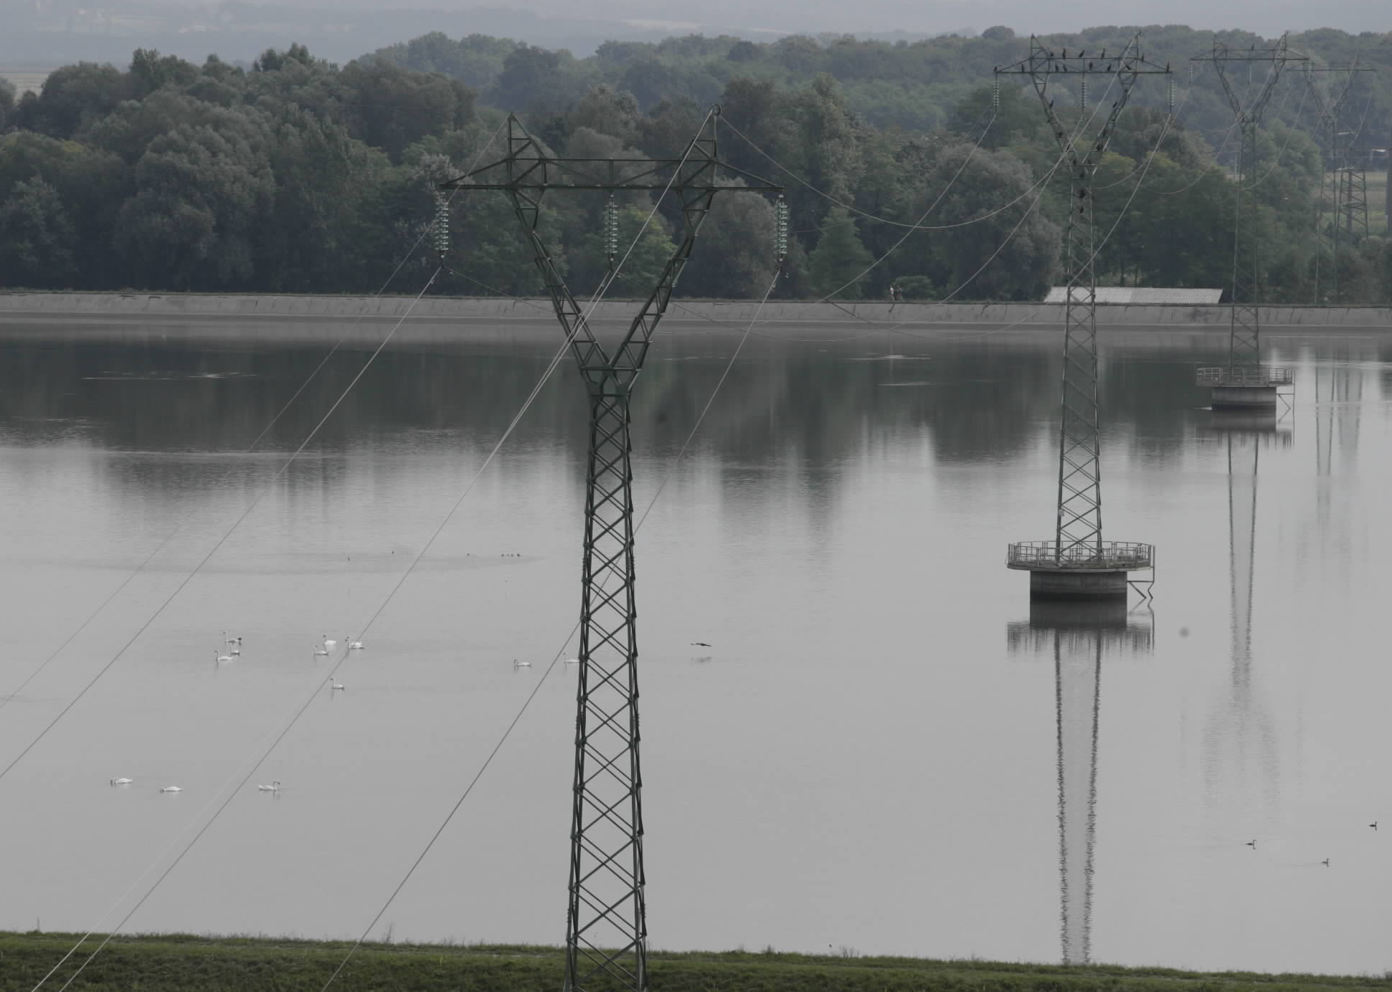
Figure 1: 110 kV Overhead line crossing Ptuj Lake with swans on the surface and other birds sitting on the second tower (Elektro-Slovenija, d. o. o., 2012)

In the last two decades there are several hydro power plants under construction on Lower Sava River, which is also an important area for some protected species. For several hydro power plants SEA and EIA were prepared which expect severe negative impacts on nature and therefore extensive mitigation measures are proposed (EIA for Hydro power plant Krško and bypass Krško, 2006 and SEA for Hydro power plant Brežice, 2011). None of the studies expects any positive contribution of new infrastructure on nature.
In Slovenia there are many abandoned open-cast clay excavation pits like Bilje or Gaj near Pragersko and sandpits like Dobrovnik, Tropovci or Pleterje, which were in use some decades ago but now they are included in protected areas because some rare or endangered species live there (Environmental Atlas of Slovenia, 2012). Those valuable habitats developed in relatively short time period, what shows fast adjustment of nature to human activities.
400 kV overhead transmission line Cirkovce-Pince has been in preparation stage for more than ten years. Line should cross several protected areas like Drava River and Mura River, which are both parts of SPA Natura 2000 sites (Environmental Atlas of Slovenia, 2012). EIA was prepared and the project design was completed (EIA for High-voltage overhead-line 2 x 400 kV Cirkovce-Pince, 2012). Area is also important habitat of white stork (Ciconia Ciconia). As mitigation measures on the whole length of the line bird flight diverters and extensive compensatory habitat was proposed.
Portugal has also areas with important habitats for white storks. According to available data towers of some transmission lines in Portugal are used as nesting places for white storks (dos Santos, 2004). As a mitigation measure nesting platforms are installed (dos Santos, 2004). Difference in estimating of impacts of transmission lines on same species and different mitigation measures are obvious; these can only partly be attributed to the differences in populations.

- Discussion
Are trade-offs possible? Projects usually affect different species in different phases, and if there are positive impacts they often affect different species than the ones that are impacted in a negative way. Can we be sure, that the negatively affected species are more valuable than positively affected ones? Is it possible, that the area is not suitable anymore for negatively affected species because of other reasons (eg. cumulative pollution, climate change)? We know that some species became extinct in the past before human started to change environment in wider extent, but we don’t know which ones are disappearing today without human intervention.
Would the expert opinion on necessary mitigation measures be the same when preparing SEA or EIA, if the expert had access to studies, assessments or reports on the same species or habitat in another country? There is lack of consistent case studies or best practice examples despite numerous SEA and EIA are continuously being prepared. These are often not easily available (except during public consultation), are in different languages or are very narrow in scope. Besides, the investors are focused on the outcome – the completed project and not on the knowledge value of the process.
There are local and regional differences as there are different ecosystems and climate, but there are also differences in practice between countries. In EU countries the SEA and EIA Directives give a common framework, but the methods of assessments, the level of detail and length of procedures are very different. In the countries with very small share of Natura 2000 sites, the assessment of impacts on priority species and habitats tend to be very detailed and prescribe elaborate mitigation measures and vast compensatory habitats. Taking this approach to the countries with large share of Natura 2000 sites creates complex conflicts as there is lack of resources (especially for mitigation measures) or suitable locations for compensatory habitats.
Several projects could be combined so that positive impacts of one project could be used for compensation of another project. There is lack of information on this – information is shared mostly among/within the NGOs and in within sectors, but not between sectors and rarely with scientific community.
Mitigation measures proposed for some planned infrastructure projects are very costly. Funds for their implementation are on the other hand generated again by an economic activity, often causing negative impacts on nature. The question is what is less harmful for nature, smaller mitigation measures or larger, expensive ones and the economic activity needed for their funding.

- Conclusions
Operation of infrastructure in the last half century shows some positive impacts on nature, which are seldom predicted by the SEA and EIA. Human interventions have negative and positive effects on the environment and also on nature, but the latter are often neglected. Positive effects should be taken into consideration to larger extent – not to justify a project/a plan and advocate its implementation, but to better consider all its impacts. Positive experience of operating infrastructure should be incorporated in SEA and EIA for similar projects/plans.
Criteria for determining impacts of similar infrastructure on same species should be standardised and comparable between SEA and EIA from different countries. Quantification of impacts should be developed and used on international level and lists of endangered species should be harmonised accordingly. Better exchange of information, case studies and best practice would help at design, impact assessment and decision making.

References
dos Santos, José Amarante (2004): Storks and Transmission - Finding a Middle Ground. Transmission and Distribution, 1st June 2004. Available from http://tdworld.com/mag/power_storks_transmission_finding/. Acessed on 2nd April 2012.
Elektro-Slovenija, d. o. o. (2012). Database, accessed on 6th April 2012.
Environmental Atlas of Slovenia (2012). Slovenian Environment Agency, Ljubljana, available from http://gis.arso.gov.si/atlasokolja/profile.aspx?id=Atlas_Okolja_AXL@ARSO&culture=en-US. Accessed on 2nd April 2012.
SEA for Hydro power plant Brežice (2011). Geateh, Ljubljana and Aquarius, Ljubljana (draft), September 2011. (only in Slovene)
EIA for Hydro power plant Krško and bypass Krško (2006). Imos Geateh, Ljubljana, June 2006. (only in Slovene)
EIA for High-voltage overhead-line 2 x 400 kV Cirkovce-Pince (2012). Oikos, Kamnik, project number 345/02, draft. March 2012. (only in Slovene)

