Finding a new world – Endoscopy of cryptic habitats
Abstract
Although features such as old woodpecker holes, cracks and crevices are usually recognized as potentially important habitats for cryptofauna communities, these small cavities have been almost entirely neglected, being the available cryptofauna studies mostly concentrated on easily accessible environments such as large caves and tunnels. Environmental impact studies often neglected cryptic species justifying technical difficulties associated with their location or arguing that they tend to exhibit low fidelity to individual crevices being the absence of data in many cases responsible for animal roosts destruction during the construction works of several projects. The bat species roosting in small cryptic habitats are an example of a group that has been neglected in Portugal, in spite of some of them currently faces high risk of extinction. A large number of groups of vertebrates and invertebrates were registered which led us to conduct studies in a broader framework to demonstrate that endoscopy is a powerful, cost-efficient, non-destructive tool for in situ observation and documentation of structure and dynamics of several cryptic communities. The results of the present study suggests that this technique, relatively simple to apply on the field, it’s important to be included on future Environmental Impact Assessment studies and will complement current methodologies to measure the effectiveness of the implementation of mitigation measures and compensatory plans.

Key Words: Endoscopy, Crevices, Cryptic habitats, Cryptofauna communities, Impact Assessment

Introduction
Small holes, cracks in trees, gaps between stones are some examples of small cryptic habitats that can support large wildlife diversity. It is well known that the structure of these small cryptic habitats influences the abundance, diversity and the biotic interactions between species of vertebrates and invertebrates.
According to the dependence of the animal to its habitat, there may be animals in the following categories: Trogloxenes (animals commonly found in the hypogean, but should leave it at some period of his life), Troglofiles (animals able to complete the life cycle both in epigean and hypogean environment, moving freely between the two environments) and Troglobes (species restricted to the subterranean surroundings due to the expertise acquired through evolution).
In the large group of invertebrates, there may be orders such as Araneae, Pulmonata, Collembola, Hemiptera, Orthoptera, Trichoptera, Diptera, Lepidoptera, Hymenoptera and Isopoda. In the group of vertebrates it’s possible to find species of the orders Anura, Urodela, Gymnophiona, Squamata, Passeriforme, Quiroptera and Rodentia.
Until now, in Portugal there is no methodology to be applied in the monitoring of these animals in these types of habitats. Environmental impact studies often neglected cryptic species justifying technical difficulties associated with their location or arguing that they tend to exhibit low fidelity to individual crevices being the absence of data in many cases responsible for animal roosts destruction during the construction works of several projects. However at international level excellent works are been done in the UK targeting bats that live in small cavities, reducing the impacts of several works in these animals.
The aim of this study was to explore the use of endoscopes to observe and record the presence of cryptofauna communities in small holes and crevices in way to complement the methodologies actually applied to study the communities of fauna during Impact Assessment studies.

Methodological approach
Many cryptofauna communities have adapted to live in buildings, bridges and trees. Features such as cracks and crevices in the walls, roof voids, ridge tile/stones, wood cladding, rot holes, cracks, flaking bark and old wood pecker holes can all be suitable for cryptic species to leave and roost. Several areas have been studied across Portugal in way to collect data on different typologies of habitats (Figure 1).
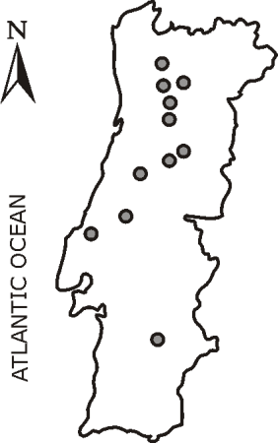
Figure 1 – Studied areas in the north, centre and south of Portugal
In each area (Figure 1) all buildings and bridges with potential for roosting cryptofauna communities were inspected inside and out, using strong light and endoscopes, looking for evidence of the presence of species including bats, ants, butterflies, droppings, feeding remains and possible roosting sites. Trees identified as having high potential for cryptic species were surveyed from the ground with the aid of binoculars looking for features such as cracks, woodpecker holes, rot holes, wound callus rolls and flaking bark. After that first stage, trees were climbed and small holes were inspected with the aid of an endoscope. The observational period varied from seconds to several minutes depending on the characteristics of each cavity. When the cavity was occupied the numbers of individuals, species and location were registered using GPS and a video was recorded with the endoscope for further view and analysis.
Results
A total of 792 small cavities were inspected, being 10.6 % (N=84) occupied by animals. On the other hand, although no individuals were found in several cavities prospected, inside 8.0 % (N=64) was possible to verify the presence of signs of use (e.g. droppings, food scraps), being the presence of animal biodiversity confirmed in 17.7 % (N=140) of the visited cavities. 134 individuals were registered inside the small cavities monitored with endoscopes. These individuals belong to 3 Phylum, 7 Classes and 14 different Orders as presented in Table 1.

Table 1 – Number of animals registered by group (including signs of presence).
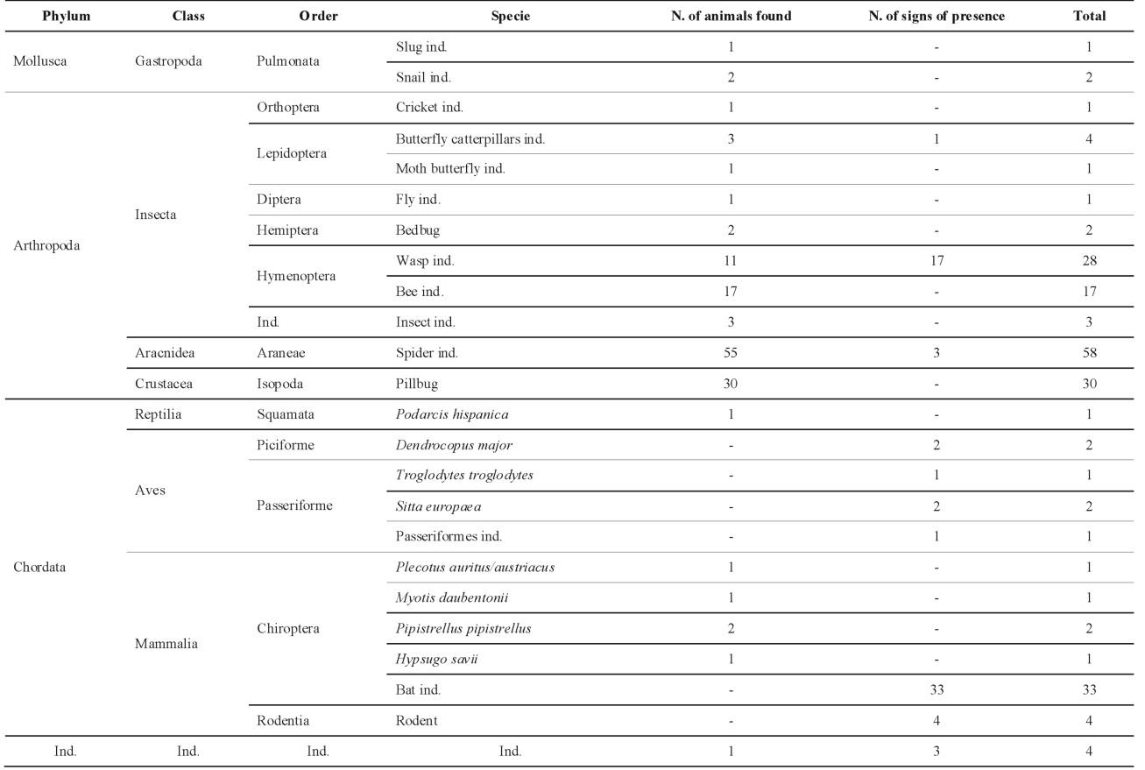

Kruskal-Wallis tests were carried out to detect significant relationships between the total number of animals/signs registered according to the type, shape and typology of the cavities monitored, as well as the type of habitats surrounding each cavity. The results showed high statistical significance for all the variables tested. As an example, the shape of the cavity (circular, square, oval) showed a significant influence on the number of individuals (H₄=26.70, N=792, p<0.001) and signs detected (H₄=13.09, N=792, p=0.011) inside the cavities, being oval cavities responsible for higher number of individuals and signs detected. Similar results were obtained for the variable “surrounding habitat of the cavity”, highlighting old oak stands in both number of individuals (H₁₀=66.66, N=792, p<0.001) and signs detected (H₁₀=30.52, N=792, p=0.001).
On the other hand, multiple regression analysis were used to test relationships between the characteristics of the cavities monitored with endoscopes (height from the ground, cavity diameter and cavity depth) and the presence of fauna in its interior. No significant influences were detected between the above mentioned characteristics on the number of animals or the number of signs of presence registered inside the cavities monitored.

Discussion
The results of the present study confirmed that endoscopy is an appropriate method for the monitoring of a large number of small cavities. It was possible to understand that there is a relevant proportion of cavities occupied by different groups of fauna, confirmed by the presence of animals or signs such as droppings and food scraps. Moreover, it was registered a wide variety of animals using such small cryptic habitats, being the Order Araneae the most abundant. Also important to highlight is the significant relationship detected between the biodiversity registered inside the cavities and variables such as the type of the cavity, its shape and habitats in the surrounded areas. On the contrary, characteristics of the cavities such as the height from the ground, cavity diameter and cavity depth do not seem to affect the cryptofauna communities present.
When compared to other methodologies to study the species that live in small cryptic habitats, endoscopy is relatively easy and quick to apply on the field and the amount of data that can be registered and stored is enormous. Moreover, video documentation saves expensive working time and the analysis can be done any time.

Conclusion
According to the results of the present study, the endoscopy of small cryptic habitats represents a useful tool to study several species of fauna and should be included on Impact Assessment studies to complement current methodologies, avoiding the lack of information that these studies actually present about the impacts of the construction projects on small cryptofauna communities, extremely relevant to the conservation of biodiversity and terrestrial ecosystems, and to measure the effectiveness of the implementation of mitigation measures and compensatory plans.

