Health and Safety System Development and Implementation: Case of MCA-Lesotho

1.0 INTRODUCTION
The $362.6 million Lesotho Compact financed by the United States Government Millennium Challenge Corporation (MCC) and implemented by the Millennium Challenge Account Lesotho (MCA-L) involves renovation and or extension of 138 health centres and 14 hospitals’ outpatient departments; construction of Botsabelo health complex; construction of 250 rural water systems and 30,000 sanitation facilities; rehabilitation and or extension of urban and peri-urban water supply systems in 11 urban centres in the country; construction of Metolong water treatment works and command reservoir, and; rehabilitation of wetlands at two of the three pilot areas in the highlands of the country.A large number of concurrent activities with varying contractor’s health and safety (H&S) capacity, involvement of foreign experts that are not familiar with local customs and protocols; and remoteness of some sites contribute to varying degree of H&S risks. The map below shows the location of MCA-Lesotho’s infrastructure projects.
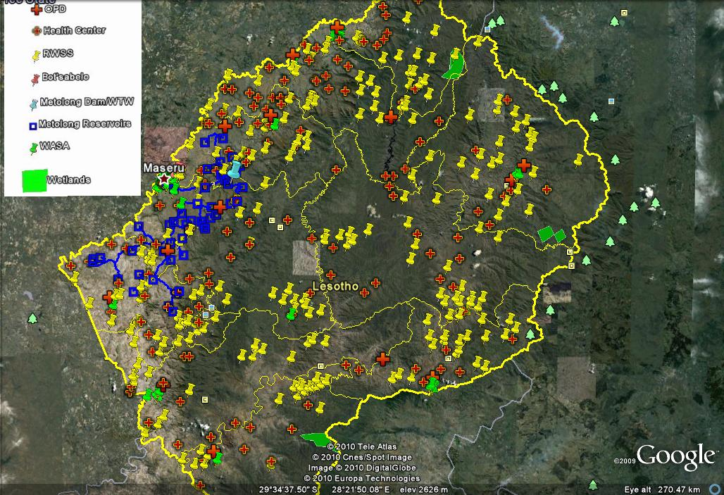
Fig 1: Location of Compact’s projects
MCA-L carried out an internal risk assessment which established that all health sector infrastructure projects as well as Metolong water treatment works, due to their nature of work ( working at heights, use of explosive, hazardous waste generation, etc), have much higher health and safety risks than the rest. The second ranked programme was urban and peri-urban water supply as it takes place in densely populated areas and it sometimes uses explosives at reservoir construction sites. The last projects were rural water systems and wetlands. However, it was also established that in terms of H&S risks, all projects have road accidents as the common denominator with health centres and rural water systems having the highest degree of exposure- given high frequency of travel involved. Prior risk assessment helped MCA-L and supervision consultants to focus on risks that really matter. In addition to MCA-L risk assessment, consultants and contractors also did their own assessments and more importantly, developed their own H&S systems that enable them to control risks and improve their performance.
This paper gives an overview of how each of the stakeholders i.e., MCA-L, consultants and contractors is contributing towards promoting a safe work environment and ultimately to reduced incidents and accidents. While a lot of attention is given to construction phase, pre-bid and planning phase requirements have also been discussed. The paper also deliberates on challenges and lessons learned. Lastly, a short conclusion is given.

2.0 HEALTH AND SAFETY REQUIREMENTS

2.1 Pre-construction requirements
MCA-L goes upstream of incidents by requesting that tenders from potential contractors should include a copy of health and safety plan that was effectively implemented by the contractor in similar projects. The requisite plan is reviewed and some points are awarded depending on the quality of the product. The said criterion is intended to select those contractors that have appropriate expertise in developing and implementing health and safety plans(HSPs).
In addition to tendering requirements, the preferred contractor is expected to develop and submit for review, HSP prior to commencement of construction. This step is intended to ensure that contractors put in place systems that will promote safety of workers during construction phase. HSP covers the safety of workers and the host community in accordance with MCA-L health and safety guidelines, 2010 as well as IFC health and safety standards, 2007. Prior to production of HSP, supervising consultants provide training on health and safety to contractors under their jurisdiction. The training equips contractors with skills they need to comply with MCC’s requirements of which they might not be familiar.
The Compact is being implemented by various stakeholders e.g. MCA-L, implementing Entities, consultants and contractors. The former two constitute the client, according to FIDIC. This makes effective communication crucial to the success of the projects. The issues of communication are clarified from the outset-during a kick off meeting for each contract. It is made clear that it is only the consultant that issues instructions to the contractor.

2.2 Construction Phase
In is a well known fact that injuries whether serious or minor are caused by an unsafe act or condition ( Du Pont, 2010). Pomfret-, argues that it is the hidden costs emanating from incidents without visible injury or damage that require the attention of the management as they have the potential to lead to higher losses ( iceberg effect) . For one to effectively ensure a safe work environment, he/she should have a system and tools that reinforce observations of unsafe practices and or conditions. It is through observations of such practices and or conditions that one can develop strategies for dealing with them e.g. raising awareness on those practices or conditions which seem to recur. Given the nature of the Compact projects, dealing with risks effectively becomes a big challenge. One must prioritise risks. As mentioned earlier, contractors and consultants are expected to carry out risk assessment to determine high risks and focus on them. Some of the high risks that were identified under the Compact projects include: hazardous waste management; working at heights, use of electric power tools; heavy snowfall/rainfall in the highlands; road accidents; etc. While low risks have also been identified, contractors and consultants are encouraged to focus on high risks as they have a potential to lead to loss of life or serious injuries.
On the basis of risk assessment, contractors are expected to develop and implement safe work procedures. In addition, contractors are expected to carry out task specific risk assessment and develop and implement appropriate safe work procedure. The process of task-specific risk assessment is participatory in that relevant groups of workers are involved. In the course of risk assessment, the workers are made aware of the consequences of non-compliance.
MCA-L believes that ensuring safety of employees at work and away from work is important to instil a strong positive safety culture. In this regard contractors are expected to hold toolbox talks dealing with all possible risks including off work risks such as attacks by the host communities, trafficking in persons, substance abuse, etc. In addition to holding tool box talks, contractors are expected to report on all incidents inclusive of off duty ones as long as they are serious i.e., loss of life or a serious injury has occurred.

2.2.1 Tools
Observed Unsafe practice or condition(OUPC) observations are made and captured in relevant forms. OUPCs are discussed with contractor’s staff and addressed immediately on site. The captured information is used by the consultant to determine the risks. It is worth noting that anyone (MCC, MCA-L, supervising Engineer, visitors, contractor’s employees, suppliers bringing material to site, etc) can make observations and discuss them with contractors without the act being misconstrued for instruction. Safety observations do not only cover wrong doings, they also give positive comments. OUPCs, therefore have a number of benefits, including prevention of injuries and loss of property, raising safety awareness, identifying weaknesses in the systems, identification and correction of unsafe situations and reinforcement of positive safety behaviour. There is a well understood proportional relationship between OUPCs and occurrence of serious injuries or fatality, Frank Bird ratio 600OUPC: 30First Aid Case(FAC): 10Recordable Case: 1Fatality. In this regard, the health sector infrastructure projects have the ratio 2,034:35:19:1 (Aurecon, 2012). This clearly shows that a lot more observations are undertaken thus raising awareness of workers. It is through the management of OUPCs that organisations are able to prevent occurrence of serious incidents.
Inspection checklists are used by all parties concerned viz MCA-Lesotho, consultants and contractors. They contain almost similar information aimed at detecting systems weakness and addressing them before occurrence of an incident.
Contractors as well as consultants are encouraged to train their employees as well as communities on health safety requirements on regular basis. The training material is packed such that it is relevant to the target group. Training is intended to equip workers with skills they need to contribute meaningfully in the implementation of the approved HSPs while in the case host communities, they are made aware of risks associated with the projects. The training covers all aspects of health and safety inclusive of HIV/AIDS and trafficking in persons with the latter two being always combined. The underlying principle is that a trained employee is better aware of risks associated with each task and as such is able to effectively implement preventive measures and deal with incidents should they arise.
Visitors that come to site are given a induction on potential hazards on site and safety measures that they need to follow. Here again, the intention is to minimise accidents during the tour/inspection of sites.

2.2.2 Early warning
Early warning in respect of potential risks is given to contractors e.g., information on inclement weather conditions (possibility of occurrence of heavy rains flooding rivers) is issued to contractors ahead of time.. Posters are used to warn contractors about common incidents and more importantly, relevant mitigation measures.

2.2.3 Incident reporting
MCA-L requires that contractors report incidents within 24 hours and that a detailed investigation report be submitted 28 days subsequent to occurrence. The first requirement is intended to manage the risk associated with information getting to the media without prior knowledge of the funder. While the second one is a legal requirement which provides detailed information to all concerned parties what happened without necessarily putting blame of any one. The findings of the report are used in developing strategies for preventing recurrence of a similar incident. Additionally, contractors are expected to develop a close out report highlighting all activities associated with the incident inclusive of costs incurred in the course of addressing the incident. The latter part is meant to remind contractors that there are costs associated with incidents and that prevention is much cheaper than dealing with a situation after it has developed.
Contractors and consultants are expected to include health and safety statistics in their monthly reports. The same information is used by MCA-L to compile quarterly reports that show trends in different incidents. The statistics stand as follows: total mileage is at 2,455,982km with 36 accidents having occurred; total number of person hours is 4,509,526 (with 89 FAC, 29 medical cases, 4 fatalities). While fatal cases are generally low(0.17 per 200,000 persons), there is a significant increase in first aid cases(3.92 per 200,000 persons) which in most cases occurred during demolition works at health centres and outpatient departments(OPDs). Road traffic accidents (RTA) stand at 1.5 per 100,000 km ( MCA-Lesotho –ESA , 2011). A lot is being done to improve on both FAC and RTA.

2.2.4 Auditing
Audits provide management with answers based on facts, which in turn generate solutions to problems (Pomfret,- ). While contractors carry out their own internal audits, MCA-L has engaged an external auditor, Nonyana Hoohlo and Associates (NHA), to review all systems that have been put in place by all parties inclusive of MCA-L. To-date, firm has produced 2 reports viz baseline and 1st follow on audit in 2011 and 2012 respectively. The first report acted as the baseline for the latter. The latter showed a slight improvement while cases of repeat non-compliance still noted.On basis of the results of audit, all parties are expected to develop their own action plans showing clearly how they intend to address the findings of the report. Second party audits are done by the supervising consultants and MCA-L.

3.0 CHALLENGES
A number of challenges have been experienced in implementing a safety management system which promotes continuous improvement. For instance, some contractors and consultants are only prepared to comply with contractual requirements which are often not elaborate on what needs to be done by them. This attitude has resulted in situations where contractors tend not to report incidents within 24 hours as this does not have a legal bearing; investigation reports often lack necessary detail as they have not identified the root cause(s) of the incident;
Contractors do not have adequate capacity in the area of health and safety as they were required to have an environmental manager as a minimum requirement. It has been established that people who have environmental management background do not necessarily have a health and safety knowledge.
Movement of contractors from finished construction site to a new one poses a risk as finishes are often done without adequate supervision. This is a common problem in rural water systems and health infrastructure projects a few construction sites under one contractor.
MCA-L has limited staff members that are expected to provide oversight in all projects that are being implemented concurrently at different sites throughout the country. This has resulted in heavy reliance of project management consultants which sometimes lack capacity to effectively supervise the projects.

4.0 LESSONS LEARNED
Some of the lessons learnt are:
- Training and awareness programs help to ensure that stakeholders, especially contractors, understand MCA-L requirements; more importantly, such programs reinforce awareness of the need to comply with those requirements. Employing competent staff is vitally important for the success of the systems that have been put in place;

- High risks such as working at heights, management of hazardous waste, and road traffic accidents should be continuously monitored, with appropriate life-saving measures put in place;
- Frequent auditing at various levels helps to draw attention to non-compliance issues and allows corrective actions to be developed and implemented;
- With involvement and commitment of all parties concerned, all injuries and occupational illnesses can be prevented;
- Health and safety is not an add-on but an integral part of overall project management;
- Safety observation are a must for everyone involved and all deficiencies that are brought to fore through observations should be corrected promptly;
- Intra as well as inter –contractors information sharing and exchange of experiences is encouraged, and;
- Issuance of early warning information to all stakeholders can help to save lives

5.0 CONCLUSIONS
MCA-L has brought about a new approach to safety where contractors are expected to go beyond on paper commitment to actual implementation of health and safety systems. It has raised the bar in terms of health and safety requirements for civil works by introducing higher performance standards (international norms), establishing rigorous monitoring systems, and demanding compliance with those requirements.
A multiple of factors including, training of contractors’ workforce, observations, inspections and auditing are contributing to reduced health and safety risks in the implementation of the Lesotho Compact. It is through a balance of the above factors that desired results are being achieved.

5.0 REFERENCES
Aurecon, 2012. Program management, construction supervision and environmental management services for the MCA-Lesotho health infrastructure program: Monthly report – February, 2012 (unpublished)
Du Pont, 2010. Managing safety: Systems that work for operations managers- facilitators guide
IFC, 2007. International Finance Corporation’s Guidance Notes: Performance standards on social and environmental sustainability

MCA-Lesotho, 2010. Occupational health and safety guidelines (unpublished)

MCA-L-ESA 2012. Annual report for October 2010- September, 2011 (unpublished)

NHA, 2011. Baseline audit report: Environmental, social, health and safety auditing (unpublished)

NHA, 2012. Follow on audit report: Environmental, social, health and safety auditing ( unpublished)

Pomfret, B. –. occupational health and safety management system auditing

