Indicators to follow-up hydro impacts and mitigation

Abstract

The hydro project is located in The Rio Verde, 60 km from the Oaxaca coastline. At present a small derivation dam (5 m in high) and 11 km of levees located approximately at 35 km upstream have modified the flow regime, ecosystems connectivity, riverbed geomorphology, sediment and nutrient transport. The river flow regime is identified as a master variable, therefore its natural variability has stated to compare and scale impacts from the mentioned infrastructure built in 1992 and the proposed hydro project to be built in the future. Under the present scenario, the main indicators are related to the derivation volumes during dry season and its impact on the low and extreme low flows downstream. During rainy season flows surpass the small dam then loads of sediments and nutrients (N and P) have been estimated annually and monthly to identify the potential retention of the new dam. Migration of some fish and crayfish species is also observed during this season too, but there are no baseline studies. Levees have modified the riverbed and lateral connectivity changing deposition patterns. In this regard, floods from different return period of time 1.5, 3 and 7 years have been identified as the driven factor to allow lateral connectivity with mangroves and lagoons. For the scenario with the proposed hydro project a re-regulation dam has been considered to mitigate four hours daily peaking flows mainly during dry season. Reducing flows during this season every three or four years has been pointed as a need to allow that aquatic fauna complete their biological cycles.

Introduction

The operation of several dams in the world is being modified to reduce the impacts imposed on aquatic ecosystems in the reservoir and downstream (Waite and Carpenter, 2000, Hickey and Warner, 2005). For new dams, the consideration of setting environmental flows and re-regulated dams are being indicators for a sustainable approach of producing energy (TNC and ENEE, 2007; HSAP, 2010). These new schemes are protecting rivers’ connectivity and the aquatic ecosystems since flow regime variability is reproducing at some scale and alterations are considering seasonal and temporal thresholds.

Associated to flow variables lateral connectivity with riparian and lagoon ecosystems as well as transport of sediment and nutrients are another indicators estimated and analyzed in this paper.

Study area

In The Rio Verde in Oaxaca, Mexico, the site for a planned hydro project has not been altered by any large dam upstream (Figure 1). The river maintain a regular inter-annual hydrograph according to the nearest hydrometric gauge (Table 1 and Figure 2).

The small derivation dam is located 38 km downstream of the new project site and it had has a low impact in the natural flow regime variability due to its low deviated volume (20 Mm³/year during dry season), but has altered mainly the riverbed and lateral connectivity due to 11 km of levees as it is shown in figure 3.

The planned project comprises a Concrete Face Rockfill Dam (CFRD) 195 m in high, with a storage capacity of 1126 hm³ and a reservoir of 25, 60 km². The total installed capacity will be 870 MW for an annual power generation of 1872 GWh.

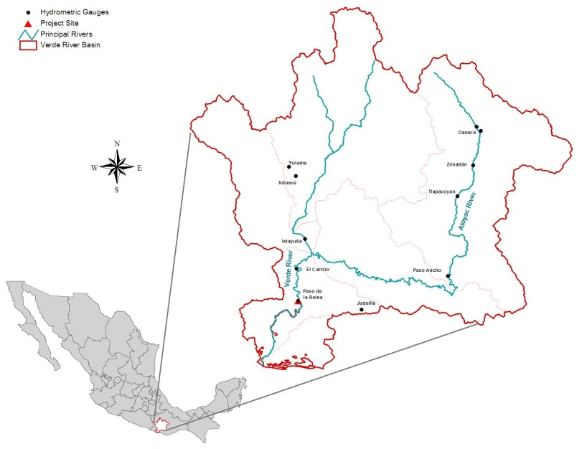
Figure 1. Rio Verde Basin and site for the proposed hydro project.
Table 1. Daily hydrometric available data

Hydrometric Gauge
Feature | Paso de la Reina
North Latitude | 16º 16’ 30’’
West Longitude | 97º 36’ 30’’
Period with data | 1962-2005
Catchment area (km²) | 17 617,00
Annual runoff volume in the river (Mm³) | 5 071,70
Annual daily medium flow (m³/s) | 161
km upstream Pacific Ocean | 60

Figure 2. Regular inter-annual hydrograph at the proposed site

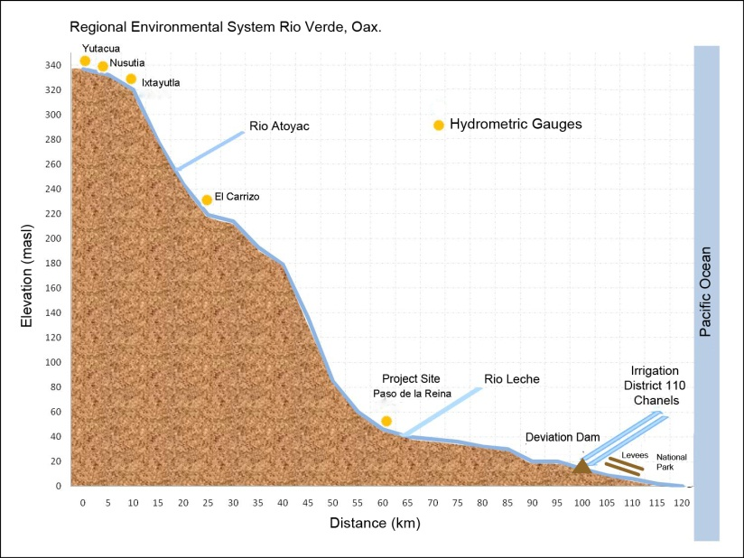
Figure 3. Profile showing project site and baseline conditions

Objective

Identify environmental indicators to follow-up impacts and mitigation of a proposed hydro project in a region with low level of eco-hydrological alteration.

Methodology

Classify the Regional Environmental System associated to a large proposed hydro project in terms of its eco-hydrological alteration (Garrido, et al., 2010).

According to baseline studies a set of indicators has been stated to follow-up impacts and mitigation related to changes in river flow regime and thresholds using the software IHA-RVA (TNC, 2009). Ecosystem connectivity such as return period flows needed to flood areas of interest and finally, transport of sediment and nutrients loads using a model for generalized loads at watershed level (AV-GWLF, Evans, et al., 2008).

Results

The Rio Verde area associated to the proposed hydro project has been classified as moderated in terms of its eco-hydrological indicators. Using 75 criteria and eleven indicators, Garrido, et al., have pointed out three main impacts on national rivers: 1) on the fluvial network; 2) on the riparian zone and 3) on the hydrographical basin.

At the same time, the project area has been also classified as low water pressure zone since there is a low demand for this resource and of a moderated ecological importance due to the presence of the irrigation district, land use changes, fishing and tourism exploitation.
For these reasons the conservation objective has been set as B as an indicator to allocate water for environmental flows and aquatic ecosystem preservation among certain limits of alteration.

From the analysis of historical daily averaged flows the range of natural variability was set between percentiles 25 and 75 (table 2). During hydro daily operation the expected hydro picking flows would be in the level of 450 m³/s during four hours and storage at the small re-regulated dam downstream. This dam would release water at 75 m³/s during 24 hours. Therefore, during dry season (January to May) flows will be upper than percentile 90. This scheme would not regulate the rainy season flows.

Months | Period of Analysis: 1962-2005 ( 44 years)
Months | 10% | 25% | 50% | 75% | 90%
January | 34.67 | 44.66 | 50.13 | 58.27 | 63.98
February | 25.94 | 34.05 | 37.44 | 42.61 | 49.31
March | 21.13 | 23.93 | 27.46 | 31.85 | 35.77
April | 15.68 | 19.42 | 23.07 | 28.14 | 33.67
May | 19.24 | 23.17 | 33.91 | 51.3 | 54.28
June | 52.87 | 82.52 | 128.9 | 198 | 327.2
July | 122.5 | 160 | 194.9 | 238.6 | 390
August | 133.2 | 171.4 | 259 | 359.1 | 464.1
September | 207.3 | 298 | 351.8 | 514.6 | 727.9
October | 157.5 | 192.2 | 246.6 | 350.8 | 483.2
November | 74.23 | 96.12 | 114.2 | 135.2 | 163
December | 48.33 | 62.26 | 68.77 | 77.53 | 93.78

Approximately 38 kilometers downstream of the proposed site, the small dam for irrigation and its levees have modified mainly lateral connectivity due to flood control. However due to the river connection with the lagoon system and with a flooded forest floods from two main return periods have been identified as needed to allow freshwater penetration: flows of 1.5 years return (1100 m³/s) and flows of 4 YR period of approximately 2800 m³/s.

In terms of nutrients loads, using a generalized watershed loads functions model AV-GWLF, results pointed out 7 220 ton of nitrogen and 2 602 ton of phosphorous annually are discharged in the coastal area and the lagoons system by the Rio Verde basin. From these loads, The Regional Ecological System (RES) produces 56, 2% of nitrogen (4 060, 4 ton/year) and 21, 3% phosphorous (554, 2 ton/year). Up to the project site 55% of nitrogen (2 235,4 ton/year) and 77,7% of phosphorous (430,5 ton/year) are produced.

In the lower part of the RES downstream the project site 45% of nitrogen account to 1 825 ton/year) and 22,3% of phosphorous are approximately 123,6 ton/year (figure 4).
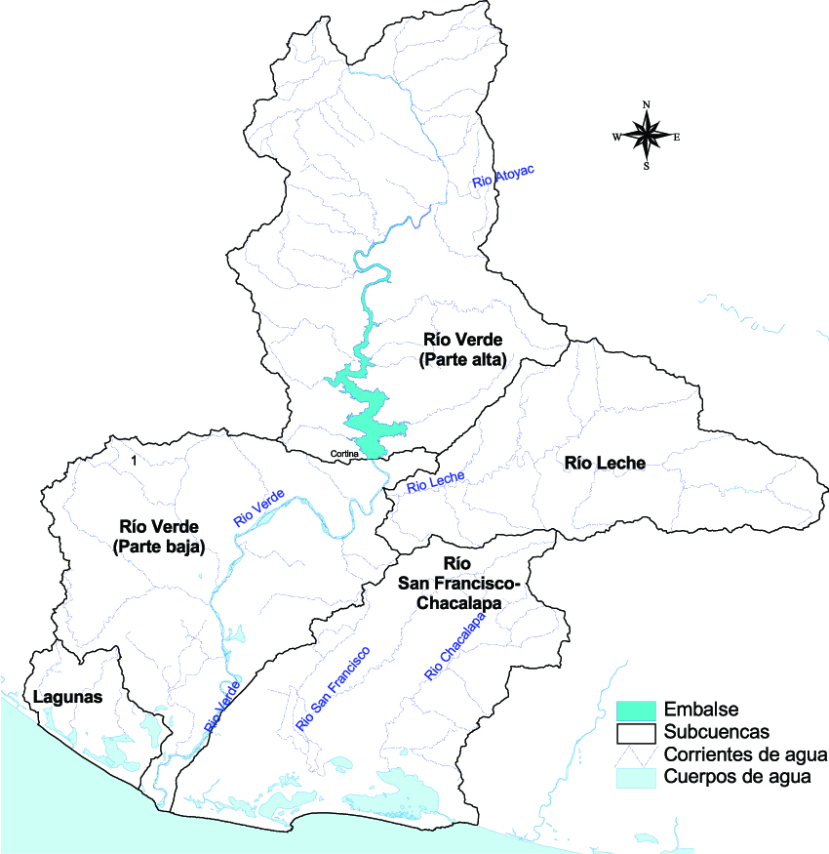
Figure 4. Main sub-basins in the Regional Ecological System
Conclusions

At present, hydrological data and approaches to set environmental flow thresholds are more available than other indicators to monitoring and follow-up hydropower projects impacts.

Based on hydrological results adaptive operation is needed to reduce the continuous higher discharge during dry season and to reproduce floods needed in the system during rainy season. Apart from magnitude, considerations are important on its duration and frequency.

Due to the connectivity with coastal and wetlands, this adaptive approach is highly recommended to maintain lateral connectivity.

The presence and distribution of fish up and downstream the derivation dam has showed differences in richness and abundance, then seasonal variations should be studied. In addition, some changes in species’ composition are foreseen with the operation of the new proposed dam.

It is important to review the contributions of sediments and nutrients from the river to the other inter-connected systems.

References
Evans B., D. W. Lehning and K. J. Corradini, 2008. AVGWLF Version 7.1 Users Guide, Penn State Institutes of Energy and the Environment, The Pennsylvania State University, USA.
Garrido-Pérez A., M. L. Cuevas, H. Cotler, D.I. González y R. Tharme, 2010. Evaluación del grado de alteración ecohidrológica de los ríos y corrientes superficiales de México, Investigación ambiental. Ciencia y política Pública. Vol 2, No. 1. Instituto Nacional de Ecología-SEMARNAT, México, D.F.

Hickey John and Andy Warner. Sustainable Rivers Project - U.S. Army Corps of Engineers and The Nature Conservancy partnership. Hydrologic Engineering Center. April 2005 issue of the Corps Environment.

HSAP Hydropower Sustainability Assessment Protocol, 2010. International Hydropower Association. London.

The Nature Conservancy TNC. 2006. Indicators of Hydrologic Alteration Version 7 User’s Manual. http://www.nature.org/initiatives/freshwater/files/ihav7.pdf
The Nature Conservancy TNC. 2009. Indicators of Hydrologic Alteration user’s manual, Version 7.1.
Waite Ian R and Kurt D. Carpenter. Associations among Fish Assemblage Structure and Environmental Variables in Willamette Basin Streams, Oregon. Transactions of the American Fisheries Society 2000: 29: 754-770

