LANDSCAPE AROUND MOTORWAYS. EVALUATION AND PERCEPTION

INTRODUCTION
The European Landscape Convention (European Council, 2000) marked a change in the way of conceiving landscape values in Europe (Fry et al., 2009). The convention endorses an integrated approach which includes the social, cultural and visual qualities of the landscape alongside its ecological functions. The European Landscape Convention defines landscape as “the territory as it is perceived by people, whose character is the result of the action and interaction of natural and/or human factors”. The convention also underlines the need for research into methodologies for the assessment of all landscapes, and not only scenic landscapes.
The objective of this work is to further the knowledge of evaluation methods for the assessment of visual landscape quality and their applicability to the landscapes which can be seen from motorways. Two different methods were studied and applied in this research. The first method, carried out by expert evaluators, involves taking photographic images of the landscapes through which the road runs, and assessing the physical, aesthetic and psychological attributes of the landscapes as seen in the photographs. The second method consists of conducting a survey, based on the same photographs, in order to reveal the public's perception of visual landscape quality.
It was decided to study the landscape as seen from the road, as roads function not only as transport routes but also as a structural element of the landscape (Nogué & Salas, 2006), in addition to being the mode through which the individual comes into contact with the landscape (Otero, et. al. 2006; Glaría and Ceñal, 1993).
Roads may therefore represent both the negative impact of anthropization, and another more positive impact of communication with the landscape. Impact studies generally focus on the alterations introduced by the infrastructure when viewed from the outside, but there has been little study of the relationship of the driver/observer with the landscape that he/she perceives when travelling along a road, when the landscape nearest the driver/observer is highly present throughout the whole of the trip.
The findings highlighted in the present article are the result of the research work carried out within the framework of the OASIS project, subsidised by the Centre for Technological and Industrial Development (CDTI) within the CENIT programme. These results are therefore the exclusive property of the companies underwriting this project, which together constitute the OASIS-CENIT, A.I.E. Business Association (OHL-Concesiones, ABERTIS, IRIDIUM, INDRA, SICE, OHL, DRAGADOS, GMV and GEOCISA).

METHODOLOGY
The two methods selected to assess the landscape are described below.

Assessment method by means of photographs
This study to assess the landscape observed from motorways follows the methodology based on the valuation of photographs first designed in the work of Cañas (1995), and which has been successfully used in various research works on landscape assessment (Otero et al., 2007, Otero et al., 2006, Hernández et al., 2004). This method takes into account the physical, aesthetic and psychological attributes of the landscape and is validated by means of surveys of experts and of the general public (Cañas, 2009). The method considers the following attributes, which in this study are given a specific numeric value:
Physical attributes:
1. Water (four variables are included: type, banks, flow and quantity).
2. Landform (one variable: type).
3. Vegetation (four variables: cover, diversity, quality and type).
4. Snow (one variable: cover).
5. Fauna (three variables: presence, interest and ease of sighting).
6. Land uses (two variables: type and intensity).
7. Views (two variables: type and intensity).
8. Cultural resources (four variables: presence, type, ease of sighting and interest)
9. Elements which alter character (four variables: intrusion, fragmentation of the landscape, obstruction of the horizon line and of the panoramic view of the landscape).
The following aesthetic descriptors are studied:
1. Form (three variables: diversity, contrast and compatibility).
2. Colour (three variables: diversity, contrast and compatibility).
3. Texture (three variables: diversity, contrast and compatibility).
The following psychological descriptors are taken into account:
1. Unity (two variables: structural lines and proportion).
2. Expression (five variables: structural lines, proportion, affectivity, stimulation and symbolism).
The final value of the landscape quality present in each photograph is established as the result of the scores assigned to each attribute, and is then classified into seven types of landscape quality (degraded, poor, mediocre, good, notable, very good, excellent).

Survey design and method of analysis
In order to reveal the public's valuation of the landscape, a survey was designed which included five questionnaires containing photographs of landscapes. Photographs are commonly used in studies on landscape perception as an alternative to direct observation of the landscape (Kaplan, 1985, Sullivan, 1994, Stamps, 1990).
Most of the photographs included in the questionnaires were taken during an inventory of Spanish landscapes observed from various motorways, which was conducted between May and June of 2009 for the OASIS project (Martín et al., 2012).
From this set of images, the photographs which were representative of different types of landscape with regard to their visual quality were selected. The photographs were shown in colour, with a resolution of 254 ppp and dimensions of 18x24 cm (2400x1800 pixels). The respondents were asked to state their preference for the landscapes on a scale of 1 to 5 (1=very bad; 5=very good). They were shown a total of 80 photographs, divided into five homogeneous groups (series or questionnaires) with regard to landscape types, arranged in a random order within the groups.

Application and comparison of the methods for assessing the landscape
Once the 80 photographs had been selected for the purposes of the study, the visual quality of the landscape shown in these photographs was evaluated by means of the assessment method described in section 2.1. The photographs were classified into seven landscape qualities (degraded, poor, mediocre, good, notable, very good, excellent).
The survey was then conducted using the same photographs. The survey was done using two systems. A survey campaign was first carried out in motorway service stations and rest areas, and the same survey was then launched through a web page.
The size of the initial sample was estimated by means of the typical deviation obtained in a similar prior study (16) using simple random sampling. The total number of answers was 737.
After applying the two methods, the average scores obtained for each photograph were compared. The goodness of fit of this assessment method using photographs for predicting the preference shown by the respondents was determined through a simple regression. This model explains the respondents' average score for each photograph (dependent variable) based on the score obtained with the model developed by Cañas (1995) (independent variable X).
β₀ and β₁ are the estimated parameters in the regression model, and correspond to the intercept and the slope of the vector.

Comparison of the results
The comparison of the results carried out by means of the regression model indicates that the method based on the assessment of photographs explains 70.52% of the variability of the preferences shown in the survey (variable Y). Furthermore the correlation coefficient is equal to 0.84, indicating a moderately strong relationship between the variables (see Table 1).
Table 1. Results of the estimated linear regression model
The graph below (Figure 1) shows the results obtained by means of the two assessment methods using photographs, on a scale of 0 to 100. In general terms, the model based on the possession of attributes allows the prediction of the valuation of the public in the questionnaire. One point worth highlighting is that the method permitted an accurate valuation of the visual impact introduced by elements which alter the landscape, such as high-voltage power lines and industrial facilities (see Figure 2, S54 and S310), as well as the valuation of landscapes with different visual qualities (see Figure 2, S522 with excellent quality and S417 with good quality). However, there are a series of photographs to the right of the graph in which the valuation obtained in the questionnaire is significantly higher than that obtained with the method based on attributes. We attempted to find patterns in these photographs to explain these differences, but none was clearly evident. As can be seen in Figure 3, the artificial increase in the contrast of the photograph using Photoshop (S11), the correct integration of an industrial estate with similar buildings to those present in the area (S35), the presence of ploughing lines (S19), and the effect of atmospheric phenomena (S47) may be causes of the difference between the results obtained from applying the model and those of the questionnaire. However a further study would be required to confirm that these are the reasons for the differences in the valuation (see photographs in Figure 3).
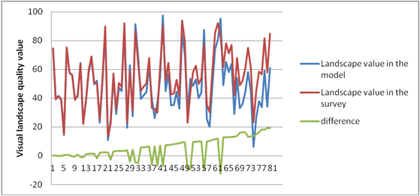
Figure 1. Landscape quality obtained with the application of the two methods in the selected photographs.
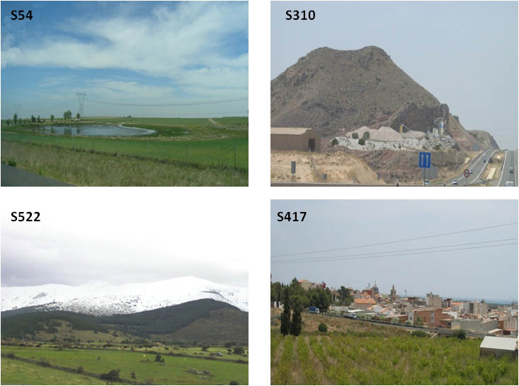
Figure 2. Examples of photographs where the valuation based on the possession-of-attributes model coincided with the results of the questionnaire.
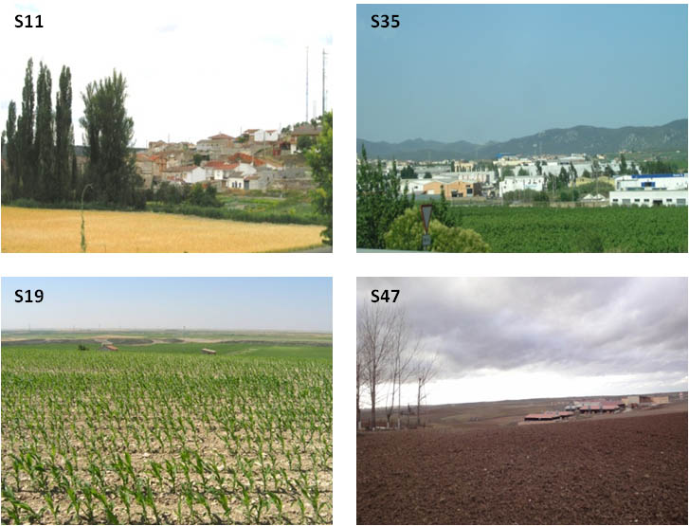
Figure 3. Examples of photographs where the valuation based on the possession-of-attributes model did not coincide with the results of the questionnaire.

DISCUSSION AND CONCLUSIONS
The study allowed us to apply and contrast the proposed methodologies for the assessment of landscape quality, and in particular of landscapes observed from the motorway.
The findings of the questionnaire, and their subsequent comparison with the results obtained by applying the method based on the possession of attributes, shows that the latter method constitutes a very useful tool for predicting the public's preferences with regard to the aesthetic quality of the landscape.
In landscape studies, physical attributes can easily be measured using themed cartography, whereas aesthetic attributes (form, colour, texture, unity and expression) are difficult to obtain by the same means due to the lack of themed cartography containing this information. The assessment of photographs can therefore serve as an effective tool for the quantification of aesthetic attributes, as well as being used to provide an analysis of sensitivity of the landscape valuation done by means of maps based on physical attributes.
The main difficulties encountered in the application of this methodology concerned the selection of the most representative photographs for each landscape unit, and the valuation of the aesthetic attributes shown in these photographs. Both cases are highly dependent on the location of the point from which the photograph is taken. Specifically, with regard to the selection of the photographs, we reached this conclusion after seeing how the model was more effective at describing the variability in the public's preferences when we eliminated the photographs where the built elements are very close together, or where the landscape quality is poor, a situation which is generally reinforced by the presence of built elements. In the case of the valuation of aesthetic attributes, colour and texture can be estimated based on chromatic and textural studies from aerial photographs and from photographs which depict the different elements of the landscape. In the case of the attribute of expression associated to landscapes which have been scarcely altered by human presence and which still conserve their ethnographic essence, its valuation could be fine-tuned with the addition of cartographic techniques (calculation of visual basins) and by the taking of photographs.
In conclusion, in view of the fact that the valuation of photographs are valuations of a particular point in the landscape (at a specific distance from the rest of the elements which comprise the landscape, and with a particular angle of vision), this method is a comprehensive tool which enables the deficiencies posed by methodologies based on landscape structure to be complemented and corrected at the local level, using cartographic analysis at smaller scales. Once the effectiveness of the method for assessing the attributes has been determined, we consider that future research should focus on improving the definition of the point from which the photograph is taken, seeking to achieve the greatest statistical representation and to reduce the influence of elements which distort the image in the analysis of the photograph. Furthermore we maintain that the systematic taking of photographs should be carried out as a prior stage to the cartographic assessment, given that certain attributes such as colour and expression which have a strong influence on landscape valuation are easier to assess with methods based on photographs.

REFERENCES
CAÑAS, I. (1995). Introducción al Paisaje. Unicopia. Madrid.
CAÑAS, I., AYUGA, E. y AYUGA, F. “A contribution to the assessment of scenic quality of landscapes based on preferences expressed by the public”. Land use Policy, 10, (2009), vol. 26, no. 4, pp. 1173-1181
EUROPEAN COUNCIL. European Landscape Convention. Florencia. (2000).
FRY, G., TVEIT, M.S., ODE, Å. y VELARDE, M.D. “The ecology of visual landscapes: exploring the conceptual common ground of visual and ecological landscape indicators”. Ecological Indicators, vol. 9, no. 5, (2009), pp. 933-947.
GLARÍA, G. and CEÑAL, Mº. A.: “Impactos paisajísticos de carreteras y medidas correctoras. Niveles de detalle”. Informes de la construcción. Monográfico Carretera y Medioambiente. Vol. 44 nº 425-426 (1993).
HERNÁNDEZ, J., GARCÍA, L. y AYUGA, F. “Assessment of the visual impact made on the landscape by new buildings: a methodology for site selection”. Landscape and Urban Planning, 5, vol. 68, no. 1, (2004), pp. 15-28.
KAPLAN, R.: “The Analysis of Perception via Preference: A Strategy for Studying How the Environment Is Experienced”. Landscape and Urban Planning. Vol.12, (1985), pp.161–176.
MARTÍN, B.; LORO, M.; ARCE, R.M.; OTERO, I. “Diferentes técnicas de integración paisajística en carreteras. Análisis de eficacia a través de la percepción de observadores”. Informes de la Construcción. (2012). In press.
NOGUÉ, J. and SALAS, P.: “Conceptual, methodological and procedural bases for the preparation of the Catalan Landscape Catalogues”. Obsservatori del Paitsaje. Olot and Barcelona (2006). url: http://www.catpaisatge.net/fitxers/SummaryPrototype.pdf
OTERO PASTOR, I., CASERMEIRO MARTÍNEZ, M.A., EZQUERRA CANALEJO, A. y ESPARCIA MARIÑO, P. “Landscape evaluation: comparison of evaluation methods in a region of Spain”. Journal of Environmental Management, 10, vol. 85, no. 1, (2007) pp. 204-214.
OTERO, I. et. al.: “La carretera como elemento de valor paisajístico y medioambiental. Captación del valor del paisaje a través de la carretera”. Informes de la Construcción, Vol.58, nº504 (2006), pp.39-54.
STAMPS, A. E.: “Use of Photographs to Simulate Environments: A Meta-Analysis”. Perceptual and Motor Skills. Vol.71 (1990), pp.907–913
SULLIVAN, W. C.: “Perceptions of the Rural–Urban Fringe: Citizen Preferences for Natural and Developed Settings”. Landscape and Urban Planning. Vol.29 (1994), pp.85–101.

