Mainstreaming the Environment in Aggregate Agricultural Support Measures

Abstract
This paper attempts to adjust an OECD indicator that aggregates agricultural public support given to farmers, the Producer Support Estimate (PSE), for the external costs that arise from agricultural activities in OECD member countries. This exercise was supported by the rationale that external costs, like overuse of natural resources or environmental pollution, can be seen as an additional subsidy given by society/taxpayers to farmers for the external costs that result from farming but for which they are not asked to pay for. Society/taxpayers do it on their behalf. A conservative estimate of the external costs rising from OECD agriculture showed that they amount for about 37% ($94 million) of the PSE figure ($256 million). The external costs’ figure is, indeed, considerable high and supports those that argue that agricultural policy reform should concentrate on measures to reduce the environmental burden from the sector.

Keywords: OECD countries; agriculture external costs; PSE; externalities adjusted PSE.

1. Introduction
Agriculture generates negative environmental impacts like soil erosion, water pollution and loss of biodiversity, but also provides environmental services like landscapes, recreation and amenity (Stoate et al. 2009). OECD (Organisation for Economic Co-operation and Development) promotes highly intensive agriculture, strongly encouraging production-enhancement through support policies. These measures can be considered as aggressive and harmful to the environment because it accentuates the overuse of natural resources (mainly soil and water), while an excessive use of agricultural inputs, like fertiliser and pesticides may result in the contamination of water resources and the harming of wildlife (Pearce et al. 1993; OECD 2001). Pollution costs arising from agricultural activities are paid neither by farmers nor by consumers, but are borne by society/taxpayers (Pretty et al. 2000).
The Producer Support Estimate (PSE) is an OECD indicator that aggregates agricultural support given by the public sector to farmers (OECD 2008). A pertinent thought might be that a more accurate figure of the total support received by farmers from taxpayers should be the PSE plus agricultural pollution costs, since farmers are not asked to pay for them, and society/taxpayers do it on their behalf. A PSE indicator accounting for the agricultural external costs (and benefits) would certainly provide better insights to policy-makers on the urgent need for agricultural policy reform.
The objective of this study is to give an estimate of the external costs rising from agricultural practices in OECD member countries and subsequently add them to the most updated PSE figure. In order to achieve this, an integrated accounting framework is proposed to internalise the costs of natural resources exploitation, aiming to get a more accurate figure for the total support given by the public sector/taxpayers/society to farmers within OECD.

2. Methodology
The methodology used in this paper was based on a previous study (Vilela 2003) that estimated the external costs rising from agriculture for OECD member countries. A literature review on the main impacts, and its consequent costs, was undertaken for the UK, which was then used on a benefits transfer exercise to calculate the external costs within OECD (Figure 1), based on the marginal external cost found. The final external cost figures for the different pollution categories do not result from the appliance of the same approach or methodology. Some were based on actual costs (eg, water pollution), others on willingness to pay studies (eg, biodiversity loss), but also on models (greenhouse gases). Across all OECD countries, clear assumptions had to be made in order to deal with many factors of variability, such as different sorts of pollution problems arising from agricultural activities, different levels of significance within the same pollution problems, different environmental conditions (eg, climate), as well as different capacities (financial and institutional resources) to perform pollution control. By transferring marginal external costs from the UK to the other OECD countries, it was assumed that the external cost per unit of agricultural pollution in the rest of the OECD countries was exactly the same as in the UK.

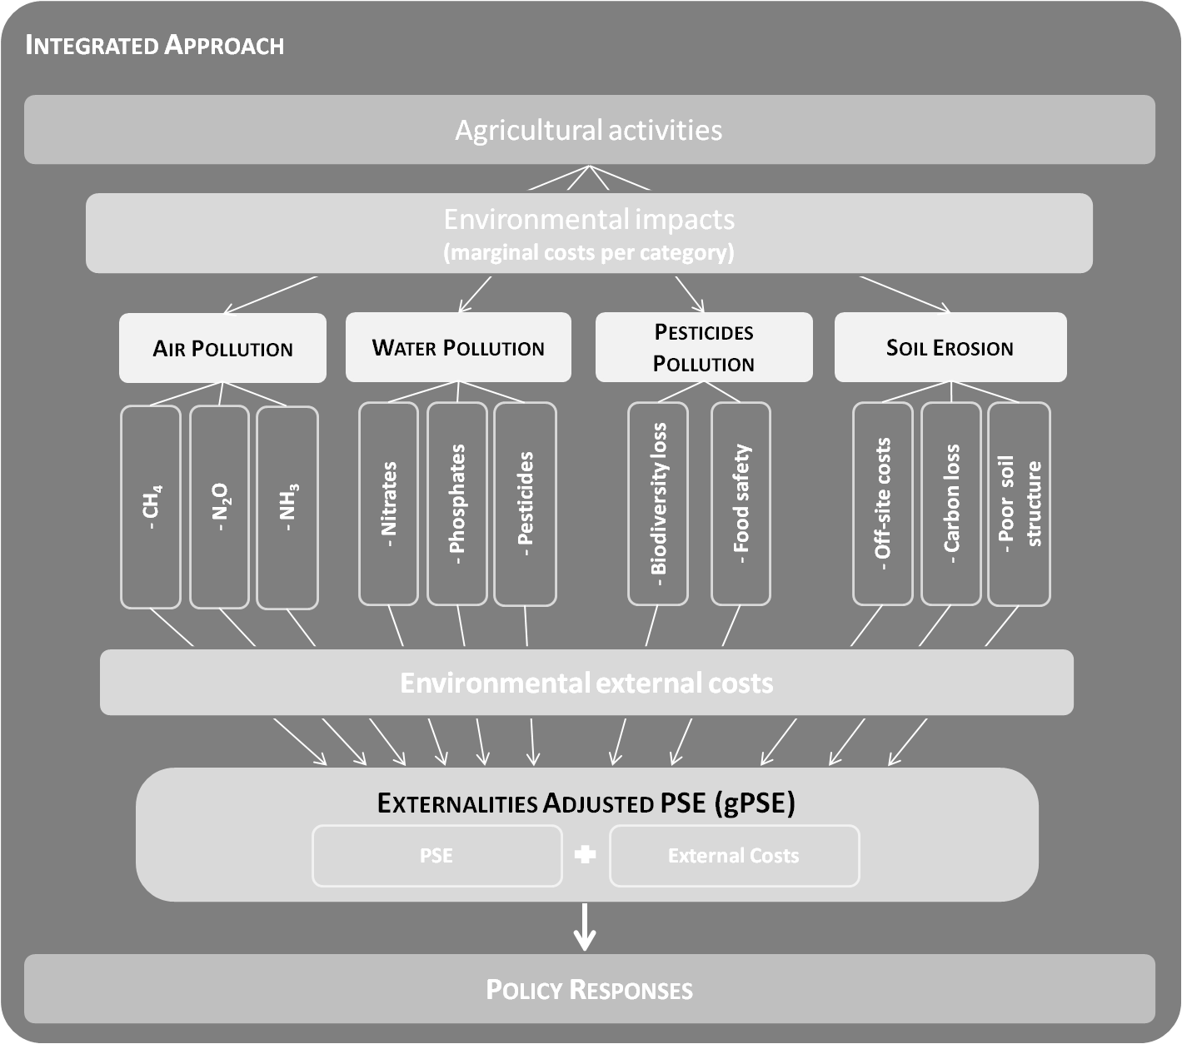
Figure 1 – Conceptual overview of the integrated approach adopted.

The specific methodological considerations undertaken on the calculations inside each of the external costs category were based on finding the marginal external costs per unit of: 1) air emissions [data for 2009 drawn from Eftec (2004) and UNFCCC (2009)]; 2) fertiliser usage [from Eftec (2004) and FAO (2009)]; 3) pesticide usage (from Foster et al. 1998, Pretty et al. 2000 and FAO 2009); 4) soil erosion [from Eftec (2004) and OECD (2009)] (Figure 1). As the sources of the UK pollution costs varied in their year prices, the final external costs for the corresponding pollution categories had to be adjusted, using the GDP deflator at market prices (H M TREASURY 2009) to bring those external costs to the same year price (2009).
The PSE figures for 2009 were drawn from OECD database (OECD 2009). OECD data did not have PSE figures for each European Union (EU) country separately, therefore, an aggregated PSE figure for all EU member countries was considered. In order to put forward the Externalities Adjusted PSE (hereafter gPSE) for 2009, the annual external costs rising from agricultural activities were added to the PSE figure, for each OECD country (Figure 1). External costs and PSE were brought into the same currency to facilitate calculations and produce the externalities adjusted PSE, in USD 2009 prices, using the Purchase Power Parity rates (OECD 2009).

3. Results and Discussion
The marginal costs considered for this analysis are presented on Table 1. The 2002 data (Vilela, 2003) was included to allow for a comparative exercise. From this comparison, it is possible to see that 2009 presented higher marginal values per unit of emission, except for NH₃ emissions marginal costs that decreased over the years.

Table 1 – Pollution categories, reference works and country from where marginal costs were obtained, 2009 and 2002 (£/tonne) marginal costs considered in this analysis.

Table 2 presents the annual external costs rising from agriculture activities in each OECD member country for the 2009 year, at USD 2009 prices.

Table 2 – Annual External costs for 2009 rising from agriculture in each OECD country (the 2002 data was also included to allow for the external costs comparison over the years).
The costs are given per OECD country and per pollution category. An aggregate pollution costs figure per country and a total external cost figure per pollution category, aggregating every OECD country member, were also put forward, as well as the overall external costs in OECD member countries, aggregating every country and pollution category. As it was not the purpose of this study to perform a per country analysis of the figures presented, only some features are highlighted below. A major feature was the USA external cost figure, which was the highest achieved value followed by Mexico, France and Canada. Moreover, almost all countries increased their total external costs associated with agricultural activities between 2002 and 2009, except for Australia that presented the opposite trend.

Table 3 shows the Externalities Adjusted Producer Support Estimate (which could also be designated as the “green PSE”- gPSE) figures for each OECD member country, as well as the overall (all countries aggregated) externalities adjusted PSE figure (converted into 2009 prices).

Table 3 – Externalities’ adjusted PSE for the 2002 and 2009 year, at 2009 prices.

From this table it is possible to observe that 5 countries (Australia, Chile, Mexico, New Zealand and USA) presented higher external costs associated with agriculture practices, than the subsidies given to producers (PSE), while the remaining countries presented higher subsidies than external costs. Moreover, significant higher external costs were achieved for countries such as Mexico, Japan or Korea in 2009, comparatively to 2002, concomitant with a PSE reduction. This unusual fact may be explained by the unavailability of data for most of environmental pollution emissions for these countries in 2002, which reduced the total external costs figures. Regarding PSE trends, EU had the highest PSE figure amongst all OECD members, which was more than two times larger than the second largest PSE figure, the USA one. This trend was also observed for the 2002 year. From Table 3 it is also possible to see that there has been a slight decrease in the externalities adjusted PSE in 2009, comparatively to 2002, mainly driven by Australia and Korea.
The most important feature to highlight from this study is that the overall external costs rising from the OECD agricultural sector in 2009, $94 billion, is equivalent to 37% of the total support given to farmers in OECD countries, which stands at $256 billion. This more accurate and environmentally adjusted picture of 2009 PSE, including the annual external costs from the sector, reveals a remarkably higher figure, $350 billion. Interestingly, these gross estimates suggest that the external costs contribution passed from 16% to 37% from 2002 to 2009, respectively, despite the decreasing trend verified in the supports given to producers. This may be due to 1) the increase in the marginal costs per emission; 2) the inclusion of more environmental categories to assess total external costs; and 3) more countries were included in the analysis (eg, Chile and new EU members).
The external costs calculations may be underestimated due to two main reasons: a) the set of categories included in this study’s calculations were not comprehensive enough to include all the important pollution problems arising from agricultural activities, like sediment removal from water by water delivery companies, costs of eutrophication and pathogens removal, opportunity costs of water abstraction for irrigation and increase in soil salinity (Middleton 1999; EEA 2003); b) inside each pollution category there were issues either with a lack of available data or with a conservative approach used, and these kept the final figures below the real scenario.
Moreover, economic differences among OECD countries can also raise the question of not all OECD countries being able to spend the same amount of money on pollution control. Therefore, using values based on UK figures would lead to an over- estimation of pollution costs in countries with less economic resources to tackle pollution (like Portugal, Greece, Spain, Mexico, Hungary, etc), that despite good-willing do not have the economic resources to accomplish it. Thus, using values based on UK figures might have the advantage of bringing pollution costs for those less wealthy OECD countries closer to the pollution control budget that those countries would be willing to spend in order to reasonably overcome their pollution problems. On the one hand, it might be a source of over-estimation, but, on the other hand, it might be a figure that gets closer to the real external costs for these less wealthy OECD member countries. For some other countries, like the USA and maybe Japan or Germany, which might spend a higher percentage of their budget on pollution control, the figures drawn from the UK might lead to an under- estimation of their agricultural external costs.
The external costs’ figure is, indeed, considerable high and supports those that argue that agricultural policy reform should concentrate on measures to reduce the environmental burden from the sector (eg, Vilela 2003; Stoate et al. 2009).

4. Conclusions
This work intended to document the changes/pressures caused by agriculture on ecosystems, measured through the external costs associated with this activity, and to discuss the consequences of a green PSE usage, based on a previous analysis (Vilela 2003). The results illustrate that the integration of environmental external costs into PSE indicators provides a common framework that benefits 1) better management actions, 2) weighting activities trade-offs and impacts on the system, and 3) policy measures to reduce impacts.
The gPSE exercise identified two main future research topics: 1) a gap analysis should be undertaken, covering more (potential) environmental impacts (eg, pesticides effect on climate changes issues), and 2) to integrate countries realities into gPSE calculation (instead of using UK as reference).

5. References

EEA (2003). Europe's environment: the third assessment. OPOCE.
Eftec (2004). Framework for Environment Accounts for Agriculture Eftec (Economics for the Environment Consultancy) in association with Institute for European Environmental Policy (IEEP).
FAO (2009). FAOSTAT Agriculture Data http://apps.fao.org/page/collections?subset=agriculture
Foster, V., Mourato, S., Tinch, R., Özedemiroglu, E., Pearce, D.W. (1998). Incorporating External Impacts in Pest Management Choices, IN Vorley, W. and Keeney, D. (eds.) Bugs in the System: Redesigning the Pesticide Industry for Sustainable Agriculture 50-93, London, Earthscan.
Middleton, N. (1999). The Global Casino. London: Edward Arnold.
OECD (2001). Improving the Environmental Performance of Agriculture: Policy Options and Market Approaches.
OECD (2008). OECD’s Producer Support Estimate and Related Indicators of Agricultural Support: Concepts, Calculations, Interpretation and Use (The PSE Manual). July 2008. 186pp.
OECD (2009). Producer and Consumer Support Estimates, OECD Database 1986-2002 http://www.oecd.org/document/23/0,2340,en_2649_33773_4348119_1_1_1_37401,00.html
Pearce, D., Turner, R., O’Riordan, T., Adger, N., Atkinson, G., Brisson, I., Brown, K., Dubourg, R., Fankhauser, S., Jordan, A., Maddison, D., Moran, D., Powell, J. (1993). Blueprint 3 – Measuring sustainable development. London: Earthscan Publications Limited.
Pretty, J. N., Brett, C., Gee, D., Hine, R. E., Mason, C. F., Morison, J. I. L., Raven, H., Rayment, M. D., van der Bijl, G. (2000). An Assessment of the Total External Costs of UK Agriculture Agricultural Systems 65: 113-136.
Stoate, C., Báldi, A., Beja, P., Boatman, N.D., Herzon, I., van Doorn, A., de Snoo, G.R., Rakosy, L., Ramwell, C. (2009). Ecological impacts of early 21st century agricultural change in Europe – A review. Journal of Environmental Management 91: 22-46.
UNFCCC (2009). Greenhouse Gases Inventory Database http://ghg.unfccc.int/default1.htf?time=02%3A18%3A20+AM
Vilela, N. (2003). Mainstreaming the Environment in Aggregate Agricultural Support Measures. Msc Dissertation. University of Edinburgh, 58pp.

