Title: Mammal’s database for a Brazilian planning approach.

Abstract

Great mammals are species-key for biodiversity conservation. Their high patterns of distribution and their capacity of migration could reflect effects of the land use alterations in the regional landscape. Nevertheless, the mammal’s available data have not been used to orientate Brazilian Environmental Impact Assessment (EIA). This study objective to evaluate the SpeciesLink database contribution to prepare great mammal’s distribution models at regional scales and to verify how those models can be incorporate in Brazilian planning and EIA process. Available data of Chrysocyon brachyurus (maned wolf), Leopardus pardalis (Ocelot) and Puma concolor (puma) were review in ArcGis version 10 and used to generated distribution models in software Maxent version 3.3.3 for central region of Sao Paulo State. The models showed that despite many records have incomplete data and inaccurate location information, the SpeciesLink already provides sufficient data (in number and accuracy) for indicate priority areas to conservation in regional scale. The final maps developed may be included in zoning and environmental impact assessment process, subsidizing decision makers to choose the best alternatives for conservation and development.

Introduction

The role of Strategic Environmental Assessment (SEA) and Environmental Impact Assessment (EIA) is crucial for the preservation of biodiversity in natural areas that are not protected by law (GONTIER et al, 2010). This impact assessment process especially in strategic level is proposed to insert biodiversity in the planning and decision making process (GONTIER et al, 2006; Slootweg et al, 2006; TREWEEK et al., 2005). For this, the Geographic Information Systems based on habitats modeling is indicated (Balfors et al., 2005; Gontier et al., 2006; Gontier, 2007; Gontier et al., 2010).
The ecological modeling can be used to assess the distribution of habitats, species and communities, and it can be used to make quantitative and spatial explicit predictions of impacts on them (Gontier et al, 2006). This tool can provide information about the impacts on biodiversity components and supports visually through maps generated for discussions on the potential impacts in EIA and SEA (Gontier, 2007).
Inventories of fauna would be the most direct way to access part of the local animal diversity components in a given space and time (Silveira, 2010). However, there are few investments in biodiversity inventories and high diversity of fauna in Brazil, due of this Santos (2004) recommends selecting good indicators of local fauna. Furthermore, top predators of the food chain could reflect processes and functions on a regional scale and simplify the management considering the larger patterns of distribution, the ability to migrate and the greater range of their trophic interactions (Beazley & Cardinal, 2004). Therefore, models of these species could represent the biodiversity in Brazilian environmental assessment process.
In São Paulo State, the Sustainable Conservation of Biodiversity Research Program (Biota / FAPESP) has been highlighted for structure and publish a biological database with species inventories called SpeciesLink. This database does not reflect the actual state of researcher’s knowledge and does not properly standardized (Metzger & Casatti, 2006), but there are modeling species distribution software, as Maxent, that has offered a good performance for these type of biological incomplete data (Phillips, 2006; Pearson et al., 2007; GONTIER et al., 2010). Thus, the modeling of species databases can be a technique to be applied to include biodiversity in Brazilian planning and decision making process.
Objectives

This study objective to evaluate the SpeciesLink database contribution to prepare mammalian predator’s distribution models at regional scales and to verify how those models can be incorporate in Brazilian environmental assessment process.

Methodology

The data of Chrysocyon brachyurus (maned wolf), Leopardus pardalis (ocelot) and Puma concolor (puma) available at SpeciesLink data bank (BIOTA/FAPESP, 2010) were review in ArcGis 9.2 to select the more recent records and in sufficient quantity and quality for modeling using software Maxent version 3.3.3k. A study area of approximately 34.232 km² meter in São Paulo State central region was selected to cover data points recovered from 1999 to 2003 (Figure 1).
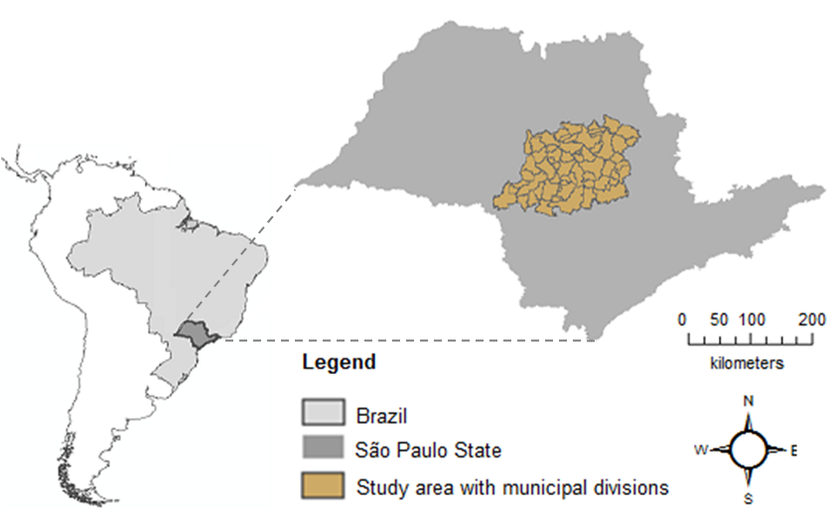
Figure 1. Study area.

The biological data used for modeling of Chrysocyon brachyurus were only 18 of 81 records available at the data bank. The records applied were 16 of 72 for Leopardus pardalis and 22 of 101 for Puma concolor. The table 1 shows the environmental data (layers) using for modeling with 0,083 km resolution in Datum WGS-84.
The maximum test sensitivity plus specificity rule was applied in software Maxent, using 75% of data for making the models and 25% for test of them with random partitions with replacement (bootstrap). The software ran 10 replicate and the average of them generated the final models. The performance was evaluated on the values ​​of the Area Under Curve (AUC) classified as excellent from 0,90 to 1,0, good from 0,80 to 0,90, median from 0,70 to 0,80, bad from 0,60 to 0,70 and very bad from 0,50 to 0,60 (Metz, 1986).
Finally, it was assumed that the higher adequability shown by modeling for the species would match to the higher priority area for management and conservation of the species and that the fewer adequability for species would match to the fewer priority area for conservation. For this, the software ArcGis version 10 was used for classify the final maps in these intervals:
- High priority areas: adequability from 0,75 to 1,0;
- Medium priority areas: adequability from 0,50 to 0,75;
- Low priority areas: adequability from logistic threshold to 0,50;
- And without priority areas: adequability from zero to the logistic threshold.

Table 1. Environmental layers used in modeling.
 | Variables | Source
Climate | average change in temperature days | Worldclim  (Hijmans et al., 2005)
Climate | minimum temperature of coldest month | Worldclim  (Hijmans et al., 2005)
Climate | maximum temperature of hottest month | Worldclim  (Hijmans et al., 2005)
Climate | average annual temperature | Worldclim  (Hijmans et al., 2005)
Climate | precipitation of the wettest months | Worldclim  (Hijmans et al., 2005)
Climate | precipitation of driest month | Worldclim  (Hijmans et al., 2005)
Climate | annual precipitation | Worldclim  (Hijmans et al., 2005)
Topography | SRTM (Shuttle Radar Topography Mition) | NASA (Jarvis et al., 2008)
Vegetation | NDVI (Normalized Difference Vegetation Index) | NASA (EOSDIS, 2009)
Vegetation | EVI (Enhanced Vegetation Index) | NASA (EOSDIS, 2009)
Natural areas | Euclidian distance of full protect areas and indicate for protection | São Paulo (2008)

Results and Discussion

The model of Leopardus pardalis showed an excellent performance with AUC of 0.9009, logistic threshold of 0.3908 and P-value of 0.0490. The figure 2 shows the average model and the priority map for ocelot.
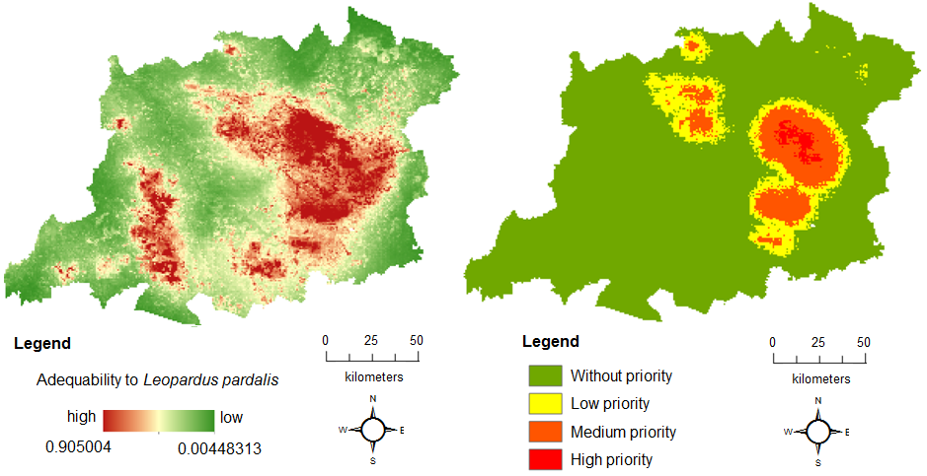
Figure 2. Adequability’s average model and priority map for Leopardus pardalis.

The model of Puma concolor showed an excellent performance with AUC of 0.9344, logistic threshold of 0.3394 and P-value of 0.0375. The figure 3 shows the average model and the priority map for puma.
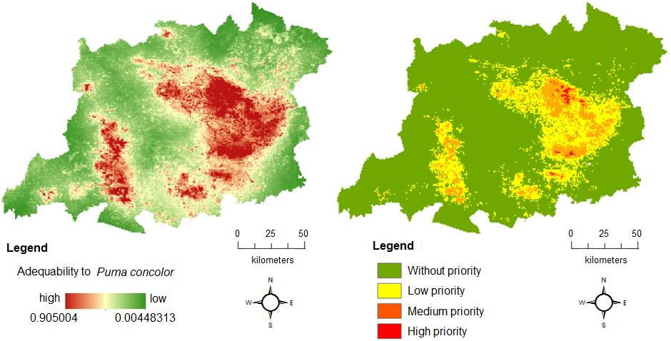
Figure 3. Adequability’s average model and priority map for Puma concolor.

The AUC of 0.8014 of the model of Chrysocyon brachyurus is lower than the other species but still showed a good performance. The P-value of 0.0549 is just above 0.05 (random limit). The priority map for this specie hasn’t the low priority class due the logistic threshold is 0.5301 (above 0.5). The figure 4 shows the average model and the priority map for maned wolf.
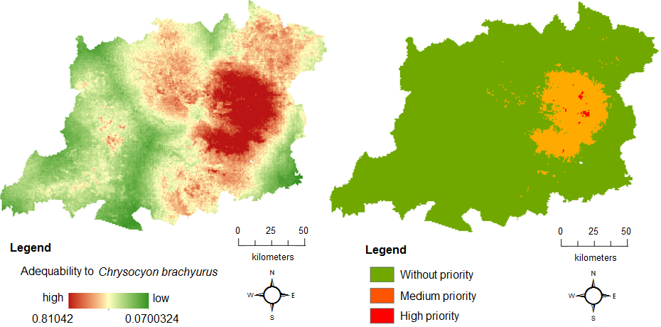

Figure 4. Adequability’s average model and priority map for Chrysocyon brachyurus.

The results presented may have been influenced by super-sampling or under-sampling of different parts of the study area due to lack of standardization of the database used.

Conclusions

The speciesLink database already provides sufficient data (in number and accuracy) for spatial distribution’s studies of some species such as Chrysocyon braquiurus, Leopardus pardalis e Puma concolor. The distribution models generated are good predictors and indicated areas with high environmental suitability for the three species studied. However, the results suggest that the Chrysocyon braquiurus data have to be improved to develop better models.
Majority of the available speciesLink data are concentrated in established area and in the considered period. Thus, the application of this technique in other periods and other areas are still not possible. To fix this, the database needs to be improving with more data standardized and distributed in time and space.
The species distribution modeling applied to biological databases can reveal valuable information to subside EIA and SEA process. The environmental assessment has to include questions about the species especially in the priority areas shown in the models. This tool could guide the choice of decision makers in licensing and planning process in Brazil.

References

Balfors, B.; Mörtberg, U.; GONTIER, M.; BROKKING, P. Impacts of Region-Wide Urban Development on Biodiversity in Strategic Environmental Assessment. Journal of Environmental Assessment Policy and Management, v. 7, n. 2 pp. 229–246, 2005.
BEAZLEY, K. & CARDINAL, N. A systematic approach for selecting focal species for conservation in the forests of Nova Scotia and Maine. Environmental Conservation, Foundation for Environmental Conservation, n. 31, v. 2, p. 91–101, 2004.
BIOTA/FAPESP. Distributed Information System for Biological Collections: Integrating Species Analyst and SinBiota (speciesLink): search. Avaiable: http://www.splink.org.br/ . Accessed on March, 2010.
EOSDIS - Earth Observing System Data and Information System. 2009. Earth Observing System ClearingHOuse (ECHO) / Warehouse Inventory Search Tool (WIST) Version 10.X [online application]. Greenbelt, MD: EOSDIS, Goddard Space Flight Center (GSFC) National Aeronautics and Space Administration (NASA). Avaiable: https://wist.echo.nasa.gov/api/ . Accessed on June, 2010.
GONTIER, M.; BALFORS, B. e MOrtberg, U. Biodiversity in environmental assessment—current practice and tools for prediction. Environmental Management and Assessment Research Group, Department of Land and Water Resources Engineering, Royal Institute of Technology, SE-100 44 Stockholm, Sweden. 2006.
Gontier, M., Scale issues in the assessment of ecological impacts using a GIS-based habitat model – A case study for the Stockholm region. Environmental Impact Assessment Review, n. 27. p. 440–459, 2007.
Gontier, M., Mörtberg, U., Balfors, B. Comparing GIS-based habitat models for applications in EIA and SEA. Environmental Impact Assessment Review. n. 30, p. 8–18, 2010.
Hijmans, R.J., S.E. Cameron, J.L. Parra, P.G. Jones and A. Jarvis. Very high resolution interpolated climate surfaces for global land areas. International Journal of Climatology. v. 25, p. 1965-1978, 2005.
Jarvis, A., H. I. Reuter, A. Nelson, E. Guevara. Hole-filled SRTM for the globe Version 4, 2008. Available from the CGIAR-CSI SRTM 90m. Avaiable: http://srtm.csi.cgiar.org. Access on July, 2010.
METZ, C. E. ROC methodology in radiologic imaging. Investigative Radiology, v. 21, p. 720-733, 1986.
Metzger, J.P and Casatti, L. Do diagnóstico à conservação da biodiversidade: o estado da arte do programa BIOTA/FAPESP. Biota Neotropica, vol. 6 no. 2, 2006.
Pearson, R. G., Raxworthy, C. J., Nakamura, M. e Peterson, A. T. Predicting species distributions from small numbers of occurrence records: a test case using cryptic geckos in Madagascar. Journal of Biogeography. v. 34, p 102–117, 2007.
Phillips, S. J.; Anderson, R. P.; Schapired, R. E. Maximum entropy modeling of species geographic distributions. Ecological Modelling, v. 190, p. 231–259, 2006.
SANTOS, R. F. 2004. Planejamento Ambiental: teoria e prática. São Paulo: Oficina de Textos, 184 pp.
SÃO PaULO (State). Unidades de Conservação de Proteção Integral Estaduais e Federais e fragmentos indicados pelo projeto BIOTA-FAPESP para a criação de Unidades de Conservação de Proteção Integral: Download shapefile Unidade de Coservação de Proteção Integral. 2008. Available: http://www.ambiente.sp.gov.br/etanolverde/zoneamentoAgroambiental.php . Accessed on March 2012.
SILVEIRA, L. F.; Beisiegel, B. de M.; Curcio, F. F.; Valdujo, P. H.; Dixo, M.; Verdade, V. K.; Mattox, G. M. T.; Cunningham, P. T. M. Para que servem os inventários de fauna? Estudos Avançados, São Paulo, v. 23, n. 68, 2010.
Slootweg, R.; Kolhoff, a.; verheem, r.; höft, r. Biodiversity in EIA and SEA. Background document to CBD decision VIII/28: Voluntary Guidelines on Biodiversity-Inclusive Impact Assessment. Netherlands Comission for Environment Assessment, 2006.
TREWEEK, J.; THERIVEL, R.; THOMPSON, S.; SLATER, M. Principles for the use of strategic environmental assessment as a tool for promoting the conservation and sustainable use of biodiversity. Journal of Environmental Assessment Policy and Management, v. 7, n. 2, p. 173–199. 2005.

Avaiable at: http://www.cs.princeton.edu/~schapire/maxent/ . Access on march 2012.
The logistic threshold was applied for ensure that the prediction could be better than the random.

