Introduction
Lately number of people living in cities has rapidly increased. This situation has negative impact on our Planet. Irreversible damage to environment, climate change, decreasing biodiversity, are all cruel effects of human activities. Cities all over the world have one common denominator- energy consumption. Buildings, which mostly are located in cities, in Poland use more than 40% of total energy (see the graph below).
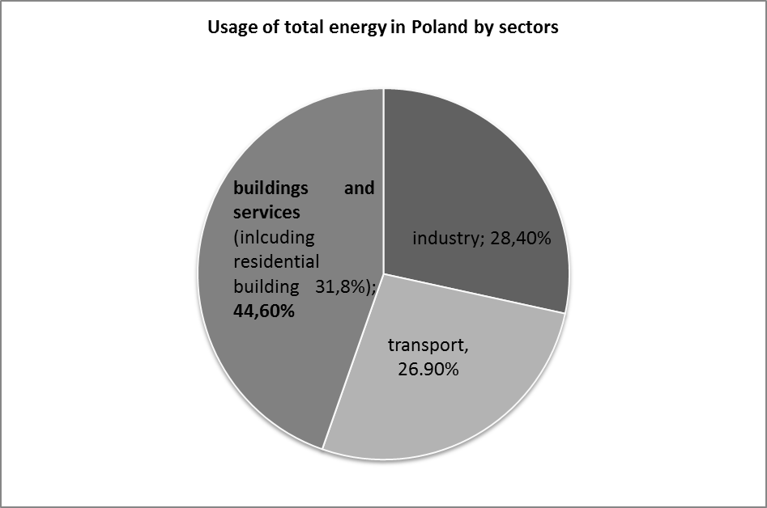
Fig. 1 Usage of Total energy In Poland by sector [source: : GUS, Polityka paliwowo- energetyczna 2007-2008 wg. Metodologii EUROSTAT (bez rolnictwo) ]

As far as energy is concerned Poland relies on coal. Taking into account that this natural resource is blamed for huge CO₂ emission imply the need to change the way we live. Slowing down the consumption rate of primary energy resources is an effective approach to protect the environment. It is crucial to convert existing cities into sustainable ones. Population with proper level of ecological awareness can change the future of our planet. Some customers are more aware of environment protection issues. Nowadays, responsible ones while making decisions take into consideration not only the price of the product but also the producer’s strategy concerning environment protection. Companies in energy sector need to face upcoming changes. Better communication with business environment and ecological approach is currently required from them.
Let’s imagine we can convert existing cities to sustainable one. How can we do it? The sustainable idea of life should be visible in everyone’s actions- starting from school kids, through customers to global companies. It is commonly known that the first step to ecological awareness is to recognize our own impact on the environment. This paper is an attempt to describe the idea of sustainable Poland. It is mainly focusing on cities. Meeting the goal “3x20” means converting to societies with lower energy consumption and renewable energy sources. As energy consumption is responsible for most of negative effects on the environment authors are showing the possible way to reduce the usage of natural resources and energy. However the ideas revealed in this paper are just created for reason of the article. The solutions are author’s own proposals for recent environmental problems and were not implemented in reality.
- Solution towards sustainable development of the cities
Lets imagine that in order to change consumption habits all energy companies and societies work together. Government creates laws and regulations to convert present energy system into more environmental friendly. The new energy usage control system is a useful tool to create sustainable societies. It could be called “MyFootPrint”. The system is introduced by Energy Companies in Poland and it’s a response to laws and regulations putting pressure on energy saving projects and technologies. European Parliament implemented new directives and regulations concerning energy efficiency. One of those documents is “Action Plan for Energy Efficiency: Realising the Potential” created by Commission of the European Communities and introduced in year 2006. It is focused on providing European citizens the most energy efficient infrastructure, housing, appliances, etc. This goal ought to be achieved by increasing the energy efficiency of buildings and devices. This Action Plan assumes financial support for energy saving actions. “MyFootPrint” has also another practical application, it can serve as an advantage while reaching energetic certificates. In Poland the most common regulation is “White Certificate”, part of energetic effectiveness legislation introduced on 15th April 2011 that aims to reach till year 2016 savings in final energy at least the level of 9% . Companies that want to apply for this certificate have to obtain savings of energy in three areas: increasing energy savings through final recipients, increasing energy savings in own machine equipment, decreasing energy loss in distribution. Another resolution that underlines the need of bigger social and environmental commitment by companies is “A renewed EU strategy 2011-14 for Corporate Social Responsibility” published in October 2011 by European Union where one of the aims is “The need to address company transparency on social and environmental issues from the point of view of all stakeholders, including enterprises themselves”
“MyFootPrint” is a panel, where customer can get information about its daily, monthly and yearly energy consumption of the building and electric devices. Consumed energy is split into segments such as:
- central heating, cooling,
- hot water,
- ventilation,
- household equipment.
Thanks to that data people are able to determinate the segment which consumes the most energy. The amount of energy is recalculated to measure the CO₂ emission of the building. The system is designed to be able to compare the energy usage of one household to average consumption of the rest of the households in the country and in the neighbourhood. “MyFootPrint” is a customer friendly application, which can be operated from home and online. The system is also combined with car’s computer and counts amount of energy used and CO₂ emission of the car. It is presumed that in the future most of the cars will be running on electricity. There is also one very interesting feature included and it’s called: “green expert”. This option gives the consumer the hints on how to decrease the energy usage which would reflect in lower impact on environment and lower energy bills. The system is also introduced to schools, museums, stores, producing plants and etc.
Thanks to “MyFootPrint” local governments and energy companies can reward those who care for environment by reducing the energy usage. To motivate societies to be more energy efficient, the price of electricity depends on the level of energy consumption. The lower level, the cheaper price of kW. The price of energy will also vary depending on the energy resources used. This action should force companies to be more environmental friendly as customers will be more likely to sign a contract with “greener” energy supplier. Special energy plans could be introduced, where price for kWh will differ depending on the source of energy used and the level of energy usage.
This idea of “MyFootPrint” system could be one of the possibilities for energy companies to be more environmental responsible and for customers to increase ecological awareness and to set new consumption habits. Previous researches show that most effective factor to create more sustainable societies is to implement both legislative and economical incentive. Thanks to “MyFootPrint” local governments and energy companies could reward those who care for environment by reducing the energy usage. “My Foot Print” can be considered as a great tool of Corporate Social Responsibility (CSR).
- “MyFootPrint” as a Corporate Social Responsibility tool
In the idea of Corporate Social Responsibility everything is about efficient functioning in whole business environment with taking into consideration all stakeholders and profits for the company. In case of CSR, the group of people that will be encompassed by specific actions can include clients, workers, suppliers, stockholders, local societies and natural environment, all of them with stronger or weaker relationships with the company. Environmental issues require new way of thinking and re-creating long term strategies in companies from energy market. New strategy means new approach and considering bigger amount of external factors that can influence business decisions. Two groups of new aspects should be taken into consideration, the first will be laws and countries regulation and the second one will be better communication and understanding of client’s needs. Each company that wants to achieve long term success should focus on new solution. “MyFootPrint” as a modern tool of CSR will allow energy suppliers to achieve competitive advantages and become a long term leader on the market. This approach is focused on communication with stakeholders, protecting natural environment in a long term perspective.
Corporate Social Responsibility is looking for the best choices to provide the biggest profits for the company in long term in the same time maintaining good relations with all stakeholders. Trying to meet stakeholders needs and expectations because they are the ones that have great influence of company being. Efficient functioning in this case is checking all alternative options and choosing the one that enable company development, keeping and increasing position on the market. This approach is compatible with economics-function, grow and earning money. CSR in energy sector is focused on four main aspects, environment protection, transparency, dialogue with customers and corporate image. “MyfootPrint” is a tool that allows the company to strengthen and intensify all four of them. As an innovative solution “MyfootPrint” builds image of the company that is continuously developing. Customers that nowadays pay more attention to the product they choose, often prefer supplier which takes care for environment and offer something more than just a product. In this case company will be seen as a subject that is trying to face upcoming environmental problems. This tool gives also a great opportunity to keep and reinforce dialogue with customers. Thanks to internet panel clients and producers have a platform to direct communication. This panel is not only a source of smart hints allowing to save energy and decrease bills, but it can also serve to exchange opinions, ideas and thoughts between supplier and client. Both are able to express their concerns, suggest some solutions or just ask questions in case of any doubts. With time customers will become used to plan and monitor their energy usage in households and they will be loyal to the certain energy supplier, which will also be a gain for company. “MyFootPrint” internet panel can be considered as a perfect source of information about the company for their customers. All corporate information, results, process, strategy and other important issues can be placed there. This solution is a warranty of transparency, which is crucial, especially in energy sector. Fundamental benefit of introducing “MyFootPrint” is protection of environment. Through permanent control of the level of energy usage, which is important to both companies and clients, the big amount of waste can be eliminated. Energy planning and adjusting according to clients needs generates real savings for customers and for environment. Thanks to this solution cities where energy suppliers offer “MyFootPrint” can profit from environmental, social and economical aspects of development.
Conclusion
It is impossible to solve all environmental problems at once, especially in such a fast changing World. Cities have big impact on implementation of sustainable development ideas. To be successful in protecting the environment all stakeholders in ”energy chain” should work together. The idea of “MyFootPrint” is the way to improve communication between them all. This solution, if ever implemented in Poland, could be treated as a modern CSR tool and could be a perfect answer for energy sector. This system will create sustainable cities with energy efficient buildings, household equipment, cars, etc. Reduction of CO₂ emission contributes to decrease of climate change effects. By choosing the CSR tool like “MyFootPrint” companies from energy sector would be able to maintain better communication with their most important stakeholders: customers and ecological surrounding. Responsible companies while setting strategy goals should apart from financial profit include needs and expectations of stakeholders with consideration of the business environment they function in. This will also help them to reach a competitive advantage and become a leader in new green world market.

Legistration of European Union created a set of goals to be achieved by 2020, increase of energy efficiency by 20%, reduction of CO₂ emission by 20% and increase of energy that comes from renewable sources by 20%
Communication from the Commission, Action Plan for energy efficiency: Realising the Potential, COM(2006)545 final, Brussels, 19.10.2006
USTAWA z dnia 15 kwietnia 2011 r. o efektywności energetycznej, Opracowano na podstawie Dz. U. z 2011 r. Nr 94, poz. 551. (http://isap.sejm.gov.pl/DetailsServlet?id=WDU20110940551)
A renewed EU strategy 2011-14 for Corporate Social Responsibility, Brussels, 25.10.2011 COM(2011) 681 final (http://ec.europa.eu/enterprise/policies/sustainable-business/files/csr/new-csr/act_en.pdf)
A renewed EU strategy 2011-14 for Corporate Social Responsibility, Brussels, 25.10.2011 COM(2011) 681 final, p.5 (http://ec.europa.eu/enterprise/policies/sustainable-business/files/csr/new-csr/act_en.pdf)

