Modeling the Implications of Land Demand for Hydropower Catchments:
SEA of Viet Nam’s Quang Nam Province Land Use Plan 2011-2020

Abstract

Land use planning has to carefully balance economic growth with the coping capacity of the underlying environment. A decline in the abundance, quality and resilience of natural resources and ecosystems does not only affect the environment itself, but also sectors that heavily depend on intact environmental services without which they can’t achieve their growth targets.

To account for such conflicts and facilitate the identification of sustainable development alternatives, Viet Nam commissioned a Strategic Environmental Assessment for the Quang Nam Province Land Use Plan 2011-2020. A land demand allocation model was embedded to review the pressures of different development scenarios on hydropower catchments.

1 Introduction

Viet Nam’s Quang Nam province is in unique geographic position: Together with Hue province, it encloses the city of Da Nang, Central Viet Nam’s third largest economic center and a node for international and regional trade (sea port, East-West and Eastern Economic Corridor).

Quang Nam contributes to Da Nang’s industrial development by supplying important provisioning services: agriculture and aquaculture outputs from the coastal plains; timber and minerals from the Annamite Mountains. The latter are also an important pillar of Viet Nam’s Power Development Plan, with several medium and large hydropower plants operating or planned there (Figure 1). Their reliance on intact regulating and supporting services (soil protection, water regulation etc.) in the dam catchment area makes them vulnerable to increasing pressure from land conversion for agriculture.

Sector development priorities and corresponding land demand are reviewed and allocated in land use plans. In Viet Nam, the provincial Departments of Natural Resources and Environment (DONRE) develop provincial land use plans (PLUP) for 10 year periods, with revisions every 5 years. Quang Nam’s DONRE started developing its latest PLUP for 2011-2020 in February 2010 and submitted the draft PLUP 2011-2020 to the Provincial People’s Committee (PPC) for approval in December 2010. To help Quang Nam DONRE to better account for the implications of land demand and land allocation on sector performance, the Greater Mekong Subregion Environment Operations Center (www.gms-eoc.org) conducted an SEA alongside (ex-ante) the writing of the Quang Nam Land Use Plan 2011–2020. The evaluation of environmental costs and benefits was strengthened through the integration of spatial decision support tools. A land demand allocation model played a central role in identifying potential conflicts between agriculture expansion and intactness of hydropower catchments, and facilitated cross-sector discussion about mutually beneficial alternatives.

2 Methodology and Results

The CLUE-s model – short for Conversion of Land-Use Change and its Effects – is a land demand allocation model developed by the Wageningen Agricultural University (www.cluemodel.nl). The SEA team formulated two land demand scenarios to preview the potential outcomes and implications of different development trajectories:
Land Demand Scenario 1 – Conserve to maintain long-term function: Emphasis on maintaining forest ecosystems that are providing critical regulating and supporting services to hydropower performance. Increased food demand (demand of agriculture sector) is satisfied through productivity enhancement measures rather than land expansion. Benefit sharing mechanisms such as PES engage local communities in forest maintenance, providing them with sustainable livelihood opportunities outside small-scale farming.

Land Demand Scenario 2 – Convert to maximize short-term output: Focus on timber harvesting and expansion of commercial plantations to satisfy increasing demand from the manufacturing sector (furniture, rubber, pulp and paper). Agricultural outputs are increased through land conversion rather than productivity enhancements. Legislation on forest and watershed protection exists, but is not strictly enforced.

The trends identified for these two demand scenarios are translated into future land allocation values (hectares) for each land use class, with a present-day baseline land use map as a reference. In the case of Quang Nam province, the baseline land use map (2007) was compiled from three sources to leverage from their respective strengths: MARD/FIPI Forest Cover Classification of 2008 (for forest classes), MONRE Land Use Classification of 2005 (for land-use classes), and classification of AWIFS satellite imagery of 2007 (to fill gaps between the MARD/FIPI and MONRE datasets).

Following the development of the baseline land use map, additional spatial components of the model were prepared. A layer of spatial policies and restrictions was generated from information on protected areas (special use forest, MONRE) and biodiversity conservation corridors (ADB CEP-BCI). The land suitability component of the model was configured with eight “explanatory” layers: elevation, slope, aspect, cost-distance to coast, cost-distance to road, cost-distance to rivers, population density, and cost-distance to settlement.

With these spatial and non-spatial inputs, the CLUE-s model produced two future land use maps: one of land use in 2020 following scenario 1 (conserve to retain function) and one of land use in 2020 following scenario 2 (convert to maximize output) (Figure 3). A third map was produced combining these both future maps with the baseline map of 2007, showing (i) which areas change in both scenarios, (ii) which areas change in either scenario, and (iii) which areas do not change, regardless of scenario (land conversion risk map, Figure 4).

3 Analysis

The CLUE-s outputs show similar land use conversion patterns in the coastal lowlands for both land demand scenarios (Figure 4). Toward the Annamite Mountains, the differences between the scenarios become apparent: At the fringe between the coastal lowlands and the upland areas, conversion rates of scenario 1 reduce significantly, while scenario 2 maintains high conversion rates, even with a tendency to larger patch sizes compared to the lowlands. Land use conversion trajectories generally align to mountain valleys, reaching even remote areas near the Laotian border.

Overlaying the catchments of major hydropower dams in Quang Nam on the land conversion map (Figure 4) puts the risk of deforestation into direct context with the needs of hydropower investments for intact watersheds. Depending on the scenario and hydropower catchment, 4%–18% of the land is at risk of being converted (The average conversion rate under scenario 1 is 5%, significantly lower than for scenario 2 (12%). Also, while in scenario 1 only one catchment (Dak Mi 4) faces the risk of more than 10% deforestation until 2020, scenario 2 has 7 hydropower catchments facing the same risk. The land demand allocation model also reveals that some dams are expected to be less affected by different development scenarios than others: while Song Bung 5, Dak Mi 1 and Dak Mi 4 show almost equal levels of risk of forestation in both scenarios, other dams show that a careful choice of development scenarios can result in significantly reduced risk of land conversion in hydropower catchments (e.g., Song Con 2: scenario 1: 5%, scenario 2: 18%; Song A Vuong: scenario 1: 4%, scenario 2: 15%).

Using these results as inputs into subsequent models, such as the Universal Soil Loss Equation can provide even more detailed figures for cost-benefit analyses and provide further important arguments for forest protection and development of ecosystem service payment trials in selected hydropower catchments.

4 Outcome and Conclusion

The purpose of the SEA of the Quang Nam PLUP 2011-2020 was to raise awareness with national and regional planners on different sectors’ requirements for provisioning, regulating and supporting services, and the need to harmonize these through sustainable land demand projections and land allocation.

The exercise yielded several tangible outcomes. All relevant provincial stakeholders, the Department of Agriculture and Rural Development (DARD) and Department of Planning and Investment (DPI) as well as DONRE, were involved in scenario development. CLUE-s outputs highlighted the potential impacts of unrestricted agricultural land expansion on the integrity of hydropower catchments. The results proved to be powerful cross-sector communication tools, increasing the recognition of sector conflicts and understanding of the role of ecosystem intactness for energy sector performance. As a result of this SEA in general and model application in particular, the LUP team revised their land allocation scenarios twice to better reflect these dependencies and harmonize sector requirements. Besides raising awareness with high-level planners and decision makers, the pilot project also built conceptual and technical capacity on SEA and scenario-based spatial models among DONRE, DARD, and DPI technical staff, creating the foundation for the successful application in future provincial planning.

Despite these successes, several broader challenges remain. First, with no legal requirement for SEAs of provincial plans, commitment of provincial authorities to support SEA exercises with comprehensive scenario and impact assessment components remains limited. The LUP land evaluation and allocation procedure is not transparent and appears to be demand driven (sector and national targets) rather than being based on a realistic assessment of the supply side, i.e., land suitability and coping capacity. Limitations with regard to GIS data availability and accuracy, particularly land cover and land-use data, need to be addressed urgently to develop reliable spatial information on sector-specific land suitability and budgeting of related supply. Viet Nam’s rapid economic growth, sector diversification, and resource demands require significant investments into a national and provincial spatial data infrastructure and management skills that can cope with the steadily increasing planning complexity.

References

ADB (Asian Development Bank). 2007. Subregional Environmental Performance Assessment (EPA) Report of the Greater Mekong Subregion. Manila.
Castella, J.-C., S.P. Kam, D.D. Quang, P.H. Verburg, and C.T. Hoanh. 2007. Combining Top-down and Bottom-up Modelling Approaches of Land Use/Cover Change to Support Public Policies: Application to Sustainable Management of Natural Resources in Northern Vietnam. Land Use Policy. 24(3). pp. 531–545.
GLOBIO3: A Framework to Investigate Options for Reducing Global Terrestrial Biodiversity Loss. http://www.globio.info/downloads/14/fulltext%20(artikel%20GLOBIO).pdf
Ramachandran, P., and L. Linde. 2011. Integrating Spatial Support Tools into Strategic Planning – SEA of the GMS North-South Economic Corridor Strategy and Action Plan. Environmental Impact Assessment Review. 31. pp. 602–611.
Trisurat, Y., R. Alkemade, and P. Verburg, 2010. Projecting Land-Use Change and Its Consequences for Biodiversity in Northern Thailand. Environmental Management. 45. pp. 626–639
UN CDB (United Nations Convention on Biological Diversity). 2006. Global Biodiversity Outlook 2. Montreal.
———. 2010. Global Biodiversity Outlook 3. Montreal.
UNEP (United Nations Environment Programme). 2007. Global Environment Outlook 4. Nairobi.

Figures

Indicator | 2000 | 2010 | Increase
Population | 1,395,297 | 1,425,395 | 2%
Agriculture - industrial plantation (rubber, coffee, tea) (ha) | 3,528 | 8,312 | 136%
Agriculture - orchards (ha) | 4,698 | 8,782 | 87%
Tourism - tourists (number of arrivals) | 1,362,000 | 2,400,000 | 76%
Tourism - revenue (billion VND) | 900 | 2,162 | 140%
Hydropower - number of dams (large) | 0 | 10 | -
Hydropower - installed capacity (MW) | 0 | 714 | -
Hydropower - remaining potential (MW) | 1,328 | 614 | -
ha = hectare, MW = megawatt, VND Vietnamese dong.

Figure 1: Growth Trends in Quang Nam Province

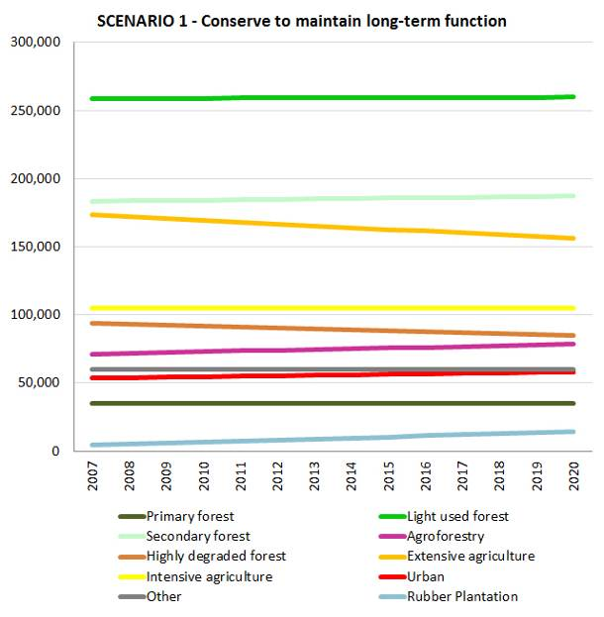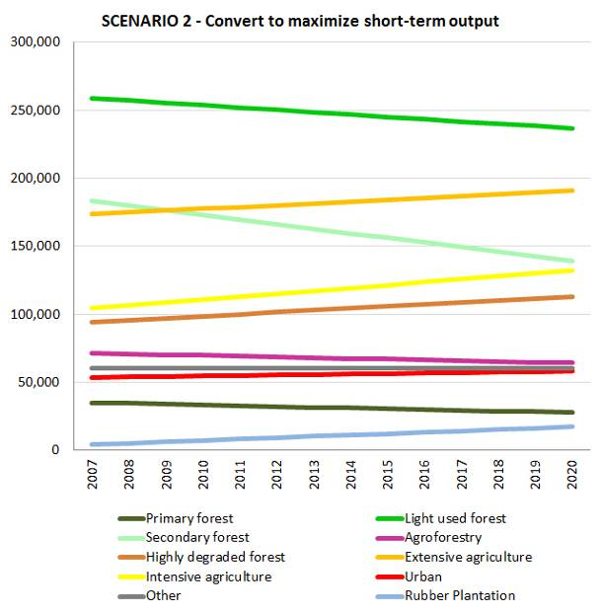
Figure 2: Two land demand scenarios (policy alternatives) used as inputs in CLUE-s. Left: scenario 1 (conserve to maintain long-term function), right: scenario 2 (convert to maximize short-term output)

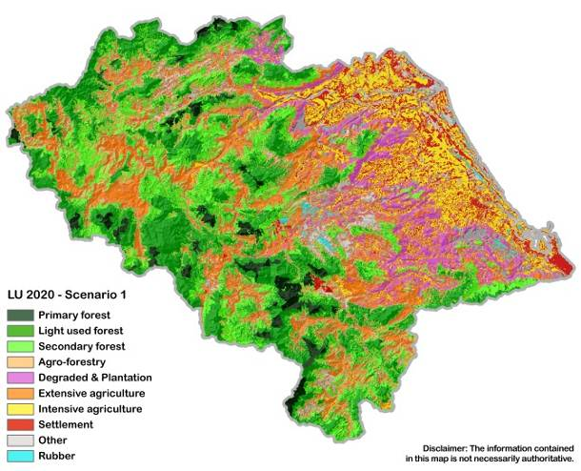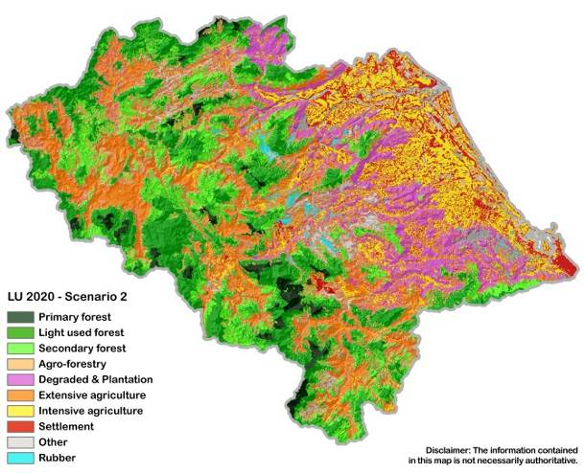
Figure 3: Output of the CLUE-s model: Future land use maps of Quang Nam province (2020), left: scenario 1, right: scenario 2.

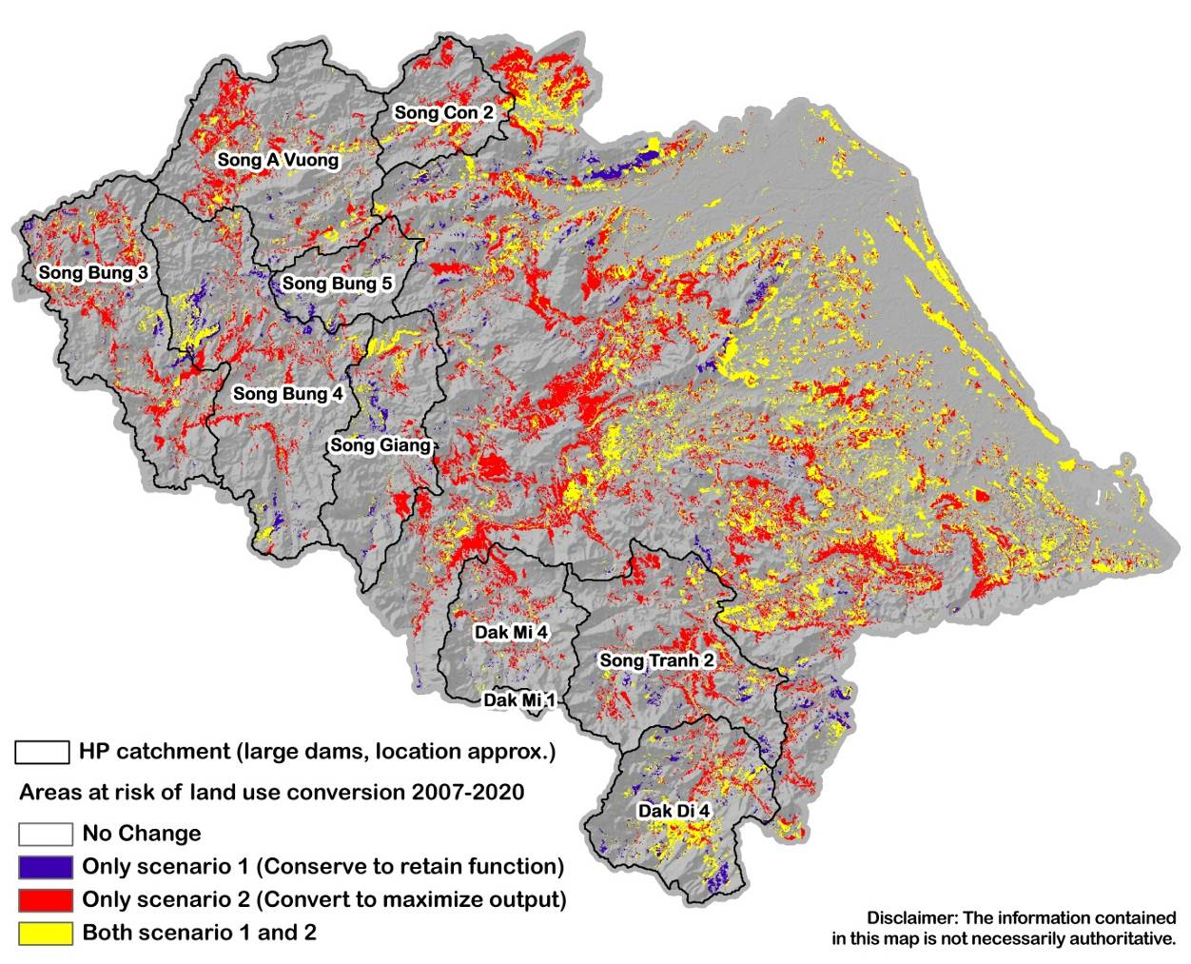

Figure 4: Land conversion map overlaying the spatial impacts of scenario 1 and 2 overlaid on major hydropower catchments.

Dam | Area (ha) | Scenario 1 | Change (%) | Scenario 2 | Change (%)
Dak Di 4 | 45,919 | 6,285 | 14% | 7,224 | 16%
Dak Mi 1 | 2,223 | 40 | 2% | 28 | 1%
Dak Mi 4 | 34,217 | 677 | 2% | 2,999 | 9%
Song Tranh 2 | 60,056 | 2,161 | 4% | 7,697 | 13%
Song A Vuong | 68,496 | 2,543 | 4% | 10,059 | 15%
Song Bung 3 | 63,049 | 2,483 | 4% | 9,281 | 15%
Song Bung 4 | 82,592 | 4,237 | 5% | 8,103 | 10%
Song Bung 5 | 19,836 | 988 | 5% | 1,229 | 6%
Song Con 2 | 24,099 | 1,197 | 5% | 4,280 | 18%
Song Giang | 41,462 | 2,411 | 6% | 4,074 | 10%
Total | 441,949 | 23,022 | 5% | 54,974 | 12%
Figure 5: Risk of land conversion (deforestation and degradation) in major hydropower catchments of Quang Nam province by 2020.

http://www.gms-eoc.org

