Modelling and Management of the Impact of Air Emissions in Urban areas
- Introduction

The health impacts of poor air quality are of such importance that policies particularly designed to improve air quality frequently need assessment; in addition many planning applications require consideration of air quality as part of an environmental impact assessment or permitting application. In view of this it is necessary to have access to tools which are able to predict impacts on air quality for a broad range of planning and policy scenarios.

In this paper we present details of one on the most widely used tools, namely ADMS-Urban and EMIT, which have been used for many air quality impact assessments across the world. The range of cases that can be considered by the model includes investigation of the impact on local up to large urban scale of air quality action plans or mitigation policies implemented at the local, urban, regional or national scale.

- ADMS-Urban and EMIT

  - Model Features

ADMS-Urban (Carruthers et al 2002, CERC 2010) is a computer based model which incorporates the latest scientific understanding of atmospheric dispersion processes but is designed to be practical to use by air quality practitioners. It models the impact on air quality of the full range of different emission sources across an urban area at very high resolution showing variations in concentration on spatial scales as small as ten metres. Amongst its many features are the following:
- advanced-Gaussian type model nested in regional trajectory model;
- chemical reaction scheme(s), meteorological preprocessor, effects of changes in roughness and terrain elevation;
- allowance for up to 6,500 individual sources including up to 3,500 explicit sources comprising up to 1,500 road sources each with up to 50 vertices, up to 1,500 point, line, area and volume sources, up to 500 aircraft jet sources and also up to 3,000 grid sources to account for a range of smaller source types which cannot be defined explicitly;
- a fully integrated street canyon model based on OSPM (Berkowicz 2000);
- algorithms to calculate emissions directly from traffic flows using road traffic emission factors or direct use of calculated emissions;
- the model is fully integrated with a Geographical Information Systems (GIS) and an Emissions Inventory Database (EMIT);
- output via GIS includes high resolution pollutant concentration maps;
- the system can consider Air Quality Management and Mitigation Options e.g. low emission zones, technical options, traffic management; source apportionment;
- short term air quality forecasting as well for impact assessment.

The model was first released in 1997. As well as being used in many hundreds of smaller municipal authorities or urban boroughs it has been applied to such major cities as London, Paris, Moscow,Rome, Bologna, Beijing, Shanghai, Singapore, Barcelona, Vienna, Glasgow and Dublin.
EMIT is an Emissions Inventory Tool. EMIT can be used to store, manipulate and assess emissions data from a variety of sources.
Emissions data held in EMIT can be used for:
- local air pollution studies of toxic pollutants;
- greenhouse gas emissions inventories;
- estimating emissions for use in IPPC applications; and
- road traffic noise mapping studies.
The data used in all these environmental assessments must be consistent and traceable—EMIT can help to do this. EMIT is particularly useful for emission-reduction scenario testing, for example to investigate the effect of Low Emission Zones and Home Zones in urban areas, and ways of reducing greenhouse gas emissions as a step towards meeting Agenda 21 or Kyoto targets.

3. Model validation and model output

A pre-requisite for the model to be used with confidence for impact assessment is the comprehensive model validation which has been undertaken. This has comprised validation of individual model modules (e.g. meteorological pre-processor, canyon module, point source module, road source module, complex terrain module, chemistry module etc., and comprehensive validation in major urban areas. This validation has been described elsewhere (for example see www.cerc.co.uk) and will not be repeated in this paper.
4. Model Applications

As discussed in the introduction, ADMS-Urban (and indeed other air quality models) have a number of key applications. These broadly comprise the following:
- assessment of current air quality; this is necessary because monitors only provide point information which must be supplemented by modelling where there are significant gradients in pollutant concentrations which is generally the case near any significant sources of pollution (see for example the concentration gradients in the urban areas shown in Figure 2);
- assessment of future air quality taking account of changes to emissions due to policy measures, planning decisions, mitigation options etc., of changes to meteorology due to climate change, of changes in urban form etc., and of changes to background concentrations due to regional/global changes. ADMS-Urban can be used to test the impact of action plans or policies (local, urban, regional or national scale) at local up to large urban scale;
- source apportionment studies to determine which sources most influence the concentration at a particular location;
- air quality forecasting.

Here we focus mainly on the second of the model applications, that is assessment of future air quality taking account of potential changes in emissions due to various planning or policy options. We also discuss air quality forecasting with reference to Beijing.

4.1 London’s air quality

Figure 3 shows an example model calculation of ozone concentrations, specifically the number of days on which the 8 hour average concentration exceed 100µg/m³ in 2001, 2010 and 2020 in London. The scenario is ‘business as usual’, i.e. it is assumed that legal requirements are put in place, including adherence to the National Emission Ceiling Directive (2001) and introduction of vehicle EURO technology standards, but that no additional measures are taken to reduce pollutant levels. The number of exceedences is seen to increase in the forward projections (2010 and 2020); this occurs because of a reduction in NO_{x} concentrations across London and therefore a reduction in the titration of ozone by NO so that the urban concentrations of O₃ approach background levels

Table 1 shows the impact of the additional policy measures studied as part of “options for further improvements in air quality” (Measure Q, DEFRA 2006), which includes a programme of incentives for early uptake of Euro V and VI standard vehicles, a programme of incentives to increase penetration of low emission vehicles and additional small combustion plant mitigation measures. For the both the business as usual case and the case including Measure Q the table shows the population weighted mean covering all London of both the annual average NO₂ and PM_{2.5} concentrations. It also shows the percentage of London’s total area where the annual average NO₂ concentration exceeds 40 µg/m³ and the percentage of the population which is ‘exposed’ to an annual average greater than 40 µg/m³. Note that for the population weighted mean and percentage of population exceeding 40 µg/m³ no account is taken of population movement with each member of the population assumed to be located permanently at their place of residence. Effects of population movement on exposure is currently a topic of great interest (e.g. GENESIS (2010) In this case the impact of measure Q is seen to be relatively modest.

Figure 3. London. Calculated O₃ concentrations for business as usual: number of days in which the 8 hour maximum concentration exceeds 100µg/m³ for 2001, 2010 and 2020.
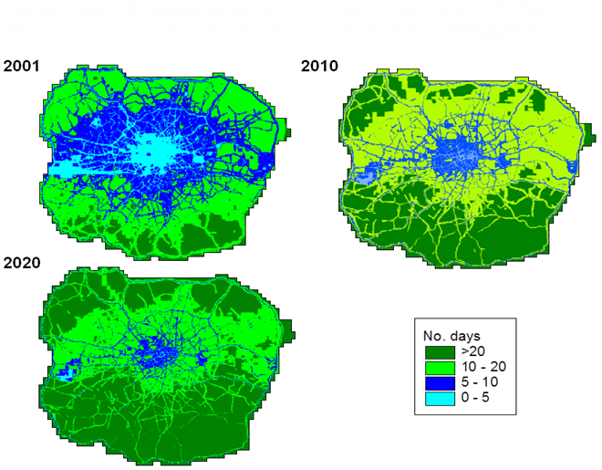
Table 1. Impact of emission reduction ‘Measure Q’ (DEFRA 2006).

- Annual average NO₂ concentrations

 | 2010 |  |  | 2020
 | Base | Q |  | Base | Q
Population weighted mean (µg/m³⁾ | 35.00 | 34.6 |  | 31.2 | 29.8
% Area exceeding 40 µg/m³ | 12.8 | 11.9 |  | 6.2 | 4.5
% Population exceeding µg/m³ | 19.9 | 18.1 |  | 10.6 | 8.0

- Annual average PM_{2.5} concentrations

 | Base | Q | Measure Q  Reduction
2010 | 13.8 | 13.7 | 1.1%
2020 | 12.6 | 11.8 | 6.7%
Year Reduction | 9.0% | 14.1%

4.2 Beijing’s air quality: emission controls

The final example relates to the multiplicity of mitigation measures that were conducted in Beijing in the run up to and during the Olympic Games. Ongoing controls introduced well before the Games included those on industry/power supply; domestic coal burning; many traffic reduction policies. The final stage of reduction was introduced on July 20 2008 and included the following additional measures:
  - reduction in the use of private cars
  - further reduction in the use of government cars
  - a temporary halt to construction during the Olympic period
  - more cleaning of the roads to reduce dust
  - the suspension of heavily polluting industry
  - a reduction in production for coal-based enterprises

Figure 4 shows the prediction ADMS-Urban air quality forecast (in hindcast mode to eliminate impacts of missing input data but no other changes) compared with monitored data (EPB) and the air quality forecast from the ministry of the environment (MEP). In each case calculations are represented using the Chinese Air Pollution Index (API). In the first time series the impacts of the emission reduction measures are included in the modelling. In the second case these are not taken into account. The time series show the generally good performance of the model forecasts and the large impact of the emission reduction measures on pollutant concentrations.
Figure 4. ADMS–Urban short term forecast of Air pollution index (API) averaged across all Beijing monitor locations compared with observed concentrations (EPB) and forecasts of the Ministry of Environmental Protection (MEP; one representative value); (a) with emission reductions (b) without emission reductions.

5. Conclusions
The paper has presented ADMS–Urban and examples of its application for assessing the impact of planning and policy measures both of the long time frame (years) and short time frame (days). The examples include assessment of current air quality, assessment of future air quality (air quality projections), source apportionment and air quality forecasting. The model set-up is robust the model predictions in general show a high degree of consistency with measurement concentrations. Confirming the model is an appropriate tool for such applications.

- References
Berkowicz R. (2000) OSPM-A parameterized street pollution model. Environmental Monitoring and Assessment, Volume 65, Issue ½ pp 323-331.
Carruthers D.J. Blair J and Johnson K. (2002) Dispersion of air pollution in urban areas in the UK.8th International Conference on Harmonisation, Sofia, Bulgaria, October 2002.
CERC (2010) ADMS-Urban User Guide at www.cerc.co.uk/environmentalsoftware/modeldoumentatiom.html
GENESIS (2010) http://genesis-fp7.eu/project_overview/
National Emission Ceiling Directive (2001) http://ec.europa.eu/environment/air/pollutants/ceilings.htm

