SEA and Climate Change in the Coastal Zone

Abstract: The coastal fringe is particularly vulnerable to climate change. Sea-level rise, changes on wave and current patterns, changes on sediment transport, and changes on the frequency and intensity of storms and extreme meteorological events, all contribute to a rapidly evolving coastline. Nevertheless the words “coastal areas” continue to act like a magnet for human settlement and most of the world’s fastest growing cities and metropolitan areas are on the coastal fringe. In this context, SEA is one extremely important tool in evaluating plans and programs that interfere with the coastal environments, and in establishing the strategic orientations and choices that can enable a compromise between development and conservation. In this paper the authors discuss some of the vulnerabilities of coastal areas, through selected examples of low sandy coastlines (barrier islands, dune ridges and beaches) and coastal wetlands (salt marshes and mangroves) of Europe and Africa. Today’s occupation patterns and their disfunctions are here discussed in order to present some guidelines for future SEA in coastal regions.

Keywords: SEA, climate change, coastal zone, sea-level rise, coastal erosion

1. Introduction
Strategic environmental assessment (SEA) is a systematic, analytical and participatory approach that aims to integrate environmental considerations into policies, plans and programs and evaluates the inter linkages with economic and social considerations (OECD, 2006). The International Association for Impact Assessment (IAIA) has provided criteria for evaluating the procedural and substantive aspects of SEA and the institutional drivers used to explain EIA effectiveness are also suited to explain SEA implementation (Hirji & Davis, 2009). SEA provides an important pathway for introducing environmental concerns into water management at the strategic level of policies, legislation, strategies, programs and plans.
Climate change, for instance, is one of the water-related environmental issues and, together with urbanization, is a major, long-term and human-induced factor that affects natural and human systems in all regions of the world (IPCC, 2007; UN-HABITAT, 2011). The earth’s climate has changed many times in the past in response to natural causes. Over the last century it has however noticeably changed in a shorter timescale, with an increase in climate extremes, leading to more frequent and more extreme floods and droughts, along with general increases in temperature and sea levels. These changes are responsible for different impacts at both surface and groundwater systems. Total quantities of surface runoff and groundwater recharge will be increased or decreased, and the timing and periodicity of these replenishment events will change. For instance the physical, chemical and biological properties of water bodies will change, with predominantly adverse impacts on biological communities and water quality. In coastal areas sea-level rise will exacerbate water resource constraints due to increased salinization of groundwater supplies. Besides coastal aquifers salinization, coastal communities will be affected also due to increases in storm frequency (IPCC, 2007; WWAP, 2009). A framework representing anthropogenic drivers and impacts of and responses to climate change is shown in Figure 1 (IPCC, 2007).
The effects of climate change in water resources are likely to be felt more intensively due to the expected demographic changes. In fact, between 2009 and 2050 the world population is expected to increase by 2.3 billion, from 6.8 to 9.1 billion. At the same time, urban populations are projected to increase by 2.9 billion, from 3.4 billion in 2009 to 6.3 billion total in 2050 (UNDESA, 2009). Those demographic changes will lead to increasing demands for water and food. Presently the growing pressures on water often concentrate in coastal areas, where climate change is expected to have the highest impact. Half of the world’s population lives within 100 km of the sea and three-quarters of all large cities are located on the coast (UNEP & UN-HABITAT, 2005). Predictions show that the proportion of world population living in coastal areas could reach 75% in the 2030s, increasing from 60% in 2010 (Cosgrove et al., 2012). The increase tendency of urbanizing coastal areas will lead to higher levels of pollution of coastal waters, higher salinization of aquifers, and higher pressure on ecosystems, such as mangroves, that serve as barriers to erosion, storm surges and tsunamis. Given the projected rates of urbanization and the concomitant pressures on water resources, risk assessment, urban planning and an integrated water management are the tools available to establish the adequate choices to allow sustainable development to occur. SEA, for instance, is an extremely important tool in evaluating plans and programs that interfere with the coastal environments, and in establishing the strategic orientations that can enable a compromise between development and conservation.

CLIMATIC CHANGE
Sea- level rise
Extreme events
Temperature change
Precipitation change
Greenhouse gases
Aerosols
CLIMATE PROCESS DRIVERS
IMPACTS AND VULNERABILITY
Ecosystems
Water Resources
Settlements and society
Food security Human health
Emissions

Concentrations
EARTH SYSTEMS
HUMAN SYSTEMS
Technology
Health Literacy Equity
Population
SOCIO-ECONOMIC DEVELOPMENT
Mitigation
Adaptation

Source: IPCC (2007)

Figure 1 – Schematic framework of anthropogenic climate change drivers, impacts and responses

2. study areas
Our main goal on this paper is to present two studies that were carried out at NEMUS, Lda. and that are illustrative of two cases of urban planning and coastal management. One of the studies is the SEA of Ria Formosa Coastal Lagoon Polis Management Program (RFMP), a coastal area in the south of Portugal. The RFMP is the first coordinated operation of coastline’s rehabilitation and recovery being performed in the Portuguese territory. Two of its main goals are the protection of nature coastline systems, infrastructures and population against natural risks such as coast erosion and flooding, and the promotion of coastal biodiversity conservation and preservation of natural heritage and littoral landscape. The other study refers to the SEA of the Regional Development Plan (RDP) of KaTembe-Ponta do Ouro in southern Mozambique, a country that is facing a demographic growth and whose population is projected to double by 2040 (from 22 million nowadays to 44 million by 2040) (U.S. Census Bureau International Data Base, 2012). RDP is a strategic planning tool that aims to envisage the south Maputo region as a whole integrating the recent development objectives announced by the government for this region with the existing environmental and social constraints and risks. Its main purpose is to delineate a strategy of regional development taking into account the economic, social and urban development projects, ongoing or planned, and the dynamics that will be generated as a result of their implementation. The new Maputo-KaTembe Bridge and the new KaTembe coastal city project (representing Maputo city’s expansion) are clearly two of the most important driving forces for predictable development of the region. Normally, SEAs are done accounting with the outcomes from several Key Environmental Issues (KEIs) studies. Although other KEIs were used in the study cases here referred, on this paper we will focus mainly on the one related to “Vulnerabilities and Environmental Risks”.
With both studies we are able to: (1) highlight some of the vulnerabilities of coastal areas across Europe and Africa; (2) enhance different realities in terms of urban planning, water supply and wastewater treatment infrastructures, risk and water management in coastal urban areas and city development levels; (3) illustrate the importance of urban planning, integrated urban water management and SEA tools to deal with the unpredictable nature of climate change.
The Portuguese coastline, with an extension of more than 900 km, is characterized by low sandy areas of barrier islands, dune ridges and beaches, rocky coasts with low and high cliffs, bays, estuaries, coastal lagoons, among other geomorphological features. Ria Formosa is a large coastal lagoon on the south coast of Algarve, centered on the city of Faro (Figure 2).

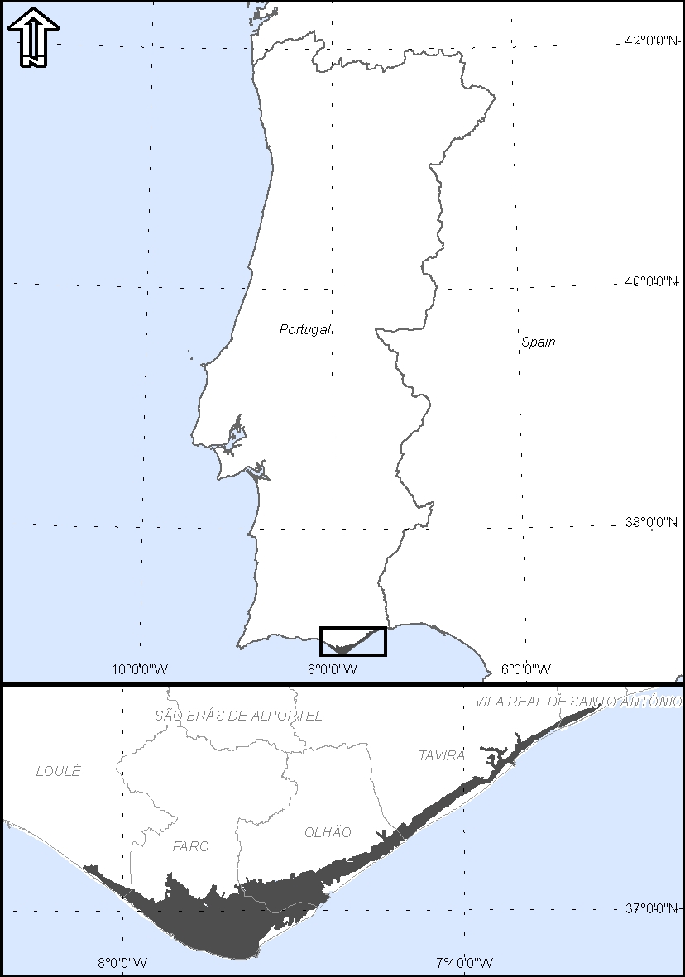
Figure 2 – Location of Ria Formosa area

This coastal lagoon is separated from the Atlantic Ocean by several barrier islands and peninsulas and is facing erosion on the oceanfront and silting up on tidal channels and inner areas. A transgressive behavior with inland displacement of barrier islands and peninsulas has been pointed out for the Ria Formosa coastal lagoon by some authors (e.g. Dias, 1988; Bettencourt, 1994).
The Mozambique coastline has an extension of 2,730 km (Halim, 1984). In the extreme south lies the Bay of Maputo, which is protected from the Indian Ocean by a sandy spit and the island of Inhaca. The Bay receives fresh water from four main rivers with torrential characteristics (Maputo, Umbeluzi, Incomati, Tembe) and is also affected by tide and wave action from the Indian Ocean. Shallow waters and a wide network of channels, sand and mud banks and wetlands also modulate the hydrodynamics of the bay (Figure 3).

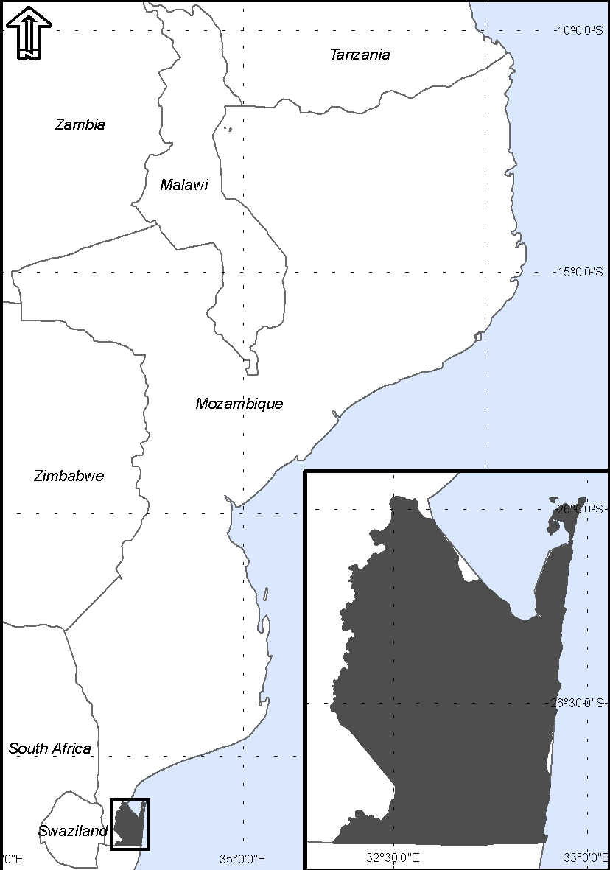

Figure 3 – Location of KaTembe-Ponta do Ouro area

3. Case Study 1: Ria Formosa (Portugal)

Introduction
The area of intervention of the Ria Formosa Coastal Lagoon Polis Management Program is composed by three natural systems that are directly associated and interdependent: lagoon area, dune systems (on the barrier islands and peninsulas) and inner coastal system (Figure 4). The lagoon area is a complex system that has important hydrological, geochemical, biological, ecological and socioeconomical impacts on a regional scale. The lagoon has an important task on the protection and stabilization of the coast against erosion and is characterized by a great biological diversity. It’s an area very sensitive to environmental disturbs, natural or anthropic. The dune system is particularly vulnerable and fragile owing to the natural dynamics and instability of the system. These structures are important because they yield protection to the peninsulas and barrier islands and promote local biodiversity.

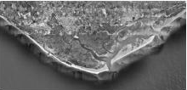
Figure 4 – Portion of the Ria Formosa Coastal Lagoon

Present-day situation and trends of evolution
As in a considerable portion of the Portuguese coast, the coastal areas considered in the RFMP are subjected to strong erosion processes caused by the wave regime. As a result, the retreat of the beach-dune system and the cliff like profile of the frontal dunes occur almost throughout all the frontal beach system of the barrier islands and peninsulas. Several areas where overwashes are frequent were already identified.
The reason for this evolution of the coast is related to the construction of several coastal structures, which block the littoral drift. Sea-level rise is surely affecting these areas contributing also to the evolution of this particular lowland coastal area. In fact, at the present, most of the barrier island systems are evolving through an active migration towards the continents most certainly as a result of the global sea-level rise. Other factors also involved in this active erosion processes are the stepping of the dunes and existence of nearby urban localities, parking spaces and roads. Due to the regional and global tectonic settings where this sandy low-coastal area is located, it is an area with high susceptibility for the effects of a tsunami of seismic origin.

Actions and projects advised in the SEA
The following actions were advised in the SEA as adequate to improve and protect this specific coastal area:
- Demolition and removal of houses and manmade structures located in high risk areas;
- Maintenance and reposition of the ecosystems’ natural conditions: decompression of the soil, restoration and stabilization of the dune fields, planting of endemic vegetation, etc;
- Artificial nourishment of the beaches affected by erosion processes; this action will provide both protection of sea-cliffs and dune recuperation;
- Dredging of the channels for maintenance of biodiversity and opening of artificial inlets for improving water quality and the lagoon capacity of sediments exportation;
- Classification of the urban and touristic core areas;
- Detailed ecologic and hydrodynamic studies of the coastal lagoon and surrounding area;
- Environmental impact assessments for projects related to coastal defense, dredging, etc;
- Involve all stakeholders in projects and actions related to the barrier islands.

4. Case Study 2: Maputo/KaTembe coastal area (Mozambique)

Introduction
The area of intervention of the Regional Development Plan (RDP) of KaTembe-Ponta do Ouro integrates the Maputo Bay, a shallow coastal body strongly influenced by ocean tides. All rivers draining to the bay (Incomati, Maputo, Matola, Umbeluzi, Futi and Tembe) are responsible for its sediment dynamics and salinity gradient. The evolution of the coastline is strongly characterized by continuous processes of erosion. The problems caused by erosion are not only reflected by the narrowing of the beach width but also by the instability of the sea-cliffs and consequent damages upon the structures and houses located over or nearby these areas. Figure 5 shows the KaTembe coastline area where it’s possible to observe sea-cliffs and the presence of a mangrove area. Mangroves protect shorelines from damaging storm and hurricane winds, waves, and floods and also help prevent erosion by stabilizing sediments. The coastline facing the Indian Ocean (at the east limit of RDP area) has an enormous potential for touristic development but is also vulnerable to erosion and sea-level rise. Other vulnerabilities include threat of hurricanes and tsunamis, shortage of usable surface water resources and exposure of groundwater aquifers to saltwater intrusion.

Present-day situation and trends of evolution
People in Mozambique concentrated in the coastal areas as a reaction to the civil war that ended in 1992. In the Maputo region pollution due to industrial activities, poor sewage management, mangrove destruction and coastal erosion, combined with resources exploitation activities, are threatening fisheries, tourism and quality of life in cities around the Maputo Bay. The evolution of the coastal area on the Maputo Bay is strongly characterized by continuous processes of erosion, mainly on the south side of the Bay. The current erosion processes occur primarily during storms; nevertheless the erosion processes certainly will tend to increase in the short-term due to the expected rise of sea level. The highly populated lowlands that surround Maputo Bay area are often flooded and the surrounding coastal areas are prone to erosion and rapid changes in morphology. This makes the existing and projected urban areas extremely susceptible to both sea-level rise and increased frequency of extreme weather events. As the Maputo coastal region is following the evolution trend appointed for other coastal regions in other developing countries the risk of disordered occupation of coastline along with the land lost due to the expected rise of sea level (estimates put Mozambique as the fifth country more vulnerable to this effect in the world) are realities that need to be carefully addressed.

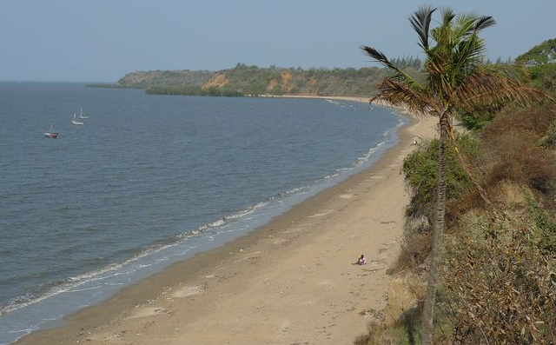
Figure 5 – Sea-cliffs and beach adjacent to KaTembe (the dark arrow → show a mangrove area)

Risks and opportunities analyzed in the SEA
An analysis of risks and opportunities was put in practice in the SEA concerning the environmental vulnerabilities. The following opportunities were identified in the RDP of KaTembe-Ponta do Ouro concerning the coastal area:
- Identification of coastal risk areas and inclusion of environmental vulnerabilities and risks on spatial planning;
- Definition of a protection environmental structure to promote ecological regulation, water management and mitigation of extreme events;
- Previous analysis of risk associated with sea-cliffs’ stability and the proposal solutions for intervention in risk situations;
In terms of guidelines for management and planning associated with the coastal area the following were proposed:
- Provision of mechanisms for the quick movement of coastal populations to inland territory as a response to an effective threat of storms / cyclones;
- Implementation of a monitoring program on the evolution of the coast;
- Interventions in the territory should be carried out favoring the options that best preserve the natural values ​​and associated ecological functions; in this context is important to stress the ecological and economically importance of wetlands (mangroves, salt marshes).

5. final considerations
In this paper we have highlighted some of the vulnerabilities of coastal urban areas namely a greater exposure to floods and storms, aquifers salinization and retreat of the coastline. The risks are exacerbated by climate change and expected tendencies of higher population’s concentrations in cities and coastal areas. From the given case studies, different realities arise in terms of development indicators. In Portugal the coverage of environmental services (sewage treatment and water supply) is high, the wastewater treatment technologies are highly developed and requalification plans such as RFMP are being put into practice as part of an integrated management plan of coastal zones and their impact are being evaluated through SEA procedures, according to national legislation. In Portugal a well-defined legislative framework for water management exists – Water Law – that defines also the planning process for water resources.
Mozambique, instead, has a different reality. The basic sanitation facilities are insufficient; water supply has low coverage and low reliability; water from surface aquifers is often contaminated; the wastewater treatment is lacking; land-use is disordered; and there’s lack of urban planning. In the recent years some steps have been given regarding water and urban management. The programmed development such as the expansion of coastal KaTembe city will be done in a sustained way right from the beginning avoiding risk areas and minimizing catastrophe situations. In this context, the KaTembe special Development Plan is being done. Mozambique doesn’t have legislative requirements for SEA. Instead, Environmental Impact Assessment (EIA) is the legal requirement available in the country for the approval of most significant projects and infrastructures. Nevertheless, a SEA of the Regional Development Plan (RDP) of KaTembe-Ponta do Ouro was carried out giving useful inputs for a sustainable development of coastal area.
Regional plans and programs for coastal areas that promote sustainable urban planning and integrated urban water management are essential to deal with climate change related impacts and to propose measures of mitigation and adaptation. SEA is important as well to establish the strategic orientations and choices that can enable a compromise between development and conservation and risk protection. Applied to the water sector SEA can be a useful instrument to effectively implement the principles of Integrated Water Resources Management (IWRM). Those principles are: using a multisectoral approach to water management, encouraging stakeholder participation and devolution of responsibility and use of economic instruments (Hirji & Davis, 2009). Because IWRM and SEAs share many concepts and characteristics, SEAs potentially offer a complementary tool to IWRM to introduce and integrate environmental considerations into water resources policy, planning, and management, and thereby support IWRM.

REFERENCES

Bettencourt, P. (1994). Les environments sedimentaires de lacôte Sotavento (Algarve Sud Portugal) et leur évolution Holocéne et Actuelle. PhD Thesis, Université de Bordeaux I.
Cosgrove, C., Cosgrove, W. J., Hassan, E. & Talafré, J. (2012). Understanding uncertainty and risks associated with key drivers. Chapter 9. In: WWAP (World Water Assessment Programme). 2012. The United Nations World Water Development Report 4: Managing Water under Uncertainty and Risk. Paris, UNESCO.
Dias, J.A. (1988). Aspectos geológicos do litoral algarvio. Geonovas, 10, 113-128.
Gallopín, G. C. (2012). Five Stylized scenarios. Perugia, Italy, UNESCO-WWAP.
Halim, Y. (1984). Marine Sciences. Restricted Technical Report RP/1981-1983/2/7.4/04. United Nations Educational, Scientific and Cultural Organization, Paris, France.
Hirji, R. & Davis, R. (2009). Strategic Environmental Assessment: Improving Water Resources Governance and Decision Making. Main Report. Water Sector Board Discussion Paper Series. Paper No. 12, April 2009. The World Bank, Washington, DC.
IPCC (Intergovernmental Panel on Climate Change) (2007). Climate Change 2007: Synthesis Report. Contribution of Working Groups I, II and III to the Fourth Assessment Report of the Intergovernmental Panel on Climate Change [Core Writing Team, Pachauri, R.K and Reisinger, A. (eds.)]. IPCC, Geneva, Switzerland, 104 pp.
OECD (Organization for Economic Co-operation and Development) (2006). Good Practice Guidance on Applying Strategic Environmental Assessment (SEA) in Development Co-Operation. DAC Network on Environment and Development Co-operation, Paris: OECD.
UNDESA (United Nations Department of Economic and Social Affairs, Population Division). 2009. World Population Prospects: The 2008 Revision, Highlights,Working Paper No. ESA/P/WP.210. New York, UN.
UNEP & UN-HABITAT (United Nations Environment Programme & United Nations Agency for Human Settlements) (2005) Coastal pollution: The role of cities. Available at: http://www.unep.org/urban_environment/PDFs/ Coastal_Pollution_Role_of_Cities.pdf.
UN-HABITAT (United Nations Agency for Human Settlements) (2006). Meeting Development Goals in Small Urban Centres: Water and Sanitation in the World’s Cities. Nairobi/ London, UN-Habitat/Earthscan.
UN-HABITAT (United Nations Agency for Human Settlements) (2011). Global Report on Human Settlements 2011: Cities and Climate Change. London/Nairobi, Earthscan/ UN-HABITAT.
U.S. Census Bureau International Data Base (2012) available at http://www.census.gov/population/international/data/idb/country.php in 28/03/2012.
WWAP (World Water Assessment Programme) (2009). World Water Development Report 3: Water in a Changing World. Paris/London, UNESCO/Earthscan.

