THE EIA EXPERT MEETING MECHANISM
–THE EXPERIENCE OF KUOKUANG PETROCHEMICAL PROJECT

Abstract
Controversies over specific environmental issues in a development activity frequently arise among the developer, local governments, and relevant organizations. Expert meeting consists of experts recommended by parties in dispute and carries out professional discussions about controversial issues. Expert meeting mechanism can effectively settle controversies, reach consensuses, and maintain public participation. This paper chooses the development project of a petrochemical industrial zone as an example to illustrate how the expert meeting mechanism was used to clarify environmental issues in this project.

Introduction
The environmental impact assessment (EIA) system has been operated in Taiwan for twenty eight years. With practical experiences accumulated in these years, the rise of public environmental awareness makes the public more actively participating important development activities and expressing a dissentient attitude to the procedure, the mechanism of public participation, and the conclusion of EIA review. Therefore, considering the increasing public attention to environmental issues, the pursuit of reasonable and effective public participation is certainly essential.

Expert Meeting Mechanism
In a development activity with controversial issues, it is often difficult to reach consensuses between stakeholders; as a result, Taiwan EPA uses the expert meeting mechanism to settle controversies. In the expert meeting mechanism, parties in dispute, such as the developer, the industry competent authority, local governments, and relevant organizations, recommend experts they trust to take part in discussions. These experts need to have experience or specialty relevant to the controversies and hold value-neutral and interest-neutral discussions about controversial issues based on personal specialty and professional ethics. The meeting finally reaches consensuses which should not be influenced and changed by stakeholders (Figure 1).

Figure 1. Flow chart of the expert meeting system.

This mechanism can effectively settle controversies and carry out risk assessment while assuring the equality of interests of relevant parties. Besides, the involvement of different parties in the expert meeting mechanism also makes the consensuses more easily being accepted by the public and increases the credibility of the EIA review.

Introduction to the Kuokuang Petrochemical Project
The Kuokuang petrochemical project was the development of an industrial zone at coastal region of southwest Changhua County by Kuokuang Petrochemical Technology Corporation (Figure 2). This project was divided into two phases of developments and included reclamation and constructions of oil refineries, naphtha cracking plants, aromatics plants, and midstream and downstream petrochemical plants.¹

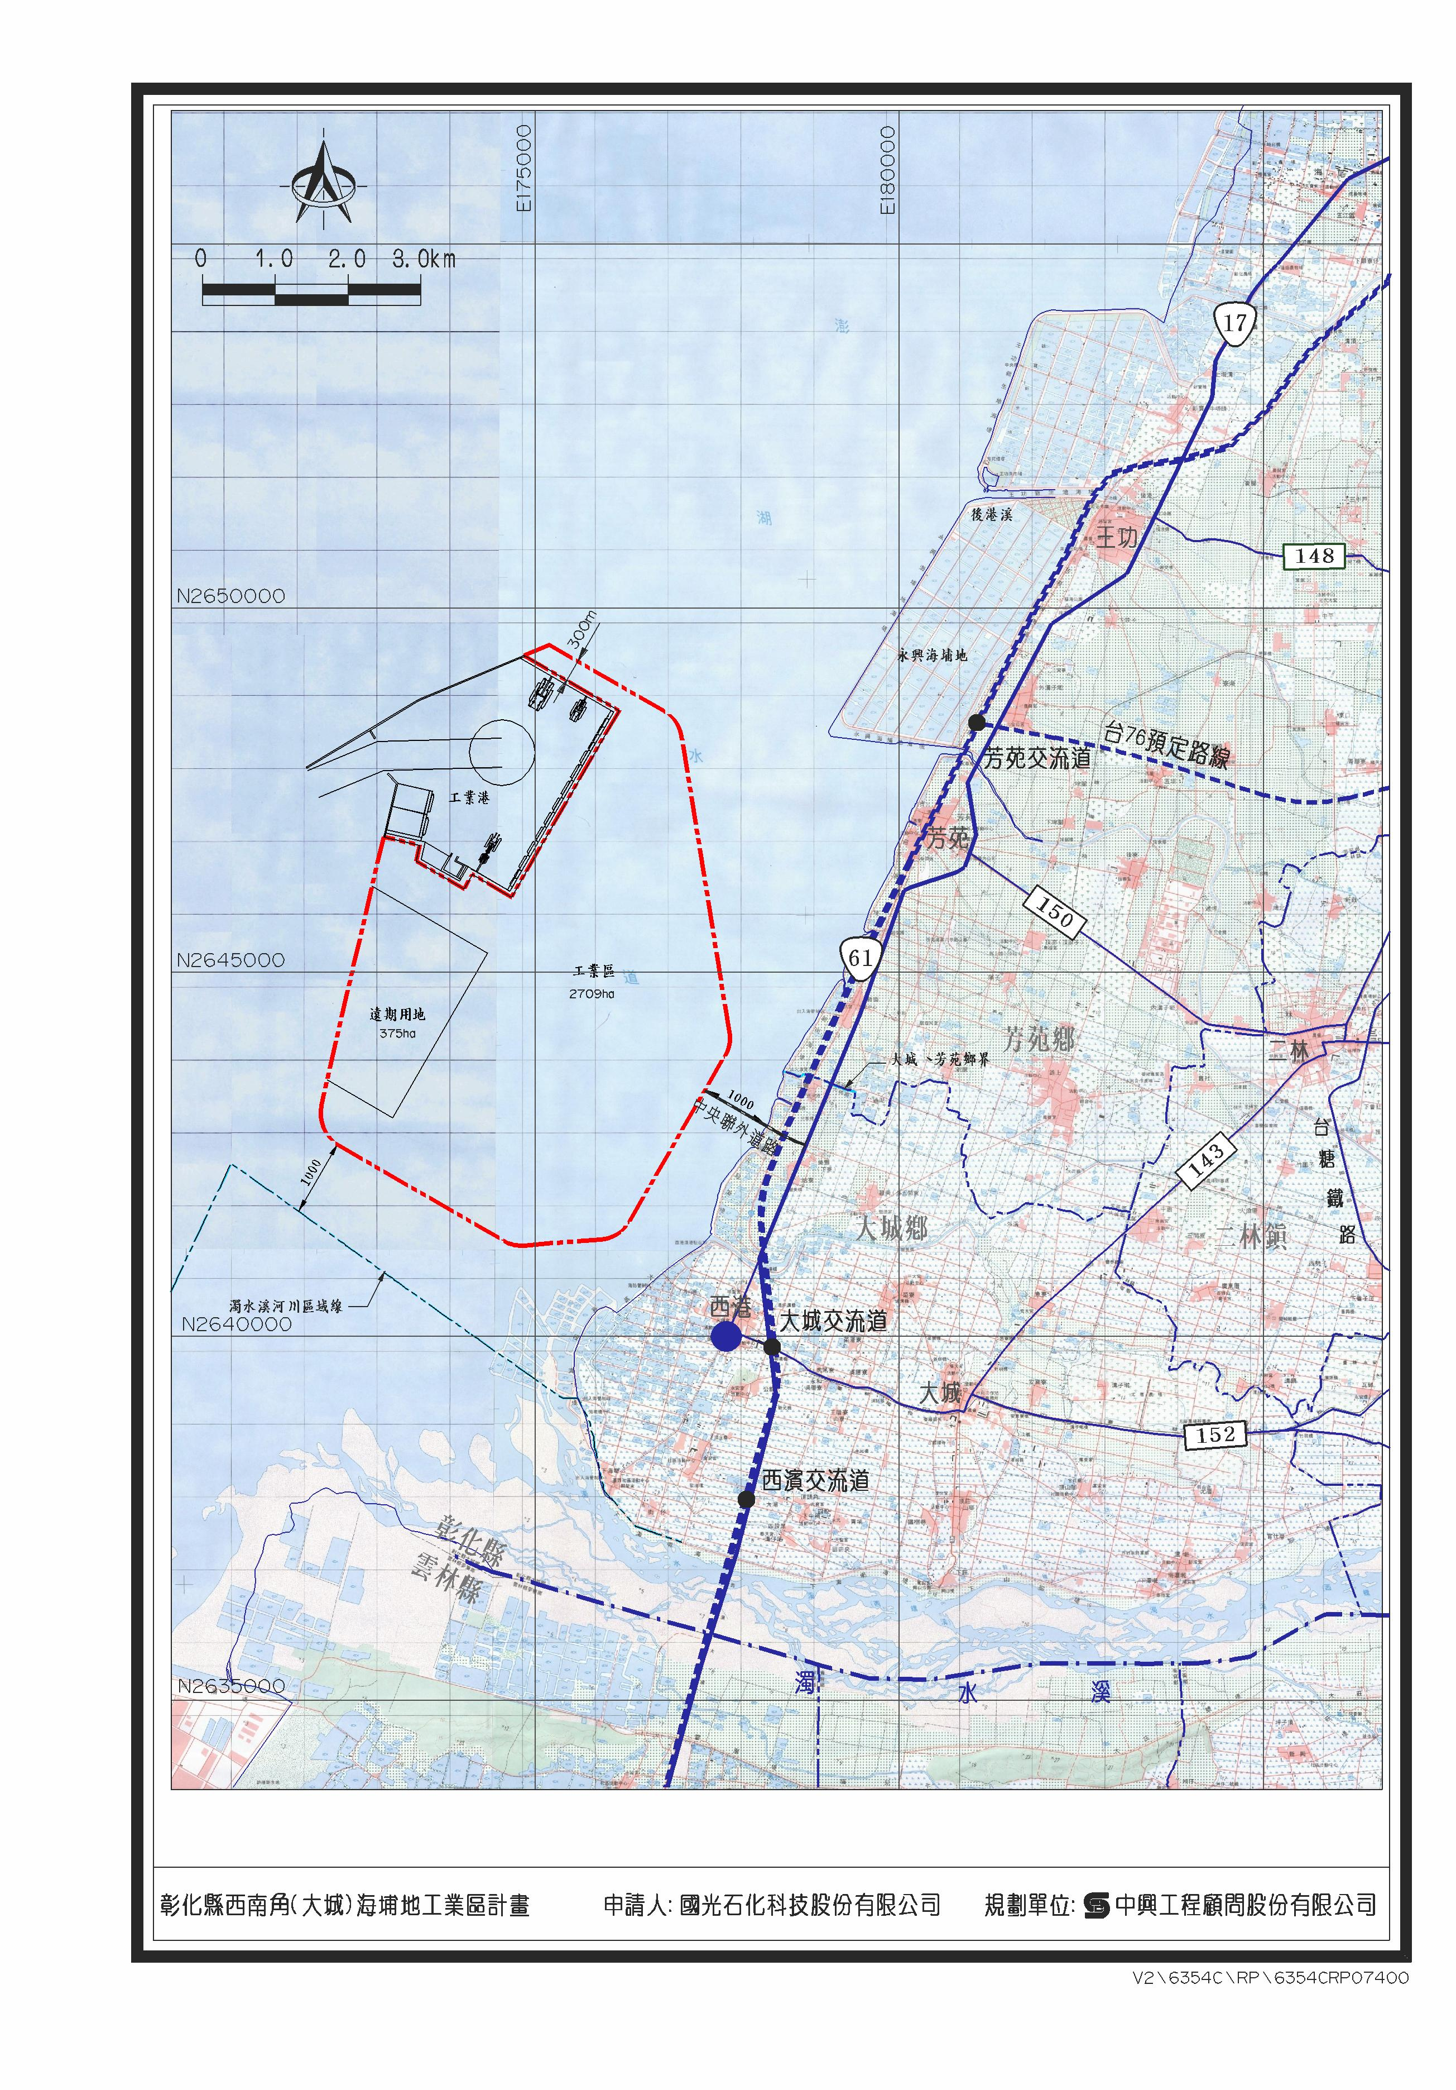
Figure 2. The development site of the Kuokuang petrochemical project.¹

After phase I EIA review of the Kuokuang petrochemical project, Taiwan EPA believed that the project required conducting a phase II EIA review due to concern of its significant impacts on the environment. During the phase II EIA review, Taiwan EPA thought that expert meetings shall be held to discuss five controversial issues, including “model simulation of coastal landform change”, “effect on Sausa Chinensis and corresponding countermeasure”, “water supply”, “greenhouse gas”, and “health risk assessment.” Among the five issues, the issue “effect on S. Chinensis and corresponding countermeasure” is taken as an example to illustrate the importance of consensuses achieved in expert meetings to the EIA review.

Introduction to Sausa Chinensis
S. Chinensis, also called Chinese white dolphin, is one kind of humpback dolphin, and it mainly distributes in shallow coastal waters of Indian Ocean and South Pacific Ocean. One population of S. Chinensis inhabits inshore waters of the eastern Taiwan Strait (ETS) ranging from Miaoli County to north Tainan County. Across this narrow home range, there are two hot spots of population distribution, coastal regions between Miaoli County and Taichung City and coastal regions of Yunlin County respectively. Although the ETS population is divided into two subpopulations corresponding to two hot spots, some commutes were observed between subpopulations. The ETS population of S. Chinensis is listed as “Critically Endangered” in the International Union for Conservation of Nature (ICUN) red list. With the fact that the total number of ETS population is below one hundred, S. Chinensis is also classified as endangered species according to Taiwan Wildlife Conservation Law.²
The development site of the Kuokuang petrochemical project locate at coastal region of southwest Changhua County, which is also the home range of S. Chinensis, so this development might block the south-north migration route of S. Chinensis or prevent the commute of two subpopulations (Figure 3).³

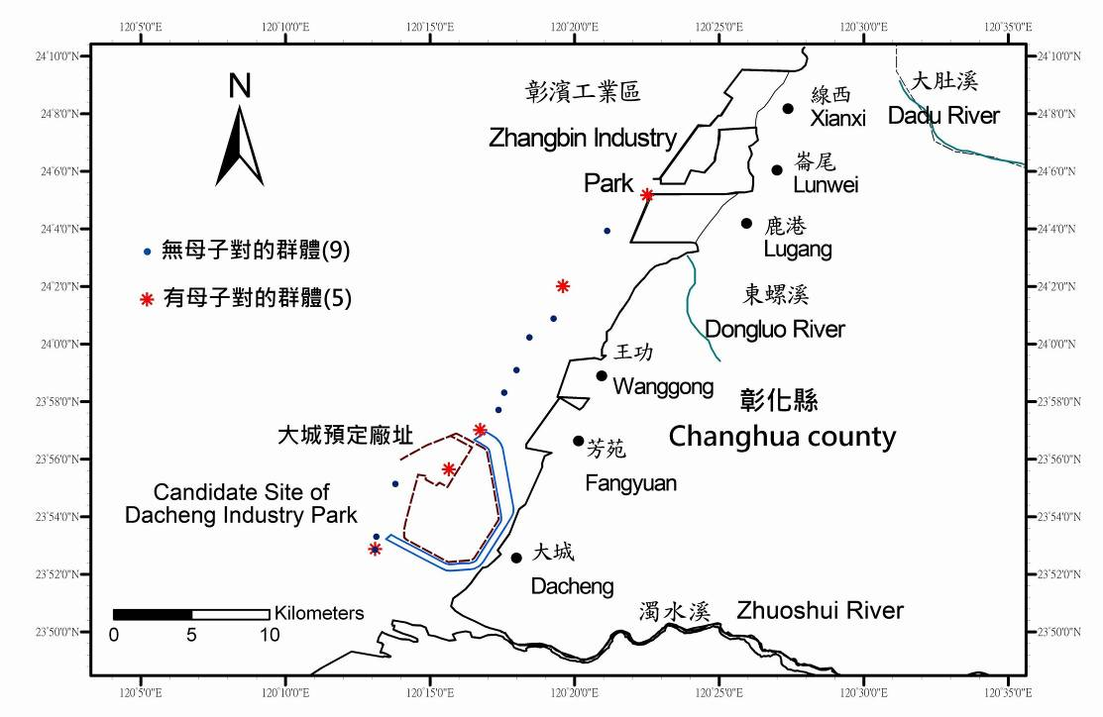
Figure 3. Sighting locations of S. Chinensis along coastal regions of Changhua County.³

Expert Meeting
Members of the expert meeting about the issue “effect on S. Chinensis and corresponding countermeasure” were recommend by the developer, the industry competent authority, local governments, and relevant organizations. Three expert meetings about this issue were subsequently held in June, July, and August 2010 respectively. After the third meeting, experts reached the following four consensuses as references for the EIA review.
First, the developer shall strengthen the expositions about the environmental situation and utilization of home range and hot spots of S. Chinensis and thereby propose related conservation measures.
Second, the developer shall further explain the effects on S. Chinensis and trends of reclamation, reduction of freshwater recharge, pollution, noise, and fishing.
Third, the developer shall meet government policies on conservation of S. Chinensis and propose mitigation measures and conservation countermeasure based on home range, habits, and distribution surveys of S. Chinensis.
Fourth, in order to preserve the nursing and feeding corridor of S. Chinensis, the industrial zone and its port should relocate outwardly to the site with at least ten meters of water depth on the ebb.
Considering the fourth consensus, the developer responded that the plan about the outward relocation of the industrial zone is impractical, so it proposed an alternate plan in which a hole could be dug on the north breakwater of the industrial zone for the passage of S. Chinensis.
Decision Making of EIA Review of the Kuokuang Petrochemical Project
After considering consensuses reached in expert meetings, responses of the developer to consensuses, and opinions of relevant competent authorities, the EIA review task force held detailed discussions and simultaneously drew two preliminary conclusions, “conditional approval of the environmental impact assessment review” and “permission not granted for development.” These two conclusions were then submitted to the EIA review committee which is responsible for the final decision making of whether the EIA of a development activity should be approved (Figure 4).

Figure 4. Flow chart of the decision making.

Environmental justice and generation justice are principles that the government needs to follow to promote policies and foster developments. The goal of these two principles is to make all people in present and future generations have the right of environmental equality, which also meets the concept of sustainable development. According to consensuses achieved in expert meetings about five environmental issues and outcomes of discussions in task force meetings, environmental impacts posed by this development project may excess environmental loads of local regions, especially in terms of the impacts on Dacheng wetland and S. Chinensis. Therefore, even the EIA review committee didn’t draw a final conclusion, the government responsibly decided not to support the Kuokuang petrochemical project in Changhua County based on the concepts of environmental justice and generation justice.

Conclusion
The EIA is an important tool to determine the environment risks of development projects and ensure the balance between economic development and environmental protection. However, certain specific environmental issues arouse controversies between different parties during the procedure of the EIA review. In expert meeting mechanism, experts recommended by parties in dispute scientifically assess environmental factors to assure environmental interests of relevant parties, and the involvement of different parties reaches the goal of public participation. Therefore, the establishment of expert meeting mechanism certainly helps to achieve consensuses and settle controversies in the procedure of EIA review.

References
- 國光石化科技股份有限公司，2010。彰化縣西南角（大城）海埔地工業區計畫環境影響評估報告書初稿。
- 周蓮香、李政諦、李培芬、高家俊、邵廣昭、莊慶達、陳孟仙、陳琪芳、魏瑞昌、楊瑋誠、蔡惠卿，2011。中華白海豚族群生態、重要棲息環境及保護區方案規劃。行政院農業委員會林務局委託研究計畫。
- 經濟部工業局、國光石化科技股份有限公司，2011。「彰化縣西南角（大城）海埔地工業區計畫環境影響評估報告書初稿」及「彰化縣西南角（大城）海埔地工業區工業專用港開發計畫環境影響評估報告書初稿」中華白海豚之影響與因應評估報告書。

