The Strategy for Securing Water Resources through
Connection with the Tunnel of Dams in Korea

Ⅰ. Introduction
The annual average precipitation of Korea is 1,245㎜, which is 1.4 times the world’s average precipitation, 880㎜. However, due to the high population density, the precipitation per capita of Korea is 2,591㎜ per year, which is only 1/8 of the world’s average(19,635㎜). Furthermore, around 70% of the precipitation is concentrated from June to September, and thus, seasonal variations are large. Korea has disadvantageous conditions in terms of the use of water resources, such as the fact that floods run off immediately due to its geographical characteristics; 65% of the country is mountainous and river slopes are steep.
Korea is implementing a project to construct five new dams in the Nakdong-River basin in order to secure 313 million ㎥ of new water resources while additionally securing 24 million ㎥ of water resources per year by connecting two existing dams to each other with a tunnel, thereby reducing the amount of spillway drift in flood seasons. This study is intended to compare and study the impacts on environments, society, and economic efficiency of the new dam construction with those of the method to secure additional water resources by connecting existing dams with one another.

Ⅱ. Materials and methods
1. Study subjects
In the Nakdong-River basin, five multipurpose dams are in operation, including Andong Dam, Imha Dam, and Hapcheon Dam, etc., and five dams are in construction, including Gunwui Dam, Seongdeok Dam, and Buhang Dam, etc. (Table 1). Of these, Andong Dam and Imha Dam are located at the uppermost stream of the Nakdong-River and the dams’ reservoirs are located around 2㎞ away from the dams. Andong Dam’s basin area is 1,584㎢, its storage capacity is 1,248 million㎥, and its normal full level is EL. 160 m. Imha Dam’s basin area is 1,361㎢, and its storage capacity is 595 million㎥(Table 2A). Since this dam discharges summer flood water downstream through its water gate, its annual spillway drift amount reaches 287 million ㎥(year 2006).
In this study, the five dams being constructed in the Nakdong-River basin and the tunnel that connects Andong Dam and Imha Dam with one another were studied. The major dimensions of the five dams in construction are as shown in Table 1. The tunnel that connects Andong Dam and Imha Dam with one another is a 1,925 m long, 5.5 m wide, round tunnel(Table 2B). The Connecting Tunnel was installed horizontally at EL.141 m so that water can move in both directions, depending on water level differences between the two dams. The tunnel inlet and outlet areas are installed with intake towers that are to be selectively opened/closed based on water quality and levels(Fig. 1).

Table 1. Present status of multipurpose dams being constructed in the Nakdong-River basin
Dam name | Basin area  (㎢) | Dam size |  | Total storage  (10⁶㎥) | Eff. storage  (10⁶㎥) | Flood control  (10⁶㎥) | Water supply  (10⁶㎥/year)
Dam name | Basin area  (㎢) | Height(m) | Length(m)
Gunwui Dam | 87.5 | 45.0 | 390 | 48.7 | 40.1 | 3.1 | 38.3
Seongdeok Dam | 41.3 | 58.5 | 274 | 27.9 | 24.8 | 4.2 | 20.6
Buhang Dam | 82.0 | 64.0 | 472 | 54.3 | 42.6 | 12.3 | 36.3
Yeongju Dam | 500.0 | 55.5 | 390 | 181.1 | 160.4 | 75.0 | 203.3
Bohyeonsan Dam | 62.6 | 57.0 | 245 | 22.0 | 17.9 | 3.5 | 14.9

Table 2. Present status of Andong Dam/Imha Dam reservoirs and Connecting Tunnel
Division |  | Unit | Andong Dam | Imha Dam
Dam reservoir  (A) | Basin area | ㎢ | 1,584 | 1,361
Dam reservoir  (A) | Total storage capacity | 10⁶㎥ | 1,248 | 595
Dam reservoir  (A) | Normal full level | EL.m | 160 | 163
Connecting Tunnel  (B) | Tunnel size | m | 1,925(L) × 5.5(D)
Connecting Tunnel  (B) | Tunnel floor height | EL.m | 141.0
Connecting Tunnel  (B) | Intake facility | - | Intake tower

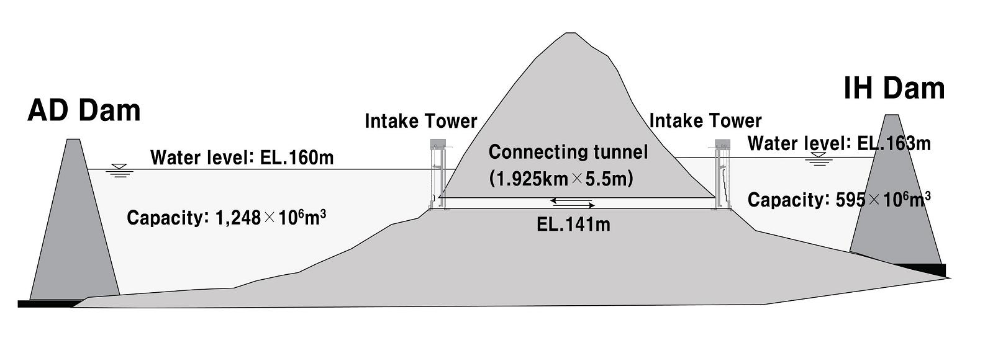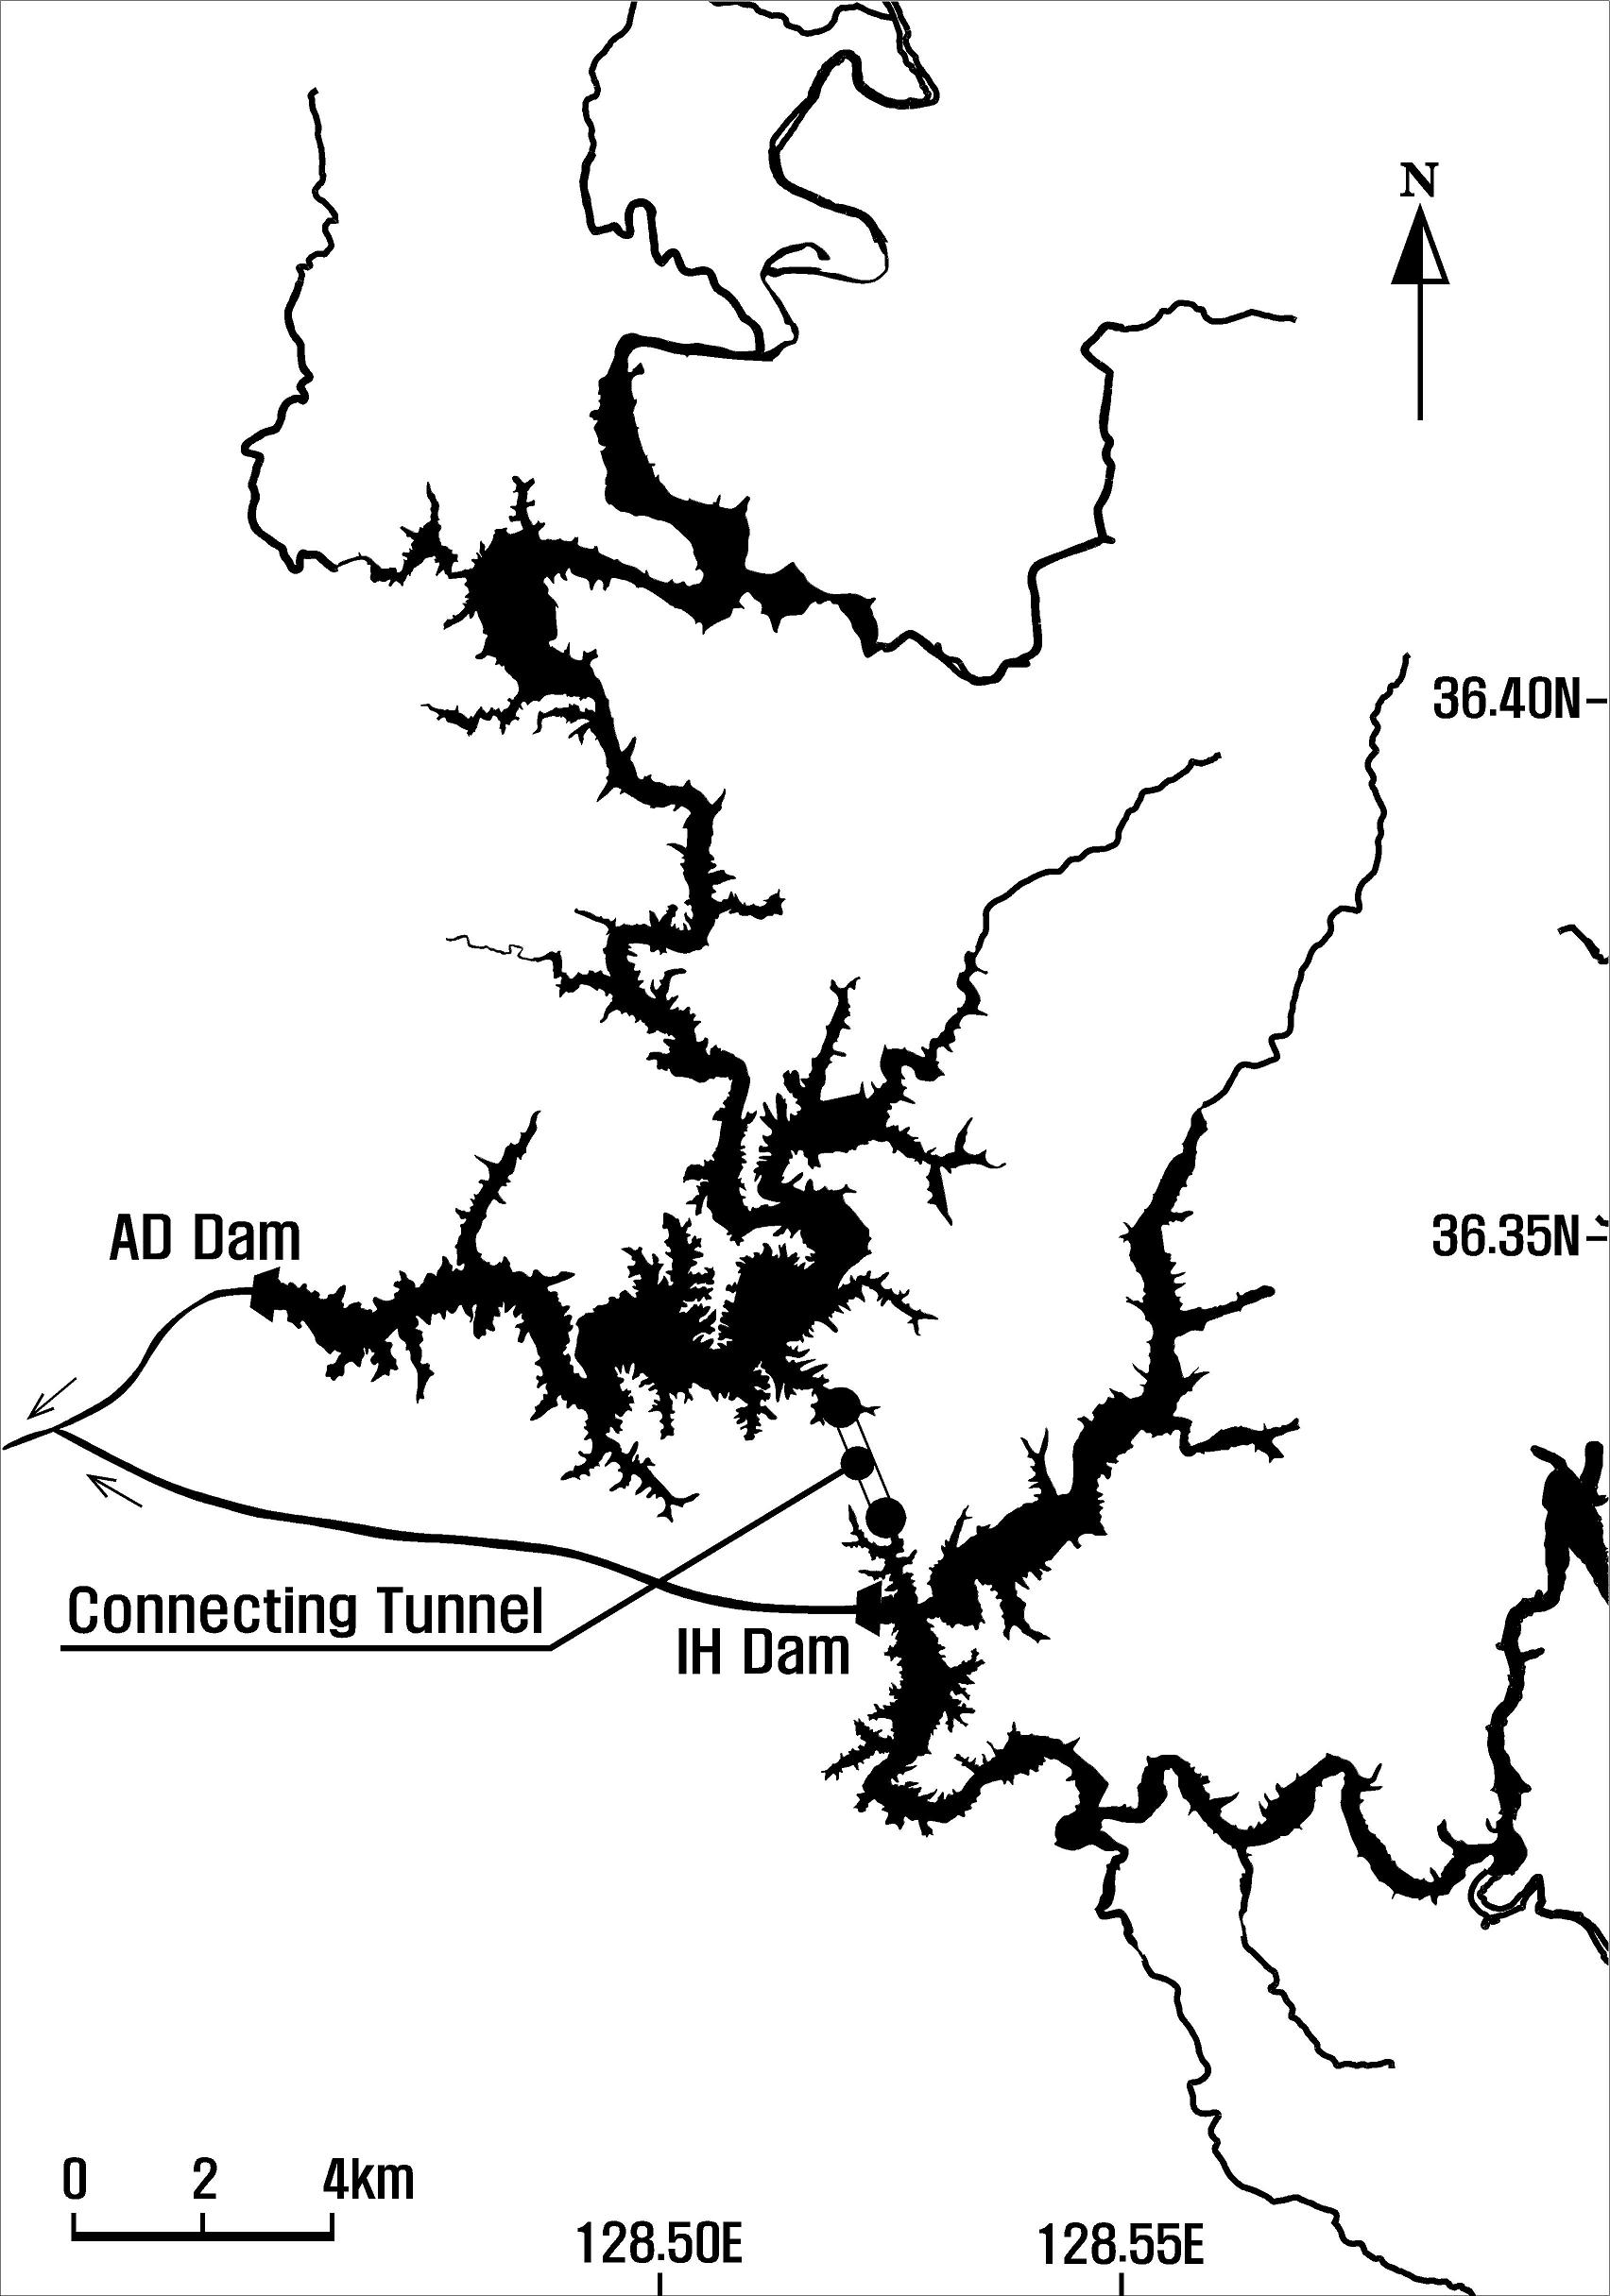
Fig. 1. Mimetic diagram of the Andong(AD) Dam-Imha(IH) Dam Connecting Tunnel

2. Study method
Before commencing dam construction, various surveys and evaluations are performed. First, the necessity, economic efficiency, and project effects of dam construction are reviewed through feasibility surveys, and then, environmental impacts are evaluated to predict the degrees of the effects of dam construction on natural environments and living environments and to establish measures to reduce such effects. Next, compensation surveys are conducted to survey the population, houses, and lands included in the project region in order to provide appropriate compensation. Then, after design, dam construction work commences.
In this study, the environmental impacts, social impacts, and economic efficiency of projects for securing water resources were compared using five new dams currently in construction and a tunnel that connects two existing dams, Andong Dam and Imha Dam, with one another as study subjects. As for impacts on natural environments, the results of surveys by area, presented in the environmental impact assessment reports of individual projects, were used. Animals, such as mammals, fish, amphibians, and reptiles, which could be affected by the dams and the Connecting Tunnel in terms of their environments and ecology, plants to be submerged, and wild animals and plants that were to be protected legally were compared in terms of the two projects. As for social impacts, the results contained in the compensation survey reports were used. The residents who were to move due to submerged regions and submerged living infrastructures, such as houses, farmlands, and roads, were compared in terms of the effects of the different projects. The economic efficiencies of the projects were compared by using the results presented in the feasibility survey reports and the design reports of the individual projects, and the unit costs of water quantities to be secured by the relevant projects were calculated and compared by summing up the construction work costs required for individual projects, compensation for the houses and lands to be submerged, and replacement costs for movement complexes, etc.

Ⅲ. Results and discussion
1. Impacts on natural environments
The regions where the new dams are being constructed were inhabited by 14 to 23 species of mammals, 13 to 26 species of fish, and 6 to 20 species of amphibians and reptiles. Of these, the animals to be protected legally in Korea included three species of mammals, otters, sables, and wildcats, and two species of fish, Gobiobotia nakdongensis and Lampetra reissneri. 334 to 545 species of plants were distributed in the regions. Of them, one species, Korean Berchmia, was to be protected legally and distributed in the vicinity of Gunwui Dam and Seongdeok Dam. The forests to be submerged were 0.51~3.11㎢ wide and had a range of 24.5~35.2% of their areas included in the projects. Animals that were living in the vicinity of the connecting tunnel showed similar distributions to those living in the new dams and included one species to be protected legally: otters. The number of plant species inhabiting this region was 192, which was relatively small, and the area of the forests to be damaged was 0.05㎢(Table 3).
Korea established the Protection of Wild Fauna and Flora Act in 2005 in order to protect and manage wild animals and plants and their environments. Korea has been managing a total of 223 endangered species of animals and plants, which are divided into two grades based on their levels of endangerment. The CITES (Convention on International Trade in Endangered Species of Wild Fauna and Flora) prohibits international trade of around 5,000 species of animals and 29,000 species of plants (http://www.cites.org). The IUCN (International Union for Conservation of Nature) Red List divides the actual conditions of endangered rare animals and plants into nine classes and publishes reports every two to five years; 11,167 species are currently recorded on this list (http://www.iucnredlist.org).
Otters that live both in the new dam regions and the connecting tunnel region are protected and managed as a class 1 endangered animal species in Korea. The IUCN Red List classifies otters as NT(near-threatened) animals and the CITES classifies otters as international endangered animals (Appendix Ⅰ) in order to prohibit their international commercial trade. Although wild cats and sables are class 2 endangered animals in Korea, they are registered as animals requiring LC(least concern) in the IUCN and registered in Appendixes Ⅰ and Ⅲ, respectively, in the CITES. The animal species living in the new dam regions and those living in the connecting tunnel region are not particularly different from one another.
The effects of dams on natural ecological environments can be divided into changes in animals’ and plants’ environments resulting from the change of river environments into lake environments, and the direct effects of submergence. Since the connecting tunnel connects already formed lakes with an underground tunnel, it does not have any direct effects, such as removing animals and plants living on the ground region, and the resultant changes in the inhabited environments are not large. However, the connecting tunnel seems to have a positive role in restoring genetic diversity because the fish species that have been isolated due to dam construction will be able to move between the two water systems via the tunnel.

Table 3. Species inhabited in the projects (new dam construction and the Connecting Tunnel)
Division | Species inhabited in the projects (species) |  |  |  | Protected legally in Korea |  | Forests to be submerged  (area ㎢)
Division | mammals | fish | amphibians & reptiles | plants | fauna | flora | Forests to be submerged  (area ㎢)
Gunwui Dam | 19 | 15 | 15 | 545 | otter | Korean Berchmia | 1.01
Seongdeok Dam | 21 | 17 | 17 | 379 | otter, sable | Korean Berchmia | 0.68
Buhang Dam | 18 | 14 | 20 | 416 | otter | - | 0.99
Yeongju Dam | 23 | 26 | 18 | 420 | otter, wildcat  & 2 fishes | - | 3.11
Bohyeonsan Dam | 14 | 13 | 6 | 334 | otter* | - | 0.51
Connecting Tunnel | 15 | 25 | 12 | 192 | otter* | - | 0.05

2. Social impacts
The average number of households moved due to the five dams currently in operation in the Nakdong-River basin was 1,583, the average number of moved residents was 9,085, and the average area included in the dams was 26.3㎢. Although 2.04㎢ to 12.71㎢ of farmlands, forests, roads, etc. will be included in the regions of the five dams under construction, only 0.19㎢ of lands will be included in the region for the connecting tunnel. In addition, although 267 to 1,564 residents would be forced to move due to dam construction, no residents would be moved due to the connecting tunnel. Most of cultural assets that were to be submerged due to the dams were buildings and ancient tombs(Table 4).

Table 4. Present status of movements or submergence due to new dam construction and the Connecting Tunnel
Division | Moving population |  | Areas included in the projects (㎢) |  |  |  |  |  | Cultural assets (piece)
Division | No. of households | No. of persons | Rice paddy | Field | Forest | Road | Other | Total  Area | Cultural assets (piece)
Gunwui Dam | 288 | 520 | 0.53 | 0.67 | 1.01 | 0.16 | 1.24 | 3.61 | 122
Seongdeok Dam | 100 | 319 | 0.21 | 0.31 | 0.68 | 0.09 | 0.64 | 1.93 | 28
Buhang Dam | 285 | 769 | 0.46 | 1.11 | 0.99 | 0.16 | 0.71 | 3.43 | -
Yeongju Dam | 564 | 1,564 | 2.59 | 1.68 | 3.11 | 0.59 | 4.74 | 12.71 | 61
Bohyeonsan Dam | 120 | 267 | 0.38 | 0.42 | 0.51 | 0.13 | 0.60 | 2.04 | 9
Connecting Tunnel | 0 | 0 | 0.00 | 0.02 | 0.05 | 0.00 | 0.12 | 0.19 | -
Multipurpose dams play positive roles in the national water supply, flood prevention, inland fisheries, community development, and tourism destination/resort provision. However, they also entail changes in the natural environments of the regions in which the dams are located and moving residents because of land submergence. Furthermore, there are cases in which many cultural assets are distributed in regions submerged due to dams. Although cultural assets in submerged regions are moved and restored, the severance of historical continuity is unavoidable. Thus, the values of the cultural assets decrease. However, the number of moving residents, areas and cultural assets in submerged regions resulting from connecting tunnels between dams may be very small or even zero. Thus, connecting the already constructed dams with one another is judged to be effective in securing additional water resources while minimizing social/cultural impacts.

3. Comparison of economic efficiency
To analyze the economic efficiency of public investment projects, such as dams, the total costs required should be calculated, and the benefits generated from the projects should be estimated. If the benefits exceed the costs, the projects are recognized as being feasible. Benefits from dams include flood control benefits, domestic and industrial water supply benefits, electric power benefits, irrigation benefits, and recreational benefits. Among the largest costs are construction costs for dams, power plants, and relocating roads as well as compensation costs for submerged regions(Fig. 2).
The water supply quantities and project costs of the study subjects were compared. The amount of water that can be secured by connecting Andong Dam and Imha Dam with a tunnel is 24 million㎥/year. The amounts of water secured by new dam construction ranged from 0.6 times (Bohyeonsan Dam) to 8.5 times (Yeongju Dam) the amount secured by the Connecting Tunnel. However, project costs for Bohyeonsan Dam were 3.3 times and those for Yeongju Dam were 10.7 times those of the Connecting Tunnel, and the unit project costs required per 1.0㎥ of water supply quantity were the largest in Bohyeonsan Dam at 5.3 times and the smallest in Yeongju Dam at 1.3 times the amount secured by the Connecting Tunnel.

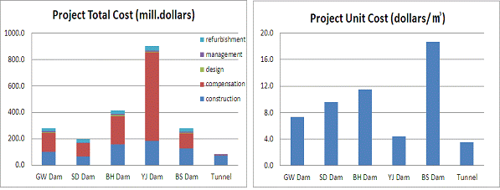
Fig. 2. Comparison of economic efficiency in relation to water supply quantities between the new dams and the Connecting Tunnel

The tunnel connecting Andong Dam with Imha Dam is designed to temporarily store the spillway drift, in flood seasons, from Imha Dam, which has a relatively small storage capacity, in the extra storage space of Andong Dam and to return it to Imha Dam in dry seasons, thereby securing an additional 24 million㎥ of water, without creating any new dams. The Connecting Tunnel was shown to have much smaller impacts on natural environments, social impacts, and cultural impacts as compared to dam construction and was shown to be an economical method of securing water resources that maximally utilizes those secured water resources.

Ⅳ. Conclusion
In Korea, large-scale water resource development projects, such as dam construction, are experiencing difficulties due to the shortage of appropriate locations and residents’ objections. Therefore, the method of connecting existing dams with one another in order to temporarily store flood water in dams that have extra space will be an alternative way of solving the problem of water resource shortage.
In this study, the impacts on natural environments, social impacts, and economic efficiency of the method of securing water resources through five new dams being constructed in Korea and those of the method of securing additional water resources by connecting two dams with one other via a tunnel were compared and studied. Although there was no particular difference in the wild animals affected by the two methods, 0.51㎢ to 3.11㎢ of forests were damaged by the new dam construction, and the area of forests damaged due to the connecting tunnel was relatively small at 0.05㎢. Whereas the dam construction entailed social/cultural impacts, such as moving residents, submergence of lands and cultural assets, such effects of the connecting tunnel were very small. The unit project costs for the water secured by the two types of projects were shown to be 4.5~18.7 dollars/ ㎥ for the former and 3.5 dollars/ ㎥ for the latter, indicating that the connecting tunnel was more economically advantageous. Connecting tunnels between dams in Korea is judged to be an economical method of securing water resources that minimizes the environmental/social impacts of water resource development while maximally utilizing existing water resources.

Reference
Chin-Sung Chang, Heung Soo Lee, Tae Yoon Park and Hui Kim, 2005, Reconsideration of Rare and Endangerd Plant Based on the IUCN List Categories, Korean J. Ecol., 28(5), 305-320(in Korean).
Kee-Hyoun Yang, Jae-Chung Park, Young-Han Ryu, Yong-Moon Jung, Sang-Jin Song, Jae-Ki Shin, 2011, Reformation Methods of Environmental Impact Assessment in Water Resources Development Project by Examining Local Resident Opinions, Environmental Impact Assessment, 20(3), 397-409(in Korean).
Korea Research Institute for Human Settlements, 1995, A Study on the Methodology of the Economic Analysis for Dam Construction, pp.126(in Korean).
Korea Environment Institute, 2003, The Value Estimation of Multipurpose Dams with Environmental Consideration, pp.177(in Korean).

