Urban development and Climate Change in Mozambique’s capital, Maputo

Abstract: Mozambique’s capital constitutes a metropolitan area of approximately 3 million inhabitants, located aside from the Bay of Maputo. This area includes the city of Maputo, and its residential and industrial surroundings such as Matola, Boane, KaTembe and Marracuene. As Mozambique’s population of 22 million is expected to double until 2040, most of the urban areas are growing very fast, generating social, cultural and environmental conflicts. EIA is required for the approval of most significant projects and infrastructures (roads, ports and airports, industry, tourism, urban developments, etc.) and the Ministry of the Environment conducts a review process prior to the authorization. In the Maputo Area this EIA process is particularly critical, because the lowlands that constitute most of this region are often flooded and the surrounding coastal areas are prone to erosion and rapid changes in morphology. This paper presents and discusses an integrated approach to Maputo’s urban development, its environmental vulnerabilities and the need for one integrated approach in the subsequent EIA processes and requirements. The paper also gives a contribution to the methodologies and the critical topics to be considered in the assessment of climate change related impacts and measures of mitigation and adaptation.

Keywords: climate change, coastal areas, risk assessment, environmental impact assessment, urban development, Maputo, Mozambique

Introduction
Mozambique’s capital Maputo comprises a metropolitan area of approximately 3 million inhabitants, located aside from Espírito Santo Estuary and Maputo Bay area. This area includes the city of Maputo, and its residential and industrial surroundings such as Matola, Boane, KaTembe and Marracuene. As Mozambique’s present population of about 22 million is expected to roughly double by 2040 (U.S. Census Bureau, International Data Base, 2012), most of the urban areas are growing very fast, generating social, cultural and environmental issues.
According with available data from several sources, the world is undergoing the largest wave of urban growth in history. In 2008, for the first time in history, more than half of the world’s population will be living in towns and cities (UNFPA, 2007). By 2030 this number will swell to almost 5 billion, with urban growth concentrated in Africa and Asia (UNFPA, 2007).
Mozambique already has one of the largest urban populations among East African countries (38%) (UNFPA, 2011; UNS-PDDESA, 2012), and is expected to reach 50% in 2025 and 67% in 2050 (UNS-PDDESA, 2012). According to figures from the UN (UNS-PDDESA, 2012), Maputo and Matola together account for almost a third (27%) of 2010 Mozambique’s urban population and 10% of the nation’s total. Maputo itself is estimated to grow above the country’s figures until 2025 (65% vs. 33%) (UNS-PDDESA, 2012).
Mozambique is recognized as one of the African countries most vulnerable to climate change, due to the extension of coastal lowlands formed by estuaries and deltas (INGC, 2009).
The highly populated lowlands that surround Espírito Santo Estuary and Maputo Bay area are often flooded and the surrounding coastal areas are prone to erosion and rapid changes in morphology. This makes the existing and projected urban areas highly vulnerable not only to the anticipated sea level rise but also to increased frequency of extreme weather events like hurricanes.
A succession of heavy rain periods associated with low pressure systems at Mozambique’s channel and latter development of hurricane Eline (cat. 4) caused historical flooding in 2000, resulting in a high death tool and huge damage to roads and other infrastructures, villages and crops, some still visible in the field. Damages caused by Eline were estimated in 12% of the country’s Gross Domestic Product (INGC, 2009).
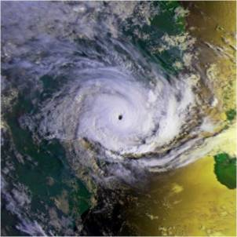
Figure 1 – Tropical hurricane Eline over Mozambique’s coast, 22nd February 2000 (in NEMUS, 2011)
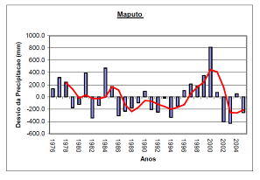Figure 2 – Precipitation deviation from annual average in Maputo, in the period 1976-2005, showing a huge peak in 2000 (MICOA, 2006)
Precipitation deviation from
annual average (mm)
Year
The earth’s climate has changed many times in the past in response to natural causes. Over the last century it has however noticeably changed in a shorter timescale, with global temperature rises and more extreme weather events. Sea level rise (SLR) is the key effect of climate change. Sea levels are rising globally, but with regional variations. There is however some uncertainty as to the rate and amount of rise that could occur by any specific time in the future.
IPCC last report (the Fourth Assessment Report, AR4, IPCC, 2007) stated a rise of about 0,60m at 2090-2099 in its most pessimistic scenario. However, there is growing consensus that AR4 figures for sea level rising are underestimated. Rahmstorf (2007) e Pfeffer et al. (2008) are examples of studies that concluded for less optimistic values.
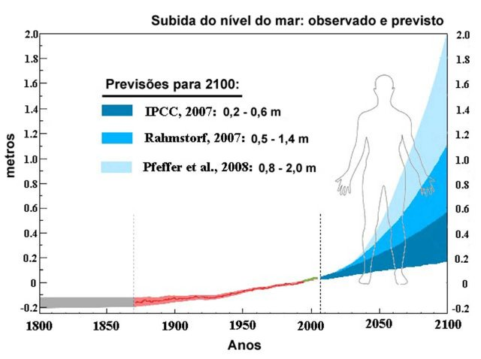Figure 3 – Sea level rise projections comparison
Local studies for Maputo region (INAHINA, 2008) estimate that sea level will rise 0,2m by 2034/2041, 0,5m in 2073/2071 and 0,8m by 2114/2098, depending on the used modelling approach (prediction based on local observations vs. IPCC model, respectively).
However, global climate changes and the risks associated to it refer not only to the sea level rise but also to the increase of frequency and intensity of extreme events, such as storms.
INGC (2009) predicted extreme sea levels in the port of Maputo combining SLR expected from climate change with storm surge calculated for several return periods. Compared with present levels (1,78m, High Astronomical Tide), the estimated 1-year return period extreme levels rise are 0,10m for 2030 and 0,2 to 1m by 2060, considering low and high SLR scenarios, respectively. For 2100 0,30 to 5m were obtained for the same two scenarios.
This shows that perhaps the most important thing to keep in mind is that, although there is no doubt that sea levels are rising, presently there is a considerable uncertainty regarding its future rates and changes on the frequency and intensity of storms. Therefore, an integrated approach, involving different specialist teams, is essential in urban planning and should take this uncertainty into account using risk scenarios and impact assessment tools.

Integrated approach to urban development in high risk coastal areas – Maputo Bay Area
Development of Southern Maputo Province was appointed to MAPUTO SUL E.P. by the government of Mozambique after the decision to built the bridge linking Maputo to KaTembe and improve the road network further south until the border with Republic of South Africa, near Ponta do Ouro.
One of the most important developments that will be catalysed by the new bridge is the future city of KaTembe, located in the south margin of the bay, just across Maputo waterfront.
First projections point out not only to a 400.000 inhabitants city by 2040, but also to touristic areas and a logistical interface for the port of Maputo.
Such significant developments in a risk sensitive area demanded an integrated approach to urban and infrastructure planning, where impact assessment was to be considered since early stages.
Environmental Impact Assessment (EIA) is a legal requirement in Mozambique for the approval of most significant projects and infrastructures (roads, ports and airports, industry, tourism, urban developments, etc.) and the Ministry for the Coordination of Environmental Action (MICOA) performs a review prior to licensing.
Sea level rise: observed and projected
With that goal in mind, MAPUTO SUL E.P. put together a large team of consultants covering various areas of expertise, in order to conduct the studies and projects needed. The team includes a vast number of experts in areas such as architecture and urban planning, civil, hydraulic, traffic and environmental engineering, oceanography, marine geology, ecology, sociology, economics, among others.
meters
Both public institutions and general public involvement was seek since the beginning, by organizing seminars and other public presentations where valuable inputs were collected.
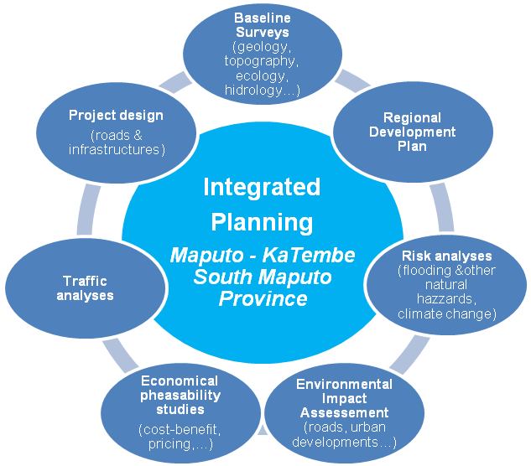
Figure 4 – Integrated approach to urban planning in Maputo – KaTembe and South Maputo province
In order to set adequate basis for subsequent planning, risk assessment studies were critical from start, particularly those regarding flooding. The primary goal was to set probable flooding levels in the bay area, that would provide input for both the urban planning and the engineering team to develop city and road layouts in the safest possible way, avoiding high risk areas.
Ecology studies were also important as the main interventions are located in a delicate estuarine environment where wetlands, such as mangroves and salt marshes, despite frequently underestimated, have an extremely important role not only in the ecological equilibrium but also economically, as fish nurseries and as natural barriers to flooding and erosion. Therefore, establishing natural areas that should be protected and defining associated buffer zones, as well as identify degraded wetlands to be restored was an essential task.
Several others baseline studies were conducted in order to provide the information basis needed to perform an sustainable land use planning. The articulation between the impact assessment and the urban planning and engineering teams was very close and iterative, resulting in a layout optimization effort right from the beginning.

Major Studies in progress
3.1 Hydrodynamic Modelling of Maputo Bay
As said, flooding risk assessment was one of the main subjects that needed to be studied. However, coastal erosion processes were locally significant and therefore were also important to take into account.
Espírito Santo Estuary and Maputo Bay area presents complex hydrodynamics due to manly shallow waters and a wide network of channels, sand and mud banks and wetlands, as well as several river contributions (Maputo, Umbeluzi, Incomati, Tembe, etc.) with torrential characteristics, tide and wave action and the Indian Ocean influence. Several study scales were needed to clearly understand the processes governing circulation: regional (large scale ocean circulation), local (Maputo bay) and hydrological (river basins, flood studies).
A sophisticated 3D numerical modelling approach was therefore essential to cover all the details and achieve adequate results to comply to initial goals. A system of nested models was developed in order to more efficiently assess the various study scales and correspondent inputs for the final predictions needed. MOHID Water/Land, SWAT, SWAN and other models were used.
The nested models scheme approach allows departing from a regional scale to arrive to a high resolution local model.
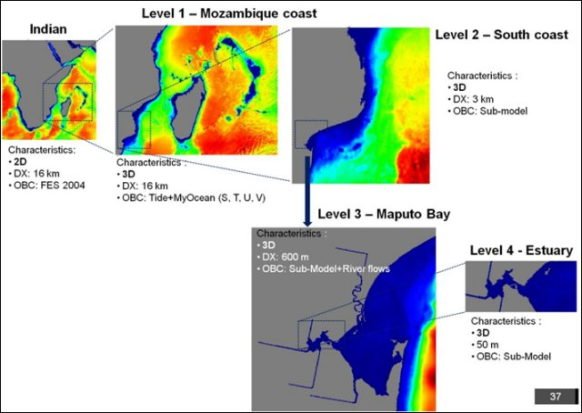Figure 5 – Nested models scheme (NEMUS, 2011)
The first step was to collect existing baseline information to validate the models. This included a significant data compilation effort, ranging from topographic to meteorological, hydrologic and oceanographic information.
Several simulations were made and results were compared with available observations quoted in references for the different parameters of interest, showing good overall correlations, which means that the models adequately describe the main hydrodynamic processes.
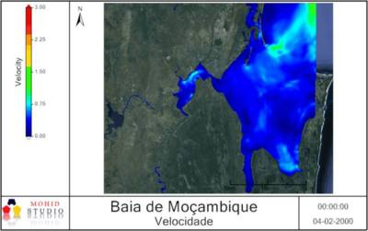Figure 6 – MOHID reproducing year 2000 floods and its impact on Maputo Bay area (NEMUS, 2011)
Major constraints that hydrodynamics and coastal evolution imposes to the occupation of the territory in Maputo bay are linked as follows:
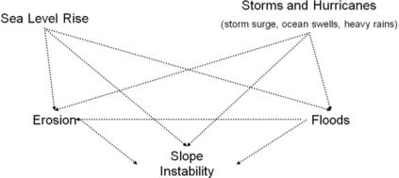
Figure 7 – Major risk factors in Maputo Bay area (NEMUS, 2012b)
As can be seen above, SLR and extreme weather events are the factors that can more drastically drive flooding and coastal erosion processes, resulting in increased risk exposure for populations that will inhabit the region.
Thus, simulations currently underway include risk scenarios that account for probable climate change issues like SLR and increased frequency and magnitude of storm surge from tropical hurricanes, to define constrains to urban and infrastructure planning.
The modelling tools will also be very useful to the subsequent EIA of the several development projects, specially for climate change related impact assessment and for defining mitigation and adaptation measures.

3.2 EIAs of Maputo-KaTembe Bridge
The proposed bridge will link the city of Maputo (north side) to KaTembe municipal district (south side) by crossing the Espírito Santo Estuary.
One of the biggest issues in this project is the location (and form-factor) of the pillars, as the bridge sections a busy port area (Maputo’s side) and the main navigation channel.
The hydrodynamics modelling study in progress will provide valuable input information on currents, flood levels and erosions patterns, that will help both engineering and EIA teams to assess bridge design elements dimensions and location (road connections, pillars, gabarit, etc.) and its impacts.
It also will be of great help for defining mitigation and protection measures for the bridge itself and for the margins or sensitive habitat, for instance.
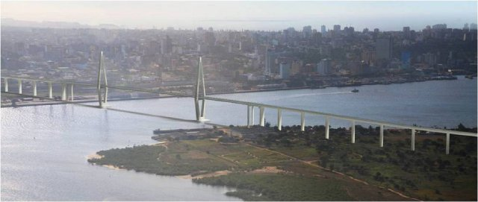 Figure 8 – Preview of Maputo-KaTembe Bridge

3.3 EIA of KaTembe City
The new KaTembe city project will definitely be the major “client” of the risk and environmental assessment studies in progress. It will allow urban planning to be adjusted in a sustained way right from the beginning, avoiding risk areas and minimizing future onus in disaster situations and/or protection measures.
A preliminary EIA is underway for the city’s Masterplan, with strong focus in flooding, coastal erosion, and wetland/ecological issues beside, of course, the highly important social and economic aspects.
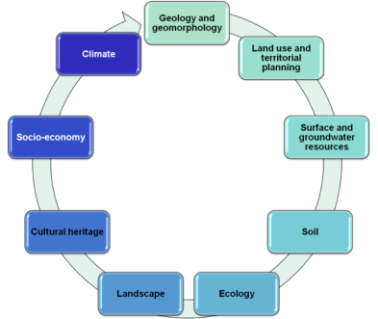
Figure 9 – Preliminary EIA main environmental aspects (NEMUS, 2012a)
Particularly, existing wetland habitats roles as fish nurseries and as natural barriers to flooding and SLR is being investigated, aiming to future use of natural engineering and habitat restoration techniques to mitigate climate change impacts.
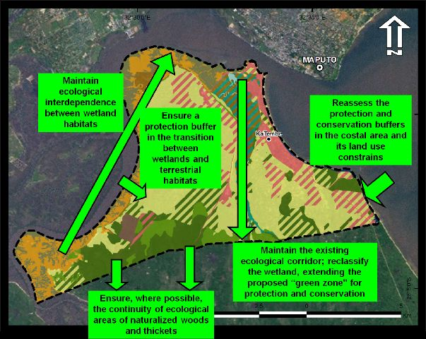Figure 10 – Example of Preliminary EIA recommendations: ecological structure (NEMUS, 2012a)
In a next planning stage formal EIAs are proposed for 3 priority development areas to be defined and detailed in the Urban Plan.

3.4 Regional Development Plan of KaTembe-Ponta do Ouro
The Regional Development Plan (RDP) of KaTembe - Ponta do Ouro is a strategic planning instrument that aims to preventively think the south Maputo province as a whole, in the wake of the of recent development objectives announced by the government for this region.
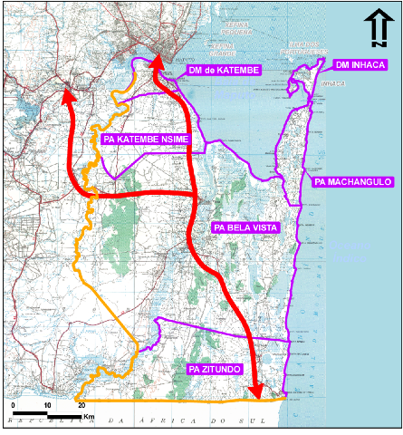
Figure 11 – KaTembe - Ponta do Ouro: Study Area and new proposed roads (NEMUS, 2012b)
Its main goal is therefore to define a strategy that weights different models of regional development, considering the economic, social and urban development projects, ongoing or prospected, its relationships with its surroundings and the dynamics that will be generated as a result of their implementation. The new Maputo-KaTembe bridge and regional road network improvement decisions are clearly the main driving forces for anticipated development, although mining and agricultural projects underway are also of great importance.
The study area is highly constrained due to its known flooding vulnerability and by extensive conservation areas of both national and international relevance (Maputos’s Special Reserve, Libombo transfrontier conservation area, Maputaland biodiversity hotspot). The coastline facing the Indian has a huge potential for touristic development but is also vulnerable to erosion and SLR besides being exposed to hurricanes and tsunamis. Other vulnerabilities include shortage of usable surface water resources and exposure of groundwater aquifers to saltwater intrusion.
As such, climate change associated issues are of major importance for this region as well, manly SLR (groundwater salinization, etc.) and flooding/erosion caused by more frequent extreme weather events.
Hydrological and other baseline studies that were conducted in the initial stages mapped natural risks areas in order to identify existing conflicts and avoid future sensitive occupation.
RDP was complemented by an Economic, Social and Environmental Development Plan (ESEDP) that, among other issues, defined the basis for rural villages water supply scheme, considering potential future climate change impacts.
Despite not being presently mandatory in Mozambique, RDP was nevertheless subjected to Strategic Environmental Assessment (SEA), according to European Union (EU) Directive standards.

3.5 EIAs of KaTembe-Ponta do Ouro and Bela Vista-Boane Roads
The new improved road network in the south Maputo crosses the interior RDP area (Figure 11) so the main issue related with climate change is flooding. The baseline studies made in the RDP as well as for the Maputo Bay (hydrodynamic modelling) will provide valuable information for assessing impacts of the proposed road layouts and define the necessary mitigation measures.
Crossing of Maputo’s Special Reserve, near Salamanga, known by its elephant population, is also a major impact that needs to be addressed in the EIA, in close collaboration with the reserve’s management authority.

Major Conclusions
The present integrated approach to urban planning, involving a large multidisciplinary team, with strong focus on risk and environmental impact assessment, and the use of sophisticated prediction tools, right from early stages, has proved to date to be successful in addressing the particularities of a sensitive and complex region such as Maputo’s.
Risk and preliminary impact assessment studies has been crucial to a sustainable urban planning, providing precious inputs to design and engineering teams that resulted in optimized layouts, better infrastructure sizing and location and better landscape integration, all of which will hopefully lead to less overall negative environmental and social impacts and less need for mitigation measures. All this will also tend to result in global cost reductions, both in short and medium-long terms.
Results from the work developed so far were regarded as highly positive both from client’s side and from local authorities and consulting and academic communities.
The wide range of detailed baseline studies done, as well as risk and impact assessment, including climate change related, has set a solid knowledge base that will be of great value to subsequent EIAs that need to be done, not only to license already known projects (Maputo-KaTembe bridge, City of KaTembe, etc.) but also future ones along the region’s progressive development process.
This kind of approach seems therefore to be very well suited (even essential) and recommended to address significant territorial transformation processes, such as those increasingly taking place in emergent countries, in a sustainable way.

REFERENCES
INAHINA – Instituto Nacional de Hidrografia e Navegação (2008). Assessment of the Impacts of Climate Changes to Sea Level Rise at Costa do Sol Beach in Maputo – Mozambique. Maputo, July, 2008. 27pp.
INGC (2009). Relatório Principal: Relatório do INGC sobre Alterações Climáticas: Estudo do Impacto das Alterações Climáticas no Risco de Desastres em Moçambique. [Asante, K., Brundrit, G., Eps ein, P., Fernandes, A., Marques, M.R., Mavume, A., Metzger, M., Patt, A., Queface, A., Sanchez del Valle, R., Tadross, M., Brito, R. (eds.)]. INGC, Moçambique.
IPCC (2007). Climate Change 2007: Synthesis Report. Contribution of Working Groups I, II and III to the Fourth Assessment Report of the Intergovernmental Panel on Climate Change [Core Writing Team, Pachauri, R.K and Reisinger, A. (eds.)]. IPCC, Geneva, Switzerland.
MICOA – Ministério para a Coordenação da Acçção Ambiental – Mozambique (2006). Avaliação das Experiências de Moçambique na Gestão de Desastres Climáticos (1999 a 2005). Maputo.
NEMUS (2011). Estudo Preliminar da Circulação na Baía de Maputo / Estuário do Espírito Santo.
NEMUS (2012a). Estudo Preliminar de Impacto Ambiental do Plano Especial de Desenvolvimento Urbano da KaTembe.
NEMUS (2012b). Plano de Desenvolvimento Regional KaTembe-Ponta do Ouro. Caracterizaçao e Diagnóstico; Modelo Territorial; Proposta de Ordenamento.
Pfeffer, W.T.; Harper, J.T. e O’ Neel, S. (2008). Kinematic constraints on glacier contributions to 21st century sea-level rise. Science.
Rahmstorf, S., A. Cazenave, J.A. Church, J.E. Hansen, R.F. Keeling, D.E. Parker, and R.C.J. Somerville, (2007). Recent climate observations compared to projections. Science.
U.S. Census Bureau, International Data Base (2012) available at http://www.census.gov/population/international/data/idb/country.php, 28/03/2012.
UNFPA – United Nations Populations Fund (2007). The State of World Population 2007, 99pp. Available at http://www.unfpa.org/swp/2007/presskit/pdf/sowp2007_eng.pdf, 28/03/2012.
UNFPA – United Nations Populations Fund (2011). The State of World Population 2011, 124 pp. Available at http://foweb.unfpa.org/SWP2011/reports/EN-SWOP2011-FINAL.pdf, 29/03/2012.
UNS – PDDESA (2008). Population Division of the Department of Economic and Social Affairs of the United Nations Secretariat. World Population Prospects: The 2008 Revision and World Urbanization Prospects: The 2009 Revision. Available at http://esa.un.org/wup2009/unup/, 28/03/2012.

