Using small-scale solar power plant to supply rural homes with electricity in the Ngan-ha locality (Cameroon)

ABSTRACT
This paper examines, from a socio-economic and environmental point of view, the implementation of solar photovoltaic system as a source of power in the Ngan-ha locality located in the Adamaoua Region of Cameroon. The results shows improvements and significant impact on education, access to water, commerce, entertainment, health; as a result of supply of power from solar photovoltaic power plants. The system also shows more advantages on consideration of its environmental effects. A great potential for dissemination of solar technology in nonelectrified rural areas exists, however, a clear and pragmatic government policy supporting solar power utilization is needed for a sustainable development of solar technology.

INTRODUCTION
Based on the 2010 census, the population of Cameroon is 20 million, of whom 46 % live in rural areas. Many of these rural residents lacked access to modern services that can be found in the urban areas. Results from this recent population census revealed that, out of the 13 104 localities identified in Cameroon, only 2.400 have access to electricity. About 511 localities without access to electricity have average population size above 10.000 inhabitants, 7.000 have their population below 300 habitants and nearly 3.000 have their population between 300 and 5000 (Ntsama, 2007).
In Cameroon, energy consumption is dominated at more than 60% by traditional energy, mainly firewood. Electricity represents about 14% of total energy consumption. The electricity supply is mainly from hydropower and is provided by the three major hydroelectric plants that are Edea, Song Loulou and Lagdo. The current production of hydropower, which represents only 3% of the hydropower potential remains below the country's energy needs.
Wider coverage of the population in terms of electrification is therefore a challenge for this country.
However, eventhough the government recognizes that access to reliable energy can enhance both human and economic development; many investments in energy sector are more focused on fossil energy and dams than on other renewable sources.
Global Village Cameroon (GVC), a country-based NGO, has been committed the idea that increasing investment in the renewable energy sector is a more viable option to improve access to electricity in rural areas. With a World Bank’s Lighting Africa Developement Market Place award, GVC implemented in 2009-2011 a pilot mini-solar power plant project in Ngan-ha locality (Adamaoua Region of Cameroon).
This paper summarizes the key lessons learned from this project and prospects for sustainable development of solar technology in Cameroon.

SITE DESCRIPTION
Ngan-ha is located in the Adamaoua Region of Cameroon. Because of its location, Adamaoua's climate is influenced by the dry air of the morthern sahelian region and by moist air of the southern tropical region. Annual rainfall ranges from 1500-2000 mm. There are generally five months of dry season (November-March) and seven month of rainy season (April-October). Temperatures are rather cool, with an average of 22°C. Minimum temperatures (10-19°C) are found during the months of December and January while maximum temperatures (27-34°C) occur during the month of March.
The vegetation consists mainly of Sudano-Guinean savannah. It provides a natural habitat for a variety of wildlife, ranging from major mammals to reptiles and birds of all species.
The population, mainly farmers and pastoralists is estimated at 45 000 inhabitants for a surface area of 2 625 km².
The main energy sources in use in the area are gasoline, kerosene, wood and coal. The distance from the nearest electrical grid from Ngaoundéré is 80 km (MINPAT, 2002). Petroleum products here are relatively expensive compare to the cities. A liter of kerosene and gasoline cost respectively 1.5 and 1.2 USD compared to 1.1 and 0.9 USD in cities.
Access to water is mostly through traditional water wells. Health problems associated to poor water quality are frequent. These are: malaria, typhoid, amoebiasis, diarrhea, cholera, etc.
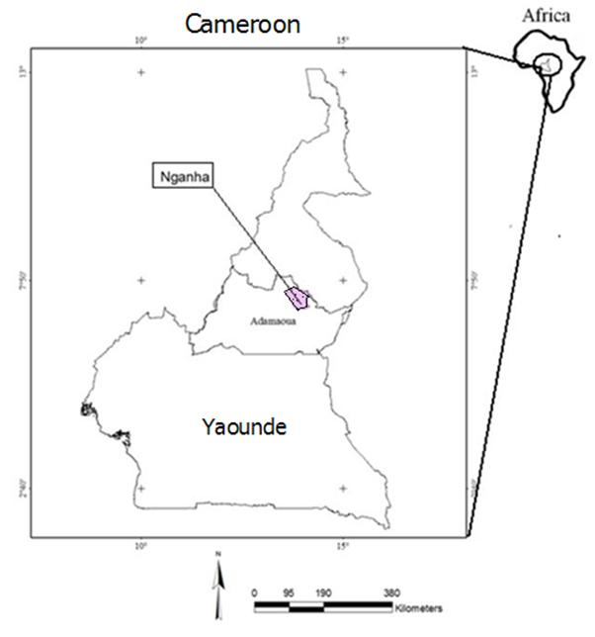
Fig. 1. Location of the project area
PROJECT OBJECTIVE
The primary objective was to provide solar energy to over 100 households, 03 public services, 01 health center, 01 primary school and 01 secondary school in Ngan-ha locality and to supply local people with potable water through the installation of two solar powered water pumps.

METHODS
The implementation approach consist of 3 phases as recommended by IEA (2003): a preparatory phase consisting of feasibility studies, local sensitization and creation/empowerment of local management committee; an implementation phase consisting of contracting with an electricity engineering company, mobilizing equipments, building the solar plant, distributing energy to the beneficiaries and a monitoring phase.
The project is described in terms of the potential impacts on the environment, local participation, the effect on local economies and the consequent change in electricity prices.

RESULTS
Highlights of the solar plant
The Ngan-ha mini-solar plant consists of consists of a photovoltaic generator; an inverter and batteries (table 1 & fig. 2).
Table 1. Main characteristics of the plant

Photovoltaic field | Batteries | Inverter
Temperature coefficient: 1.04  Energy corrected: 45,005 Wh / day  Sunshine minimum: 4.66 kWh / m² / day  Battery capacity: 1945.5 Ah  Installed Capacity: 9453.2 Wc  Number of panels: 73 | System voltage: 48 V  Range: 2 days  Maximum Discharge: 0.8% | Input voltage: 48 V  Rated power: VA 7561.4  Efficiency: 96%
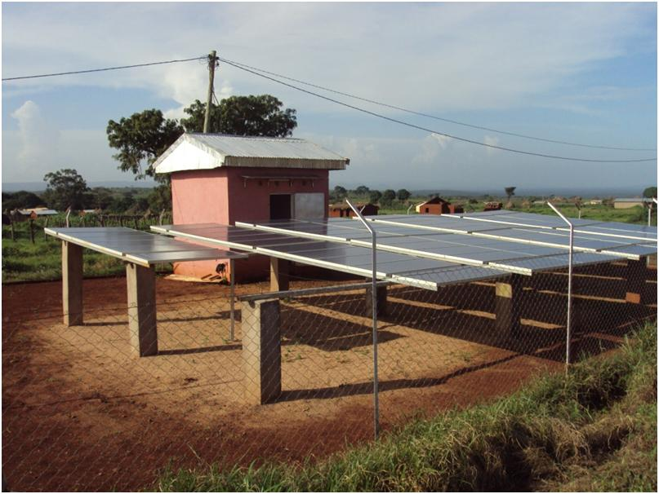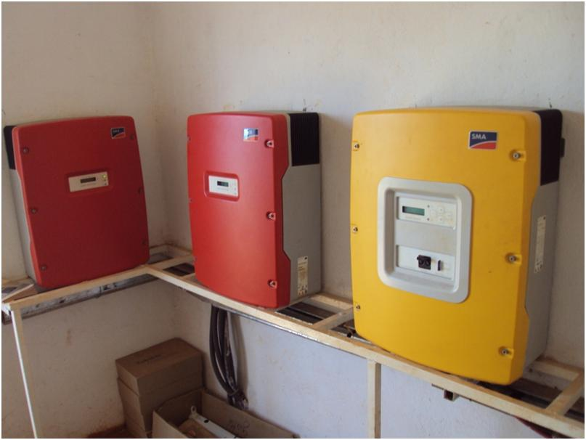
Fig. 2. The Ngan-ha mini solar plant
Ownership and management of the equipment
A Community Management Committee (CMC) was established to manage the project, chaired by the Mayor of the town, assisted by the chairman of the Local Development Committee. The project also provided a Technical Unit with a Director and two local technicians trained by the partner company that constructed the plan. However, as the CMC could not pay for the service of the Director hired by the Mayor, he was removed; the remaining two technicians trained by the company are involved in the maintenance. These technicians are paid by project revenues or eventually by the mayor in case of difficulties.
The project involved the connection of 75 households with a reserve of unused power that could help achieve 100 households in cases of energy saving by these households. Fifty subscribers regularly pay their invoices. The rules of the CMC provides for sanctions ranging from suspension of electricity to prosecution in case of nonpayment.
Prior to the validation of a subscription request, an engagement document is signed between the consumer and the CMC.
Each consumer pays a monthly bill at a fixed price of 2000 CFA (4 USD) for household and 5000 CFA (10 USD) for the Mayor and the Sub-Divisional Officer services.

The beneficiaries of the electricity generated
Households
About 75 households are connected, not including fraudulent connections.
For the 75 households, the feasibility study provided for each household: a television / radio / telephone, and three energy saving bulbs.
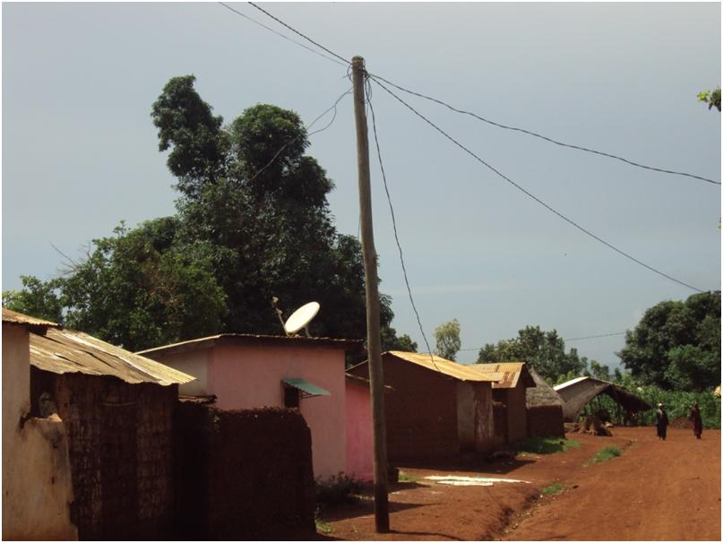
Fig. 3. Household connection grid
Public services
- The city council, with the possibility to use a photocopier, a computer, a television and at least five bulbs as these facilities can not operate at the same time,
- The Sub-divisional Officer services with possibility to use a computer, at least five bulbs, a TV,
- The chiefdom with the possibility to use a laptop, at least five bulbs, a TV,
- The primary school with at least five bulbs, a TV,
- The health center with the microscope, at least five light bulbs, refrigerators for storing drugs,
- An entertainment hall with possibility to use at least five bulbs, television, musical instruments,
- Street lighting with four lamps.
Solar Powered water pumps
Two water pumps are functional, powered by the electricity generated by the solar plant.
The system consists of a PV generator, an inverter and a submersible motor pump that delivers water to a high-level water tank (fig. 4). The water reservoir feeds the water by gravity to public water taps. The water is distributed free of charge to all residents.
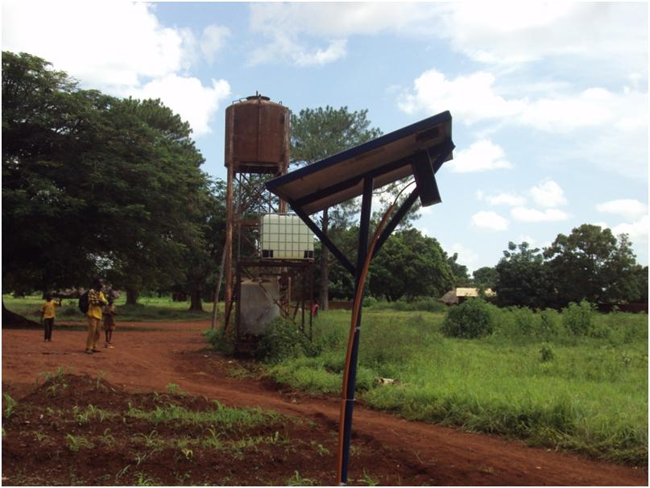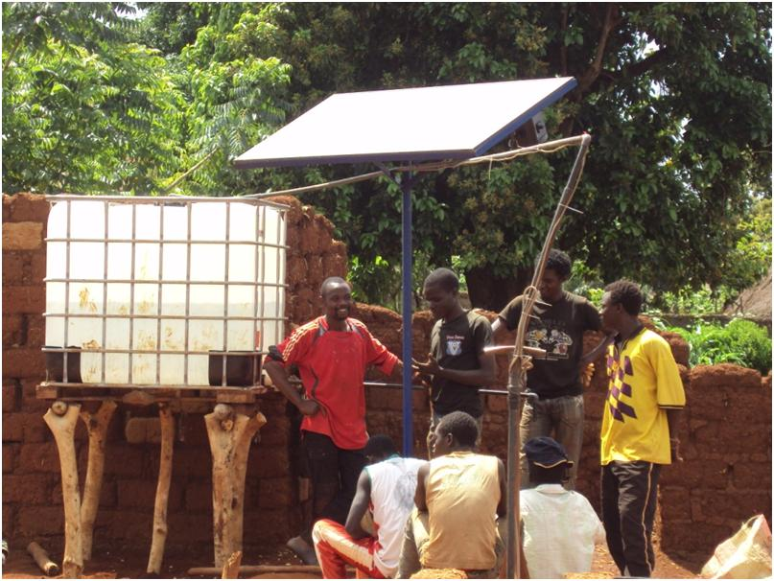
Fig. 4. The solar powered water pumps
Environmental and social impacts
Photovoltaics are known to be generally of benign environmental impact, generating no noise or chemical pollutants during use (Tsoutsos et al, 2005), though, in an area of natural beauty like Ngan-ha, visual intrusion can be significantly high.
Within a short spell of time of two years, there have been noticeable improvements and significant impact on education, access to clean water, entertainment, health as a result of supply of power from the solar photovoltaic power plant. Improvements are also observed in access to information as more radio telephone and TV can be used, reducing the cost of buying batteries.
Important indicators identified for the degree of acceptance are:
- Ownership attitudes of persons or groups toward the installations,
- Regular payment of electricity charges by most users,
- Careful handling of technical devices and initiatives for maintenance and repair,
- Taking over obligations regarding accompanying measures (e.g. hygiene campaigns) and task assignments on a community basis.
In general the economic viability is ensured both technically (high year-round utilization of the electricity and pumped water, well-designed systems with good efficiencies), organizationally (costs for operating staff are low, installation, maintenance and repair work are performed by qualified local staff).
The project is innovative since it introduces measures and activities that will improve access to rural solar energy. Knowledge transfer was also achieved through trainings of two villagers on solar panels and home system production and installation and for better customer service.

DIFFICULTIES ENCOUNTERED
- The populations of Ngan-ha were not used to making financial contributions for such project for which they are beneficiaries and that meets their energy needs;
- Energy demand by the household is very high and exceeds the installed capacity;
- The refusal of some administrative authorities to pay the bill for the electricity consumed;
- The various fraud due to lack of technical designs to limit and control the consumption of each household and to allow them to follow the regulations;
- The difficulties of local staff trained by the company to adapt to solar technology (most failures requiring the mobilization of the technician from Yaoundé);
- The capture of the project by political leaders without real financial commitment (no contribution of the council and refusal to legally register the texts of the CMC to give a legal power.

LESSONS LEARNED
Due to the reliability of photovoltaic systems, a huge potential for dissemination in nonelectrified rural areas can be expected. A recent study commissioned by the World Bank in 2003, indicated a very positive impact of using solar power on the rural socio-economic development. However, lack of clear and pragmatic government policy supporting solar power utilization, inadequate government’s support to various programs initiated by international donors and agencies is likely to discourage these or international financial institutions to create new initiatives.
ACKNOWLEDGMENT
This project was financially supported by the World Bank’s Lighting Africa Developement Market Place award. We wish to express our gratitude to all the residents for their co-operation, assistance and warm hospitality during the survey.
BIBLIOGRAPHY
International Energy Agency, 2003. Case Studies on the Deployment of Photovoltaic Technologies in Developing Countries. Photovoltaic System Programme. 117 p.
Justin NTSAMA, 2007. Situation électrique du cameroun. 14 p.
MINPAT, 2002. Province de l’Adamaoua. Schéma directeur régional d’aménagement et de développement du territoire. 16 p.
Soedjono Respati. 2007. Lesson learned and best practices in the implementation of solar PV project in rural areas from solar PV dealer. Round table discussion organized by Yayasan bina Usaha Lingkungan, jakarta, november 15, 2007.
Theocharis Tsoutsos, Niki Frantzeskaki & Vassilis Gekas, 2005. Environmental impacts from the solar energy technologies. Energy Policy 33 (2005) 289–296. Elsevier Eds.

