Global-scale analysis of climate change impact on vegetation greenness by land cover type over the last 33 years

Abstract
Vegetation and climate variable trends and correlation analysis are among the important issues of global land degradation. However, present climatic impacts on global vegetation trends are uncertain. Here we use the Advanced Very High Resolution Radiometer - Global Inventory Modelling and Mapping Studies NDVI3g data, land cover data of the Climate Change Initiative, and Climatic Research Unit Time Series climate variable (temperature, rainfall) global time series over the last 33 years. First, we estimated the overall trends for vegetation greenness and climate variables over five time periods and analyzed four-season trends. Second, we performed correlation and regression analyses to detect correlations between vegetation greenness and climate variables. Next, we extracted trends and correlation results by mainland cover type (forest, cropland, and grassland). The largest decreasing trend of vegetation greenness and grasslands were found in the mid-latitude regions of the northern hemisphere and in Argentina, western South America, North America South Africa, north Africa, Saudi Arabia, and south and northeast Asia. Temperature and rainfall were the main impacts on vegetation growth; however, in the northern regions, the temperature was a more important factor in vegetation greenness when vegetation greenness and rainfall were highly correlated.
Keywords: vegetation greenness trends, rainfall, temperature, global scale, land cover, NDVI, AVHRR, time series analysis
INTRODUCTION
The Global Inventory Modelling and Mapping Studies (GIMMS) NDVI3g data is critical to the effort to directly determine changes in vegetation growth. Some researchers have suggested that GIMMS NDVI3g data have good reliability for long-term trend analysis in arid regions, whereas GIMMS NDVI3g trends should be calculated with obvious provisions for humid, subhumid, semi-arid and hyper-arid regions caused by temporal discordances between sensors (Fensholt et al., 2009; Tian et al., 2015). To mitigate this uncertainty in satellite-observed trends in vegetation growth, broader attempts are required to compute normalized difference vegetation index (NDVI) time series against field measurements and multi-scale imagery before completing trend analysis to acquire demonstrative results (Guay et al., 2014).
Previous studies have widely reported that continued global warming would possibly drive crops away from their optimum growth temperatures, particularly in the relatively wet region (mainly driven by temperature variability), thereby offsetting the potential increase in crop yield due to increased rainfall. Studies have also reported that in south Asia over the last 30 years, the region changed from forest or rangeland to cropland, but that land use change is not likely to be a major driving factor contributing to forest browning (Wang, et al., 2017).
Our study provides an analysis of the overall and seasonal trends of vegetation greenness and climate variables, the correlations between vegetation greenness and rainfall, and temperature extracted by main land cover type. Specifically, our study aimed to answer the following questions: (1) What are the spatial and temporal dynamics trends of global vegetation greenness, rainfall, and temperature during the period 1982–2014? (2) What are the seasonality (four-season) trends of global vegetation greenness, rainfall, and temperature during the last 33 years? (3) Which results show correlations between the vegetation greenness and the climatic factors? (4) How do climate factors affect vegetation greenness? (5) What are the trends of vegetation greenness, climate variables, and the correlation between vegetation greenness and climate factors in main land cover type (forest, cropland, and grassland)? These findings not only contribute to the analysis of vegetation greenness but also have great significance to predicting the effects of global change and climate change on global vegetation greenness and main land cover type.

MATERIALS AND METHODS
Materials
Remote-Sensing Vegetation Data
The NDVI dataset is the current version of GIMMS NDVI3g. It is derived from the U.S. National Oceanic and Atmospheric Administration’s (NOAA’s) Advanced Very High Resolution Radiometer (AVHRR) satellite record, and is the longest global sub-monthly time series of greenness index, more than twice as long as those available from recent sensors such as the U.S. National Aeronautics and Space Administration’s (NASA’s) Moderate Resolution Imaging Spectroradiometer (MODIS, February 2000–present). NDVI3g data was collected over the 33-year period spanning from 1982 to 2014 with a spatial resolution of 8 km, and calculated using the average monthly NDVI from January to December.
Land Cover Data
In the framework of the Climate Change Initiative (CCI) of the European Space Agency, the CCI Land Cover partnership recently announced the official release of the CCI 300-m annual global land cover time series from 1992 to 2015. These land cover products rely on the state-of-art reprocessing of five very different satellite missions.
Methodology
Temporal Trend Analysis
The monotonic trend (Mann-Kendall) is a non-parametric test for determining trends in time series data and uses the significance of Sen’s slope. The advantages of this method are that the data do not need to have a normal distribution and are not sensitive to outliers in the dataset (Sen et al., 1968; Fensholt et al., 2012). The indicator measures the degree to which a trend is consistently increasing or decreasing. It ranges from −1 to +1, and a value of +1 demonstrates a trend that continuously increases and never decreases. The contrary is true when the value is −1, and a 0 value indicates no consistent trend.
Statistical Analysis
The relationship coefficient, R, is a measure of the strength of a linear relationship between two variables. The coefficient of definition R is the proportion of the variation of a response variable that is explained by a fitted statistical model; R is typically expressed as a percentage. The relationship is computed from the strength of the linear correlation between NDVI, temperature, and rainfall by computing the per-pixel relationship coefficient R from 33 years of overlaid monthly observations (January 1982 to December 2014). The linear association between the NDVI and climatic variables and vegetation growth was determined using single-correlation R analyses. An annual time step (starting in January 1982) was used to examine the effects on the climatic driver and vegetation growth (Rasmus et al., 2012). The regression analysis, a causal correlation between the dependent NDVI values and independent temperature and rainfall variables was calculated; the predicted high NDVI values for each month and each pixel were calculated from the observed rainfall and temperature.
RESULTS AND DISCUSSION
Trend Analysis of Vegetation and Climate Factors
Trend of the Vegetation and Climate Factors in the Five Decades
In this research, we choose the decades 1982-1992, 1992-2002, and 2002-2014, and the periods 1982-2003 and 1982-2014. We mapped z-values for the Mann-Kendal test. According to the results of the analysis of test power (the analysis was made using the language R with the use of an additional package asbio) for a period of 10 years, the z-values more than 0.87 and less than -0.87 are statistically significant. For 20 years z-values more than 0.7 and less than -0.7 are statistically significant. For the full time series 33 years z-values more than 0.58 and less than -0.58 are statistically significant.
Generally, between 1982 and 2014, the vegetation greenness trend decreased overall, with the largest decreases in Argentina, western South America, North America, South Africa, north Africa, Saudi Arabia, south Asia, and northeast Asia. Previous studies have also studied that greening was mainly covered in areas with relatively sparse vegetation cover in the Australian rangelands, African open shrubland, and the Sahel, mostly in combination with gradual browning, whereas abrupt browning was detected in more densely vegetated regions of the broadleaf forest in Europe and North America and in humid grasslands (Rogier et al., 2012). However, we showed increased vegetation greenness in southern Australia, a small area of north Africa, the Amazon, around the Sahel region of central Africa, Spain, India, and southeast China. In this case the main of three cycles calculated over 10 years, in most of the regions, vegetation greenness indicated an upward trend from 1992 to 2002. However, in the next ten years (2002 to 2014), most vegetation greenness decreased (Figure 2).

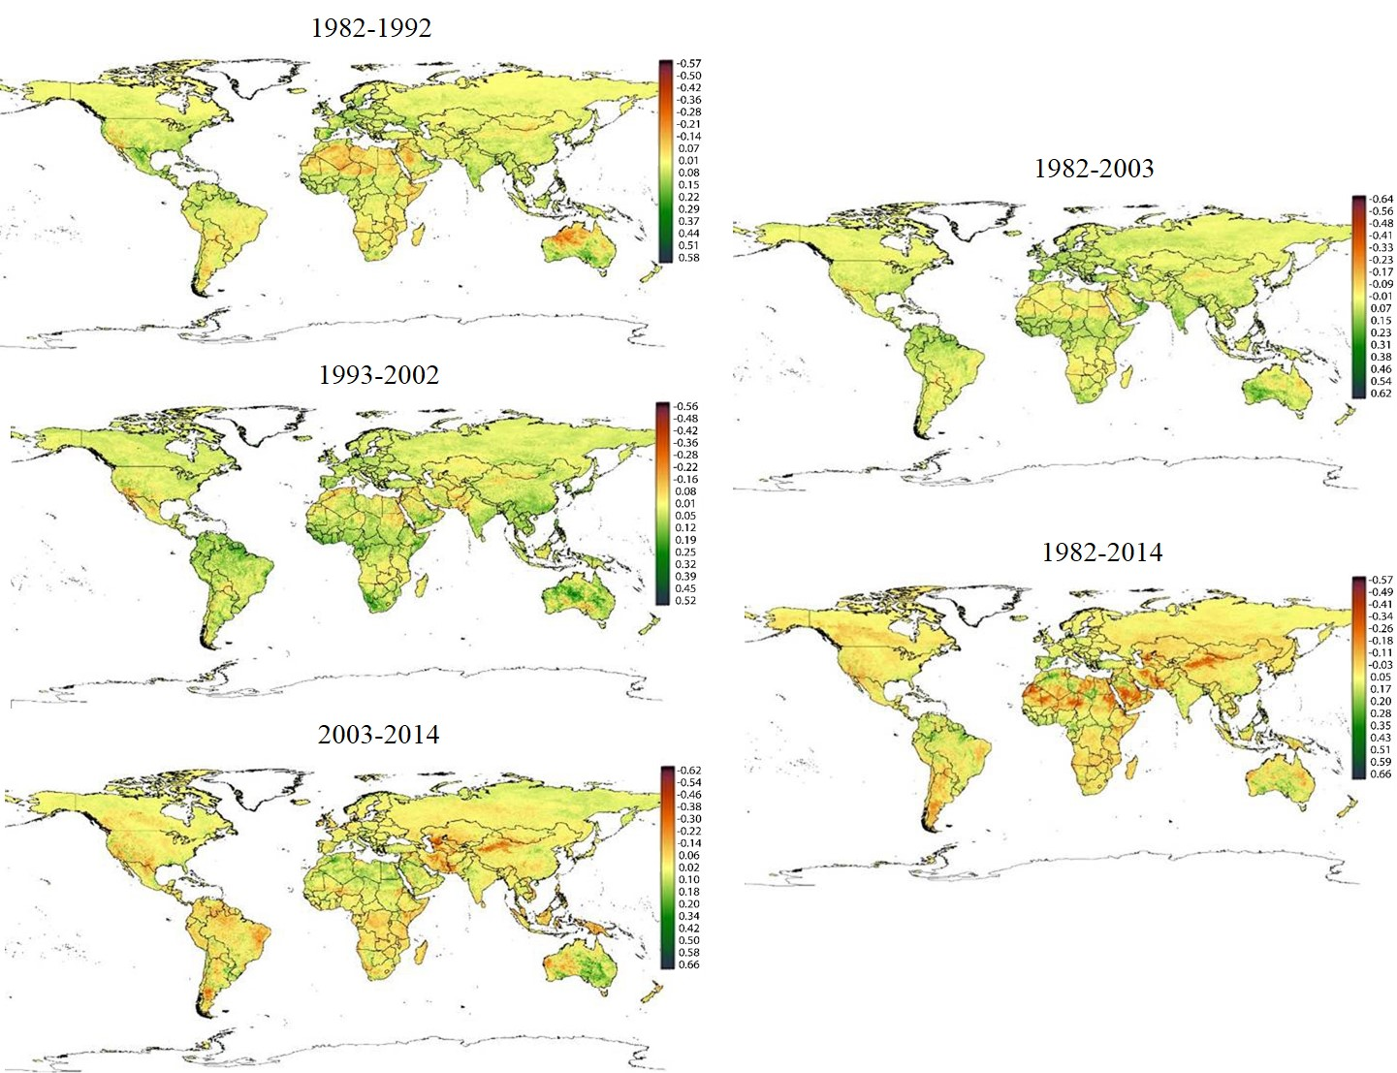
a)
b)
c)
d)
e)
Figure 2. Overall trend of vegetation greenness for 4 division into periods (a. 1982-1992, b. 1993-2002, c. 2003-2014, d. 1982-2003, e. 1982-2014, It ranges from −1 to +1, and a value of +1 demonstrates a trend that continuously increases, -1 value is decreases)
a)
b)
c)
d)
e)

Conclusion
In this study, we monitored and trends of vegetation greenness, temperature and rainfall, and calculated the correlations between each of them. In particular, we investigated how vegetation growth correlated with temperature and rainfall worldwide in the last 33 years. Vegetation greenness and growth are among the most important direct impacts of the land degradation; the indirect impacts are temperature and rainfall. Today, land degradation directly and indirectly impacts human lives and livelihoods and is the leading threat affecting food security, health, and sustainable economic opportunities. In addition to of climate change, desertification and land degradation are driven by human activity, particularly unsuitable land use and management, deforestation, mining, overgrazing, and pollution. These are all human-induced problems, so rest assured we can produce human-led solutions. Finally, vegetation and climate trend monitoring analysis is an important part of identifying land degradation; one of the most important issues is which policies prevent the expansion of degradation area when applied to land users, landowners, and governmental authorities.
References
Angert A, Biraud S, Bonfils C. 2005. Drier summers cancel out the CO2 uptake enhancement induced by warmer springs. Proceedings of the National Academy of Sciences of the United States of America, 102:10823–10827.
Barichivich J, Briffa KR, Myneni RB et al. 2013. Large-scale variations in the vegetation growing season and annual cycle of atmospheric CO2 at high northern latitudes from 1950 to 2011. Global Change Biology, 19:3167–3183.
Buermann W, Parida B, Jung M, Macdonald GM, Tucker CJ, Reichstein M. 2014 Recent shift in Eurasian boreal forest greening response may be associated with warmer and drier summers. Geophysical Research Letters, 41:1995–2002.
Cleland EE, Chuine I, Menzel A, Mooney HA;, Schwartz MD. 2007. Shifting plant phenology in response to global change. Trends Ecol. Evol. 22: 357–365.
Donghai Wu, Xiang Zhao, Shunlin Liang, Tao Zhou, Kaicheng Huang, Bijian Tang and Wenq Ian Zhao. 2015. Time-lag effects of global vegetation responses to climate change. Global change biology, 21: 3520–3531
Frank D, Reichstein M, Bahn M, Thonicke K, Frank D, Mahecha MD, Smith P, Velde M, Vicca S, Babst F, Beer C. 2015. Effects of climate extremes on the terrestrial carbon cycle: concepts, processes and potential future impacts Glob. Change Biol. 21: 2861–2880.
Fensholt R, Langanke T, Rasmussen K, Reenbreg A, Prince SD, Tucker C, Scholes RJ, Le QB, Bondeau A, Eastman R, et al. 2012. Greenness in semi-arid areas across the globe 1981–2007—An Earth observing satellite based analysis of trends and drivers. Remote Sens. Environ. 121: 144–158.
Fensholt, R., Proud, S. R. 2012. Evaluation of earth observation based global long term vegetation trends – Comparing GIMMS and MODIS global NDVI time series. Remote sensing of Environment, 119: 131-147
Zhao M, Running SW. 2010. Drought-induced reduction in global terrestrial net primary production from 2000 through 2009. Science, 329: 940–943.

