ID65: *Social and Environmental Impacts of Marine Renewable Energy*

Glasson, Durning, Welch, Olorundami and Carnie, Impacts Assessment Unit (IAU), Oxford Brookes University, UK

***Socio-economic impacts of OWFs (Offshore Wind Farm) projects***

**--------------------------------------------------------------------------------------------------------------------------------------------------------------------------------------**

**EU marine renewable energy context**

The EU has witnessed a dramatic growth in offshore wind farm (OWF) energy generation, especially in the North and Baltic Seas. The tables (1-2) and figures (1-2) indicate the scale of this growth, and the significant role of UK projects. The UK is and will continue to be the largest OWF energy generator. The recently commissioned Hornsea 1 project, with 170 x 7MW turbines, a total capacity of 1.2 GW, covering an area of 407sqkm, 100 km off the English East Coast, is the largest OWF in the world.

**Range of impacts of OWF projects**

For England and Wales, the Planning Inspectorate examines the potential impacts of OWFs of 50MW under the Nationally Significant Infrastructure Projects (NSIP) regime (Planning Act 2008). OWF energy is widely viewed as a positive renewable energy option, but recent examinations have focused on a range of potential, largely biophysical, negative impacts, including:

* Ornithology: flight displacement; bird collision. This is an area with plenty of research, although the widely used predictive algorithms may be ahead of evidence.
* Cetaceans disturbance, especially from pile driving.
* Fishing disturbance.
* Shipping routes diversions.
* Conflicts with other seabed users – e.g the oil and gas industry.

Socio-economic impacts, on the other hand, have had a relatively low profile – until recently. There is concern that the benefits leak away anyway from local areas, and, being offshore, there may be an out of sight, out of mind mentality? On the other hand, socioeconomic impacts may have the potential to bring positive socio-economic impacts of a rapidly evolving technology to often deprived local and regional coastal communities. Coastal areas, certainly along the UK East Coast, have suffered from the decline of traditional industries, such as fishing, shipbuilding, and to some extent, tourism. This research, funded by an EU/Vattenfall grant, explores the potential significance for local areas of the socio-economic impacts of OWFs.

**Researching the socio-economic impacts of OWFs**

The **Aims** are toexplore methods used to predict socio-economic impacts, compare predicted impacts with actual impacts, seek to enhance understanding of OWF socio-economic impacts, and highlight best practice in how to maximise local benefits.

The **Methods** has four elements, to:

* Examine socio-economic impacts literature on OWFs
* Monitor the Vattenfall European Offshore Wind Deployment Centre (EOWDC) (Aberdeen OWF) over the project lifecycle
* Review socio-economic content in recent OWF ESs for UK and other EU states
* Compare EOWDC impacts with other studies of OWF: Beatrice (NE Scotland), the Hornsea cluster (England East Coast) and floating OWFs.



**Table 1**: European OWF-connected turbines & installed MW capacity (2017) (Wind Europe 2018)



**Table 2**: European offshore wind power--cumulative capacity to 2030 (Wind Europe 2018)

**Figure 1**: UK OWF zones **Figure 2**: Hornsea 1 Project

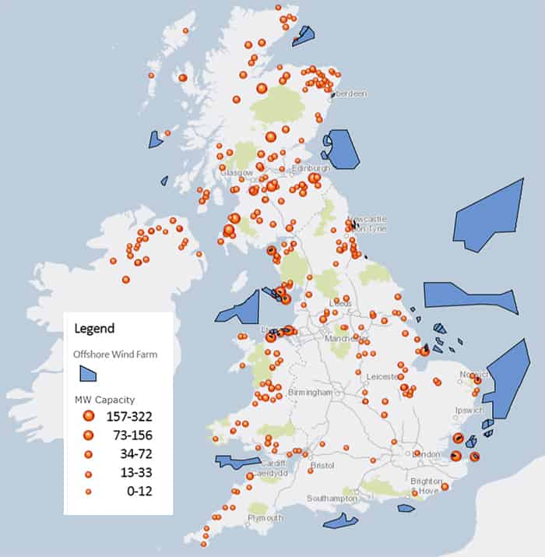 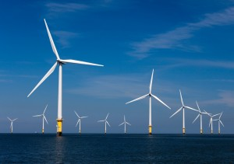

Studies of the socio-economic impacts of wind energy have until recently focused on the more numerous onshore wind farm activities. However, over the last 5-10 years there has been growing interest in the impacts of OWF. A key practice focus in the UK has been on the issue of local content, and reducing economic leakage. Table 3 illustrates the variations in UK leakage, estimated from data from recent operational stations, across the various stages in the project life cycle -- from pre-construction development work (DEVEX), through the major construction stage (CAPEX) to the operation and management stage (OPEX).

Research findings (eg. Firestone et al, 2012; Hattam et al, 2015) indicate that OWFs overall can have a positive impact on well-being. Social impact studies focus on factors influencing public attitudes to OWF including potential conflicts in the dynamic use of the sea by many users simultaneously, concerns about marine wildlife and visual impacts ; see for example Wiersma and Devine-Wright (2014).  Other findings show that early community engagement in the development of an OWF can alleviate fears and uncertainty, which in turn has a positive effect on the social impacts of an offshore development. Mitigation and enhancement methods, such as offering community benefits, are also seen as positive.

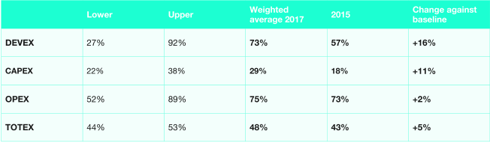

**Table 3:** 2017 Industry Report on UK Content (RenewablesUK (2017)

**Predicted impacts from review of ESs**

The focus of this element of the research is the socio-economic content of Environmental Statements (ESs) for OWF consent applications since the start of 2010 – for developments of at least 50 MW. We reviewed the ESs for 24 UK OWF projects, and 12 non-UK OWF projects (Belgium, Netherlands, Denmark, Sweden and Ireland). The UK review includes projects ranging in size up to 2400MW. In total, the ESs contain proposals for over 15GW of power. Below is a summary of some key findings:

* *All ESs include section on socio-economic effects*, ranging in length from 17pp to 150 pp.
* *The bulk of ESs come under English NSIP regime*. Major developers include DONG/Orsted, Vattenfall, and SSE.
* *Much more coverage of economic than social* *impacts* (ratio of about c 5:1). *Economic focus* *is on employment especially and supply chain impacts.* Coverage of social impacts (eg visual, local services, wellbeing etc) is even less in some recent ESs, with much scoping out.
* *Methodology* – scenario approach gives vast ranges of predicted economic impacts; ambiguity over port location is a major issue, resulting in uncertainty about impacts.
* *Focus is on construction stage, especially offshore*; but important to recognise *the local potential of the impact of O&M stage.* A topic of growing importance for the 20-25 years project lifecycle is the opportunity for *community benefits initiatives, which can be substantial*.
* Many ESs cover *impact of project on other economic sectors, especially on tourism and fishing.*
* Recent ESs include good practice of an *Employment and Skills Plan*, to support effective implementation of socio-economic undertakings.

**Actual economic impacts from North Sea case studies**

The research includes a *major case study* of the local socio-economic impacts of the construction and O&M stages, from 2016 to 2019, of the Aberdeen Offshore Wind Farm. This is a small (11 turbines, 96 MW, £300m) but innovative project (largest 8.8MW turbines, suction bucket foundations, high wind operable). It is only 2km offshore and, as an aside, controversially abuts a Trump golf course. Two other *minor case studies,* which provide contrasts to the Aberdeen OWF, include the Beatrice OWF, a 600MW, £2.6bn project off the NE tip of Scotland, and the set of four Hornsea projects off Humberside in England. The latter will provide the largest UK cluster of offshore wind power, totalling up to 7000MW, with an estimated total investment of c£20-25bn. In addition, latterly, we have included two small NE Scotland floating OWF projects.

The key message from the Aberdeen and other small projects is that there is a major local leakage out of the substantial investments, especially of the main offshore construction works. For the Aberdeen project, an initial tracking of contracts indicates about 25% of the investment is UK-based, 2% is from Scotland, and 1% is from the Aberdeenshire local area. This was less than predicted in the ES. At peak construction, the Aberdeen project employed c500 people on installation vessels, with 15 nationalities: Europeans (80%), British (10%) and other (10%). For such a small project, with a short construction period (around 1.5 years), the main personnel come from established companies, mostly outside Scotland. However, the research also highlighted the greater local economic significance of the onshore construction works, and the more long-term (20 years) O&M stage. About 33% of the onshore works expenditure was local, as was c60% of the workforce. The figures are higher for the O&M stage economic impacts -- similar to the ES predictions. The Aberdeen and Beatrice projects have also led to the regeneration of small ports, with associated benefits for other coastal industries.

The Hornsea projects (Figure 3) present a very different scale of coastal socio-economic impacts. They lie about 80-120 km offshore. When fully developed, they will constitute one of the largest clusters of OWF energy worldwide, with up to 900 large turbines, and around 7GW of power. They also lie off a major port and industrialized coast, including the ports of Hull, Grimsby and Immingham. As such, the Hornsea case study provides an example of offshore wind farm development on a large scale, with the potential for substantial supply chain development, and associated production initiatives. Cumulatively the projects provide a set of overlapping socio-economic impacts, with the medium scenarios for projects 1 and 2 averaging about 1000 local construction jobs pa, and project 3 double that number. Similarly, the O&M stage is very significant cumulatively, with over 1000 jobs pa over much of the combined project life cycles.

**Figure 3**: Hornsea OWF projects

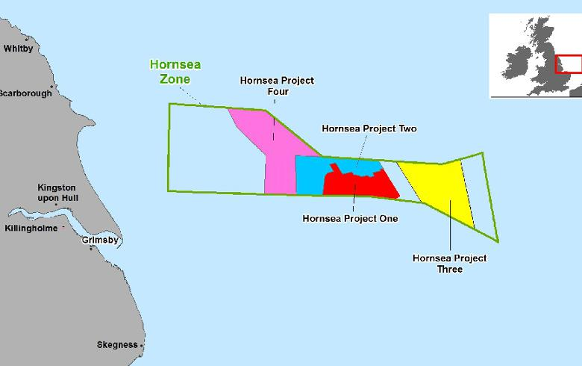

The Hornsea projects indicate the strengths of a pipeline of projects for substantial local and regional socio-economic impact. Examples of inward investment include: Siemen’s £310m turbine factory in Hull with 1100 direct jobs, the Able Marine Energy Park, a bespoke £450m Humber port facility for the renewable energy sector, and Orsted £200m OWF O&M servicing base in Grimsby Docks, which became operational in Spring 2018, creating a further 200 jobs. Cumulatively, the OWF developments and onshore investments all enhance the identification of the Humber as a major OWF hub.

**Actual social impacts**

The focus is on the detailed assessment of actual social impacts over the lifecycle of the Aberdeen OWF**.** The content in the ES had only limited coverage of visual effects on landscape and seascape, and effects on local coastal recreation activities, all seen as of negligible significance. What was impressive during the project lifecycle was the developer’s commitment to an e*ngagement and social interaction programme,* between the Vattenfall Local Community Liaison Officer (LCLO) and the local Blackdog community, impacted by the sub-station development. A key component of the engagement strategy has been educating and raising awareness of the renewable industry and the innovations of the Aberdeen project. There was also a set of i*nitial community benefits* eg. To Aberdeen Science Centre, Aberdeen FC, Blackdog Residents’ Association (c£80k in total to date).

A key feature of the late construction/ early O&M stage has been the development of the *Aberdeen OWF Community Benefits Fund (CBF*). This has built on pioneering Scottish guidance, as well as on other UK and international examples (Haggett 2017). The LCLO followed up such guidance with local stakeholders and an online survey of the local community on various options for the Aberdeen CBF. The positive outcome is a CBF of £150,000 pa for 20 years. It applies to the whole of Aberdeen City and Aberdeenshire, but with 10% (ie £15,000) pa ringfenced for Blackdog projects. This fund is a major additional, social and economic benefit, for the O&M stage, which, with multipier impacts, is likely to generate a substantial social return on investment. If the claims made for the equivalent Beatrice Fund (NEF, 2017) were to eventuate for the Aberdeen Fund, the £3m fund might deliver total social benefits of up to £9m (at current prices) over the life of the project.

Surveys of the residents of the small Blackdog community, and the wider population of Aberdeen residents, indicated at worst neutral and, in many cases, very positive attitudes to this very visible near shore development. Comments included, for example: *sense of pride-demonstrating Scotland’s commitment to renewables; I love the look of windfarms, they are beautiful; clean energy is beneficial to everyone; benefits for jobs and the environment; can take over when oil runs out.* There were far fewer negative comments, but some examples included:  *possible disruption to wildlife/sealife; disruptive onshore infrastructure; visual disbenefits.* For the Blackdog community, there was some initial impact on community cohesion with some community members opposing the development strongly especially in relation to construction traffic activities. There were also some dashed early perceptions on potential local benefits, including whether the community would receive cheaper electricity, and improved broadband. However, in general there was acknowledgement that Vattenfall had engaged with the community better than expected and that the main financial benefits would come in the O&M stage.

**Conclusion: major opportunities in a technologically rapidly evolving industry**

Offshore wind power is a rapidly growing source of marine renewable energy. However, will the adjacent coastal communities benefit? There is a growing recognition of potential socio-economic benefits in UK ESs. However, our research indicates that the social impacts are very much the poor relation, with the focus on economic impacts, especially on employment and investment/expenditure impacts. The ESs use a scenario approach, making accurate prediction difficult, although this may change over time as service port hubs become established. The focus has also been on the offshore construction element of the project, yet there is major leakage of local benefit from that element. It is the onshore construction element and the O&M stage that have the greater local economic potential for smaller projects and settlements. Only with a pipeline of major projects, is there the critical mass for onshore fabrication and installation bases, and substantial benefit from offshore construction. The case studies also show that community acceptance of such projects benefits from a well-structured programme of developer/community engagement and interaction from very early in the life of projects. In the later stage, the increasing use of community benefits agreements can generate a substantial social return on investment

**Figure 4**: The visible near-shore **Figure 5**: Floating wind farm areas of potential Aberdeen OWF

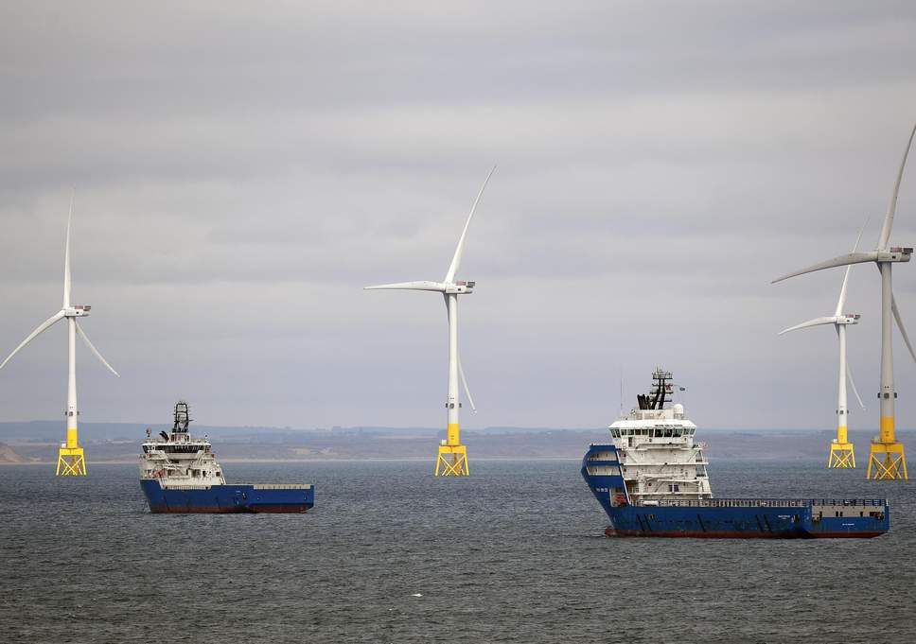

  
 Source: Crown Estate (2018)

The OWF industry is innovative and technological advances are rapid. The assessment of impacts needs to be alive to such developments, as they may have consequences for impacts. For example, drones might substitute for boat crews for monitoring the performance of projects in the O&M stage. NE Scotland is also home to the first floating OWFs -- the 5x30 MW, floating Hywind Scotland Pilot Park Project (Peterhead) now operational and the Kincardine Offshore Windfarm. Details of the Hywind project, largely manufactured in Norway, suggest even more economic leakage. However, they also open the potential for more OWF development in the deeper waters off the Scottish coast (Figure 5). About 80% of the UK offshore wind resources are in deep waters (more than 60 m) where traditional installations are not suitable.

**References**

Crown Estate (2018). *Macroeconomic Benefits of Floating Offshore Wind in the UK*.

Firestone J, Kempton W and Lilley M B and Samoteskul K (2012). Public acceptance of offshore wind power: does perceived fairness of process matter. [*Journal of Environmental Planning and Management*](http://www.tandfonline.com/toc/cjep20/current), 55, 10, pp1387-1402

Haggett, C (2017). *EOWDC Community Benefits Baseline Study*. University of Edinburgh.

Hattam C, Hooper T and Papathanasopoulou, E (2015). *Understanding the Impacts of Offshore Wind Farms on Well-Being,* Marine Research Report, Crown Estate

NEF (New Economics Foundation) Consulting (2017). *SSE—Beatrice Social Return on Investment (SROI) framework*, NEF: London

RenewablesUK (2017). *Offshore Wind Industry Investment in the UK: 2017 Report on offshore wind UK content.* RenewableUK

Wiersma B and Devine-Wright P (2014). Public engagement with offshore renewable energy: A critical review, *Wiley’s Interdisciplinary Reviews: Climate Change*, 5, 4, pp.493-507

WindEurope (2018). *Offshore Wind in Europe—Key trends and statistics 2017.* Brussels:Wind Europe.