Holistic Approach to University’s Ethical Decision

Susumu Teshima, Shinichiro Tanaka (Chiba University of Commerce)

1. Introduction
Japan ratified the Paris Agreement in November 2016 and committed to decarbonization. In accord with the agreement, the Japanese government decided to implement its Intended Nationally Determined Contributions (INDC). The greenhouse gas (GHG) reduction target prescribed in the Japanese INDC is a 26% reduction in 2030 compared to 2013.
Moreover, Japan has rapidly increased renewable energy (RE) since July 2012 when the Feed-in Tariff system (FIT) was put in force. Installed Capacity of RE has increased from 8 GW to 55GW by December 2018. The 55GW breakdown is that PV for the house (from 10kW on down) is 10.5GW, PV for all other them is 37.5GW, Wind is 3.6GW, Small Hydro (from 30,000kW on down) is 0.6GW, Geo is 0.02GW, Biomass is 2.7GW.
The Paris Agreement and RE are exerting significant degrees of influence on the private sector, especially advanced companies. A lot of famous companies accede to RE 100 Projects which is “a global corporate leadership initiative bringing together influential businesses committed to 100% renewable electricity”. The prominent companies are IKEA (home furnishing company), 3M (manufacturing and technology company), Adobe (multinational software company), AXA (insurance company), Bank Australia (customer-owned bank), Burberry (luxury fashion brand), LEGO (manufacturers of creative play materials), Starbucks (global coffee company), Wal-Mart Stores (global retailer), Microsoft, Google, Apple, Facebook and so on.
All academics should not ignore the movement from the Paris Agreement and RE because all universities have the responsibility to lead people into the future path as the knowledge hub. In other words, all universities in the world should lead RE100% society as a RE100% university.
However, universities have many problems to become a RE100% university such as costs and lack of understanding. RE100% university proponents need the knowledge to persuade opponents.
What are the benefits for a university to become RE 100% university? This study is intended to reflect on the benefits and to indicate them with a case of Chiba University of Commerce (CUC). It is a collaborative study by Susumu Teshima, who is in charge of the case study, and Shinichiro Tanaka, who is in charge of the benefits research. Teshima is a specialist in the RE business. Tanaka is a specialist in the RE policy.

2. Environmental and Social Benefits raised by RE100% University
The hypotheses of benefits of RE100% university are the next five points. They are derived from the business experiences of this study researchers.
- Environment Benefit
RE 100% university project reduces the effects on the environment resulting from the university activity. Especially, introducing renewable energy and energy-saving facilities to the university reduces dependence on fossil fuels. Naturally, RE 100% university cut emissions of CO2 from the university.
- Economic Benefit
RE 100% university project reduces the energy bill of the university. The university can spend more money on education, research and the future. It will improve the intrinsic value of the university. Considering the higher prices trend of fossil fuels, it would decrease the management risk of the university.
- Academic and Education Benefit
RE 100% university project offers the opportunities to study sustainable energy, social entrepreneurship, business ethics and SDGs practically. For example, supposable cases are an energy company established by students, energy policy research and so on. It means providing human resources with energy business skill to society by the university.
- Health Benefit
RE 100% University Project reducing the physical and mental effects on the indoor thermal environment of the school buildings depending on insulation, airproof, insolation control and heat exchanging air ventilation. It would encourage good physical condition of people of the university and learning efficiency of students.
- Disaster Prevention Benefit
RE 100% university project reduces the effects on the disasters depending on offering the university facilities supplied with electricity as a shelter for neighboring residents and a local disaster preparedness center. It would improve the value of the university in the city additionally.

3. The Case of RE100% Project at Chiba University of Commerce (CUC)
Chiba University of Commerce (CUC) has its main campus (site area 109,500 m² ) in Ichikawa City, bordered Tokyo to the west, accommodating 6,500 students and over 700 faculties and staff. From July 2015 to February 2016, CUC conducted a feasibility study toward RE100%. In cooperation with CUCEnergy Co., CUC’s subsidiary incorporated to conduct energy saving and RE projects, it listed up potential solutions to reduce energy consumption on campus. Calculating costs and benefits, it found that, among many potential solutions, replacing fluorescent lightings with LEDs was the best to reduce energy consumption and was the most cost-effective. (Figure 1)

Figure 1. List of potential solutions and evaluations
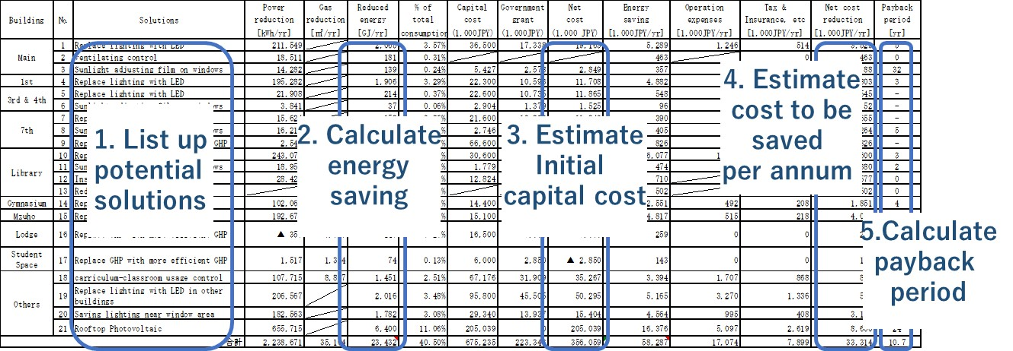

In 2017, CUC launched RE100% Project, as one of President’s initiatives, to reduce energy consumption on campus and increase RE production until both matches in a total amount.
For energy saving, based on the feasibility study, CUC first installed LED lights, which contributed to a 25% reduction of annual power consumption. In the same year, the student group researched power consumed by 38 vending machines of canned soft drink on campus and suggested the university take away four and replace old six with new energy-efficient machines. The university reduced the number of vending machines from 38 to 31, of which 19 were replaced with high energy efficiency ones.
For energy production, in 2018, it added solar panels (427 kW) to its existing CUC Mega-solar Noda Power Plant, where there was still available space. The power generated at Noda Power Plant, located 25 km from CUC campus, is entirely sold to a power company with feed-in tariff scheme and not transmitted to the university campus. By the end of January 2019, the amount of power produced at Noda Power Plant for the last 12 months became 101% of that consumed at Ichikawa campus for the same period. CUC aims to produce power to match not only electricity consumption but also total energy including heat in the amount. It placed solar panels (448 kW) on the roofs of 10 buildings on campus, commissioned in March 2019. Both facilities, i.e., enhanced Noda Power Plant and solar panels on rooftops, will be expected to generate power equivalent of 113% of electric power and 92% of total energy consumption (both heat and power) on campus.
One of the critical success factors for achieving RE100% goal at CUC was the approach to forming the project. High-goal setting (i.e., RE100%) and cross-functional project organization lead to produce multiple co-benefits, which enabled more sub-projects to be executed. It is often the case that investment decision on installing facilities such as LED lightings are made based on a pay-back period, where benefit from cumulative amount of cost saving for a certain period is compared to hardware investment. (Figure 2) In contrast to the simple hardware decision making, the holistic approach counts all the co-benefits derived from the one packaged project with a high stretched goal. In addition to cost saved by installing hardware (e.g., reduction of power bills), promotional effects and educational opportunities are the values the project can provide. As returns are combined, more sub-projects are accepted in the project. (Figure 3) In the case of CUC, LED lights replacements were made to almost all buildings although only five buildings had a payback period of fewer than five years if the calculation was made without co-benefits.

Figure 2. Illustration of simple hardware investment decision making
Only two sub-projects are selected when the cut-off year is five.
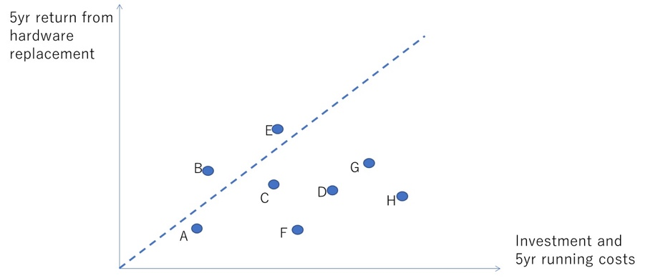

Figure 3. Illustration of holistic decision making in one packaged project
Two additional sub-projects are accepted by counting co-benefits.
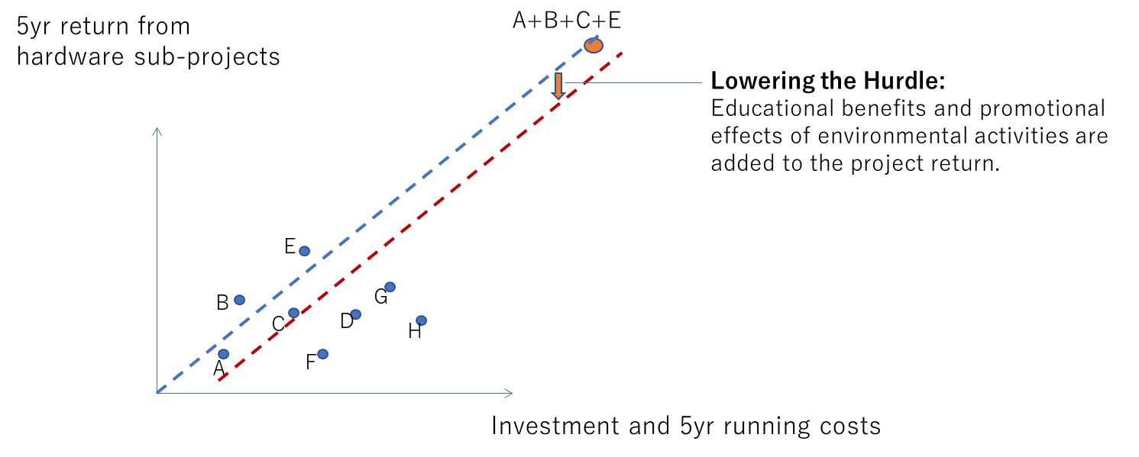

Great goal setting drew significant attention from both inside and outside of the university. As the project became internally well-known, several faculties in different departments began to use the project as a learning opportunity for their students. Staff and faculties were widely selected as project members, and this cross-functional selection made it easy to gain value from the project. Media got interested in the project and made many articles on it and related activities. (Figure 4)

Figure 4. Comparison of two different approaches
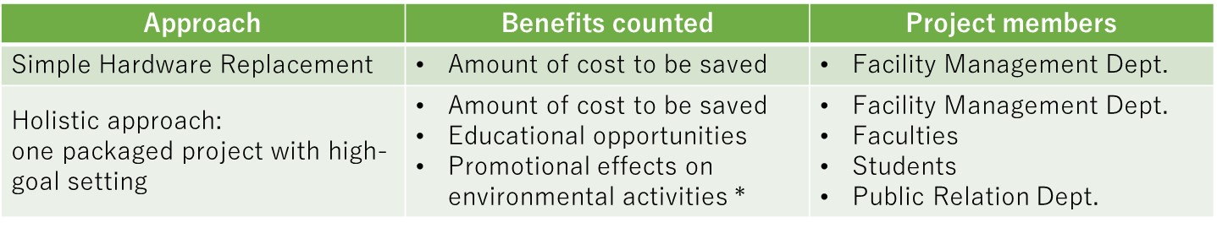

Out of five benefits, Although CUC has so far achieved environmental, economic and educational benefits, solutions for health and disaster-prevention benefit are under consideration. The power production exceeded power consumption, providing environmental benefit; there still need 20% to fill the gap between total energy production and total energy consumption (heat and power). CUC gained mild economic benefit by reducing the electric power bill. Academic and educational benefits were used well for students to learn the environment, socio-economic problems, project management and team building. CUC has not gain health and disaster prevention benefits. For health benefit, installing heat insulation windows is probably the most realistic solution that CUC need to research. For disaster prevention benefit, battery installation on campus will be considered.

4. Conclusion
RE100% university has environmental, economic, academic, health, and disaster prevention benefits. In the case of CUC, by taking a holistic approach to decision making in hardware investment, three of the five benefits, environment, economic and educational/academic, are confirmed by this study. Validation of others is left as the next agenda. Furthermore, the wide-ranging impact assessment of RE100% university is a future agenda. As accurate impact assessment requires many cases, more RE100% universities are needed. The cases would contribute to the development of a sustainable society and impact assessment study.

Susumu Teshima (Chiba University of Commerce)
Shinichiro Tanaka (Chiba University of Commerce) tanakash@cuc.ac.jp
https://www.fit-portal.go.jp/PublicInfoSummary
http://there100.org/re100
International Energy Agency, World Energy Outlook 2018, https://www.iea.org/weo2018/
Explanations were added to an excerpt from the worksheet made for the feasibility study report in 2016.
The CUC’s RE100% project was cited by over 100 articles after the press conference in November 2017, regarded as USD 515,000 if they were converted as advertisement price.

