Barriers and Breakthroughs:
The roles of Indigenous Women in Canadian Impact Assessments
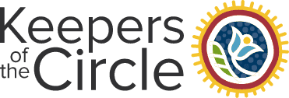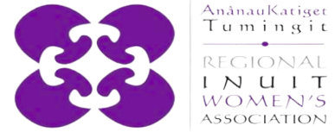
__________________________________________________________________________________________________
Authors: Britney Zacharuk, Alexandra Bridges, and Johanna Tuglavina
A partnership between Keepers of the Circle & AnânauKatiget Tumingit Regional Inuit Women’s Association

Equitable and sustainable resource development methodologies are being developed in Canada and across the globe, creating a new era of land use planning and decision-making systems. The Government of Canada has taken steps in the last several years in response to key publications such as, the Missing and Murdered Indigenous Women and Girls Report (MMIWG, 2019), the United Nations Declaration on the Rights of Indigenous Peoples (UN General Assembly, 2007), and the Truth and Reconciliation Calls to Action (Truth and Reconciliation Commission of Canada, 2015). These reports brought to light the lived realities of Indigenous communities in Canada, as they recover from the lasting impacts of colonization, genocide, ongoing systematic violence, and assimilationist policies. Indigenous communities across the country are on a path of cultural resurgence, intergenerational healing, and restorative justice. The Government of Canada improved land use planning and resource development policies and legislation to become more inclusive of Indigenous perspectives. As exemplified when Canada updated the Canadian Environmental Assessment Act (CEAA, 2012) to become the Impact Assessment Act (IAA, 2019). The Canadian impact assessment system seeks to recognize and account for impacts beyond environmental, extending the scope to include economic, social, and health considerations.

The Impact Assessment Agency of Canada created the Indigenous Capacity Support Program to help enhance meaningful engagement and consultation with Indigenous Peoples in impact assessment processes. Our partnership initiative, the Invitation to Voices project, is funded through the Indigenous Capacity Support Program. The goal of our project is to build the capacity of Indigenous women to participate in impact assessments. The project was motivated by the lack of existing literature available for solutions-based approaches that adequately respond to the historical exclusion of Indigenous women and girls, who face distinct and significant impacts from extractive industries. We applied gender-based analysis+ techniques, conducting a thematic analysis to identify the barriers that are currently being experienced by Indigenous people. We investigated how Indigenous women and girls are being included -or left behind- in consultation, planning, and project implementation processes, while acknowledging that these exclusionary trends go beyond sex and gender. Focussing on intersectional identity inclusion, we invited Elders, youth, two-spirit people, and members of the LGBTQ+ community to participate.
Throughout the project, we engaged with Indigenous people living in Northern Ontario and coastal Labrador- the regions encompassing our organizational hubs. We conducted interviews, launched workshops, and piloted training sessions about impact assessments and the existing opportunities to get involved in land use planning and decision making. During these sessions, we used trauma-informed methods and invited participants to share their experiences in a safe space. We engaged with community members who had experience with previous environmental assessment processes, worked at resource extraction sites, or lived in surrounding areas. As a result, we were able to better understand the contemporary barriers to participation being experienced by marginalized identity groups.

To summarize the findings of our initial publication, “Indigenous Women’s Participation in Impact Assessments: An Examination of Barriers in Impact Assessments and the Navigation of Violence to Land and Body” (Keepers of the Circle, 2022) we heard that:
- Indigenous people expressed a lack of familiarity with legislative processes and were overwhelmed with the amount of highly technical content they were expected to review in relatively short timelines;
- They expressed having a lack of capacity to volunteer, their already limited free time, to review information and provide comments in a system they felt wasn’t truly listening to their concerns;
- Information is inaccessible, whether that be due to technological barriers or educational disparities, Indigenous people feel that information is not reaching them or is not being presented in a way that they can understand;
- The systematic bias towards western worldviews created feelings of otherness that were intensified by the lack of Indigenous people leading engagement sessions and the lack of Indigenous knowledge systems in engagement sessions;
- When able to participate, people felt that their contributions were silenced or ignored;
- The gender-based violence and discrimination, that is unfortunately all too common, at resource extraction worksites can bring up past traumas and further deter participation;
- As the cumulative lasting impacts of intergenerational trauma continue to unfold, Indigenous women are often the primary caregivers and must prioritize their need to provide for their families while struggling with food, water, and housing insecurity;
- Indigenous people are most likely to experience the negative impacts from resource extraction projects and are simultaneously the least likely to have access to the potential benefits of such projects.

The second phase of our project focussed on creating the Shared Responsibilities Framework which guides community members, proponents, and government agencies to conduct more equitable and inclusive impact assessments. Our publication, “Shared Responsibilities: Indigenous Lens Gender-Based Analysis+ in Impact Assessments” (Keepers of the Circle, 2023) details this framework, our research methodology, and major findings, presented below in Figure 1.

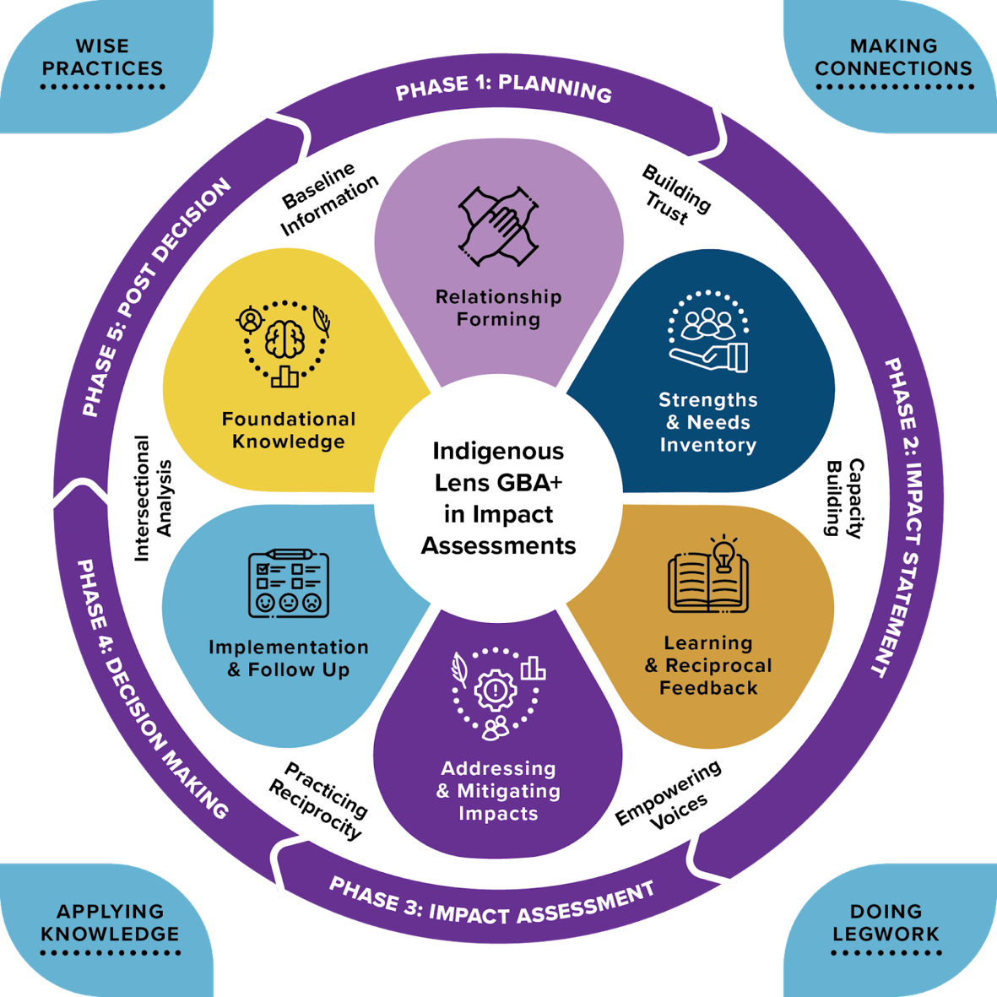
Figure 1: Indigenous lens gender-based analysis+ framework for Impact Assessments. This model supports four key recommendations: Making Connections, Doing Legwork, Applying Knowledge, and Wise Practices. The model is centered within the 5 Phases of an IA developed by IAAC: Planning, Impact Statement, Impact Assessment, Decision Making and Post Decision. This circular model presents a method to achieve equitable intersectional representation in IA processes beginning with Relationship Forming, Strengths and Needs Inventory, Learning and Reciprocal Feedback, Addressing and Mitigating Impacts, Implementation and Follow-up, and Foundational Knowledge. These steps overlap to accomplish: Trust building, Capacity building, Empowers Voices, Reciprocal Practices, Intersectional Analysis, and contributes to Baseline Information gathered.

The Shared Responsibilities Framework is centered within the 5 phases of Canadian Impact Assessments which are:
- Planning
- Impact Statements
- Impact Assessments
- Decision-Making
- Post-Decision Monitoring
We heard concerns related to the linear and reductive nature of the federal impact assessment system, so we created a circular framework that allows past projects to become the baseline information for future projects. The Shared Responsibilities Framework supports four key themes: making connections, doing legwork, applying knowledge, and building wise practices. These broad goals are accomplished by forming relationships and building trust with communities, conducting strengths and needs inventories to understand the unique capacity of each community, and providing resources that support widespread capacity building. Only once community capacity has been increased can authentic and reciprocal knowledge exchanges take place - leading to more meaningful consultation and relationship building overall. Empowering everyone’s voices in the impact assessment process facilitates equitable exchanges of knowledge between distinct worldviews. With more authentic knowledge sharing, project impacts can be better addressed and mitigated with the goal of enshrining protective measures in legislation and policies. Focusing on the use of intersectional gender-based analysis, the Shared Responsibilities Framework supports equitable inclusion informing impact assessments. It is essential to have foundational knowledge that represents diverse ways of knowing and doing, ensuring that intersectional identity holders are not only included, but can be leaders and decision makers.

In conclusion, the Shared Responsibilities Framework has four key takeaways. Firstly, recognizing that all our relations are connected is imperative. By recognizing that we are all interconnected, that we share this Earth with one another and with all the beings of creation, we better understand the responsibilities we bear as land stewards. Next, the path forwards requires that we weave multiple knowledge systems. Indigenous knowledge, traditional ecological knowledge, and culturally rooted knowledge systems must be considered to the same extent of western scientific knowledge. Historically, land use planning and impact assessment systems have failed to ensure intersectional identity representation. Moving forwards, we must acknowledge that representation matters and include Indigenous women and all marginalized identities equally. Finally, community empowerment is essential in this time of intergenerational healing and cultural resurgence. Our collective power is valuable and together we are stronger.

The Invitation to Voices project created a framework for meaningful engagement processes. We stress that much work remains to be done to intentionally apply these teachings and create inclusive impact assessments. As we actionize the next phase, the Empowered Voices project, we aim to build a national coalition of meaningful community-led consultations. We are eager to see how Indigenous engagement and consultation within impact assessment systems will evolve. We are paying attention, and we hope that you will too.

References
CEAA. (2012). Canadian Environmental Assessment Act, 2012, SC 2012, c 19, s 52. Retrieved from, https://laws-lois.justice.gc.ca/eng/acts/C-15.21/

IAA. (2019). Impact Assessment Act, SC 2019, c 28, s 1. Retrieved from, https://laws.justice.gc.ca/eng/acts/I-2.75/index.html

Keepers of the Circle. (2022). Barriers Report, Indigenous Women’s Participation in Impact Assessments: An Examination of Barriers in Impact Assessments and the Navigation of Violence to Land and Body. Keepers of the Circle and the AnânauKatiget Tumingit Regional Inuit Women’s Association.

Keepers of the Circle. (2023). Shared Responsibilities: Indigenous lens Gender-Based Analysis+ in Impact Assessments. Keepers of the Circle and the AnânauKatiget Tumingit Regional Inuit Women’s Association.

MMIWG. (2019). Reclaiming Power and Place: The Final Report of the National Inquiry into Missing and Murdered Indigenous Women and Girls. Canada. [Web Archive] Retrieved from the Library of Congress, https://www.loc.gov/item/lcwaN0028038/.

Truth and Reconciliation Commission of Canada. (2015). Calls to action. Truth and reconciliation commission of Canada. Winnipeg, MB. Retrieved from www.trc.ca

UN General Assembly. (2007). United Nations Declaration on the Rights of Indigenous Peoples: resolution / adopted by the General Assembly, 2 October 2007, A/RES/61/295. Retrieved from, https://www.refworld.org/docid/471355a82.html

